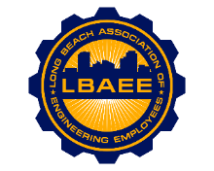

LONG BEACH ASSOCIATION OF ENGINEERING EMPLOYEES
BOARD MEETING AGENDA
Location: Zoom
January 10, 2024
12:00-1:15 PM

Call to Order
Jason Rodriguez, President
Henry Corzo, Vice President
Chris Sanatar, Treasurer
Jennifer Williams, Executive Assistant
Tai Vu, Director Group A
Gian Moral, Director Group B
Dillon O’Donohue, Director Group C
Jorge Castillo, Director Group D
Juan Arias, Director Group E
Robert Tinsley, Director Group F
Jeffrey Natke, CEA

Approval of Minutes

Approval of the August and October meeting minutes.

Treasurer’s Report

Committee Reports
- Member Relations
- Grievance status - CEA
- Health Insurance Advisory (HIAC) – Rodriguez
- Deferred Compensation Advisory Committee (DCAC) - Rodriguez
- Miscellaneous Member Items

New Business

- Track metrics for 2023 MOU negotiations starting in 2024.

Continuing Business

Round Table

Close Session

Adjournment

