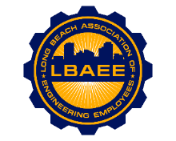

LONG BEACH ASSOCIATION OF ENGINEERING EMPLOYEES
BOARD MEETING AGENDA
Location: Teams
July 11, 2024
12:00-1:00 PM

Call to Order
Henry Corzo, President
Jennifer Williams, Vice President
Chris Sanatar, Treasurer
William Stevenson, Executive Assistant
Tai Vu, Director Group A
Gian Moral, Director Group B
Dillon O’Donohue, Director Group C
Jorge Castillo, Director Group D
Juan Arias, Director Group E
Jeffrey Natke, CEA

Treasurer’s Report

Committee Reports
- Member Relations
- Grievance status - CEA
- Health Insurance Advisory Committee – Corzo
- Deferred Compensation Investment Committee (DCAC)- Arias/Sanatar
New Business
Continuing Business

Round Table
- Discuss holding a general meeting in October.
- Discussion on Group Composition.

Close Session

Adjournment

