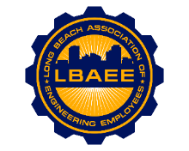

LONG BEACH ASSOCIATION OF ENGINEERING EMPLOYEES
BOARD MEETING AGENDA
Location: Virtual
January 9th, 2025
12:00-1:30 PM

Call to Order
Henry Corzo, President
Jennifer Williams, Vice President
Chris Sanatar, Treasurer
Aaron Machado, Executive Assistant
Tai Vu, Director Group A
Gian Moral, Director Group B
Dillon O’Donohue, Director Group C
Jorge Castillo, Director Group D
Juan Arias, Director Group E
Annie Mosher, Director Group F
Jeffrey Natke, CEA

Approval of Minutes
- Approval of the December 2024 meeting minutes

Treasurer’s Report
- Monthly Update

Committee Reports
- Member Relations
- Grievance status - CEA
- Health Insurance Advisory Committee - Williams
- Deferred Compensation Investment Committee (DCAC) - Arias/Sanatar

New Business
- DCHE’s Update
- Newsletter

Continuing Business
- Civil Service Charter Amendment timeline
- Discussion on next steps for Enterprise Classifications
- 2025 Budget
- AEE Mixer update
- Mission Square informational session

Round Table

Closed Session

Adjournment

