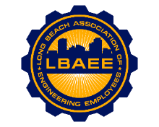

LONG BEACH ASSOCIATION OF ENGINEERING EMPLOYEES
BOARD MEETING AGENDA
Location: Virtual
June 12th, 2025
12:00-1:30 PM

Call to Order
Henry Corzo, President
Jennifer Williams, Vice President
Chris Sanatar, Treasurer
Aaron Machado, Executive Assistant
Tai Vu, Director Group A
Gian Moral, Director Group B
Jorge Castillo, Director Group D
Juan Arias, Director Group E
Annie Mosher, Director Group F
Jeffrey Natke, CEA

Approval of Minutes
- Approval of the May 2025 meeting minutes

Treasurer’s Report
- Monthly Update

Committee Reports
- Member Relations / Grievance status - CEA
- Health Insurance Advisory Committee - Williams
- Deferred Compensation Investment Committee (DCAC) - Arias/Sanatar
- Education & Community - Mosher
- Social & Networking - Williams

New Business
- Fire Prevention Group Classifications
- Salary Survey
- October AEE Members Meeting

Continuing Business
- Scholarship follow-up
- Calpers Power of Attorney Survey
- Board Positions Manuals

Round Table

Closed Session

Adjournment

