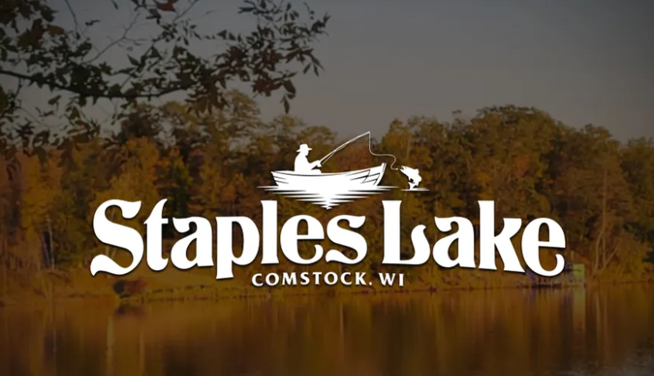
www.StaplesLake.com
May 30, 2026
Welcome to Our New Website!
Why We Built It
The Staples Lake website was created to bring our lake community together in one central place. Over the years, information, photos, and history have been scattered across conversations, emails, social media, and individual families.
This gives us a shared “home base” to preserve what matters and make it accessible for everyone—now and for future generations.

What the Website Is Used For
- A central hub for lake information, events and updates
- A place to share and preserve memories and history
- A resource for residents, property owners, and visitors
- A way to support lake stewardship and community connection

Branding & Logo
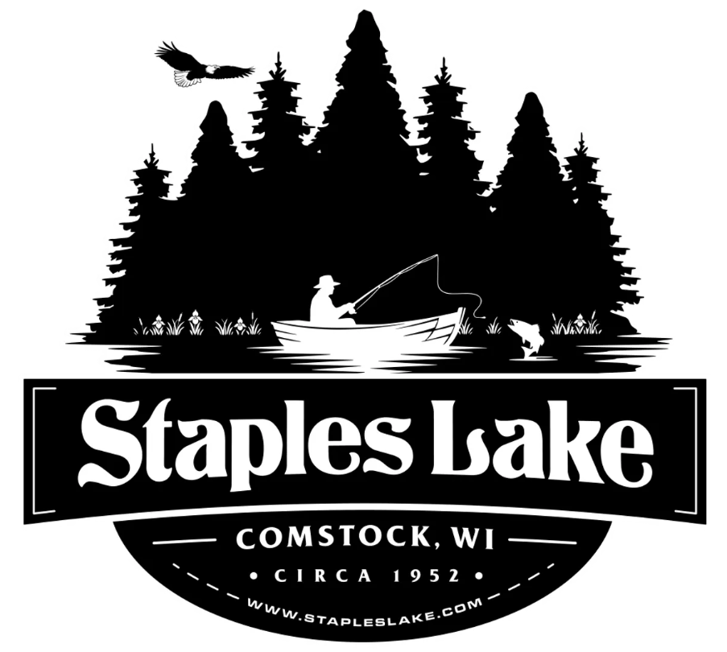
We created a custom logo to reflect what makes Staples Lake special:
- The eagle and fisherman represent the peaceful, timeless nature of the lake
- The bass reflects one of the lake’s most common and enjoyed activities
- The shoreline plants highlight our focus on maintaining a healthy lake
- Circa 1952 connects to the early roots of our community
The goal was a logo that feels meaningful and lasting—not trendy.
Additional logo variations are available for flexible use, including merchandise.

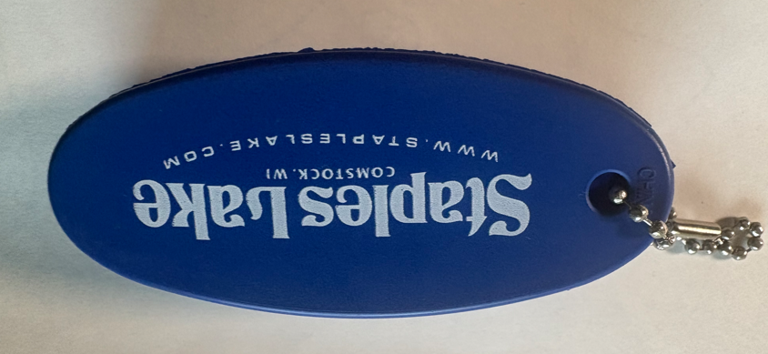

Key Areas of the Website
About
History, landmarks, legacy, and the Memory Book all come together here. This section will continue to grow as memories and information are shared.
Contribute: https://stapleslake.com/share-a-memory
Local Favorites
Favorite spots around Staples Lake and the surrounding areas, including Turtle Lake and Cumberland. Suggestions are welcome as this section grows.
Resources
Helpful contacts and information for lake living, including emergency services, local providers, handymen, and general lake resources. Intended as a community reference—not an endorsement.
Lake Protection
Focused on lake health, shoreline care, and conservation efforts. StaplesLake.com now serves as the primary community hub while continuing to support Staples Lake Protection (www.stapleslakeprotection.org). These will be consolidated over time.
Trails and Riding
Links and information for local trail systems and riding resources.
Memory Book
A growing collection of stories, traditions, photos, and memories shared by the Staples Lake community.

Communication
info@stapleslake.com provides a centralized way to communicate with the association/board. Email inbox is managed on a volunteer basis.

What’s Next
This website will continue to grow and evolve as more memories, history, and information are shared by the community—helping preserve the past, support the present, and create something lasting for the future of Staples Lake.

Website & logo designed, built, and maintained by Laura Thomalla DeGree (volunteer)
Suggestions, feedback, or edits? Send to info@stapleslake.com OR
Call/Text 612-704-9537
Thank you!

