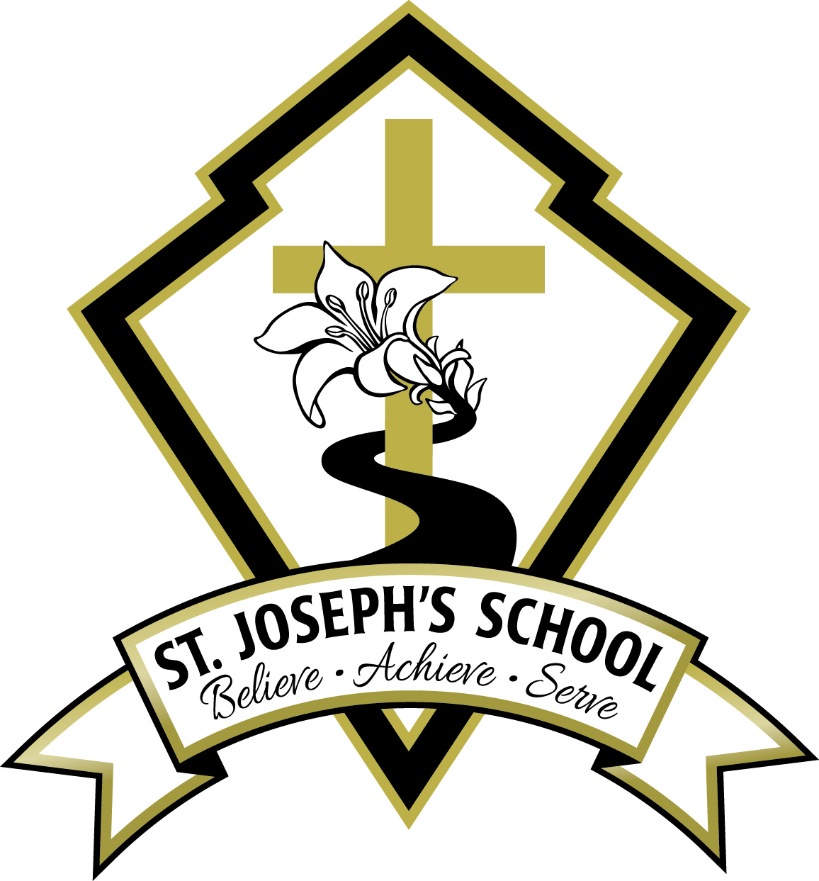
St. Joseph’s Elementary School

March 27, 2020

Dear Parents,
The Ministry of Education and the Superintendent’s Office of CISVA have provided guidance as to what the expectations are regarding the resumption of learning once the spring break ends. Schools are working now to put in place a plan for an alternate delivery of learning opportunities for students. I will present these guidelines, as well as some of our school’s own local decisions, in a question and answer format below. There will be many more questions that will arise as we go through this process together and I ask for your patience as we work to get this organized and communicated to you.
Also attached with this letter is a very helpful set of frequently asked questions released by the Ministry of Education on March 25.
I hope that you and your families remain well during this unsettling time. Please know that I am praying for your health and well-being every day and that I and the staff are working hard to make sure that your children’s learning will continue during this time away from regular classes. If you have questions, please email me directly at docallaghan@cisva.bc.ca.

Sincerely,

Deirdre O’Callaghan

Q & A for Parents Regarding Learning for the Remainder of the Year

1). Will schools re-open on March 30?

Schools will reopen on Monday, March 30 for staff only. The Ministry of Education and CISVA have stated that parents should expect learning to commence within a week or two of that date. Because in-classroom learning has been suspended in the province, the ways that schools are to deliver education will take on some new forms and approaches. Staff are currently working on getting a comprehensive plan together and we will have these details to families as soon as possible.

Our school office will not be open on March 30. We will notify you regarding the hours that the office will be open during the week. When it does open, it will be open for telephone calls and for urgent needs only. It will not be open for the purchase of gift cards or for incidentals. We will be maintaining the physical distancing and isolation requirements as prescribed by the Provincial Health Officer.

The Ministry of Education is expected to release a planning framework document for teachers on Friday, March 27, which will provide support and direction for our school’s plan. Our teachers will need some time to digest this framework and put it into practice. In the meantime, our staff have already been working to anticipate the changes needed to ensure the continuity of learning for your child.
2). How will teaching and learning take place when in-class instruction has been suspended?
Learning for your child will be delivered in a variety of ways. We recognize that the methods used will need to be age appropriate and our teachers are working to ensure this goal is met for our students.
It will take time to work out this plan and we ask for your patience and understanding as we work through the logistics of how this will occur. The goal is not to replace the classroom experience, but to provide the best possible learning under these circumstances. We do not want learning to become a source of stress and conflict in the home and recognize that striking the right balance will take some time. Ultimately, it will be up to parents to determine when and how much work can be accomplished each day. This is an opportunity for all of us to work together to support our students.
3). What materials and equipment will students use?

The students will need to have a computer or device with internet access, email and possibly Skype. The students will be accessing online resources in addition to completing written assignments in Word and submitting them to the teachers through email. Otherwise, the students will need paper, pencils and pens for the purposes of practice, rough drafts, note-taking, etc.
4). How do we collect our child’s personal items from school?

We have not yet established if this is necessary for the students’ learning. I will communicate this information to you after I have conferred with the staff.

5). Will students who receive learning support at school continue to receive support at home?

We are working hard to establish the manner that students who have received support during the school year will continue to receive support in their work. Those families will be contacted directly in order to make arrangements.
6). When can I expect to be contacted by my child’s teacher?

The teachers will make an initial contact with your child during the week of March 30, so please allow your children to have access to this message. We want to maintain the relationships that the teachers have built with the students and so this first message will be intended directly for your child. Further communications between you and your child’s teacher will be established after that time. The teachers will be in regular communication with you over the coming weeks, as they support you and your children in their ongoing learning.

7). Will tuition be waived?
The Ministry of Education has been clear that while in-classroom learning has been suspended, student learning continues. Our goal is to ensure that this takes place in as seamless a way as possible, recognizing the challenges this presents for all concerned – parents, students and staff. As per instructions from the CISVA, all Catholic schools will continue to charge tuition to meet their financial obligations to staff and suppliers.

If you have any questions or concerns regarding the continuation of tuition payments, please contact me at docallaghan@cisva.bc.ca and we can discuss your circumstances and make a plan. We are here to help. We do not want anyone to withdraw from the school should they be unable to pay tuition.
8). Will this impact First Communion and Confirmation dates?
Students in Grades Two and Seven will continue their preparation for receiving the Sacraments. Formal celebrations will be postponed until further notice from the Archbishop’s office. Further information will follow regarding the grade two sacraments as the situation evolves.

