St. Joseph’s School Safety Plan
COVID-19 Restart
May 25, 2020
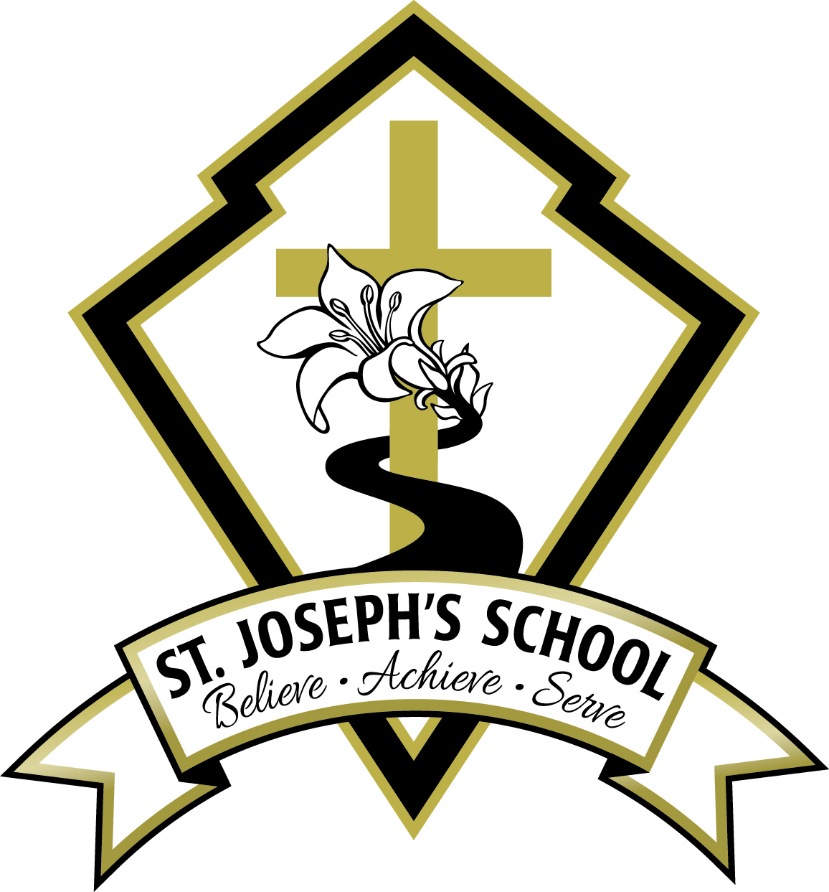

Step 1: Assess the Risks in the Workplace
- We have identified locations in the school where people gather for diverse purposes
  - Classrooms
  - Staff room
  - Photocopy room
  - School office
  - Student washrooms
  - Gymnasium
- We have identified situations in which people may be closer together and for which modifications will be made
  - School office
  - Photocopy room
  - Individualized support from an Education Assistant
  - Art supply room
- We have identified common tools that are shared among people
  - Photocopier
  - Laminator
  - staff room items: kettle, coffee maker, utensils, refrigerator, dishwasher
  - art supplies in the Art room
  - classroom supplies for student use
  - classroom toys/games
  - gym equipment
  - outdoor play equipment/toys
- We have identified high-touch surfaces in the school
  - Photocopier
  - Door handles
  - Handrails
  - Toilet flushers
  - Toilet stall doors/locks
  - Faucets
  - Staff room items: microwave, toaster, refrigerator, dishwasher handle, door handles, cupboard door pulls, table
  - Staff mailboxes
  - Water fountains
  - Playground structure
  - Light switches

Step 2: Implement Protocols to Reduce the Risks
Protocols pertaining directly to K-12 schools:
Restricting Access to Schools
- All workers and students who have symptoms of COVID-19 or have travelled outside Canada in the last 14 days or were identified as a close contact of a person with a confirmed case of COVID-19 must stay home and self-isolate in accordance with guidance from the BC Centre for Disease Control.
- Staff members entering the school will complete the COVID-19 Workplace Health and Screening Form before entering the building and leave it available for the principal to review.
- Parents and caregivers are communicated as part of the broad plan and the safety plan that they must assess their children daily before sending them to school.
- Parents and caregivers must assess their child daily for symptoms of common cold, influenza, COVID-19, or other infectious respiratory disease before sending them to school. If a student develops symptoms while at home, parents or caregivers must keep their child at home until they have been assessed by a health care provider to exclude COVID-19 or other infectious diseases, and their symptoms have resolved.
- If a student develops symptoms while at school:
  - The student will be removed to the front hall of the school under supervision
  - Student and the supervising staff member will put on masks and maintain physical distance
  - School secretary or bookkeeper will contact the student’s parent or guardian to notify them that their child has shown symptoms of illness and must be picked up from school
  - Parents or caregivers must pick up their child as soon as possible if they are notified their child is ill.
  - School principal will contact 811 to inform public health and request guidance for follow-up procedures
  - Avoid touching the student’s body fluids (mucous, saliva). If this occurs, staff member practices diligent hand hygiene immediately
  - Once the student is picked up from the school, all staff members who came into contact with the student (even at appropriate physical distance) must practice diligent hand hygiene
  - Workers responsible for facility cleaning must clean and disinfect the space where the student was separated and any areas used by him or her (e.g., classroom, bathroom, common areas).
Administrative Areas
- Parents and guardians are not permitted to enter the school unless they are doing business at the school office (tuition payment, etc.)
- Parent inquiries need to be made via telephone or email.
- Stop signs are posted at the door of the office so that parents/guardians will wait for admittance to the office area
- The hallway outside the office is marked off at two-metre intervals to indicate physical distancing requirements (for lining up).
- A plastic barrier has been installed at the front office desk for the safety of the school secretary
Student Management and Hygiene
Hygiene
- Hand sanitizing stations are located throughout the school, including the front hall and in common areas
- Students must wash their hands or use hand sanitizer at regular intervals. At a minimum, students must clean their hands:
  - When they arrive at school and before they go home
  - Before and after any breaks (e.g. recess, lunch)
  - Before and after eating and drinking
  - After using the toilet
  - After sneezing or coughing into hands or tissue
  - After handling any common resources
  - Whenever hands are visibly dirty
  - When moving between different learning environments (e.g., outdoor-indoor transitions, from the gym to the classroom).
- Teachers will instruct students on the proper hand-washing techniques and the procedures for using hand sanitizer correctly.
- Students will use proper cough and sneeze etiquette:
  - Cough or sneeze into elbow or sleeve, not hands. Avoid touching the face with hands. OR
  - Cover mouth and nose with a tissue. Put the used tissue in the wastebasket
  - Wash hands with soap and warm water for 20 seconds OR
  - Clean hands with an alcohol-based hand sanitizer.
- Students will not share food. No prepared food will be provided for students by staff members.
- Parents are not able to drop off lunches for their children. Students must bring their lunches with them upon arrival at school.
- No outside food may be brought in to be given to students (e.g. for birthdays, etc.)
- No food will be given to the students. In the event that a student does not have lunch, a staff member will sanitize the outside of a pre-packaged item and give it to the student.
- All fruits and vegetables will be washed with soap and cold water and rinsed before they are eaten.
- Water fountains will be closed.
Physical distancing
- A parent survey was distributed in order to ascertain the numbers of students in each class who would be returning to school
- The students were divided into groups to attend school on alternating days
- Parents and caregivers need to remain outside of the school to drop off and pick up their children
- All will avoid close greetings such as hugs or handshakes
- Staff members will remind students to keep their hands to themselves
- Staff members will teach students in such a way as to keep them physically distanced from one another
- Staff members will teach outside whenever possible
- Physical Education classes will be adjusted to accommodate physical distancing and will not incorporate shared sports equipment
- Students will have contact with their classroom teachers, specialist teachers. Education assistants will be assigned to a minimum number of classrooms
- Desks have been re-configured in the classrooms to keep them at a two metre distance
- “teacher zones” have been marked off in each classroom with tape on the floor and signage
- Students will keep their bags/tubs/supplies beside their desks
- Students will not have access to soft items that cannot be disinfected (carpet, cushions, soft chairs, etc.)
- Drop-off will occur during a 30-minute window of time. The front door will be propped open. Students will be greeted at the door and will be given hand sanitizer upon entry. Parents will be asked about the health of their child. Students will proceed directly to their classrooms.
- Pick-up will occur at designated doors, according to the proximity to classrooms.
- Recess and lunch breaks will be staggered to allow wider play areas in the playground.
- The primary play structure will be closed.
- Line-up “wait” signs are posted on the floor to line up for student washrooms
- “wait” signs are posted on the stairways to indicate physical distancing
Safety for Staff
Physical distancing
- Occupancy signs mark the number of occupants allowed in different areas at one time. These include: photocopy room, staff room, student washrooms. Staff may eat outdoors if they so choose.
- Breaks will be staggered for the students and staff in order to facilitate the safe use of the staff room.
- Staff meetings will be held in the school gym in order to facilitate physical distancing
- Staff are instructed through the training session and the safety plan that they need to refrain from close contact (within two metres) of one another and of students and may not greet others by hugging or shaking hands.
- Hallways are marked off at two metre intervals with tape.
- Hallways are marked off with arrows to facilitate physical distancing.
- Weekly assemblies have been cancelled.
- Physical distancing reminders are posted throughout the school.
- A parent survey was distributed in order to ascertain the numbers of students in each class who would be returning to school
- The students were divided into groups to attend school on alternating days
- Classrooms were re-arranged to place the student desks at two-metre distances
- “teacher zones” were marked off in each classroom with tape on the floor and signage
- Line-up “wait” signs are posted on the floor to line up for student washrooms
- “wait” signs are posted on the stairways to indicate physical distancing
- Staff are trained on the protocols and have been given the safety plan. A health and safety meeting was held on the first day the staff members returned to the school.

Hygiene
- Staff members need to remain on-site for breaks
- Hand sanitizer is available at the front door and throughout the school (classrooms, common areas)
- Soap and paper towels are available at each sink.
- Handwashing policies were reviewed at health and safety meeting
- Handwashing and hygiene signage is posted at each sink and throughout the school.
- Staff members are expected to wash their hands regularly. At the very least, they must wash hands:
  - When they arrive at school and before they go home
  - Before and after any breaks (e.g. recess, lunch)
  - Before handling food or assisting children with eating
  - Between different learning environments (e.g. outdoor-indoor transitions, from the gym to the classroom)
  - Before and after eating and drinking
  - Before and after giving or applying medication or ointment to a child or self
  - After using the toilet
  - After contact with body fluids (i.e., runny noses, spit, vomit, blood)
  - After cleaning tasks
  - After removing gloves
  - After handling garbage
  - Whenever hands are visibly dirty
- Staff members will use proper cough and sneeze etiquette:
  - Cough or sneeze into elbow or sleeve, not hands. Avoid touching the face with hands. OR
  - Cover mouth and nose with a tissue. Put the used tissue in the wastebasket
  - Wash hands with soap and warm water for 20 seconds OR
  - Clean hands with an alcohol-based hand sanitizer.
Use of personal protective equipment (PPE)
- BC Centre for Disease Control (BCCDC) guidance for K-12 school settings states that personal protective equipment, such as masks and gloves are not needed, beyond those used by staff as part of regular precautions for the hazards normally encountered in their regular course of work.
- Where PPE has been identified for tasks prior to the COVID-19 pandemic, continue to use this PPE when performing these tasks.
- Each staff member was given a non-medical mask for his or her own use. Worksafe BC procedure for the safe use of a mask was distributed with each mask. Staff are able to use the masks according to their own preferences. Education Assistants who are working with individual students will maintain two metre distances, but may still choose to wear a mask.
Cleaning and Sanitizing
- The school is cleaned and disinfected in accordance with the BC CDC’s Cleaning and Disinfectants for Public Settings. Cleaning practices are in line with the provincial health officer’s COVID-19 Public Health Guidance for Childcare Settings
- The school’s cleaning policy focusses on high-traffic areas and high-contact surfaces such as doors, cabinet handles, stair railings, washrooms, school office, photocopy room, staff room, light switches, common telephones.
- High-touch surfaces will be cleaned a minimum of twice each day (after recess break and after lunch break), with extra cleanings as necessary throughout the day. Disinfectant and paper towels are available in the photocopy room and staff room for individuals to use after they have used the equipment.
- General cleaning and disinfecting of the school will take place once each day, in the evening, after students and staff have left the building.
- Student desks will be disinfected (interior and exterior) at the end of each day in preparation for the next day of in-class learning
- Disinfectant and single-use paper towels are located in the following areas: photocopy room, staff room, school office, staff washroom, individual classrooms, gymnasium, Learning Commons.
- Staff have been trained on the procedure for disinfecting the surfaces that they have touched in the staff room after use.
- The students will not share school supplies. Toys will be removed from use in the classrooms.
- Shared equipment in the staff room, such as coffee maker and kettle, have been removed from use.
- Garbage bins will be emptied daily. Kitchen waste will be put into the garbage and not the compost bins. Recyclables will be taken home for disposal.
- Cot will be used only in a dire emergency and will be supplied with single-use sheets and pillow cases. These will be disposed of after each person.
- Our school custodian has been informed of the Worksafe BC protocols and is trained in cleaning and disinfecting practices.
Step 3: Develop Policies
COVID-19 Sick Policy:
As part of the infection prevention and exposure control measures to create a safe environment for staff and students, the following measures are in place to reduce the transmission of COVID19:
For the safety of all, the following conditions necessitate an individual remaining at home and self-isolating:
- All students and staff who have symptoms of COVID-19 OR travelled outside Canada in the last 14 days OR were identified as a close contact of a confirmed case or outbreak must stay home and self-isolate, including children of essential service workers who are ill.
- Parents and caregivers must assess their child daily for symptoms of common cold, influenza, COVID-19, or other infectious respiratory disease before sending them to school.
- Staff must assess themselves daily for symptoms of common cold, influenza, or COVID-19 prior to entering the school.
- School Administrators must ensure school staff are aware of their responsibility to assess themselves daily for symptoms of common cold, influenza, COVID-19 or other infectious respiratory disease prior to entering the school.
- School Administrators must:
- Clearly communicate with parents and caregivers their responsibility to assess their children daily before sending them to school.
- Alternatively, daily checks for respiratory illness will be conducted at drop-off by asking parents and caregivers to confirm the child does not have symptoms of common cold, influenza, COVID-19, or other respiratory disease.
- Established procedures for students and staff who become sick while at school will be followed. This entails staff and students being sent home as soon as possible.
- Staff and students who are ill, including children of essential service workers, will not be permitted to attend school
- Those unsure of if they or a student should self-isolate will be directed to use the BC COVID-19 Self-Assessment Tool. https://bc.thrive.health/
- If deemed warranted, they will be advised to contact 8-1-1 or the local public health unit to seek further input.
- They may also be advised to contact a family physician or nurse practitioner to be assessed for COVID-19 and other infectious respiratory diseases.

Note: There is no role for screening students or staff for symptoms, checking temperatures, or COVID-19 testing. Such activities are reserved for health care professionals.

What to do if a student or staff member develops symptoms at home or at school:
If a student develops symptoms at home:
- Parents or caregivers must keep their child at home.
- The student must self-isolate for a minimum of 10 days from the onset of symptoms AND until symptoms resolve, whichever is longer.
If a student develops symptoms at school, staff must take the following steps:
- Immediately separate the symptomatic student from others in a supervised area.
- Contact the student’s parent or caregiver to pick them up as soon as possible.
- Where possible, maintain a distance of 2 metres from the ill student. If not possible, staff may wear a mask if available and tolerated, or use a tissue to cover their nose and mouth.
- Provide the student with tissues to cover their coughs or sneezes. Throw away used tissues as soon as possible and perform hand hygiene.
- Avoid touching the student’s body fluids (e.g. mucous, saliva). If this occurs, staff member must practice diligent hand hygiene.
- Once the student has been picked up, practice diligent hand hygiene.
- Staff responsible for facility cleaning must clean and disinfect the space where the student was separated and any areas used by them (classroom, washroom, common areas).
- Contact 811 or the local public health unit to notify them of a potential case and seek further input
- If the student is severely ill (e.g. difficulty breathing, chest pain), 911 is called.
***Parents or caregivers must pick up their child as soon as possible if they are notified their child is ill.
If staff develops symptoms at home:
- Staff must be excluded from work and stay home.
- Staff must self-isolate for a minimum of 10 days from the onset of symptoms AND until symptoms resolve, whichever is longer.
If staff develops symptoms at work, staff should go home as soon as possible.
If unable to leave immediately:
- Symptomatic staff should separate themselves into an area away from others.
- Maintain a distance of 2 metres from others.
- Use a tissue or mask to cover their nose and mouth while they wait to be picked up.
- Staff responsible for facility cleaning must clean and disinfect the space where the staff member was separated and any areas used by them (classroom, washroom, common areas)
- If concerned, contact 811 or the local public health unit to seek further input.
- If the staff member is severely ill (e.g. difficulty breathing, chest pain), 911 is called.
***If a student or staff member is assessed by their family physician or nurse practitioner and it is determined that they do not have COVID-19, they may return to school once symptoms resolve.
Step 4: Develop Communication Plans and Training
Communication Strategies
- Staff are reminded that all health and safety measures that were in place prior to the pandemic remain in place.
- The school safety plan was shared with the staff. Each staff member received a copy and the plan was reviewed fully with a health and safety meeting on the first day they returned to school. The staff were able to ask questions throughout the meeting.
- A shared online document will be set up for staff to post questions that can be answered by the principal. All staff will have access to the document for their information.
- New information regarding the pandemic will be posted to the shared online document and on the common bulletin board in the staff room.
- At morning prayer, staff members will have the opportunity to hear new information and to raise questions or concerns.
- Parents have been informed in writing that they must keep their children at home if they are sick in any way. This information is posted on the front door and at the front office.
- Parents and caregivers are not permitted to enter the school unless they have specific business in the school office. They must wait outside for pick-up and drop-off.
- Parents received an electronic copy of the school safety plan. It was posted on the school website. A hard copy of the school safety plan is posted inside the front door of the school.
- Updates to the safety plan or the protocols will be communicated electronically to the parents through email and by posting on the school website.
Documentation and Training
- staff members have been trained on:
  - The risk of exposure to COVID-19 and the signs and symptoms of the disease. Signage indicating the signs and symptoms are posted throughout the school.
  - Safe work procedures or instruction to be followed, including hand washing and cough/sneeze etiquette. The safety plan has been communicated to staff members through a health and safety meeting and with a hard copy of the plan.
  - How to report an exposure to or symptoms of COVID-19. The staff member will report an exposure or symptoms directly to the principal, who will contact 811 and follow the procedures.
  - Changes you’ve made to work policies, practices, and procedures due to the COVID-19 pandemic and keep records of that training. The health and safety meeting on May 25 reviewed the safety plan and changes to the daily running of the school.
- Minutes of the meetings are emailed to staff members and are posted in the staff room.
- Exposure reports or first aid records are completed and filed in the school office.

Step 5: Monitor the Workplace and Update Plans as Necessary
- Principal monitors procedures on a daily basis by moving about the school regularly throughout the day.
- Staff members address concerns at morning prayer or at any time throughout the day with the principal.
- Concerns are addressed at staff meetings (regular or ad hoc) in order to update the necessary procedures to address changes in the daily routine, numbers of students, issues that arise, etc.
- Changes to procedures or protocols will be communicated in written form and electronic form, and addressed in additional training sessions.
- Parents will be updated in writing with changes to procedures or protocols that directly affect them or their children.

Step 6: Assess and Address Risks from Resuming Operations
- Our school has been in modified operation since April 6, 2020. Equipment has been in use at least three days per week since that time. There is a very low risk in resuming full equipment operations.
- Staff members were given two non-instructional days to prepare their classrooms and to attend the health and safety/training session.
- Any issues that arise with resumption of equipment use will be addressed before June 1, 2020.

