**COMMUNICABLE DISEASE PREVENTION PLAN**

**ST. JOSEPH’S SCHOOL**

**January 7, 2022**

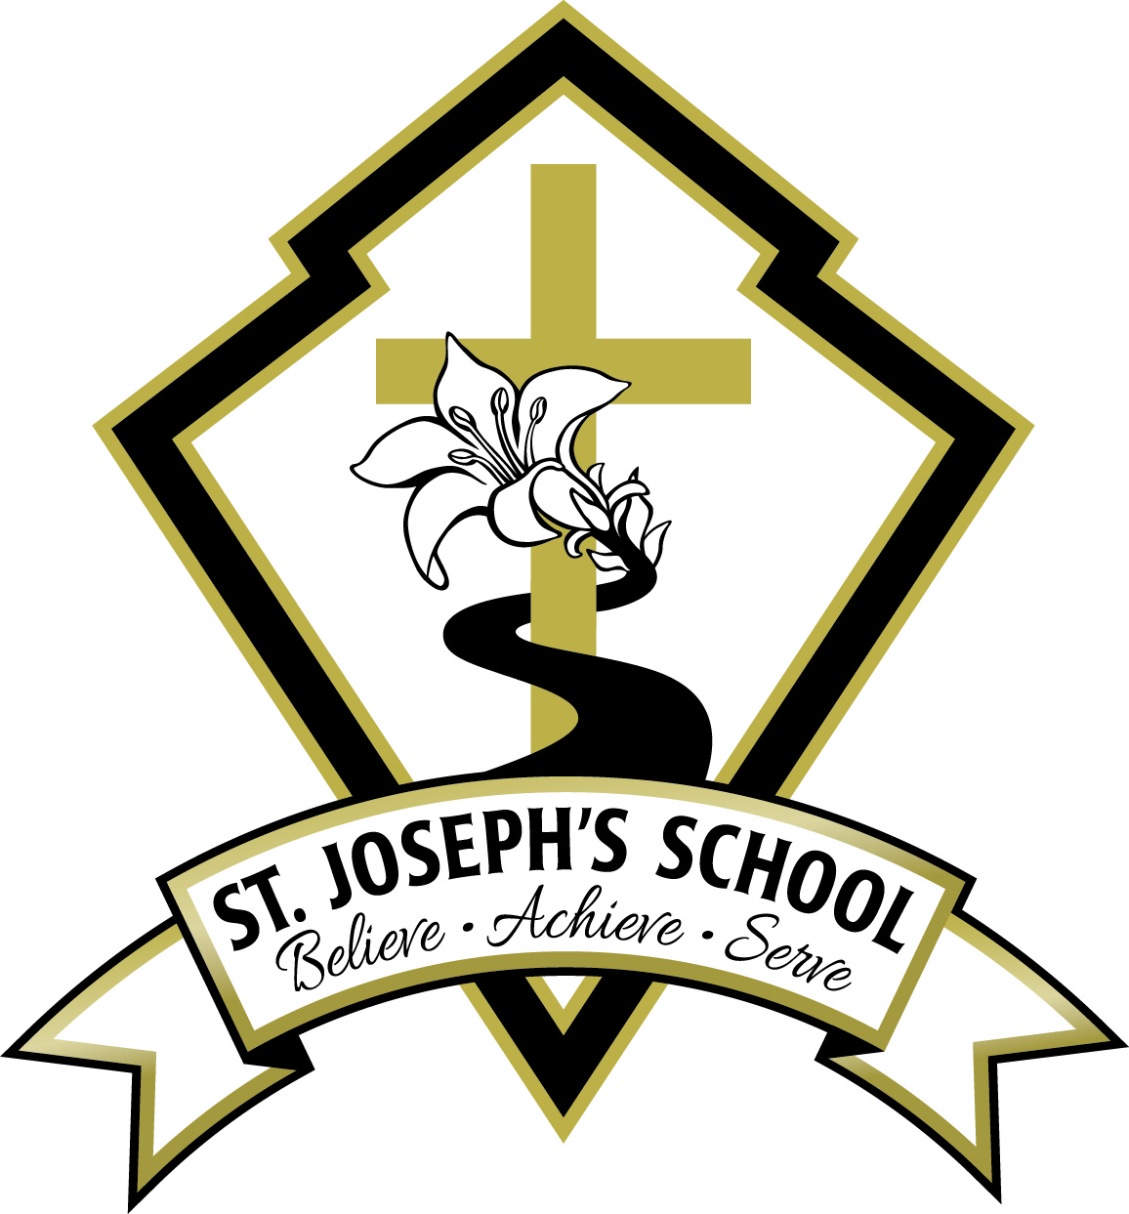

**Revisions according to the following documents:**

* Addendum – Provincial COVID-19 Communicable Disease Guidelines for K-12 Settings (December 29, 2021)
* Addendum – Public Health Guidance for K-12 Schools (December 29, 2021) - BCCDC

Excerpted from the aforementioned BCCDC document:

*Due to the recent rise in cases of COVID-19 in BC and the emergence of the more transmissible Omicron variant, public health has recommended time-limited enhancements to the Public Health Guidance for K-12 Schools. While these enhanced measures may provide additional layers of protection, vaccines continue to be the most effective way to reduce the risk of COVID-19 within K-12 settings. Everyone eligible is strongly encouraged to be fully vaccinated against COVID-19.*

**Step 1: Understanding the Risk:**

*Excerpted from Public Health Communicable Disease Guidance for K-12 Schools: Appendix A – August 24, 2021

The information below summarizes high-level evidence gathered since early Spring 2020 about COVID-19, including its impacts on people and K-12 schools in B.C., nationally and internationally. Up-to-date information about COVID-19 is available from BCCDC.

• B.C. currently has variable community prevalence of COVID-19; some parts of the province have relatively low community transmission while other parts have relatively high levels of community transmission. Communities with high levels of transmission are typically those with lower vaccination rates. Since early summer 2021, the rate of COVID-19 cases has increased due to the easing of pandemic restrictions. Most cases, hospitalizations, and deaths were among unvaccinated individuals.

• B.C. has a highly vaccinated population, with the majority of those aged 12 and older having received two doses of a COVID-19 vaccine. As of August 22nd, 83% of eligible people 12 and older in B.C. had received their first dose of COVID-19 vaccine and 75% had received their second dose. Vaccinated individuals tend to have milder illness if they get infected and are also less likely to pass virus on than unvaccinated individuals. Severe outcomes in fully vaccinated individuals are infrequent. The vaccines delivered in B.C. remain highly effective against variants, including the Delta variant, especially against severe outcomes.

Based on national and international evidence collected between January - July 2021:

• There is little high-quality evidence to suggest that having schools open meaningfully contributes to community transmission.

• The likelihood of a person attending school while infectious with COVID-19 reflects local community prevalence.

• The consistent implementation of prevention measures, particularly in communities with higher transmission and/or lower vaccination uptake, is critically important to limiting the spread of COVID-19. Within clusters and outbreaks, adult to adult transmission appears more common than child to adult or adult to child.

• Widespread asymptomatic transmission is not commonly occurring within schools.

• Evidence continues to be gathered about the impact of staff and student vaccinations on mitigating risk of COVID-19 transmission at school.

During the 2020-21 school year in B.C. COVID-19 cases in schools reflected the number of cases in their communities. Most cases of COVID-19 among students and staff were acquired outside of school, in their community or household.

• Vancouver Coastal Health and Fraser Health led school transmission studies to understand transmission in school settings. In Vancouver Coastal Health from September 10 – December 18, 2020, out of 699 cases among students (77%) and staff (23%), 55 cases (8% of student and staff cases) were likely acquired in school. When transmission did occur, a case would typically lead to 1 or 2 other cases in the school. In Fraser Health from January 1 – March 7, 2021, out of 2049 cases among students (83%) and staff (17%), 267 cases (13% of student and staff cases) were likely acquired in school. When transmission did occur with a school setting, a case would typically lead to 1 other case in the school. Regional school medical officers noted that these results were similar to those seen in all health authority regions, based on case reviews.

• School staff do not seem to be at any greater risk of getting COVID-19 at work compared to other workplaces that include people. In Vancouver School District, despite a high rate of reported exposure to COVID-19 cases, the rate of COVID-19 infections among school staff (detected by sensitive serology testing) was the same as the local community. This suggests school staff did not experience a greater risk from COVID-19 than the general population with the measures implemented during the 2020-21 school year.

Most children are not at high risk for COVID-19. If they do get COVID-19, most children will have mild symptoms, or they may have no symptoms at all (“asymptomatic”).

• COVID-19 continues to have a relatively low infection rate among school-aged children (5-18). Research is underway to understand the impact of the Delta variant on children, including differences in how it spreads and if there is increased risk of more severe illness in children who are not yet eligible to be vaccinated (i.e., under age 12).

At St. Joseph’s, over the course of the year, the principal will continue to monitor changes in the level of risk through the following means: the weekly Deputy Minister’s Bulletin and special bulletins; the weekly Superintendent’s Bulletin and special bulletins; media sources; attendance at the monthly webinars with VCH. As changes are warranted, the principal will update the Communicable Disease Prevention Plan and inform staff, students and parents/caregivers of the changes.

**Step 2: measures, practices and policies to reduce the risk:**

The school will create a supportive environment through the following:

* The staff will model appropriate behaviours that reduce the risk.
* Information that is shared with parents, caregivers and students will be taken from reliable sources, such as the BCCDC and the Office of the Provincial Health Officer
* Safety measures will be promoted through visual aids and signage
* The school will continue to use a trauma-informed lens when planning school activities, including considerations around respecting others’ personal space.

All eligible members of the community (staff, parents/caregivers, eligible students) are highly encouraged to be fully vaccinated in order to protect themselves and those around them.

*Physical Distancing and Space Arrangement:*

* Students will be reminded both verbally and through visuals that they must respect others’ personal space
* All available space will be utilized in the classrooms and the gym
* Students will be dismissed through the exit doors that are closest to their classrooms in order to avoid crowding in the hallways.
* One stairway will be designated as UP and the other as DOWN
* Arrows are placed on the walls in the hallway to indicate direction of traffic
* Lines to indicate appropriate distancing are placed down the hallways
* All staff members are responsible for reminding students of safe distancing practices. Reminders also will be given at the weekly assemblies. Appropriate signage will be placed around the school.
* Student desks have been moved even further apart in classrooms; group interactions are minimized
* Teachers have created distance between themselves and their students
* Students will enter through the front door and proceed directly to their classrooms when they arrive at school in the morning
* Recess and lunch breaks have been staggered to create more space on the playgrounds and to avoid congestion in the hallways on entry and egress; students will use exits that are proximate to their classrooms
* Pick-up times are staggered according to grade level; students are escorted outside through the exits that are closest to their classrooms; they will wait in designated areas for pick-up; they may not interact/play and must leave the area as soon as their parents arrive
* Parents must wait for their children outside the gates; they may not wait on the playground or on the benches near the front door of the school

*Staff-only spaces*

* Room occupancy limits will be in place for staff-only spaces (e.g. staff room, photocopy room); limits will be reinforced
* People will be spread out to use available space in staff-only spaces
* Meetings and morning prayer will be held virtually
* Staggered breaks facilitate less congestion in the staff room; staff members are encouraged to eat in a variety of places
* There will be no shared dishes or cutlery in the staff room

*School Gatherings and Events*

* Weekly assemblies will continue to be held virtually
* School Masses will be suspended at this time
* School events involving gathering or spectators will be suspended at this time

*Personal items*:

* Staff and students can bring personal items to school, but they are encouraged not to share items that come in contact with the mouth. Food and drinks will not be shared.

*Staff working with students with disabilities/diverse abilities*

* Where possible, work will be done with a barrier in place; masks remain in use.
* Students from Kindergarten through Grade 7 and all staff and visitors must wear a mask at all times indoors; three-layer masks are the optimal masks to use

*Illness and self-assessment policies and protocols:*

* All staff and other adults (including visitors) need to complete a daily health check before entering the school. The following resources provide guidance regarding specific symptoms of illness, including those symptoms particular to the Omicron variant (fever, chills, tiredness, headache, runny nose and congestion)

▪ Parents/caregivers and students can use the *K-12 Health Check app*. [K-12 Health Check (gov.bc.ca)](https://www.k12dailycheck.gov.bc.ca/healthcheck?execution=e2s1)

▪ Staff and other adults can use *When to get tested for COVID-19*

▪ Staff, students and parents/caregivers can also use the *BCCDC Online Self-Assessment Tool (*[BC COVID-19 Self-Assessment Tool (thrive.health)](https://bc.thrive.health/covid19/en)*,* call 8-1-1 or their health care provider.

* Parents/caregivers are responsible to complete a daily health check with their child and keep them home from school if they are sick.
* Students, staff or other adults who are sick must not enter the school
* Students, staff or other adults must stay home if they are required to self-isolate.

If a student develops symptoms while at school:

* + The student will be escorted by a staff member from the classroom to the front hall of the school and remain under supervision until he/she is picked up
  + Student and the supervising staff member will be masked and maintain physical distance
  + School secretary or bookkeeper will contact the student’s parent or caregiver to notify them that their child has shown symptoms of illness and must be picked up from school immediately. Office staff will remind the parents of the following directives from the Provincial Health Officer regarding isolation periods:
    - “People should only be leaving home after five days if their symptoms have ‘resolved or have mostly improved,’ the provincial health officer added, stressing that no one should be ending their self-isolation while they still have a fever. ‘This is a risk mitigation strategy, it doesn't mean that every single person will be through their infectious period, where they're infectious to others, within five days,’ Henry said. ‘But the vast majority of people are.’ Even once people go back into the community, they must diligently wear a mask any time they're around others for an additional five days. Henry said they also must abstain from social gatherings during that period. Unvaccinated B.C. residents who catch COVID-19 are still required to self-isolate for a minimum of 10 days, either from the onset of symptoms or their positive test result.” (CTV news report from December 31, 2021)
  + Avoid touching the student’s body fluids (mucous, saliva). If this occurs, staff member practices diligent hand hygiene immediately
  + Once the student is picked up from the school, all staff members who came into contact with the student (even at appropriate physical distance) must practice diligent hand hygiene
  + Workers responsible for facility cleaning must clean and disinfect the space where the student was separated and any areas used by him or her (e.g., classroom, bathroom, common areas).

***Parents or caregivers must pick up their child as soon as possible if they are notified their child is ill.

If staff develops symptoms at work, staff should go home as soon as possible.

* Symptomatic staff should separate themselves into an area away from others and leave as soon as possible.
* Staff responsible for facility cleaning must clean and disinfect the space where the staff member was separated and any areas used by them (classroom, washroom, common areas)
* If concerned, contact 811 or the local public health unit to seek further input.
* If the staff member is severely ill (e.g. difficulty breathing, chest pain), 911 is called.

Students and staff who experience symptoms consistent with a previously diagnosed health condition (e.g. seasonal allergies) can continue to attend school when they are experiencing these symptoms as normal. They do not require re-assessment by a health-care provider and should not be required to provide a health-care provider note. If they experience any new or unexplained symptoms, they should seek assessment by a healthcare provider.

Self-isolation for close contacts ( [Self-Isolation and Self-Monitoring (bccdc.ca)](http://www.bccdc.ca/health-info/diseases-conditions/covid-19/self-isolation)

If you are fully vaccinated or had COVID-19 in the last 90 days, you are not required to self-isolate, and you can continue to participate in routine activities, such as work or school, as long as you do not have any symptoms. However, do not visit friends or relatives who are higher risk for severe COVID-19 (e.g. those currently in hospital, long term care, those with compromised immune systems, or over the age of 70 years) for 14 days after you were last exposed to COVID-19. More details on risk factors for severe disease are available on the BCCDC website.

If you are not fully vaccinated and did not have COVID-19 in the last 90 days, you are required to self-isolate for 10 days from the day you last had contact with the person who has COVID-19, even if you do not have any symptoms. Self-isolation means keeping away from others to help stop the spread of COVID-19. Visit the BCCDC website to learn more about how to self-isolate: bccdc.ca/covid19selfisolation. In addition to the 10 days of self-isolation, you should not visit friends or relatives who are higher risk for severe COVID-19 (e.g. those currently in hospital, long term care, those with compromised immune systems or over the age of 70 years) for 14 days after you were last exposed to COVID-19. More details on risk factors for severe disease are available on the BCCDC website.

Note: According to the Province of British Columbia, you are considered fully vaccinated with 2 doses of a COVID-19 vaccine. Your [booster dose](https://www2.gov.bc.ca/gov/content/covid-19/vaccine/booster) does not affect your proof of vaccination.

*Hand Hygiene*

* Hand sanitizing stations are located throughout the school, including the front hall and in common areas.
* Portable hand washing stations are available in addition to existing sinks.
* Students will use hand sanitizer throughout the day. They will wash their hands with soap and water before eating.
* Students should perform hand hygiene:
  + When they arrive at school
  + Before and after any breaks (e.g. recess, lunch)
  + Before and after eating and drinking
  + Before and after using an indoor learning space used by multiple classes with shared equipment
  + After using the toilet
  + After sneezing or coughing into hands or tissue
  + Whenever hands are visibly dirty
* After the Christmas break, teachers will reiterate the procedures of proper hand-washing techniques and the procedures for using hand sanitizer correctly with the students. Staff will support younger students.
* Students will use proper cough and sneeze etiquette:
  + Cough or sneeze into elbow, sleeve, or a tissue
  + Throw away used tissues and immediately perform hand hygiene
* Staff should perform hand hygiene:
  + When they arrive at school
  + Before and after any breaks (e.g. recess, lunch)
  + Before and after eating and drinking.
  + Before and after handling food or assisting students with eating
  + Before and after giving medication to a student or self
  + After using the toilet
  + After contact with body fluids (i.e. runny noses, spit, vomit, blood)
  + After cleaning tasks
  + After removing gloves
  + After handling garbage
  + Whenever hands are visibly dirty
* Signs are posted beside sinks and handwashing stations to remind of proper handwashing technique
* Signs are posted around the school as reminders of cough/sneeze etiquette

*Cleaning*

The school uses commercial disinfectant products as per directives from Health Canada. The school is cleaned according to the procedures outlined in in the BCCDC Cleaning and Disinfectants for Public Settings document. Our school custodian has been informed of the Worksafe BC protocols and is trained in cleaning and disinfecting practices.

Frequency Guidelines:

* General cleaning of the school and cleaning and disinfecting of frequently touched surfaces at least once in 24 hours.
* Clean and disinfect any surface that is visibly dirty
* Empty garbage containers daily
* Custodial staff will focus on cleaning and disinfecting those spaces that have been utilized by staff or students
* Frequently touched surfaces are sanitized twice during the school day: after the recess and lunch breaks. Frequently touched surfaces include: items used by larger numbers of students and staff, including doorknobs, light switches, hand railings, water fountains, faucet handles, and toilet handles; shared equipment; appliances; service counters. Disinfectant and paper towels are available in the photocopy room and staff room for individuals to use after they have used the equipment.

Water fountains are available for filling water bottles only; they are not available for drinking.

Students will practice hand hygiene before and after using shared toys or manipulatives.

*Visitors*:

* Visitors are limited to those who support activities that are of direct benefit to student learning and well-being. Itinerant visitors (SLP, BI, etc.) who support students will continue. Each will receive this revised Communicable Disease Prevention Plan. All visitors must conduct a daily health check before entering the school.
* Parents may only enter the school if they have specific business to conduct at the school office.
* Parent meetings will be conducted virtually.
* All visitors must wear a mask when they are inside the school.
* Students must be picked up and dropped off outside of the school
* Parents and caregivers should respect others’ personal space while on school grounds, including outside.

Masks:

* All students, staff and visitors must wear a mask indoors at school. (PHO Order – Face Coverings: December 3, 2021) and on school buses
* Parents are reminded of the need for a three-layer mask.
* Proper fit is a key factor in mask effectiveness. Masks worn at school should fit well. Parents are given the guidelines for a proper fit as per the Government of Canada website.
* Teachers will review proper mask wearing and safety practices with the students.
* Families will provide masks for students. The school has a small supply of masks for emergency purposes.

*Ventilation*

* Whenever possible, activities will be moved outside
* Windows will remain open as much as possible
* Fans may be used, but they must be placed so that air is moved from high places to lower places instead of blowing air directly from one person’s breathing zone to another’s. Horizontal cross breezes must be avoided.
* Using fans or portable air conditioners in unventilated places with doors and windows closed should be avoided, except when necessary during high or excessive heat events

*Additional Measures:*

* Field trips may occur, particularly those which take place outdoors; when school buses are in use, students must follow these protocols: everyone on the bus (without exemptions) wear masks in accordance with the PHO Order on Face Coverings; students and teachers will practice hand hygiene before and after bus trips; passengers are spread out if empty seats are available; windows are opened when the weather allows.
* Parent volunteers are suspended for indoor activities.
* Music classes will proceed. Staff and students from Kindergarten through Grade 7 must wear masks indoors, including while singing; masks may be removed temporarily while engaging in an educational activity that cannot be performed while wearing a mask. Shared equipment will be cleaned and disinfected after use. Students will perform hand hygiene before and after use of the equipment
* PE classes will take place. Students and staff will spread out in the gym and outdoor activities will take place as much as possible. Staff and students from Kindergarten through Grade 7 must wear masks indoors. Mask use during high-intensity physical activities is left to each student’s personal choice. Students must wear masks in low intensity activities. Students will perform hand hygiene before and after use of the equipment.
* Students will engage in hand hygiene before and after playground use and before and after a change in venue within the school (gym, Music class, Learning Commons, etc.).
* Extra-curricular sports will occur according to the guidelines for PE classes. There will be no games played with other schools at this time.
* Emergency drills will continue to occur, as required the BC Fire Code.

**Step 3: Communication**

The school will continue to communicate appropriate messaging from the BCCDC to parents, reiterating the protocols and the need to follow them.

Parents and caregivers will receive updates over the course of the year, as the school receives updated information from the PHO and MHO. Staff will address ongoing changes at the weekly staff meetings or at morning prayer.

The Communicable Disease Prevention Plan is communicated in the following ways: emailed directly to staff members and to parents/caregivers; it is posted on the school website; staff are trained on the new protocols.

**Step 4: Monitoring and Updating the Plan**

The Health and Safety committee regularly reviews and updates policies and protocols and makes revisions as necessary. Random checks are conducted by the Health and Safety Committee to ensure adherence to policies and protocols.