The 13th Annual

South Texas Association of School Maintenance

Officials Summer Conference 2025

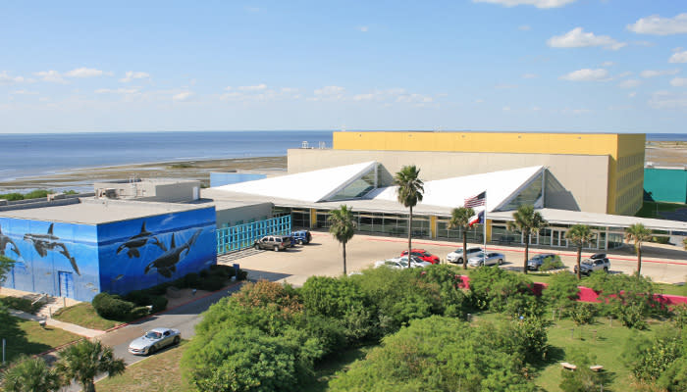

July 16-17th, South Padre Island Convention Center, 7355 Padre Blvd

Who Should Attend

If you are involved in school maintenance or construction in any form or fashion this is the conference for you. Visit our [**site to register today**](https://stasmo.zohobackstage.com/STASMOSummerConference2025#/)! District and non-profit entity folks only pay **$150** for both days. We look forward to seeing YOU at our 13th Annual Summer Conference!

Why Should I Attend?

This our 13th Annual M&O Summer Conference at South Padre Island on July 16 & 17th! The two-day conference is a mix of school maintenance-related presentations, networking opportunities and a trade show. The conference takes place at the South Padre Island Convention Center. The first day consists of well thought out presentations and a fun evening social event involving a spacious boat. The second day is more presentations that are interesting, delicious lunch and our Trade Show that will include up to 40 vendors. The day ends with incredible door prizes give away.

STASMO or the South Texas Association of School Maintenance Officials hosts the conference. STASMO was established in 2006. **Our mission** has been to bring together maintenance/facilities related school district officials primarily in the ESC Region One area to provide learning opportunities, share successes & concerns and develop relationships between districts and associated vendors to allow members to better serve their districts.

**Community support**. Thanks to the support of our vendor partners STASMO annually awards seven or more $1,000 scholarships to students of parent(s) that are involved in school maintenance as well as donating generously to the [**Food Bank**](https://foodbankrgv.com/) of the Rio Grande Valley.

For District Employees

These conferences include breakout sessions specifically geared toward maintenance, grounds and custodial issues. Registration is only $150 each for both days. If you can commit early, we are offering a $25 Early Bird discount through May 31st! In addition to our amazing presenters, we have a trade show showcasing up to 40 related vendors and lots of networking opportunities. Visit our [**site to register today**](https://stasmo.zohobackstage.com/STASMOSummerConference2025#/)!

For Service Affiliates (Vendors)

**Exhibit space** otherwise referred to as our **Trade Show** is available to vendors for a limited time on the second day of the conference. All of our school district participants **will** visit with our trade show participants. The atmosphere gives vendors and district professionals the opportunity to really share and make good contacts. There will be up to 40 trade show booths available for our vendors. Booths are available for $549 and include: two participants, attending the presentations, lunch on Thursday as well as the Bay Cruise. There is also an option to participate in the conference without signing up for a trade show table. Visit our [**site to register today**](https://stasmo.zohobackstage.com/STASMOSummerConference2025#/)! **Very important**- when you sign up as an Exhibitor **remember** to **also go** to the **Tickets** tab to actually purchase the ticket and register your folks! Trade Show materials can be *mailed in* up to a week in advance. Mail to, SPI Convention Center, 7355 Padre Blvd, South Padre Island, TX 78597, (956) 761-3000.

Sponsorship Opportunities

Limited conference sponsorship opportunities are available to school maintenance and custodial related vendors. Your sponsorship contribution helps us to offset the costs, gets you/your company name out there and helps to keep the registration cost for District Professionals affordable, while providing outstanding visibility for your products and services.  **[Sponsorship opportunities are available.](https://stasmo.zohobackstage.com/STASMOSummerConference2025" \l "/sponsors?lang=en)**

Host Hotel

The host hotel for this year’s event is the **Holiday Inn Resort** on 100 Padre Blvd. Rooms are $140 plus tax and must be reserved as soon as possible. The booking link is [**South Texas**](https://na01.safelinks.protection.outlook.com/?url=https%3A%2F%2Fwww.holidayinnresorts.com%2Fredirect%3Fpath%3Dhd%26brandCode%3DRS%26localeCode%3Den%26regionCode%3D1%26hotelCode%3DPDITX%26_PMID%3D99801505%26GPC%3DSTM%26cn%3Dno%26viewfullsite%3Dtrue&data=05%7C02%7C%7Ca8585c5efa2f49ca0a6b08dd9079a019%7C84df9e7fe9f640afb435aaaaaaaaaaaa%7C1%7C0%7C638825574229957182%7CUnknown%7CTWFpbGZsb3d8eyJFbXB0eU1hcGkiOnRydWUsIlYiOiIwLjAuMDAwMCIsIlAiOiJXaW4zMiIsIkFOIjoiTWFpbCIsIldUIjoyfQ%3D%3D%7C0%7C%7C%7C&sdata=ssL827hRIO50GyPWj5OQWLhTQp%2F6MyLfPKeQb3Wb3Ps%3D&reserved=0)**.**  You also have the option to call the resort directly at **956.426.9066** and use the block code **STM** when booking.

Conference Agenda Summary

**Wednesday**, 7/16 continental breakfast, sign in/registration begin at 9:00 am. Presentations are from 9:45 am to 4:00 pm. Lunch will be “on your own.” There will be a Bay Cruise social from 5-7 pm.

**Thursday**, 7/17, continental breakfast, sign in begin at 8:00 am. Presentations are from 8:45 to 11:45 am. Lunch will be provided followed by the Trade Show from 1:00 pm to 3:00 pm. The conference **concludes** at **3:30 pm** with closing remarks and door prizes give away.

Contact us

-Martin Castaneda, President, 956.310.8703, [mvcast59@mcisd.org](mailto:mvcast59@mcisd.org)

-Luis Silva, Secretary, 956-451-6432, lsilva@southtexascollege.edu

-Dan Cantu, Founder, 956.620.4643, dcantu79@outlook.com