7/11/24

Dear friends,

Our summer conference is just around the corner! I’ve put together some reminders and last-minute information to help you prepare for the conference. The first section applies to school districts and vendors alike-

1. The conference **sign in** for both days is at the [**Convention Center**](https://www.sopadre.com/meetings/facilities/south-padre-island-convention-centre/) (*not the hotel*). You will be issued a name badge which we ask you to wear on both days. On **Wednesday** the sign in is from **9- 9:35** am and **Thursday** **7:45- 8:25** am. This year Gulf Coast Paper will be helping us man the registration table. Copies of the sign in will be available on the STASMO website after the conference for those who need to submit a copy for your leave paperwork. Participating vendors will be sent copies of the final registrations after the conference.
2. **Meals/Snacks**. There is a **continental** **breakfast** both mornings at the Convention Center. Wednesday, Lunch is, “on your own”. I know that many of our vendors will be looking for the opportunity to take you to lunch. **Thursday**, a catered lunch is provided for districts and vendors. Food and refreshments for both days is catered by [**Cobble Heads**](https://cobbleheads.com/) of Brownsville.
3. The **President’s Social** takes place **Wednesday** evening at [**Breakaway Cruises**](https://breakawaycruises.com/private-boat-charters-in-south-padre-island/) on 33384 State Park Road 100, 4.7 miles south of the Convention Center. The **Bay Cruise** will depart at **5 pm** and return by **7 pm**. There will be refreshments, wings and things available sponsored by MEG and LPS Green Technologies. Sponsors will purchase two tickets for refreshments. **Additional tickets** can be purchased at Breakaways’ front desk. Credit cards can be used at the front desk but once on board only cash is accepted.
4. School district folks- remember to bring your **business cards**…

**Vendors**

1. **You** are invited to sit in any or all the **presentations**, join us for the **mixer** and of course the **catered lunch** on **Thursday**. During the **lunch** on **Thursday** is when we recognize the scholarship students who were able to join us. This is also the time that we give our **Diamond** and **Gold level** sponsors a minute to **address** the group so please make your way over to the main room by 12:30 on Thursday.
2. **Door Prizes.** Vendors are encouraged to bring in door prizes. Door prizes can range from gift cards to whatever…The door prizes will be awarded after the Trade Show to school district participants. Our registration folks will take care of documenting the **door prize** contributions. They will go on/under a table in the main room. For now, you can call or email Dan Cantu if you have any questions. Remember to include your **business card** on the door prize.
3. **Trade show layout.** See the attached Trade show layout attached. This layout will be displayed at the site. We will label the tables in advance to avoid confusion. If you have any questions or concerns, please get with our VP Martin Castaneda.
4. **You** will be given access to the **Trade show** room starting at **9:30 am on Thursday**...Loading in and out will be from the back of the building (loading dock), see picture (item #9) below.   The intent of the timing is to schedule the setup period to minimize competing with the presentations...Table assignments will be posted. The tables are 8’x30”. The **Trade Show** will run from **1:00 to 3 pm** followed by the awarding of **door prizes** back in the presentation/theatre room. If you have any questions about **shipping** material to the Convention Center please contact **Mariana Estrada** at 956.761.8383.
5. **Parking**, general, see graphic below (yellow arrows). **Vendors** setting up for **Tradeshow** will need to come in from the back, see graphic *(red* *arrow*). Time and other setup info is available on our website on the Summer Conference tab.

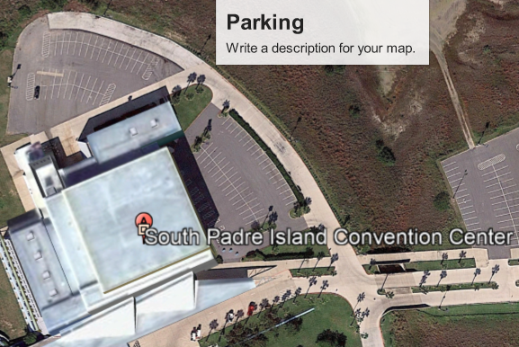

1. If you have any questions or concerns, please don’t hesitate to call or email one of us.

Rolando Borrayo, President Martin Castaneda, Vice-President Dan Cantu, Secretary

956.832.2085 956.310.8703 956.832.2412

rborrayo15452@lfcisd.net mvcast59@mcisd.org dacantu@lfcisd.net