PLANNING COMMISSION MEETING
MARCH 7, 2022 7 PM
TOWN MUNICIPAL CENTER
Agendas were posted at the Municipal Center, and on website- townoftexas.com. Agendas were also sent to Town Board members, Planning members and interested citizens by email.
Meeting was called to order by Chair Paul Anderson.
Roll Call was taken. Members present Paul Anderson, Gary Bootz, Tom Domka, Kathy Hornung, and Keith Plautz, . Zoning Inspector Duane Dittmar and Clerk Lorraine I Beyersdorff were also in attendance.
Minutes were read by the Clerk. Because Paul was absent in February , he had many questions on the discussions and minutes. In the definitions of the Town Ordinance on page 3 is BUILDINGS, ACCESSORY and on page 10 is STRUCTURE, ACCESSORY. There was a question about whether it should be in both places and the wording of the definition should be the same in both.
When a Zoning permit is required was further discussed. Town Zoning 17.12 (1)(a) will be changed to the following County Wording of A. 1. 2. 3.
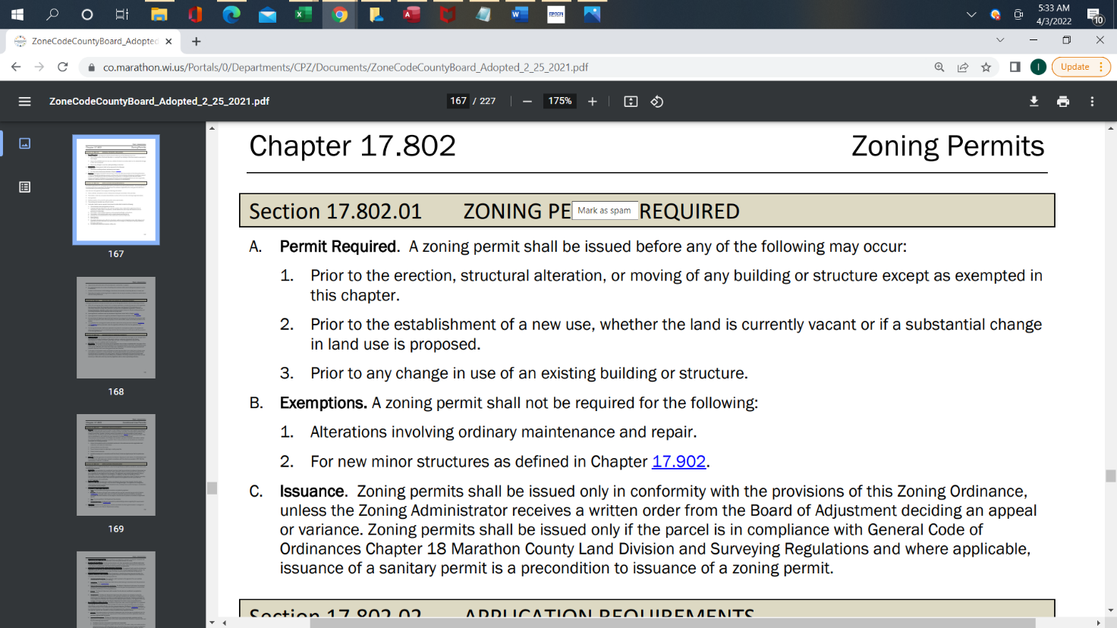
In the Town Ordinance, the second (b) will be (d) Zoning Permit. (c) in the Town Ordinance will be Exemptions. The original (c) will be (e) and be Issuance as in county C above with corrections by changing Board of Adjustment to Planning Commission and Board of Appeals.

Structure Minor needs to be added with County Definition.
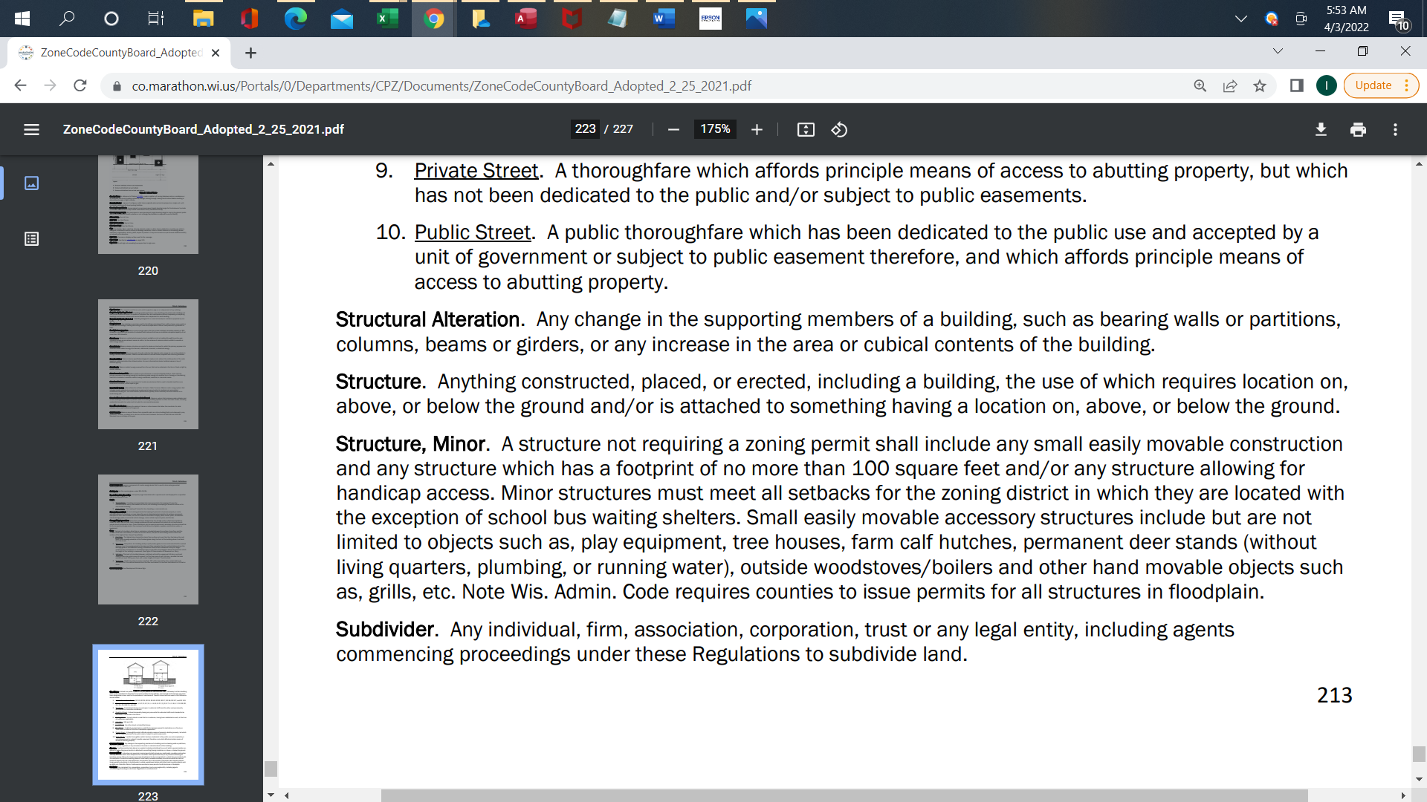
The February motion was to approve this definition of a Structure Minor with the change of 100 square feet to 150 sq feet. The motion was carried in February. This confirms wording.
After these discussions, a motion was made by Keith, seconded by Tom to accept the minutes with additional explanations and details of last month. Motion carried.
Delmar brought up a request for a communication tower along County Line Road. In A-1 Ag permitted uses on page 34(k) Towers are permitted..
Delmar discussed the Slagoski shed with people living in it with the Town Attorney. Attorney would need proof to take action. Town could take action on too many unworking vehicles
Richard Burch attended to question if our Ordinance has any regulations on mailboxes. The consensus was that the USPS office has placement regulations for mailboxes and town does not.
Duane Dittmar stated that Stainless Specialists need a letter that the town does not have an occupancy permit for a state zoned property. Clerk to send letter to Stainless as such.
A-1 Ag side and rear yards were discussed. Leave (d) and (e) at 50 foot. Under (f) is a paragraph about substandard lots that existed prior to Zoning Ordinance revisions that would allow less footage per previous rules.
Duane reported that Justin Thoma wants to add on the north side of his home. Many questions were brought up about side yards, culvert installed without permission, size of lot and current structures on the site. The Town worked to allow the stairs closer to road for ingress-egress of the structure. The lot is small and has a home, garage and shed. Property is located at 243411 Buffalo Ridge Road. Justin will try to work with adjacent land owner for more land but it may be in a forest program. We will discuss more later
There are still more discussions to have on potential Ordinance revisions that will be done next month including wedding barns, and expiration of Zoning Permits.
Motion to adjourn by Tom. Second by Kathy and carried.

Lorraine I Beyersdorff, Town of Texas Clerk.

