TOWN OF TEXAS SPECIAL TOWN BOARD MEETING
September 20, 2023
7:10 PM
MUNICIPAL CENTER
Notices were posted at the Municipal Center, on the website and emailed to interested parties.

Meeting was called to order by Delmar Winter for the Town Board. Richard and Tom were in attendance.

Meeting was called to order by Paul Anderson for the Zoning and Planning. Todd, Gary and Tom were in attendance.

Paul was thinking that we leave the M1, residential and commercial the same. That is Stainless and Riverview.

Everything on the North side of WW stays the same.

Motion by Delmar to notified 17 property owners (plus or minus) and surrounding property owners by letter to the following Land Owners listed below* and Richard Second. Motion carried.

The Parcel #_______ Hsu will be Ag and commercial, not M1. The Stainless Specials property on Steele Lane from M1 to C1.

* PIN : 07829070210982 – Owner (s)-- Brian Thompson Bradley Thompson
PIN : 07829070220998 -- Owner (s)-- Brian Thompson Bradley Thompson
PIN : 07829070220999 - - Owner (s)-- Brian Thompson Bradley Thompson
PIN : 07829070210993 -- Owner (s)-- Dale A. Lindwall Marie L Lindwall DML Income Trust
PIN : 07829070210991 -- Owner (s)-- Dale A. Lindwall Marie L Lindwall DML Income Trust
PIN : 07829070250998— Owner (s)-- Dale A. Lindwall Marie L Lindwall DML Income Trust
PIN : 07829070110997 -- Owner (s)-- David A. Marcis Helen M Marcis
PIN : 07829070110001 -- Owner (s)-- David A. Marcis Helen M Marcis
PIN : 07829070110999 -- Owner (s)-- Douglas W. Wilke Bernadine A Wilke
PIN : 07829070110966 -- Owner (s)-- Douglas W. Wilke Bernadine A Wilke
PIN : 07829070120976 -- Owner (s)-- Corey Baumann
PIN : 07829070120988 -- Owner (s)-- Corey Baumann
PIN : 07829070120999 -- Owner (s)-- Christopher Coushman
PIN : 07829070120981 -- Owner (s)-- Paul Hsu
PIN : 07829070130995 -- Owner (s)-- Paul Hsu
PIN : 07829070130994 -- Owner (s)-- Paul Hsu
PIN : 07829070130992 – Owner (s)-- Beverly J Wischmeyer Ruffles LLP
PIN : 07829070120983 -- Owner (s)-- David A Blaubach Brenda L Blaubach

In attendance:
Missie Thompson- 153187 Cty WW
Will Hsu-237895 Cty W
Doug Wilke-239403 Cty Rd W

Motion by Delmar to adjourn. Second by Tom and carried.

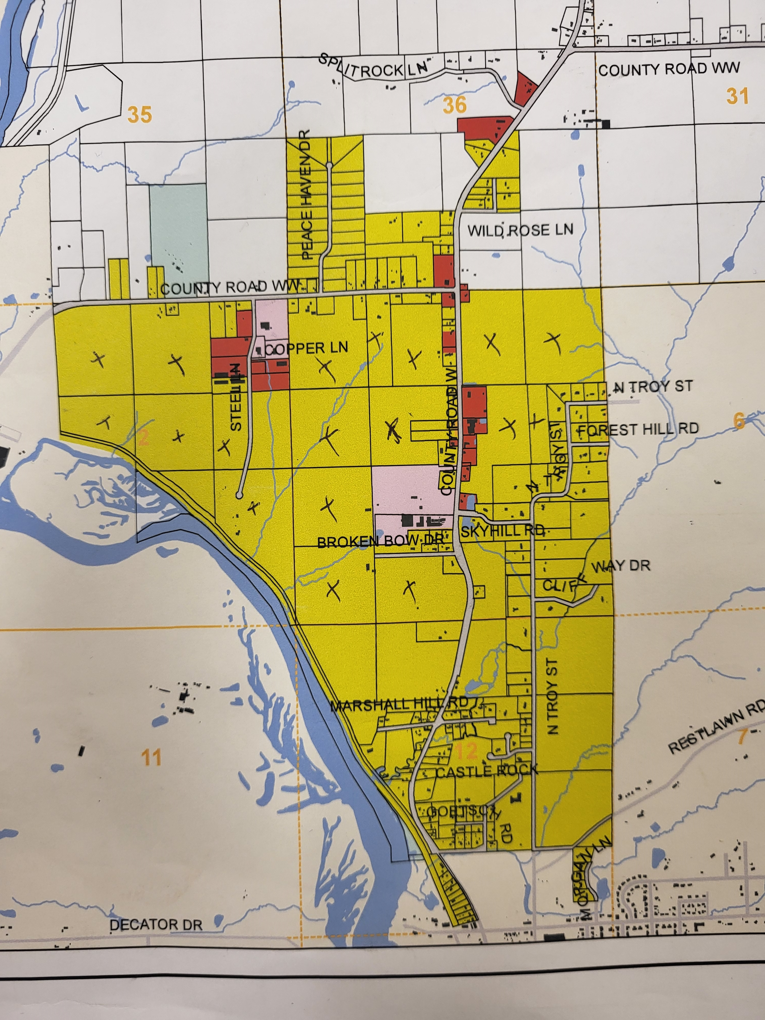

-*--------------------------------------------------------------------------------------------------------------------
Todd’s email: Toddc1975@yahoo.com

