Book Cover: Dancing Shapes
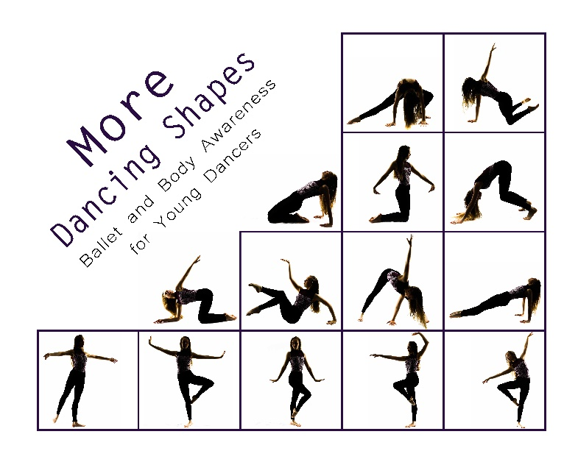Nutcracker Dancing Shapes Book Cover
More Konora's Shapes Book Cover



Ballerina Dreams

Konora 
Dancer shape in silhouette





Princess Naomi Helps a Unicorn  
April 2021

Konora posing as a rock






Danny, Denny, and the Dancing Dragon  
April 2021

