FOR IMMEDIATE RELEASE
Crazy dance teacher lacking technical/publishing skills becomes a recluse for eighteen months creating children’s books. Delirious typing heard at all hours. Deranged lunatic mumbles “book empire” and “give away all the money.”
November, 2021, Seattle (Redmond), WA Author/Publisher: Once Upon a Dance
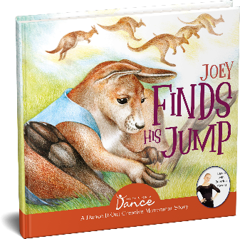
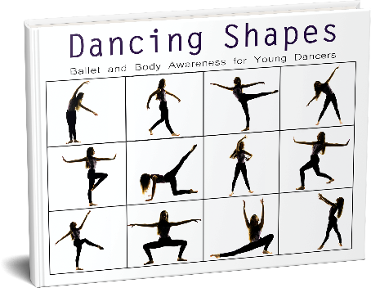
With eighteen published kids’ dance books and more in process, one COVID-sidelined dance teacher sees no end to her obsessed creations. Titles to date include:
▪ Dancing Shapes
▪ More Dancing Shapes
▪ Nutcracker Dancing Shapes
▪ Dancing Shapes with Attitude
▪ Konora’s Shapes
▪ More Konora’s Shapes
▪ Joey Finds his Jump!
▪ Petunia Perks Up
▪ Danny, Denny, and the Dancing Dragon
▪ Princess Naomi Helps a Unicorn
▪ The Cat with the Crooked Tail
▪ Brielle’s Birthday Ball
▪ Mira Monkey’s Magic Mirror Advenutre
▪ Belluna’s Big Adventure in the Sky
▪ Freya, Fynn, and the Fantastic Flute
with four more books scheduled for publication.
The maniac dragged her daughter along. They renamed her Konora in an effort to make something beautiful from coronavirus and created Once Upon a Dance from a desire to keep kids stuck at home connected with movement.
The ballerina heroine had climbed the pre-professional ballet ladder up to Pacific Northwest Ballet’s Professional Division. Along the way, she danced iconic roles such as Sugar Plum Fairy and Cinderella. She’s one of the fortunate ones whose dreams didn’t die under covid’s shadows, and she’s now an apprentice with Ballet Idaho.

While the woman knew nothing of bookmaking, she was an award-winning dance teacher who had worked in early childhood education and for non-profits supporting kids, served on boards related to parenting and ballet, and watched oodles of dance through the years. Now, she’s an award-winning author.

Sample Story
A mother-daughter duo created dance books during COVID. They donate every sale ($75,000) to struggling ballet companies and animal welfare non-profits.
Each Dancing Shapes volume gives readers a glimpse into Konora’s ballet journey, along with a warmup, ballet lesson, and an exploration of movement details. The series highlights storytelling, imagination, theater, and choreographic elements, as well as good habits, discipline, kindness, gratitude, persistence, and joy.
The second series, Dance-It-Out! Creative Movement Stories for Young Movers, is designed for a younger crowd to share with caregivers (ages 4–7). Kids are invited to express movement, with Konora along as movement guide.
For information, visit www.OnceUponADance.com, www.creativemovementstories.com, or Amazon.
[Thank you! Review books happily provided: Contact Terrel at 425-883-0836 or terrel@OnceUponADance.org.]
###

