Sell Sheet
Author/Publisher: Once Upon a Dance
All books available on Amazon. Hardcovers produced by Ingram Spark. Sold in all supported territories.
50% discount. Hardcovers also available at Barnes & Noble.
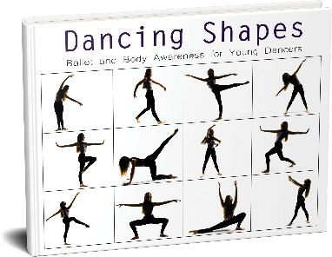

Dancing Shapes provides an inside gorgeous glimpse into ballerina Konora’s journey.
Konora, whose career has been sidelined by COVID-19, leads readers through warm-up steps, a basic ballet technique lesson, and an exploration of movement and form.
Ideal for ages 6–8 or younger kids undaunted by challenge.

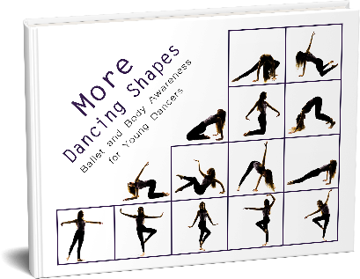
Nonfiction > Performing Arts > Dance > Classical & Ballet
Juvenile Nonfiction > Concepts > Body
52 pages
$7.48 paperback ISBN: 978-1735984407
$24.99 hardcover ISBN: 978-1735984414
$2.99 Ebook ISBN: 978-1735984421
Published: 11/29/20
In More Dancing Shapes Ballerina Konora leads readers through:
• an inside glimpse into her continuing almost-ballerina journey
• a warm-up and basic ballet technique lesson
• an exploration of form and shape
• creating their own unique shapes
Preschoolers can try broad shapes, older kids can fine-tune details, and all ages can delve into storytelling and discover the crazy pre-professional ballet world.

Juvenile Fiction > Picture Books
Juvenile Nonfiction > Performing Arts > Dance > Ballet
44 pages
$7.99 Paperback ISBN: 978-1735984438
$24.99 Hardcover ISBN: 978-1735984445
$3.99 ebook 978-1-7359844-5-2
Published: 12/23/20
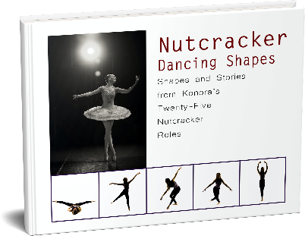
In Nutcracker Dancing Shapes, join Konora as she looks back through her twenty-five Nutcracker roles and explore her performance-based shapes and poses. Includes
• the story of The Nutcracker
• Konora’s personal Nutcracker experiences
• storytelling and imagination
• ballet shapes
• candid stories about some of the funny happenings along the way
This third installment presents a fascinating peek at the life of an almost-ballerina. Ideal for ballet fans ages 7-11.
Juvenile Nonfiction > Holidays & Celebrations > Christmas & Advent
Nonfiction > Performing Arts > Dance > Classical & Ballet
44 pages
$8.99 Paperback ISBN: 978-1736353622
$24.99 Hardcover ISBN: 978-1736353639
(No ebook for dancer privacy)
Published: 12/23/20
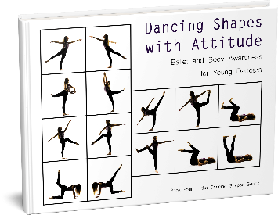
Dancing Shapes with Attitude presents captivating straight talk and inspiration from Ballerina Konora and is ideal for young ballet fans ages 9-11.
Aspiring dancers get an inside perspective on casting, competitions, and career, as well as a lesson in movement and dance, in this fourth book in the Dancing Shapes collection.
Juvenile Nonfiction > Performing Arts > Dance
48 pages
$8.99 Paperback ISBN: 978-1736589946
$24.99 Hardcover ISBN: 978-1-7365899-5-3
$2.99 ebook: ISBN: 978-1-7365899-6-0
Published: 3/30/21

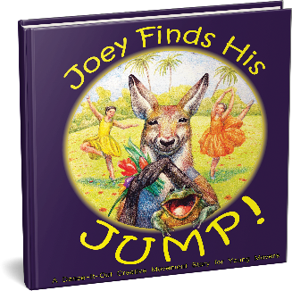
Joey Finds His Jump!: A Dance-It-Out Creative Movement Story for Young Movers
Joey Kangaroo never learned how to jump, and he desperately wants to find the secret. Ballerina Konora helps readers express their movement alongside Joey in this interactive story of determination, friendship, and jumping jubilance.
Juvenile Fiction > Imagination & Play
Juvenile Fiction > Animals: Kangaroos
40 pages
Illustrated by Olha Tkachenko
$6.99 Paperback ISBN: 978-1736353615
$2.99 ebook ISBN: 978-1736353646
Published: 02/18/21
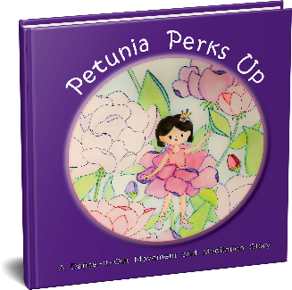
Petunia Perks Up: A Dance-It-Out Movement and Meditation Story
Petunia woke to yet another rainy day, and she feels particularly gloomy about being stuck inside. By letting ordinary objects and elements of her daily routine spark her imagination, she finds a happy calm she wants to share. Ballerina Konora is there to help readers connect with movement and focus the breath.
Juvenile Fiction > Imagination & Play
Juvenile Nonfiction > Health & Daily Living > Mindfulness & Meditation
42 pages
Illustrated by Catherine Yeh
$7.48 Paperback ISBN: 978-1736353677
$2.99 ebook ISBN: 978-1736353660
Published: 02/26/21
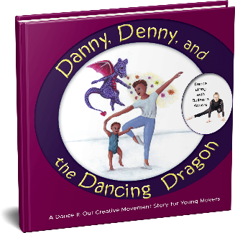
Danny, Denny, and the Dancing Dragon
Interactive movement wrapped up in a charming story of new baby disappointment.
Only little brother Denny has an amazing surprise for his brother Danny!
Juvenile Fiction > Animals > Dragons, Unicorns & Mythical
Juvenile Fiction > Imagination & Play
32 pages
Illustrated by Anka Willems
$7.48 Paperback ISBN 978-1736875070
$2.99 ebook ISBN 978-1736875087
$19.99 Hardcover ISBN 978-1736875094
Published: 05/2/21

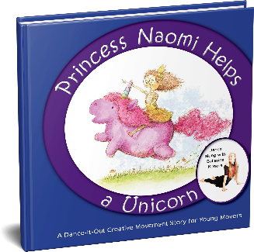
Princess Naomi Helps a Unicorn
Interactive movement wrapped up in a charming story of new baby disappointment.
Only little brother Denny has an amazing surprise for his brother Danny!
Juvenile Fiction > Animals > Dragons, Unicorns & Mythical
Juvenile Fiction > Imagination & Play
34 pages
Illustrated by Ethan Roffler
$7.48 Paperback ISBN 978-1736589922
$2.99 ebook ISBN 978-1-736875056
$19.99 Hardcover ISBN 978-1736875063
Published: 05/6/21

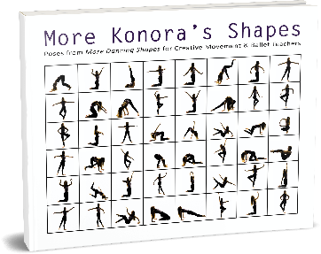
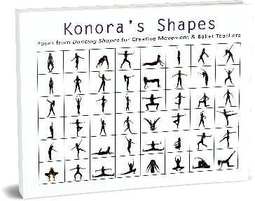
Konora’s Shapes and More Konora’s Shapes were created for dance educators to use in their ballet and creative movement classes. With wide inside margins and blank, even pages, instructors can cut out each book’s fifty poses to enjoy an instant collection of images. Multiple ideas for engaging young dancers ensure teachers cherish their near-silhouette, dance-inspired poses.
Nonfiction > Performing Arts > Dance > Classical & Ballet
Education & Reference > Education > Teaching Methods & Materials > Arts & Humanities
108 / 120 pages
$16.99 / $19.99 paperback ISBN: 978-1735984469 / 978-1-7359844-8-3
$2.99 / $3.99 Ebook ISBN: 978-1735984483 / 978-1-7359844-9-0
(No hardcover)
Published: 12/15/20

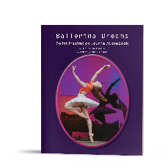
Ballerina Dreams Ballet Inspiration 8x10 Journal/Notebook
26 pages
$6.99 Paperback ISBN: 978-1736589915
Published: 02/2/21

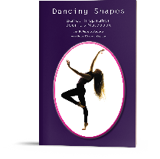
Dancing Shapes Ballet Inspiration 6x9 Journal/Notebook
32 pages
$6.99 Paperback ISBN: 978-1736589908
Published: 02/2/21

Coming Soon:
Dance-It-Out Series
• Brielle’s Birthday Ball (June)
• The Cat with the Crooked Tail (July)
• Danika’s Dancing Day (July)

Dancing Shapes Series
• Dancing Shapes with Cats (July)

Dance Inspiration and Choreography Concepts Series (ages 8-11)
• Dance Stance (August)
• Falling into Dance with Ballerina Konora (August)
• Turning it Around (October)

Holler if there’s other information you’d like—happy to provide!
Terrel@OnceUponADance.org
425-883-0836

