
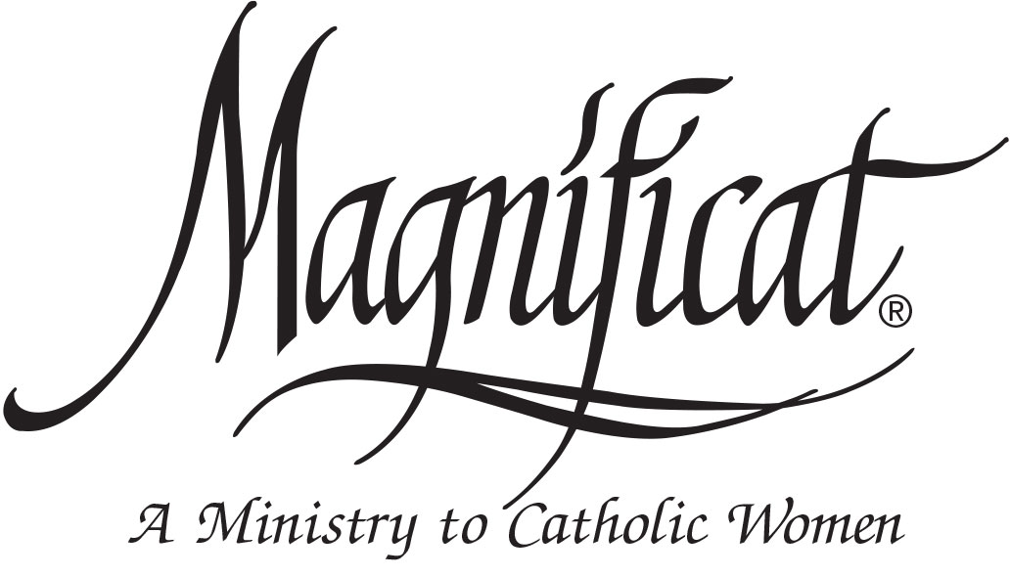

All women are invited to the Magnificat-Omaha* Fall Brunch at St. Robert Bellarmine Catholic Church on September 20 from 9:30 AM to 12:30 PM. Our guest speaker, Felice Gerwitz, founder of the Media Angels Radio and Podcast Network, will inspire you to Transform Crazy BUSYNESS into Prayer and Productivity. Cost: $20. For Reservations and information, go to www.MagnificatOmaha.org
* Magnificat-Omaha is an archdiocesan-wide Catholic women’s organization focused on evangelization.

