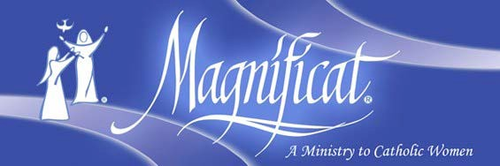 **All Women are Invited to a Brunch Sponsored by Magnificat-Omaha**

Saturday, December 4, 2021 Advent Brunch: 9:30 AM–1 PM

St. Robert Bellarmine Catholic Church

11802 Pacific St, Omaha, NE 68154

*“My soul proclaims the greatness of the Lord, my spirit rejoices in God my Savior…*

*The mighty ONE has done great*

*things for me Holy is His name.”*

Luke 1:46-49

In these words of the Magnificat, Mary proclaimed to Elizabeth her gratitude for the wonderful action of God in her life. Please join us at a brunch for women where we will share together in that same spirit of gratitude and praise of God. After the meal, there will be a time of prayer for the needs of all present and an opportunity to hear Kitty share her dramatic story of conversion and beautiful music. Please plan to come and bring a friend to rejoice in the presence of the Lord.

# Reservations & Information

**Guest Speaker: Kitty Cleveland**

Reservations are required as seating is limited.

Please make your reservation before

November 30, 2021.

The cost is $20.00.

Register and prepay at our website:

[**www.MagnificatOmaha.org**](http://www.MagnificatOmaha.org/)

Spiritual Advisor: Fr. Michael Voithofer



Magnificat-Omaha invites all women to our Advent Brunch with guest speaker Kitty Cleveland, inspirational speaker and award-winning singer and songwriter. Kitty has been delighting audiences around the world with song and testimony for over 25 years.

Thousands of people have heard Kitty’s stirring testimony, a story both dramatic and humorous, which takes her all the way to the U.S. Supreme Court. Most recently Kitty was added to the roster of Lighthouse Catholic Media, a non-profit corporation which has distributed over five million CDs of talks and teachings by Catholic evangelists worldwide. Kitty lives in New Orleans with her musician husband Mel and teen daughter Cecilia, whom they adopted form China. Please join us for an Advent Brunch of laughter and song.