
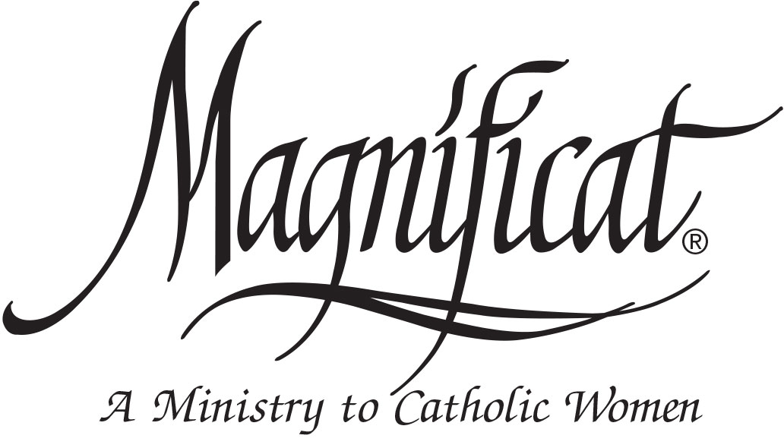

All women are invited to a special Magnificat-Omaha Advent Brunch at St. Robert Bellarmine Catholic Church on December 6 from 9:30 a.m. to 12:30 p.m. Our guest speaker, Fr. Michael Voithofer, Founder of the Ablaze House of Prayer and Eucharistic Revival Worship Nights, will inspire you to live in the Hope, Peace, and Joy of Advent. Cost: $20. For Reservations and information, go to www.MagnificatOmaha.org
* Magnificat-Omaha is an archdiocesan-wide Catholic women’s organization focused on evangelization.

