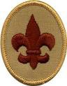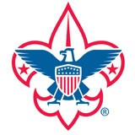

# Scout Advancement

Scout Name:

* Requirements 1 – 7 completed
* Complete Skills Review:
  + Square Knot
  + Two-half hitches
  + Taut-line hitch
* Understand and agree to live by:
  + Scout Oath
  + Scout Law
  + Scout Motto
  + Scout Slogan
  + Outdoor Code

I certify that I have completed all the

requirements for this rank advancement.

Scout Signature Date

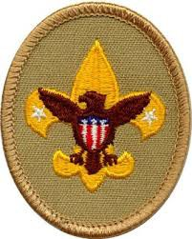

# Tenderfoot Advancement

Scout Name:

* + - 1 through 11 requirements completed
    - Troop activity prior 2 months:
      * 50% troop meeting attended
      * 50% outside troop meeting
    - Demonstrated:
      * Scout Oath
      * Scout Law
      * Duty to God
    - Complete Skills Review
      * Knots
      * Cooking
      * First Aid

Describe 4 “specific” examples of how you lived the points of the Scout Law

|  |
| --- |
| 1. |
| 2. |
| 3. |
| 4. |

I certify that I have completed all the

requirements for this rank advancement.

Scout Signature Date

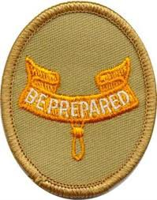

# Second Class Advancement

Scout Name:

* + - 1 through 12 requirements completed
    - Troop activity prior 2 months:
      * 50% troop meeting attended
      * 50% outside troop meeting
    - Demonstrated:
      * Scout Oath
      * Scout Law
      * Duty to God
    - Complete Skills Review
      * Knots
      * First Aid
      * Compass

Describe 4 “specific” examples of how you lived the points of the Scout Law

|  |
| --- |
| 1. |
| 2. |
| 3. |
| 4. |

I certify that I have completed all the

requirements for this rank advancement.

Scout Signature Date

# First Class Advancement

Scout Name:

* + - 1 through 13 requirements met
    - Troop activity prior 2 months:
      * 50% troop meeting attended
      * 50% outside troop meeting
    - Demonstrated:
      * Scout Oath
      * Scout Law
      * Duty to God
      * Leadership
    - Complete Skills Review:
      * Cooking
      * First Aid
      * Knots
* Lashing
* Map and Compass

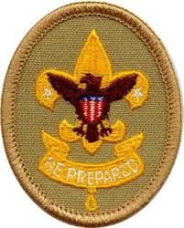Describe 4 “specific” examples of how you lived the points of the Scout Law

|  |
| --- |
| 1. |
| 2. |
| 3. |
| 4. |

I certify that I have completed all the

requirements for this rank advancement.

Scout Signature Date

# Star Advancement

Scout Name:

Leadership Position Start/End

* + 1 through 8 requirements completed
  + Troop activity prior 4 months:
    - 50% troop meeting attended
    - 50% outside troop meeting
  + Demonstrated:
    - Scout Oath
    - Scout Law
    - Duty to God
    - Leadership
    - Service

Eagle required Merit badges:

|  |
| --- |
| 1. |
| 2. |
| 3. |
| 4. |

Additional Merit badges:

|  |
| --- |
| 1. |
| 2. |

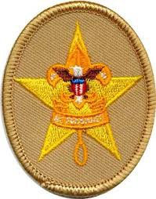I certify that I have completed all the

requirements for this rank advancement.

Scout Signature Date

# Life Advancement

Scout Name:

Leadership Position: Start/End

* + 1 through 8 requirements met
  + Troop activity prior 6 months:
    - 50% troop meeting attended
    - 50% outside troop meeting
  + Demonstrated:
    - Scout Oath
    - Scout Law
    - Duty to God
    - Leadership
    - Service
    - Teaching younger Scouts

Eagle required Merit badges:

|  |
| --- |
| 1. |
| 2. |
| 3. |

Additional Merit badges:

|  |
| --- |
| 1. |
| 2. |

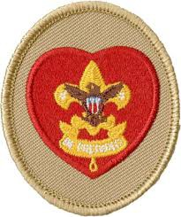 I certify that I have completed all the

requirements for this rank advancement.

Scout Signature Date

# Eagle Advancement

Scout Name:

Leadership Position**:** Start/End

* 1 through 7 requirements completed
* Troop activity prior 6 months;
  + 50% troop meeting attended
  + 50% outside troop meeting
* Demonstrated:

|  |  |  |
| --- | --- | --- |
| * Scout Oath | * Scout Law | * Leadership |
| * Duty to God | * Service | * Teaching younger Scouts |

* Eagle Scout project completed

Eagle required Merit badges:

|  |  |  |
| --- | --- | --- |
| 1 | 6 | 11 |
| 2 | 7 | 12 |
| 3 | 8 | 13 |
| 4 | 9 |  |
| 5 | 10 |  |

Additional Merit badges:

|  |  |  |
| --- | --- | --- |
| 1 | 4 | 7 |
| 2 | 5 | 8 |
| 3 | 6 |  |

I certify that I have completed all the

requirements for this rank advancement.

Scout Signature Date

Pass Signature Date

# Eagle Bronze Palm

Scout Name:

* Troop activity 3 months since Eagle Advancement;
  + 50% troop meeting attended
  + 50% outside troop meeting
* Demonstrated:
  + Scout Oath
  + Scout Law
* Developed and demonstrated leadership ability

Merit badges:

|  |
| --- |
| 1. |
| 2. |
| 3. |
| 4. |
| 5. |

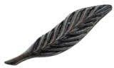I certify that I have completed all the requirements for the bronze palm.

Scout Signature

Date

# Eagle Gold Palm

Scout Name:

* Troop activity 3 months since Bronze Palm;
  + 50% troop meeting attended
  + 50% outside troop meeting
* Demonstrated:
  + Scout Oath
  + Scout Law
* Developed and demonstrated leadership ability

Merit badges:

|  |
| --- |
| 1. |
| 2. |
| 3. |
| 4. |
| 5. |

I certify that I have completed all the

requirements for the gold palm.

Scout Signature Date

# Eagle Silver Palm

Scout Name:

* Troop activity 3 months since Gold Palm;
  + 50% troop meeting attended
  + 50% outside troop meeting
* Demonstrated:
  + Scout Oath
  + Scout Law
* Developed and demonstrated leadership ability

Merit badges:

|  |
| --- |
| 1. |
| 2. |
| 3. |
| 4. |
| 5. |

I certify that I have completed all the

requirements for the silver palm.

Scout Signature Date