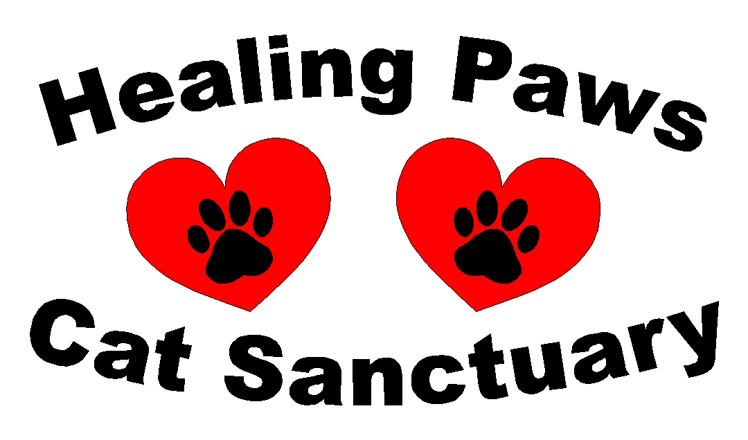

ADOPTION CONTRACT
Adopting a rescued animal is a lifelong commitment!

Date of Application: _______________ Date of Home Visit: _________________ Date of Adoption: ______________

Name(s) of Adopted Animal(s): ___________________________________________________________________________________

DOB of Adopted Animal(s): ______________________________________________________________________________________

Breed/Color/ Sex of Adopted Animal(s): ____________________________________________________________________________

Name(s) of Adopter(s): ___________________________________________________________________________________________

Address: _______________________________________________________________________________________________________

DL #(s) and State Issued: __________________________________________________________________________________________

Phone #(s): Home: _____________________________ Cell(s): ___________________________________________________________

Employer(s): ____________________________________________________________________________________________________

Employers Phone #: ______________________________________________________________________________________________

If You Rent Landlord’s Name & Number (WILL be verified cats are ok): _________________________________________________

Email Address(s): _______________________________________________________________________________________________

Will This Be An Inside, Outside, or Both Cat and if Outside Are You Near Any Busy Roads or Intersections: ____________________

________________________________________________________________________________________________________________

Do You Have Any Other Animals: Dog(s): ___________ Cat(s): ____________ Bird(s): ____________ Fish: ______________

Personal Vet’s Name and Number (prior to adoption this WILL BE VERIFIED):________________________________________

________________________________________________________________________________________________________________

Extra Information: _________________________________________________________________________________________________

____________________________________________________________________________________________________________________

____________________________________________________________________________________________________________________

Pg. 1

*Adoptee contact information: If you have ANY questions or concerns please contact Jackie Kibler at 386-795-5371 or Summer Cleland at (386) 500-1813 or email us at HealingPawsCatSanctuary@gmail.com

I, ____________________________________ & ______________________________________ am/are agreeing to give this/these animal(s) a safe and loving home for the rest of their lives. I also agree to seek ANY AND ALL medical
care associated with the adopted animal(s) as needed over their lives.

I also agree to the following (please initial):

______ Adoptee reserves the right to visit my home at ANY time for a home inspection and reclaim this animal(s) if there is any question
of proper care of them.

______ I/We are adopting this animal(s) for myself and cannot give him/her away PERIOD.

______ I/We agree to ONLY contact and return the animal to Healing Paws Cat Sanctuary if there are any issues with the adoption

______ If the adopted kitten/cat has ANY health issues in the future and ALL future vaccines are the adopter’s responsibility.

______ I/We agree to an adoption donation of $60.00(1st rescue) $30.00 (each additional rescue) which is TAX DEDUCTABLE.

I certify that I have read the above and agree to ALL terms.

X _______________________________________________________________________________ Date: _____________________
Signature of Adopter

X _______________________________________________________________________________
Printed Name

X _______________________________________________________________________________ Date: _____________________
Signature of Adopter

X _______________________________________________________________________________
Printed Name

X _______________________________________________________________________________ Date: _____________________
Signature of Adoptee

X ________________________________________________________________________________
Printed Name

1124 Landers St. Ormond Beach, FL 32174 Healingpawscatsanctuary.org

501C3 Non Profit Organization EIN# 83-1492409

Pg. 2

