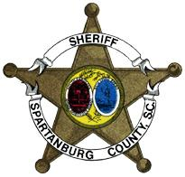
SPARTANBURG COUNTY SHERIFF'S OFFICE
CHUCK WRIGHT, SHERIFF

March 18, 2020

Dear Spartanburg County Bar Association Member:

First and foremost I would like to take the time to say thank you, to each member of the Bar Association, on how well you work with me and the Detention Facility Staff. By now everyone is aware of the State of Emergency declared by our Governor and by orders from the Sheriff, I have been instructed to closed our public lobby and must restrict all traffic inside the secure area of the facility to Staff and Deputies only.

I completely understand how this will pose an inconvenience as it has to us all, so I humbly request everyone’s patience during this very trying time in our country and work together through this crisis. We will still allow client attorney visits through our old visitation booths located in the main lobby. We only have two booths available so please limit your time affording other attorney’s the same opportunity.

I know this will be a very difficult time but if we continue to work together to keep everyone safe and healthy, it will be worth any inconvenience we may experience.

I have reached out to Clerk of Court Madam Cox to disseminate this letter out to everyone in hopes that I do not miss anyone who may have clients incarcerated at our facility.

Thank you and hopefully this will only before a short period and we will resume normal operations soon.

God Bless and God Bless the U.S.A.,

Major Allen Freeman

