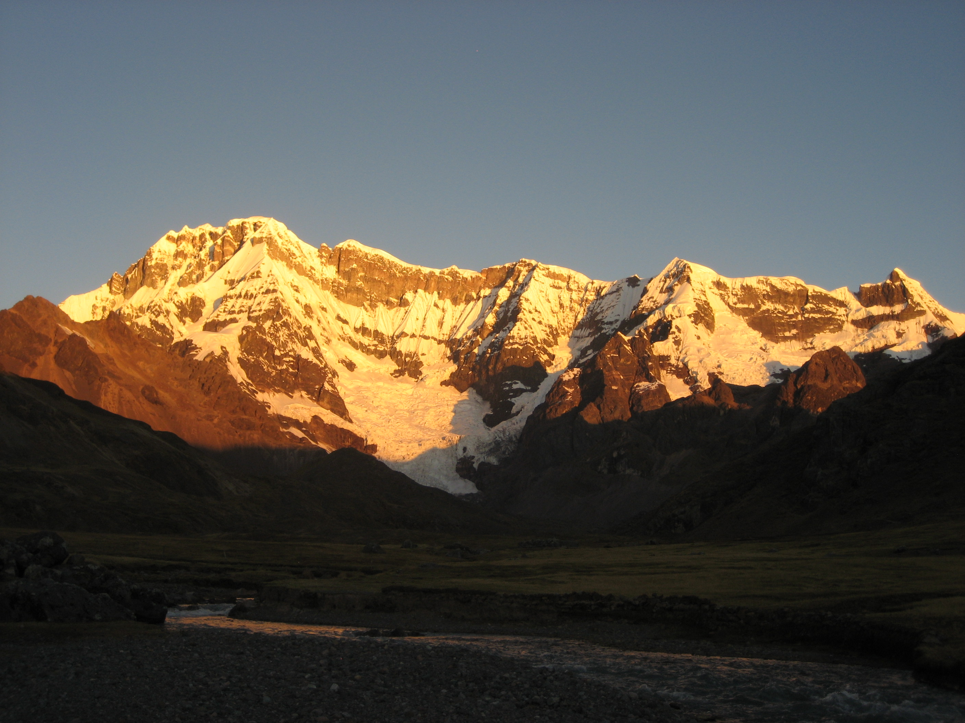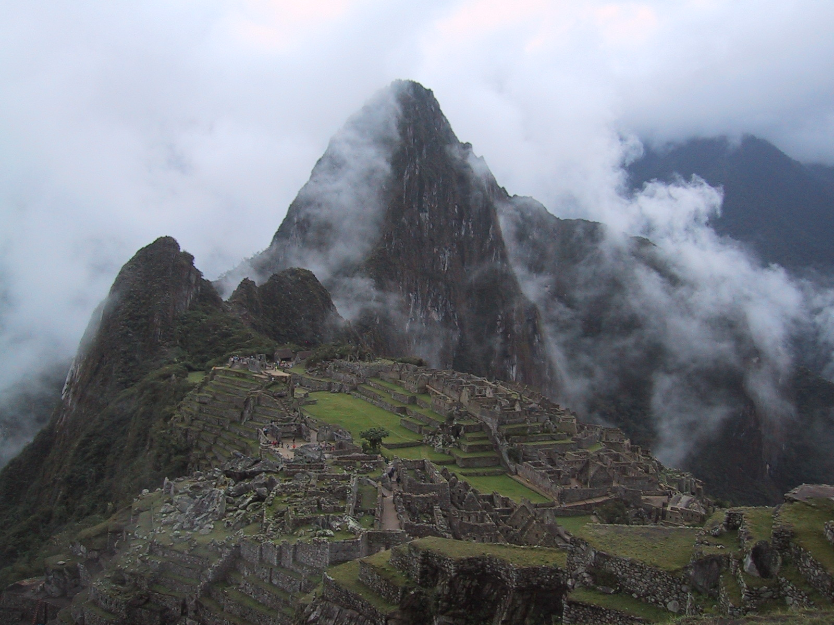

**The Mythic Journey of Origin of the Inka**

**From Machu Picchu to Holy Mountain Ausangate**

**June 10 - 22, 2018**

We fly high above the Andes Mountains and land in Cusco, the old capital of the legendary Inka Empire. The Jaguar city of Cusco is one of the oldest dwellings in the Americas. Timeless temples and palaces stand as living legacy of the magnificent mixture of Inka and Spanish architecture. We visit the temple fortress of Sacsaywaman, the head of the jaguar, and participate in ceremonies as we connect with the organizing energies of the Andes. We retrace the footsteps of Inka wizards who have mastered the principles of the land as we participate in meditations and ceremonies with Medicine People. In the Sacred Valley of the Inkas we are guests in one of the most wonderful settings for our work, surrounded by 19,000 ft. towering glaciers. We visit the Temple of the Winds at Ollantaytambo and its timeless village with water aqueducts still flowing as it did 500 years ago. Medicine people believe that power in the journey of life is sourcing from our healed and fulfilled states, hopefully, becoming collective individuals along the way. We visit the Temple of the Visionary at Pisaq to reenact the journey into our own becoming as we meditate, embraced by incredible vistas. The energy of this site allows us to tap into the visionary within. It is said that comprehending the Kausay Pacha (the life force we source from), is embracing our love, our potential, and ultimately our transcending.

In Machupicchu, the most prized indigenous sacred site and the most enigmatic for westerners, our guide accompany us in an experiential journey through talks, tours, and meditations. The breathtaking vistas of the Vilcabamba range and the unsurpassed stone work make this site truly spectacular.

South of the valley of Cusco, the majestic ice clad Holy Mountain Ausangate, stands at 20,350ft. It is considered one of the holiest deities in Andean Spirituality. Through rites of passage, offerings, and cleansing ceremonies, initiates receive power and healing from the Holy Mountain. For thousands of years, aspiring apprentices and mentors have gathered around sacred lagoons at the foot of the mountain; Apu Ausangate is revered throughout Peru as a benefactor for people, animals, and crops. This trekking journey retraces the initiation footsteps of medicine people, allowing initiates to step into paradigm shifts and healing. We travel across high mountain roads, snow covered peaks, emerald lagoons, hot springs, and camp under the brightest stars of the southern hemisphere. Master ceremonialists teach us the Andean ways to personal power and attainment of perfect Ayni with the powers of the land.

In addition to ceremonies and sightseeing, participants will be given the opportunity to sample a variety of delicious Peruvian cuisine, as well as experience the culture through shopping for beautiful Andean souvenirs.

**ITINERARY**

**JUNE 10 USA/LIMA**

Late evening arrival in Lima, Peru. You may choose to transfer to a nearby Hotel for a few hours of rest (on your own). If you arrive early in the morning, it is preferable to stay at the airport and immediately transfer to a Cusco bound flight.

**JUNE 11 LIMA/CUSCO/MARAS**

Morning flight to Cusco, the capital of the Inka Empire. After a short city sightseeing, our bus takes us to the sleepy village of Maras above the Sacred Valley of the Inca an hour away from Cusco. The drive is filled with breathtaking views of the Urubamba mountain range and colorful villages along the road. Our hotel is spread out on a mountain balcony overlooking the Sacred Valley. Late afternoon orientation and opening ceremonies. (L, D)

**JUNE 12 MARAS/PISAQ**

We drive upriver the Urubamba and visit one of the most prized archeological sites in the Sacred Valley: Pisaq or the Temple of the Visionary. Gravity defying terraces, unchanged Inka walls, notable for the precision of the stone fittings and trapezoidal patterns surround the sacred site. We follow and ancient royal trail along the crest of the mountain and arrive into the Hitching Post of the Sun. Talks and ritual are part of our visit. After lunch, we feast our senses in the colors and bargains at the indian market nearby. Once at our Lodge, we participate in a Healing Fire Ceremony. (B, L, D)

**JUNE 13 MARAS/OLLANTAYTAMBO**

We drive to the temple fortress of Ollantaytambo. The commanding site stands above the village and displays an amazing array of gigantic blocks of polished stone. Even more puzzling is knowing that the quarries were located across the valley half way up in the opposite mountain. With no doubt, one of the finest examples of Inka architecture as it displays beautiful cascading terraces, temples, palaces, tunnels, double jamb doors, and so on. After lunch we drive to our Healing Center above the Sacred Valley to meet and work with medicine people. (B,L,D)

**JUNE 14 MARAS/MORAY** Today we visit the Temple of Pachamama at Moray. The big concentric circles embedded in the highland topography as a series of round amphitheaters host unique vortexes of energy. This mythic belly of the Andean Mother Pachamama is highly regarded as a place to tune one’s medicine body with the ways of the land. We are led by master shamans in meditations and ritual. After lunch we visit the archeological complex of Chinchero filled with sacred shrines, stunning temples, ample terracing, and breathtaking views. Late afternoon return to our Lodge. (B,L,D)

**JUNE 15 SACRED VALLEY/MACHUPICCHU** Early morning train ride to the city of light of the Inkas. Once we arrive in the village of Aguas Calientes, we check into our hotel and immediately we drive up to the fabled city and spend the day exploring. We are guided by an expert historian as we visit the different temples, palaces, and sections of the city. Exuberant orchids, semitropical vegetation, low clouds give Machu Picchu an aura of enigma and mystery. Free evening in the colorful village abundant with shops and restaurants. Dinner on your own. (B, L)

**JUNE 16 MACHU PICCHU/MARAS** We return early in the morning to the Ollantaytambo train station where we meet our bus and are driven to our Lodge in Maras. Afternoon visit with the local shamans for ceremony and candid dialogues at our Lodge. (B, L, D)

**JUNE 17 MARAS/CUSCO** We visit the first Temple of the Sun at Sacsaywaman. The site is enshrouded in mystery and its megalithic construction has challenged everyone. Theories and legends abound about its purpose and origin. For the medicine people the three gigantic tiers that make up the complex is the representation of the lightening god in charge of fertility and continuity. In the afternoon, we are free for lunch and explore the city and optional visits to different museums and archeological sites. Late afternoon return to Maras (B, D)

**JUNE 18 MARAS/TRAILHEAD (KASERCOCHA - AUSANGATE)/HARMACOCHA.** We board our vehicles and drive southeast to the Vilcanota mountain range at the edge of the Amazon. The range is home to the largest tropical ice cap in the southern hemisphere: Qelkaya. Northwest from Qelkaya lies the majestic Ausangate flanked by Santa Catalina, Wayna Ausanagte, Tres Picos, Colque Cruz, Hariwanaki Holy Mountains. Between the creases and ridges of mountains there are numerous emerald colored lagoons. Some of them with incredible healing powers. At Maranpaki, we meet our mountain crew and start trekking into a broad valley below the Holy Mountain Colque Cruz. We camp right before a mountain pass at Harmacocha. Horses, wranglers, and an excellent mountain staff are the core of our high-altitude outing.

(B, L, D)

**JUNE 19 HARMACOCHA/KOMERCOCHA**. We go over the Condorpaka Mt pass and descend into an archipelago of glacier lagoons displaying spectacular emeralds and azures. Full day dedicated to ritual, contemplation, and cleansing ceremonies. The isolation and the breathtaking views will make this day one of the most memorable: dotted mountain sides with llamas and alpacas plus glacier lagoons and snowcapped mountains all around. (B, L, D)

**JUNE 20 KOMERCOCHA/AZULCOCHA.** A short hike will take us into an open valley and witness the holy of holies: Ausangate. We camp right below the Holy Mountain on the shores of Azulcocha or blue lagoon. On this big day we undergo the High Mountain Rites of Passage after performing personal and Collective Celestial Despachos. Our medicine people friends take the lead in all aspects of our visit to the Holy Mountains. (B, L, D)

**JUNE 21 AZULCOCHA/CUSCO**. Winter Solstice Ceremony. We welcome the new cycle of life with Conch Shells and Despachos. Later, we break campsite and hike down the mountain to Pacchanta to optional relaxing hot springs. We’ll meet our vehicles, load up our gear, and head back to Cusco to hot showers and the comforts of the city. Free evening (B, L)

**JUNE 22 CUSCO/LIMA/HOME.** Morning free for packing and last-minute shopping. Afternoon departure to Lima to connect to your HOME bound flight. We strongly recommend that you take the last flight out of Cusco in order to spend less time in between planes in Lima. (B)

**B = Breakfast, L = Lunch, D = Dinner.**

**LAND COST $2999.00** *Itinerary subject to change at the discretion of tour providers and Spirit␣*

**INCLUSIONS:**

* Transportation throughout by private motor coach.
* All Hotel accommodations based on double or triple occupancy.
* Meals as detailed in itinerary.
* All airport group transfers and baggage handling.
* All entrance fees to archeological sites as outlined in program.
* Activities including talks and ceremonies by renowned Medicine People.
* Services of Rainbow Jaguar tour leader and staff.
* Local and return flight reconfirmation, airport check-in, luggage assistance.

**EXCLUSIONS:**

* Meals not specified in the detailed itinerary of the tour.
* US domestic, International or flights within Peru.
* Airport departure taxes within Peru.
* Transfers for **independent** arrival or departure.
* Optional gratuities.
* Additional hotel nights made necessary by airline schedule changes or other factors.
* Traveler's insurance.
* Cost of medical immunizations (if any).
* Items of a personal nature (liquor, laundry, toiletries, phone calls, etc.)
* Single supplement charge, if requested. ($550 extra)

**Registration Form**

Name: ________________________________________________________________________________

Phone: ________________________________________________________________________________

E-mail: ________________________________________________________________________________

Address: _______________________________________________________________________________

_______________________________________________________________________________________

**Land cost: $2990.** (Save $100 by registering with non-refundable deposit by March 1st, 2018)

_____ I am enclosing a non-refundable deposit of $1000; balance due by June 1, 2018 of $1999.

_____ Enclosed is my full payment of $2999. (includes $1000 non-refundable deposit).

_____ I am requesting single occupancy. An additional $550.00 is enclosed.

Payment made by: (please check one): ___Check ___ VISA ___ MC

Roommate Request: ____________________________________________________________________

**Terms & Conditions**

**A minimum of 12 participants is required. If trip is cancelled due to insufficient number of participants, you will receive refund of your land costs. Reservations:** All reservations are subject to availability. A $1,000 non-refundable deposit is required to confirm your reservation. ***Final payment is due 30 days prior to the starting date of the program.*** Persons with health or psychiatric problems may find this program physically or mentally trying. We recommend that in case of doubt, a physician or mental health professional be consulted.

**Costs:** All prices are per person, *double occupancy.* Single occupancy accommodation is available for an additional $550 fee. **Cancellations & Refunds:** If you must cancel the journey, your paid monies will be refunded in full less a $1000.00 cancellation fee if written cancellation is received **30 days** before the program departure. Thereafter, all refunds are limited to amounts recoverable from land operators. No refunds will be given for unused accommodations or services. **Insurance:** We strongly recommend participants purchase travel insurance in order to protect yourself in case extenuating circumstances force you to cancel your journey. Rainbow Jaguar LLC or Landspirits and its affiliates assume no liability whatsoever for damage, delay or loss of property. *Most companies require purchase of travel insurance within 2-3 weeks of booking your flight.* **Responsibilities:** Rainbow Jaguar LLC (RJ) & Landspirits reserves the right to accept or reject any participant at any time, and to make changes in the itinerary whenever deemed necessary for the comfort, convenience, and safety of the participants, and to cancel a program at anytime. In the event a program is canceled (RJ) shall have no responsibility beyond the refund of monies paid to it by program participants as listed. By registering, the participant agrees that neither RJ nor its affiliates shall be liable for any damages, loss or expense occasioned by any act or omission by any supplier providing services to any program participant. While as accurate as possible at the time of printing, the program should not be considered an inflexible schedule of events, as it is subject to change due to circumstances beyond our control such as weather, festivities, strikes, etc. Participants are required to sign a Release Form before journey begins.

**PERU EXPEDITION TRAVELING INFORMATION**

**FLIGHT** You will be booking your own international flight to Lima, Peru and from Lima to Cusco. (LandSpirits will assist) Plan your *return* flight to leave from CUSCO, Peru to Lima to your home. If you arrive before the starting date of our trip, you will be responsible for your own taxi transfers, hotel accommodations before the trip starts, and transportation to where ever the group is meeting. Plan your flight to arrive into **Cusco** on **June 11th.**

Independent arrivals (not arriving on June 11th in Cusco) should notify us about your flight arrangements, so our Peru staff can help you with airport and hotel transfers. Lima is a big city and is the only entry point to Peru with connections to all Peruvian cities. While changing planes in Lima, you may choose to spend the night at a local hotel (on your own). Please plan your flight reservations accordingly. The Peruvian airline with offices in the U.S. is Lan Peru 1-800-735-5526 ([www.lanperu.com](http://www.lanperu.com)) TACA Airlines also flies within Peru and their number is 800-535-8780 ([www.grupotaca.com](http://www.grupotaca.com)) Purchase your tickets all the way to Cusco and return.

You will have to stop in Lima, go through Costumes/Immigration, and then board a plane to Cusco in the domestic concourse.

**PASSPORT** A valid passport is required for entry into Peru, and a ninety day visa is given to US or European citizens automatically upon entry. For US Citizens, you can go to the web site at <http://www.travel.state.gov/passport> for renewing your passport or go to your local post office to obtain one. Make a photocopy of the personal data page of your passport. Your copy of your passport is the easiest way to prove your identity if you were to lose your passport. If you are traveling with a passport from a different country other than the USA, you can also check the requirements for each country by logging onto [www.peru.embassyhomepage.com](http://www.peru.embassyhomepage.com).

**TRANSFERS** Rainbow Jaguar staff people in Cusco will be facilitating all hotel/airport transfers for group arrivals as scheduled in Tour Itinerary (i.e. Arriving in Cusco the morning of **June 11th**).

Earlier arrivals or arrivals not scheduled with our office in Peru are at their own risk. For individuals arriving early in Lima and wishing to rent a hotel, there is a Taxi Booth right at the Airport exit door.

Fares are usually $25 US and no tips are expected. The hotel we use in Lima is Hotel Exclusive in downtown Miraflores (40 min. from the airport). Their phone number is 1- 444-1922.

At arrival in Cusco our staff people will be waiting for you with a Rainbow Jaguar or your name placard outside the airport exit. Make sure your luggage has any distinctive label, colored yarn or ribbon for easy recognition at airports and hotels.

**CONTACT NUMBERS** The phone numbers of our Peru office is 51-84-984608063. E-mail [rainbowjaguar@gmail.com](mailto:rainbowjaguar@gmail.com) Email service is widely available at Internet Cafes throughout Peruvian cities. If necessary, you can have our office receive your messages. Ms Ita Choque is in charge of manning all operations and any requests should be addressed to her at the email or numbers above.

**FORMS** 30 days prior to this trip you will need to send to Landspirits/Rainbow Jaguar Institute LLC the following forms:

* Flight Information Form
* Emergency Travel Form
* Release Form

**Additional Traveling Information**

**HEALTH** This is a demanding trip physically. We will be hiking at elevations of 9,000 - 15,000 ft. The altitude will challenge our bodies and it will be important that your condition in general be good for your enjoyment of the journey. We suggest that you begin an exercise regimen through walks, aerobics, hikes, cycling, etc. Good physical condition is no guarantee against altitude sickness. Symptoms vary from dizziness, headaches, sleeplessness, lack of appetite, and shortness of breath, to the more severe and dangerous symptoms of high altitude pulmonary or cerebral edema. Anyone with a history of lung or heart disease, other serious medical problems, or a history of severe reactions at high altitudes should not undertake such a journey.

**CLIMATE** The high mountains where we will be traveling only have two seasons: rainy and dry. From April through September the Andean skies are blue with starry nights. Daytime temperatures fluctuate between 60-75 degrees and nighttime 30-40 degrees. Make sure you have enough warm layers.

**DOCUMENTS** A valid passport is required for entry into Peru, and a ninety day visa is given to US citizens automatically upon entry. You should carry a second form of photo ID, such as your driver's license, or a photocopy of the personal data page of your passport-if you lose your passport this is the easiest way to prove who you are. If you are traveling with a passport from a country other than the USA, please call the Peruvian Consulate nearest you and inquire about any visa requirements.

**MONEY** The Peruvian Sol has been stable for the past few years. The current exchange rate is roughly 3.2 Soles per 1 US Dollar. The best place to buy it is in Peru, either upon arrival at the airport, banks, or hotel. Traveler's checks are the safest way to carry money; although they have a commission charge of about 5% and may not be accepted in many places. You should allocate $25 - $30/day for food and beverage. You can also obtain money from ATMs located in most cities. Contact your bank *before* coming to the country to inform them that you will be traveling abroad and to make sure you have access to foreign ATMs.

**MEDICAL** No immunizations are required for travel in Peru. If you take any prescription medicines make sure to bring enough for your travels. Containers should be clearly labeled with prescription forms to avoid problems at customs. You can visit the CDC web site for US government information about traveling to Peru. You are responsible for your own personal health.

**PERSONAL HEALTH** It is important that you let Rainbow Jaguar LLC know of any medical problems, allergies, etc. you may have. Rainbow Jaguar LLC (RJ) has the right to disqualify anyone at anytime during the trip if RJ feels it is medically necessary. Refunds are not normally given under such circumstances. Rainbow Jaguar assumes no liability regarding provision of medical care.

**FOOD AND WATER** Most illnesses in journeys are caused by contamination of food or water. These are some precautions we suggest to observe:

* Use bottled water for drinking and brushing your teeth.
* Do not use ice cubes unless you know them to be safe.
* Do not drink from streams.
* Beware of uncooked food (including salads), and food from sidewalk vendors. This leaves freshly cooked food, preferably eaten while still hot, and fresh fruit that you peel yourself.
* Adequate fluid intake is important and easy to overlook, especially when hiking at high altitudes.
* It is fine to eat what you like at the hotels we will be staying at, as their hygiene and food preparation standards are very high.
* It not advisable to drink tap water, or to eat from street vendors, as our digestive systems are not used to the local food.
* Bottled water is available at markets and shops

**LUGGAGE** We urge that your daypack or fanny pack be your airplane carry-on. Everything else should fit inside your main, checked suitcase. Also remember to leave some space in your main bag (or bring an extra bag) for souvenir purchases. Many airlines have changed their luggage weight rules and the number of bags allowed. Check with your airline for their current regulations as many have changed their limits in the past year.

**WHAT TO BRING** These are **suggested items** to consider:

* Reusable water bottle
* Day pack or Fanny pack.
* Hiking boots and Sneakers.
* Sun-screen SPF 30 or higher, Lip balm.
* Sun Hat and Sun Glasses.
* Warm thick socks & moisture wicking hiking socks.
* Pocket Knife, Flashlight and extra Batteries.
* Photo camera, extra digital card & batteries
* Items of a personal nature
* Hair Dryer and 110 volt electric socket converter for South America.
* Personal hygiene products and toiletries.
* First Aid kit
* Emergen-C (electrolyte) packets & protein bars.
* Layered clothing for day hiking. Zip-off pants are great. Ideally you could wear all your clothes layers at once if needed (tank under button-down hiking shirt under fleece under rain gear.)
* Shorts & T- shirts for day hiking.
* Comfortable Jeans/Cargo pants (3-4).
* Fleece Jacket & Pants.
* Long-sleeved light weight shirt (3-4)␣moisture wicking are nice.
* Down vest and or warm jacket for night time.
* Rain Gear (Breathable waterproof garment).
* Swimsuit
* Warm hat and gloves (or buy alpaca ones in Peru!)
* Sleeping bag (rated 0 degrees!) and sleeping mat.

**CONTACTING HOME** International phone cards are available at the airport and some stores in Peru for a nominal fee considering the distance. Most towns have Internet Cafes as well. Cell phone reception is unreliable.

**GRATUITIES** We like to collect tips for the medicine people and porters at the end of our journey to thank and honor their time and talents they have shared with us. We ask for a $50 donation per person collected by a volunteer to be given as a group to them at the end of our trip.

**HEALING OPPORTUNITIES/COCOA LEAF READINGS** The shamans may be available on free evenings to do healing work, Coca Leaf readings or Despacho ceremonies by individual request. If you choose to participate in one of these you will pay them directly.