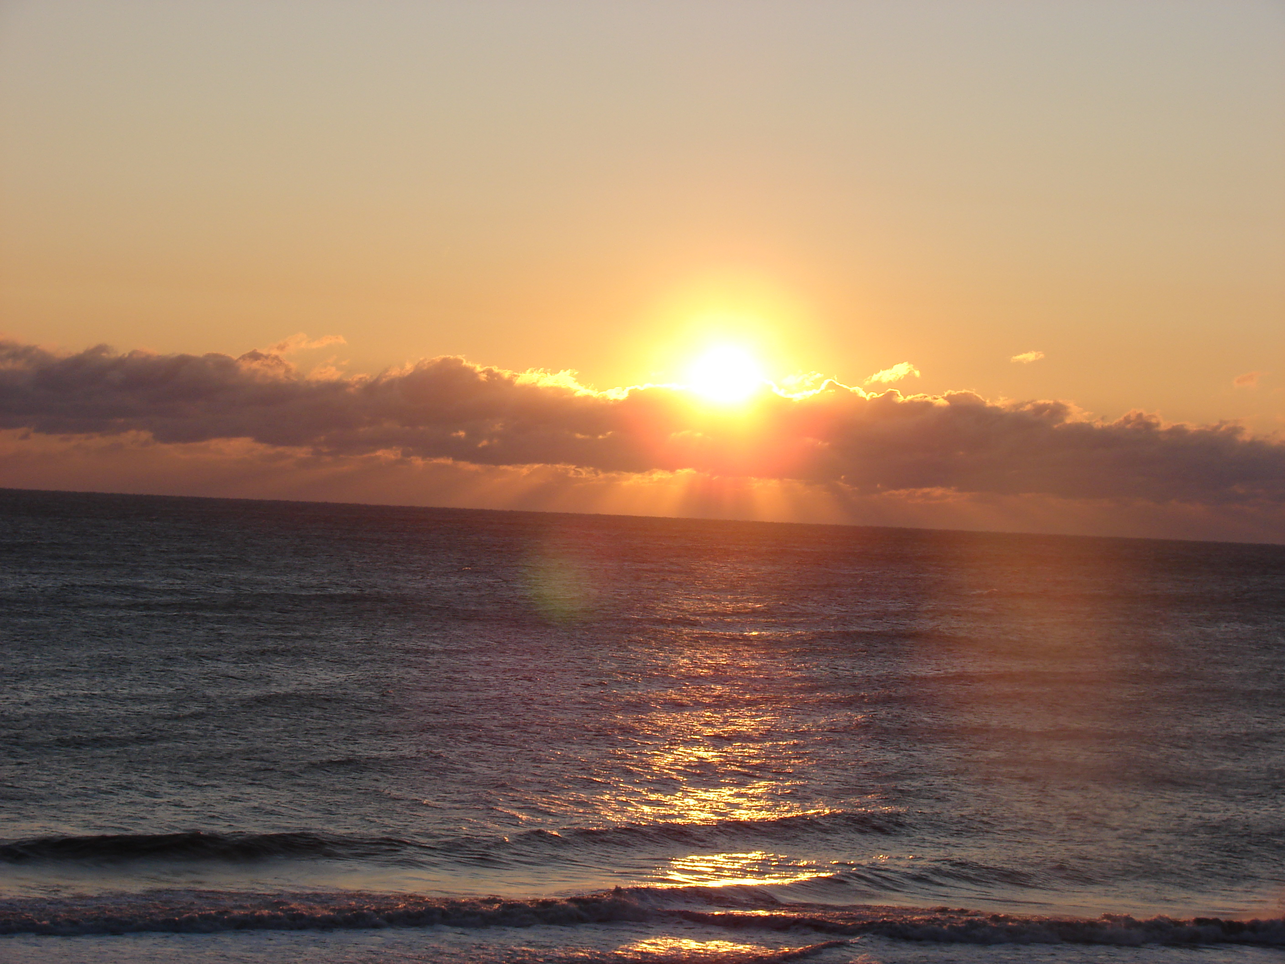  January 18-20  Retreat to the Beach and Renew  Our journey together will take place on the belly of Mama`Qocha (Sea Mother). She will assist us as we do our work. We will make it conscious through cleansing, the shamanic journey, movement, ceremony, and co-creating with Spirit.  We are situated with views of the Atlantic in comfortable accommodations. All meals will be healthy, wholesome and provided with infused love. This transformative weekend can be extended if you’d like to stay on longer to integrate your experiences, at no additional cost. In addition, all rooms, (double occupancy), healthy meals, materials and teachings are included in one price. (Single supplement rooms available for an additional cost). | Accommodations Double occupancy  ────  King Room with private Bathroom  $450pp  King Room with shared bathroom  $400pp  (add $200 single supplement)  Double Room with shared bathrooms $400pp  ────  Register now and save $50  Pamela Panneton  Sykesville, Md. 21784  410-978-2066  www.LandSpirits.com  pspanneton@gmail.com

