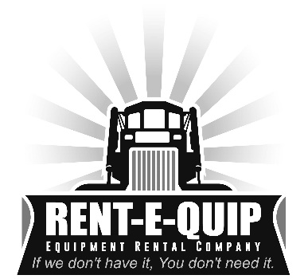

**Rent-E-Quip Delivery Rates**

5 miles or less $60 each way/$120 round

10 miles or less $90 each way/$180 round

15 miles or less $105 each way/$210 round

20 miles or less $120 each way/$240 round

25 miles or less $135 each way/$270 round

30 miles or less $150 each way/$300 round

35 miles or less $165 each way/$330 round

40 miles or less $180 each way/$360 round

45 miles or less $215 each way/$430 round

50 miles or less $235 each way/$470 round

55 miles or less $255 each way/$510 round

60 miles or less $280 each way/$560 round