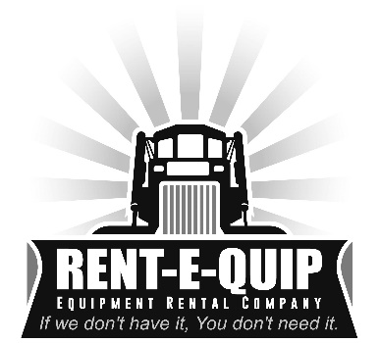

**Rent-E-Quip Delivery Rates**

5 miles or less $50 each way

10 miles or less $60 each way

15 miles or less $70 each way

20 miles or less $80 each way

25 miles or less $90 each way

30 miles or less $110 each way

35 miles or less $120 each way

40 miles or less $130 each way

45 miles or less $140 each way

50 miles or less $160 each way

55 miles or less $180 each way

60 miles or less $200 each way