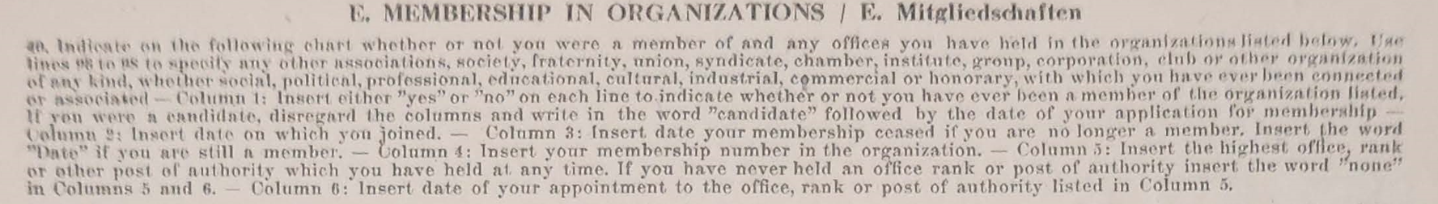

Reichsbesoldungsgesetz Gruppe

Inspektorengruppe

Belege nicht vorhanden.

Endgehalt 5400

**Reich salary law Group**

**Group of inspectors**

**Documents not available.**

**Final content 5400**

**Mitglied = member**

**Georg Waltenberger Fragebogen**

Born 10/2/1889 Ursberg (Schwaben) **57** years old

168 cm **5’6**  57kg **125 pounds**

**Gray** hair but **Bald**  **brown** eyes. Roman Catholic

He speaks English, French and Latin.

ORGANIZATIONS

NSDAP **National Socialist German Workers Party** 1933- end of war

NSFK **National Socialist Flyers Corps 1935 -end**

NSV **National Socialist People’s Welfare** 1935 to end

Reichsb. Deutschen Beamten **Imperial German Civil Servants**

NS Reichsbund deutscher Leibesbüngen **NS Physical association.** 1934 -end

Reichsluftschutzbund **Paramililtary air raid precautions** 1935-end

Reichskolonialbund **Group to reclaim colonies lost at treaty of Versailles.** 1935-end