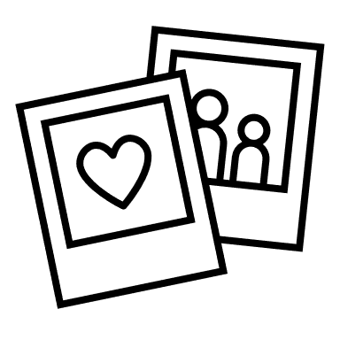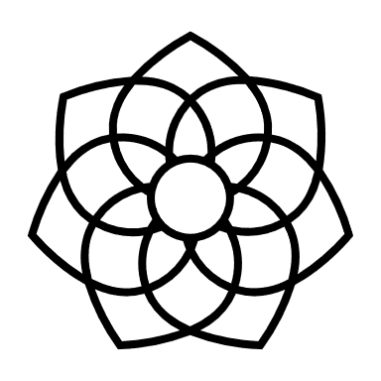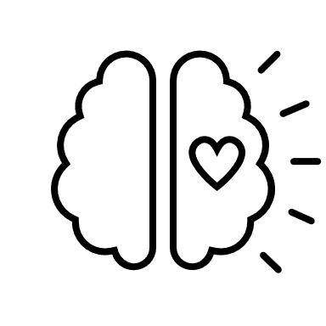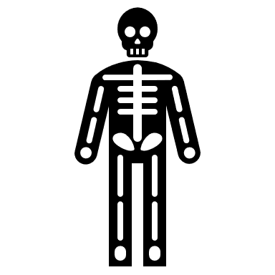

Aspirations

Relationships

Spirit

Body

Mind

My Self-care Plan:_______________