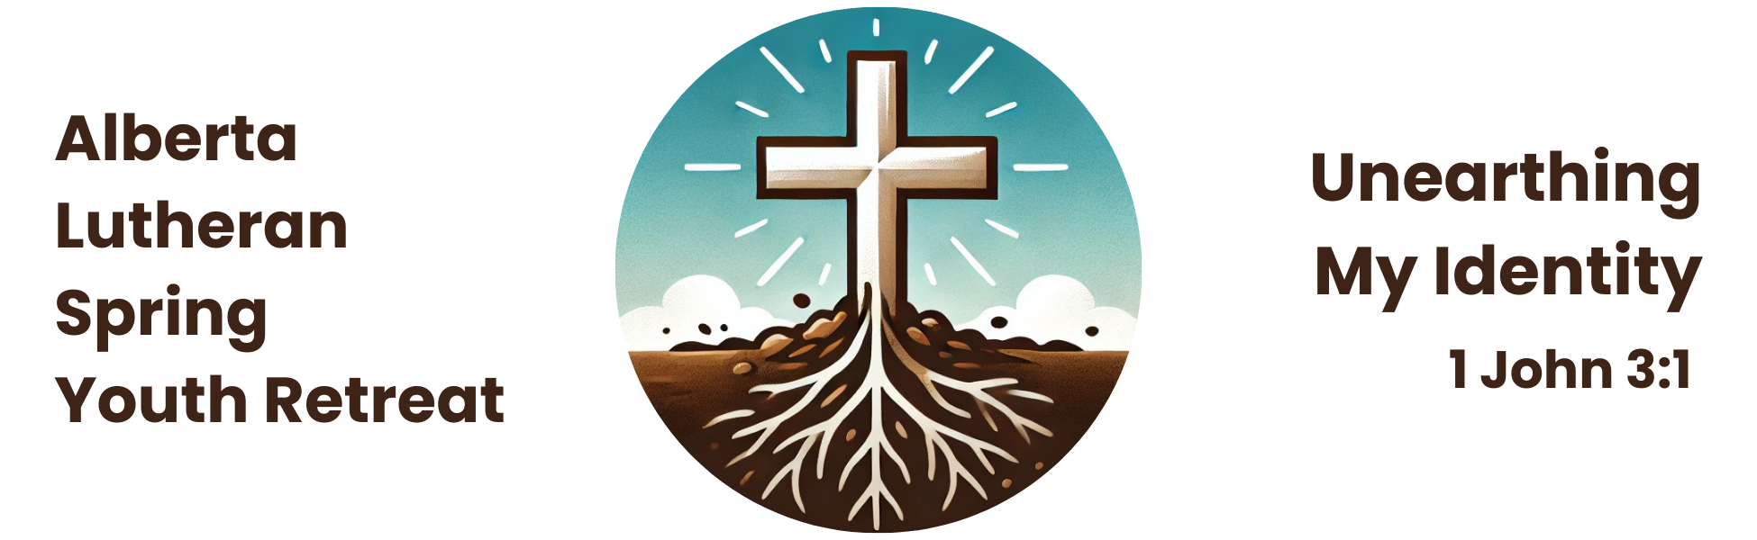

January 20, 2025

Dear Pastor, Deacon, and/or Youth Leader;

We are pleased to announce the

**Alberta Lutheran Spring Youth Retreat**

on the topic of Identity

Camp Bar-V-Nok

Pigeon Lake

May 2-4, 2025

You and your youth are invited!

Please see the enclosed FAQs and registration checklist for further information about the weekend, and visit the website ([www.lutheranyouthretreat.ca](http://www.lutheranyouthretreat.ca)) to download a registration package. The registration deadline is midnight on Friday, March 21, 2025.

We have received a generous grant from the West Region RMMC, and are able to offer a subsidized registration fee of $100.00 per person for the whole weekend.

Questions? Contact the Registrar, Deacon Miriam Winstanley ([miriam@foothillslutheran.com](mailto:miriam@foothillslutheran.com)).

We hope to see you and your youth in May!

In His Service,

The Retreat Planning Committee

*Grace Henderson, Elizabeth Schieman, Samantha Neeb, and Deacon Miriam Winstanley*

[www.lutheranyouthretreat.ca](http://www.lutheranyouthretreat.ca)