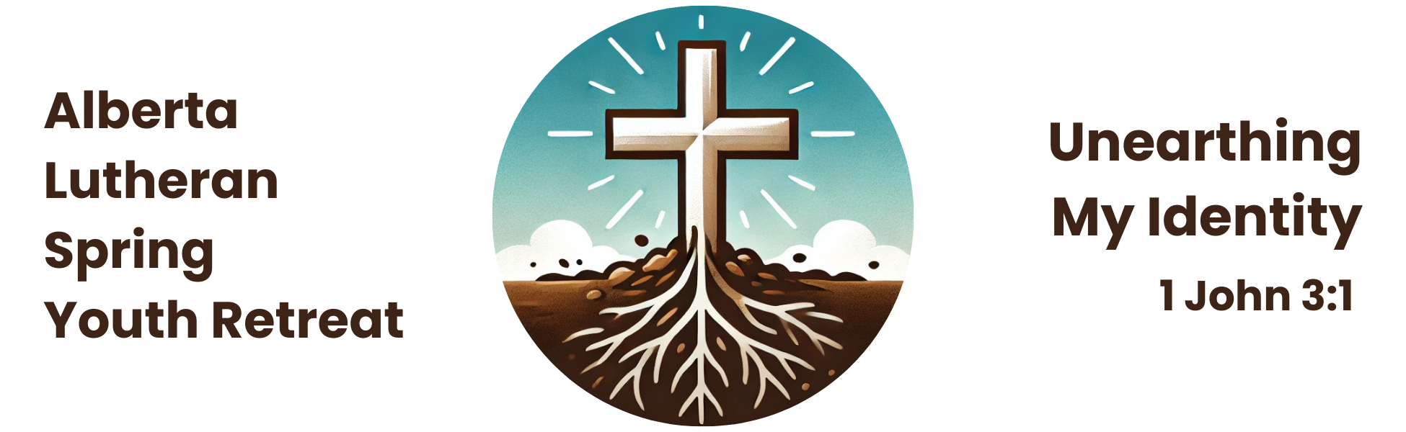

**Registration Checklist**

**1:** Choose one person to be the main point of contact between your group and the registrar. This person doesn’t need to be a leader attending the retreat, for example, a church office administrator would make a good point of contact.

**2:** Ensure the leader(s) who will be attending have a current police check (done within the last year), or have ordered one. In Calgary, they can take up to six weeks to arrive, so plan ahead!

**3:** Download the registration package from [www.lutheranyouthretreat.ca](http://www.lutheranyouthretreat.ca)

**4:** Distribute registration forms to youth, leaders, and iBods (adult volunteers).

**5:** Set an internal registration deadline – we suggest Sunday, March 16 – for your youth and volunteers to return their completed forms, police checks, and fees to you. Each leader also needs to sign a group registration form.

**6:** Fill out the online registration form for everyone in your group by midnight on Friday, March 21, 2025.

**7:** Get one cheque or make one e-transfer for the fees for your whole group. Cheques should be payable ‘King of Kings Lutheran Church’. E-transfers can be sent to [kklc.donations@gmail.com](mailto:kklc.donations@gmail.com), with your congregation's name and Youth Retreat in the details, and should be sent by May 2, 2025. The fees are $100 per youth, leader, and iBod.

**8:** Bring printed copies of all of the original forms, police checks, and, if paying by cheque, one cheque for the fees of your entire group, with you to the retreat. Bring confirmation of your e-transfer if using that method of payment.

**The paper registration package you prepare for the registrar must include:**

* An original registration form for each youth, signed by his or her parent or guardian.
* An original registration form for each leader, and iBod (adult volunteer).
* An original police check for each leader/iBod (adult volunteer).
* An original group registration form signed by each leader.
* One payment for the entire group.

**9:** Wait for the registrar to confirm receipt of your online registrations. You should receive a confirmation letter within a week of the registration deadline. If you do not, please follow up!

*Questions? Contact the Registrar, Deacon Miriam Winstanley (miriam@foothillslutheran.com), ASAP! Don’t wait till the last minute!*