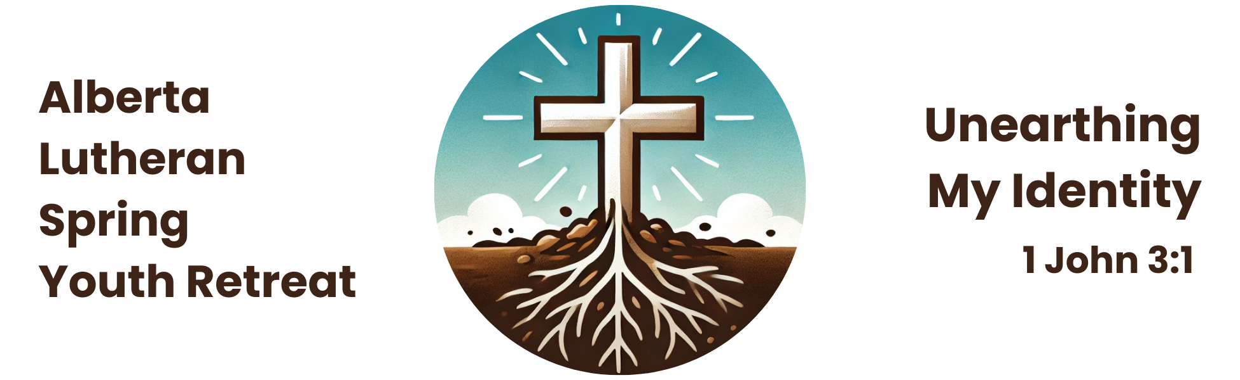

**7+1 Leader Responsibilities**

**Before the retreat:**

1. Pray for God’s blessing on the retreat and the preparations.
2. Encourage your congregation to support the youth and their friends.
3. Reach out to all youth of the congregation with info about the retreat and encourage them to invite friends.
4. Involve the youth in planning, registering, making travel arrangements, fundraising, etc.
5. Request a police check in adequate time for it to be received before the retreat (it may take up to 6 weeks).
6. Lead a pre-retreat information session reviewing the expectations of the youth in your group.
7. Discuss any youths’ medical concerns or allergies with the parents and be sure the information is recorded accurately on their registration forms.
8. Assist with roommate assignments if needed.

**During the retreat:**

1. Register your group upon arrival.
2. Attend the 7+1 leader orientation.
3. Be responsible for your 7+1 group at all times. Know their location and let them know where you are at all times. Make sure they are aware of the retreat rules and the self-discipline necessary in a large group. Monitor any health concerns.
4. Attend and participate in all events and encourage your group to participate.
5. Transport your youth to and from off-site venues, as needed.
6. Conduct late night checks and get up early.
7. Be prepared to correct and offer discipline (if needed). Also, be prepared to receive discipline from retreat leadership (if necessary).
8. Pray that, through the work of the Holy Spirit, all involved would be encouraged in the faith.

**\* The leader registration fee is $100.**

**7+1 Leader Registration Form**

Name: _____________________________________________________________________

Address: ___________________________________________________________________

City: ___________________________ Prov: ___ P.C. ________ Gender (M or F): ______

Phone: (____)___________________________________________________

Email: ______________________________________________________________________

Home Congregation: _________________________________________________________

Pastor: ____________________________________________________________________

How long have you been a member at your church/LCC? ____________________

□ I would like to lead a Bible study/discussion group (materials will be provided).

□ I have First Aid/CPR Certification

Emergency Contact Name: _____________________________________________________

Emergency Contact Number: ___________________________________________________

Allergies (indicate severity, e.g. nuts=anaphylactic shock/carries Epipen):

___________________________________________________________________________

___________________________________________________________________________

Special Needs (indicate medications or medical conditions):

___________________________________________________________________________

___________________________________________________________________________

**Youth Leader Agreement**

I have read the stated expectations for being a 7+1 leader (on page 1) and I agree to carry out the role to the best of my ability.

Signature: ____________________________________________ Date: _______________

**Authorization for Collection of Personal Information**

I, ______________________________, authorize the Alberta Lutheran Spring Youth Retreat Committee to collect personal information appropriate for my application to serve as a volunteer youth leader at the Spring Retreat. I understand that the information obtained will be confidential but may be shared with the Lutheran Church—Canada synodical office.

Signature: ____________________________________________ Date: _______________

# Photo/Video Release Form

*The Alberta Lutheran Spring Youth Retreat falls under the privacy policy of Lutheran Church–Canada* [*https://www.lutheranchurchcanada.ca/wp-content/uploads/sites/11/2021/05/PRIVACY-POLICY-for-LCC-1.pdf*](https://www.lutheranchurchcanada.ca/wp-content/uploads/sites/11/2021/05/PRIVACY-POLICY-for-LCC-1.pdf)*. Unless otherwise noted, registration implies that the Alberta Lutheran Spring Youth Retreat will use basic information provided by the registrant to communicate information about the retreat and publish photos and/or video taken at the retreat for publicity purposes.*

I hereby give permission for images of myself, captured during regular and special retreat activities through video, photo, and/or digital camera, to be used solely for the purposes of the retreat, and/or Lutheran Church-Canada promotional material and publications, and waive any rights of compensation or ownership thereto.

Signature: ____________________________________________ Date: _______________

*Questions? Contact the Registrar, Deacon Miriam Winstanley* ([miriam@foothillslutheran.com](mailto:miriam@foothillslutheran.com)).

**Permission to Serve as a 7+1 Leader**

I, the Pastor/Church Worker/Elder (please circle one) of _____________________ Church, give permission on behalf of our congregation to ___________________ to act as a Youth Leader at the Alberta Lutheran Spring Youth Retreat. He/She has read and understands the 7+1 requirements on page 1 above, and I believe he/she is fully equipped to take on this responsibility.

# Signature: ____________________________________________ Date: _______________