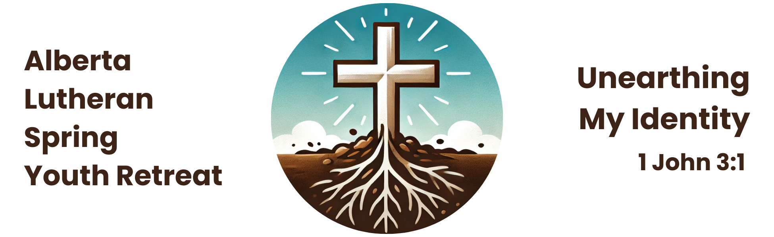

**Youth Registration Form**

Name: __________________________________________________________________________

Address: ________________________________________________________________________

City: _________________________________________ Prov: ______ P.C. __________________

Phone: (____)___________________________________________________

Email: ___________________________________________________________________________

Birth date (m/d/y): ______________________________________________

Age: ___________ Grade: __________ Gender: M or F *(circle one)*

Leader: _________________________________________________________________________

Home Congregation: _______________________________________________________________

Preferred Bible Study Buddy: ________________________________________________________

Preferred Roommate (same gender): __________________________________________________

Emergency Contact Name: __________________________________________________________

Emergency Contact Number: _________________________________________________________

Health Care #:__________________________________________________

Allergies (indicate severity, e.g. nuts=anaphylactic shock/carries Epipen):

___________________________________________________________________________

___________________________________________________________________________

Special Needs (indicate medications or medical conditions):

___________________________________________________________________________

___________________________________________________________________________

*The youth registration fee is $100.

**Photo/Video Release Form**

*The Alberta Lutheran Spring Youth Retreat retreat falls under the privacy policy of Lutheran Church–Canada* [*https://www.lutheranchurchcanada.ca/wp-content/uploads/sites/11/2021/05/PRIVACY-POLICY-for-LCC-1.pdf*](https://www.lutheranchurchcanada.ca/wp-content/uploads/sites/11/2021/05/PRIVACY-POLICY-for-LCC-1.pdf)*. Unless otherwise noted, registration implies that the Alberta Lutheran Spring Youth Retreat will use basic information provided by the registrant to communicate information about the retreat and publish photos and/or video taken at the retreat for publicity purposes.*

I hereby give permission to the Lutheran Church–Canada and Alberta Lutheran Spring Youth Retreat for images of my child, captured during retreat activities through video, photo, and/or digital camera, to be used solely for the purposes of Lutheran Church–Canada promotional material and publications, and waive any rights of compensation or ownership thereto.

**Name of Participant:** _________________________________________

**Name of Parent/Guardian:** _____________________________________

# Parent/Guardian Signature: ________________________________ Date: _______________

In addition, Lutheran Church–Canada is committed to safeguarding all information provided on the Alberta Lutheran Spring Youth Retreat registration forms. Your information will not be shared with any organization beyond Lutheran Church–Canada, its institutions, boards, and agencies.

**Permission Slip**

***(to be signed by parent/guardian if child is under 18)***

I thank God for the opportunity to send my son/daughter to the Alberta Lutheran Spring Youth Retreat. In order to clearly proclaim the Gospel of our Lord Jesus Christ, I realize that the Retreat Committee will do its best to make this an exciting, meaningful, and safe experience for my son/daughter. I give permission for my son/daughter to attend the retreat, and I release the committee from any liability.

# Parent/Guardian Signature: ________________________________ Date: _______________