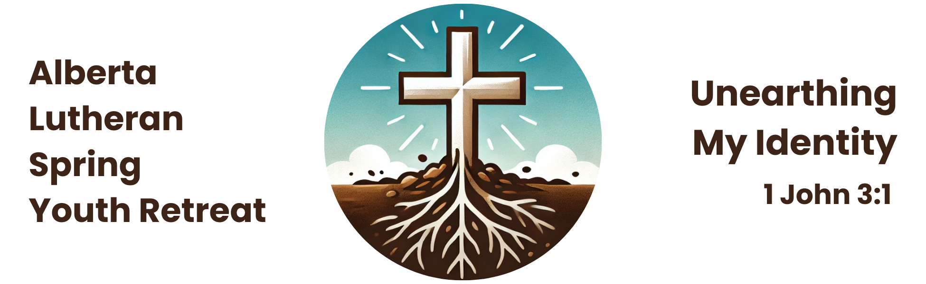

**iBod (Adult Volunteer) Registration Form**

***Being an iBod requires that you are willing to participate in all retreat events as required by the planners of the retreat. It also means that you will be willing to pitch in and help as needed. The position of iBod carries with it great responsibility, but also promises to be an opportunity for growth as a leader and as a Christian servant.***

**What is an iBod?**

iBods are adult volunteers who are eager to serve in a variety of ways at the retreat (i.e. security, welcoming, hosting, or being an athlete, comedian, organizer, Bible study leader, certified in CPR & First Aid, takin’-care-of details, etc.). The registration fee for iBods is $100.

**Who can be an iBod?**

iBods must be 19 years old or older at the time of the retreat, and must submit an iBod form, a recent police record check (within the past year) arranged by your local police department, and a church leader’s authorization to our registrar. Please beware that police checks can take up to six weeks to complete, and that adults may not attend without one. In some police districts, if you identify that you require a police check for a volunteer position, they may provide the record check free of charge. If there is a cost, it should be assumed by the iBod.

**Do I *have* to get a police check?**

Yes! All adults (people over the age of 18) attending the retreat in any capacity must provide a printed original police record with vulnerable sector check done within the year! The original document will be returned to you after the retreat, and we will keep a copy for our records.

**iBod Volunteer Registration Form**

Name: _____________________________________________________________________

Address: ___________________________________________________________________

City: __________________________ Prov: ___ P.C. ________ Gender (M or F): ______

Birth date (m/d/y): _________________ Age: ___________

Phone: (____)___________________________________________________

Email: ______________________________________________________________________

Home Congregation: _________________________________________________________

Pastor: ____________________________________________________________________

How long have you been a member at your church/LCC? ____________________

My particular skills/talents include *(leading small groups, cooking, drama, leading games, PowerPoint, etc)*: _____________________________________________________________

___________________________________________________________________________

□ I would like to lead a Bible study/discussion group (materials will be provided).

□ I have First Aid/CPR certification.

Allergies (indicate severity, e.g. nuts=anaphylactic shock/carries Epipen):

___________________________________________________________________________

___________________________________________________________________________

Special Needs (indicate medications or medical conditions):

___________________________________________________________________________

___________________________________________________________________________

Emergency Contact Name: _____________________________________________________

Emergency Contact Number: ___________________________________________________

**\* The iBod registration fee is $100.**

**iBod Volunteer Agreement**

I have read the stated expectations for being an iBod volunteer (on page 1 above) and I agree to complete assigned tasks to the best of my ability.

Signature: ____________________________________________ Date: _______________

**Authorization for Collection of Personal Information**

I, ______________________________, authorize the Alberta Lutheran Spring Youth Retreat to collect personal information appropriate for my application to serve as a iBod volunteer at the Alberta Lutheran Spring Youth Retreat. I understand that the information obtained will be confidential but may be shared with the Lutheran Church—Canada synodical office.

Signature: ____________________________________________ Date: _______________

# Photo/Video Release Form

*The Alberta Lutheran Spring Youth Retreat falls under the privacy policy of Lutheran Church–Canada* [*https://www.lutheranchurchcanada.ca/wp-content/uploads/sites/11/2021/05/PRIVACY-POLICY-for-LCC-1.pdf*](https://www.lutheranchurchcanada.ca/wp-content/uploads/sites/11/2021/05/PRIVACY-POLICY-for-LCC-1.pdf)*. Unless otherwise noted, registration implies that the Alberta Lutheran Spring Youth Retreat will use basic information provided by the registrant to communicate information about the retreat and publish photos and/or video taken at the retreat for publicity purposes.*

I hereby give permission for images of myself, captured during regular and special retreat activities through video, photo, and/or digital camera, to be used solely for the purposes of the retreat, and/or Lutheran Church-Canada promotional material and publications, and waive any rights of compensation or ownership thereto.

Signature: ____________________________________________ Date: _______________

*Questions? Contact the Registrar, Deacon Miriam Winstanley (*miriam@foothillslutheran.com)*.*

**Permission to Serve as an iBod**

I, the Pastor/Church Worker/Elder (please circle one) of _____________________ Church, give permission on behalf of our congregation to ___________________ to act as an iBod at the 2024 Alberta Lutheran Spring Youth Retreat. He/She has read and understands the iBod requirements on page 1 above, and I believe he/she is fully equipped to take on this responsibility.

Signature: ____________________________________________ Date: _______________