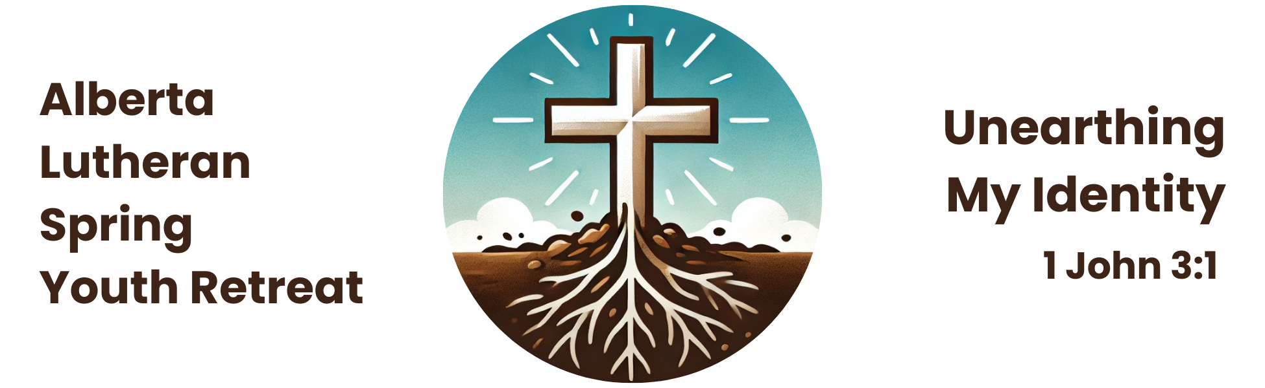

**Youth Retreat FAQs**

WHO: Youth in grades 7 to 12 (or ages 12 to 18), their leaders, and adult volunteers (iBods)

WHEN: 7:00 pm on Friday, May 2, to 1:00 pm on Sunday, May 4, 2025

WHERE: Camp Bar-V-Nok, Pigeon Lake (https://www.barvnok.com)

**How much will it cost?**

$100 per youth, leader, and iBod (Adult Volunteer), due to a generous subsidy from the LCC Mission and Ministry Council. This includes accommodations at the camp, programming, and five meals (breakfast, lunch, and dinner on Saturday, and breakfast and lunch on Sunday). Fees are not refundable – once you’ve registered online, we’re counting on your attendance and your registration fees. However, a registration transfer may be allowed at the Registrar’s discretion.

**How do I register?**

***See the enclosed ‘Registration Checklist’ for more information.*** A registration package is available for download from our website, and **the** **final registration deadline is midnight, Friday, March 21, 2025**. Once your youth and leaders have completed their forms and returned them to you, **register your group online at** [www.lutheranyouthretreat.ca](http://www.lutheranyouthretreat.ca) **no later than midnight on March 21.** You are required to bring with you to the retreat all original copies of the parental permission and waiver forms.

**What’s happening at the retreat?**

Eating, sleeping, worship, Bible studies, sessions with various leaders, outdoor activities, games, and a servant event! There will be a tentative retreat schedule posted on the website, to give you an idea of the weekend’s activities.

**What about accommodations?**

Participants will stay in dorms at Camp Bar-V-Nok. Each dorm has 10 rooms, and each room has four beds.

**Who’s the speaker?**

There will be study leaders from various walks of life in the Church who will lead us through four sessions on the topic of our identity as a child of God, and how that impacts our daily lives.

**What is a 7+1 Leader?**

Every group that attends must have at least one leader who is responsible for a maximum of 7 youth. This means if 7 or fewer youth attend, 1 leader must accompany them. If 8 attend, 2 leaders must accompany them, etc. 7+1 Leaders are responsible for the care and nurture of each youth in their group throughout the retreat. Leaders are expected to attend all retreat activities and participate fully with their group.

**Who can be a 7+1 Leader?**

A 7+1 leader must be a confirmed member of Lutheran Church—Canada, be at least 21 years old at the time of the retreat, be approved by their pastor/elder/church worker for their role as a Youth Leader, and submit an original police check that is not more than one year old. *(We strongly discourage congregations from sending leaders under 21. However, if another leader over 21 is attending and will co-lead, an exception may be made. Please contact the committee to discuss.)*

**Do I send a male *and* a female 7+1 leader if I have more than 7 youth?**

No! You are only required to send one leader for every seven youth. However, we recommend that you consider having a 7+1 leader of each gender.

**Can I come if I’m not a youth or a leader?**

There are opportunities for volunteers, ‘iBods’ (adult volunteers), to attend the retreat. These volunteers assist as needed with kitchen duties, leading games or Bible studies, and other jobs. iBods (adult volunteers) must be 19 years or older, and provide a police check, as well as a reference from a pastor, church worker, or church elder. Please see the iBod (Adult Volunteer) registration form for more information.

**What’s the deal with police checks?**

All adults (persons over the age of 18) attending the retreat must provide a police check to the planning committee. Confirm with the registrar that you have a recent police check (not more than one year old) in your possession. This is done out of a desire to protect our youth and see to their safety to the best of our ability. Check with your local police department – some of them will give you a discount on the fee if you provide a letter from your church.

**Do I *have* to get a police check?**

Yes! All adults (people over the age of 18) attending the retreat as leaders or iBods must provide an original police record with vulnerable sector screening done within the last year! The original document will be returned to you after the retreat, and we will keep a copy for our records.

**How do we pay our registration fees?**

We accept cheques or e-transfers. Cheques should be made payable to ‘King of Kings Lutheran Church’. E-transfers can be sent to [kklc.donations@gmail.com](mailto:kklc.donations@gmail.com), with your congregation's name and Youth Retreat in the details. Please make just one payment (cheque or e-transfer) for the whole group.

**Why do you want all of these original police checks and paper forms with signatures? Can’t we just go paperless?**

We need all the paper registration forms with original signatures on file for seven years, for legal reasons!

**What if I (or my youth) can’t attend the whole weekend?**

Contact the retreat committee to discuss the situation. However, if you register a youth who will not be present for the whole weekend, you must notify the registrar regarding when the youth will be absent. (We do not offer a discounted rate for only a portion of the weekend.)

*Leaders must be present for the whole weekend, and must supervise their youth at all times.* ‘Switching’ leaders in and out is not permitted without special permission from the committee for extraordinary circumstances.

**Other questions?** Contact the registrar, Deacon Miriam Winstanley ([miriam@foothillslutheran.com](mailto:miriam@foothillslutheran.com)), or the committee chair, Grace Henderson ([bitb@telus.net](mailto:bitb@telus.net)).