Ipswich Philatelic Society Coronavirus Lockdown Newsletter #1

As we are all currently ‘confined to barracks’ and therefore cut off from many of the links to our hobby, such as the society meetings, the excellent exchange packet and stamp fairs, I thought this might be an opportune moment for us all to stay in touch through a simple newsletter, nothing very fancy just the odd item or two of (possible) interest and any philatelic gossip or news of members etc.

I’ll start it off by saying I hope you are all finally getting up to date with those stamps you always meant to sort out and mount up but never got around to, re-organising that collection you first put together years ago in a long outgrown album or, when every outstanding task is done, reading up and researching a new country or theme for when all returns to normal.

I received an interesting item in the post a few days ago from a regular Delcampe contact of mine in Amsterdam or should I say the envelope which held the item, had been made interesting. The letter had for some reason, for it contained only a set of stamps in a small inner envelope and the seller’s business card, been selected for examination by the Home Office Border Force, (the failed modern day attempt to replace Her Majesty’s Customs and Excise)

Some of you may know I spent my whole career in that proud department (hence my biased comment above) and I was therefore well acquainted with colleagues work in parcel post depots throughout the UK, the best known one being at Mount Pleasant. Customs Officers selected suspect parcels for examination which then had to be opened by Post Office staff for Customs perusal.

As far as I was aware standard 6.5 x 4.5 inch envelopes with no thickness other than a business card offered no threat to either Customs duties or prohibitions. Things must have changed. My letter had been opened for examination for some inexplicable reason and had been resealed with a strip of bright purple ‘Home Office Border Force’ sticky tape (right across the stamps of course!) It made for an interesting item which I intend to send to my seller in Amsterdam for his amusement, or is he the one who is suspect I wonder?

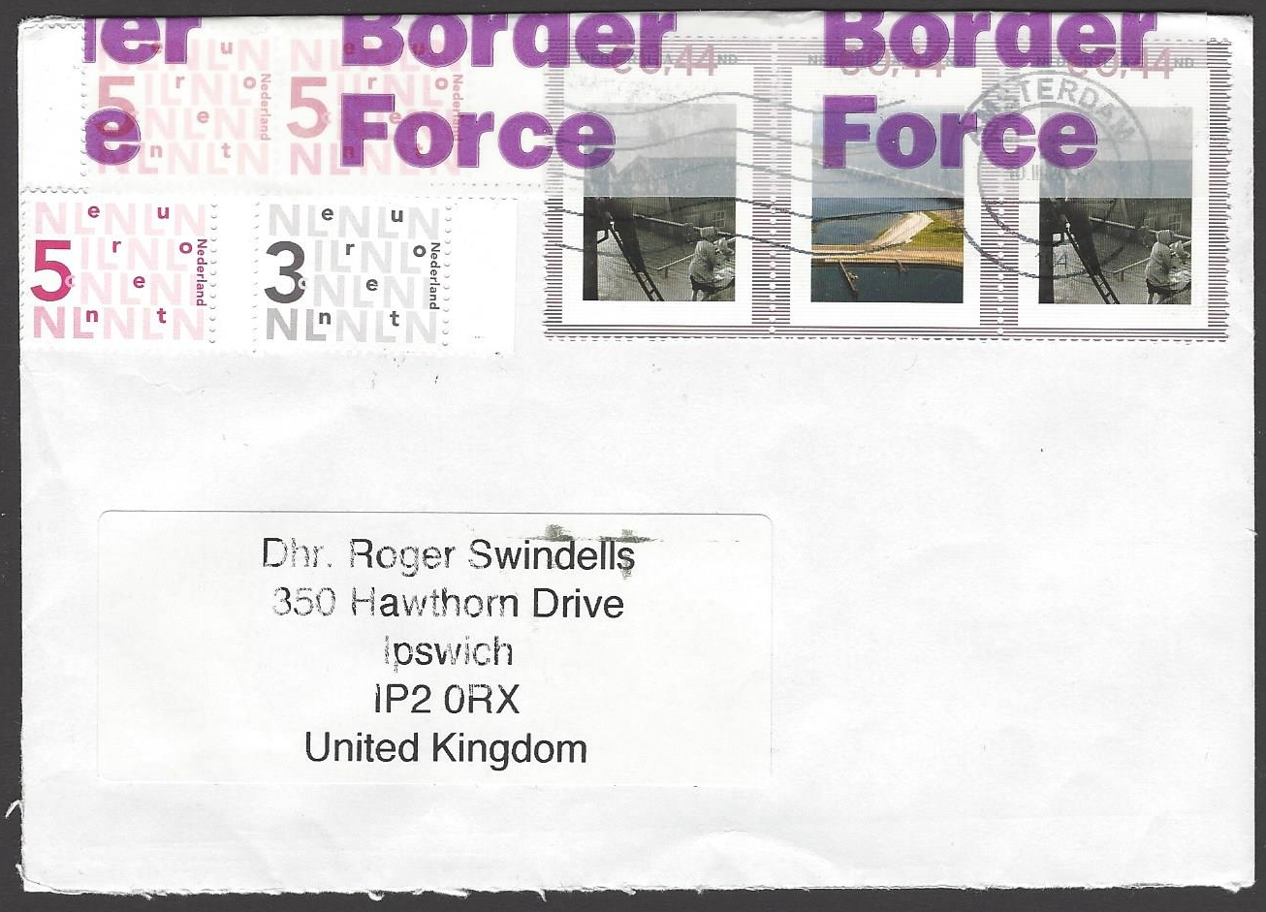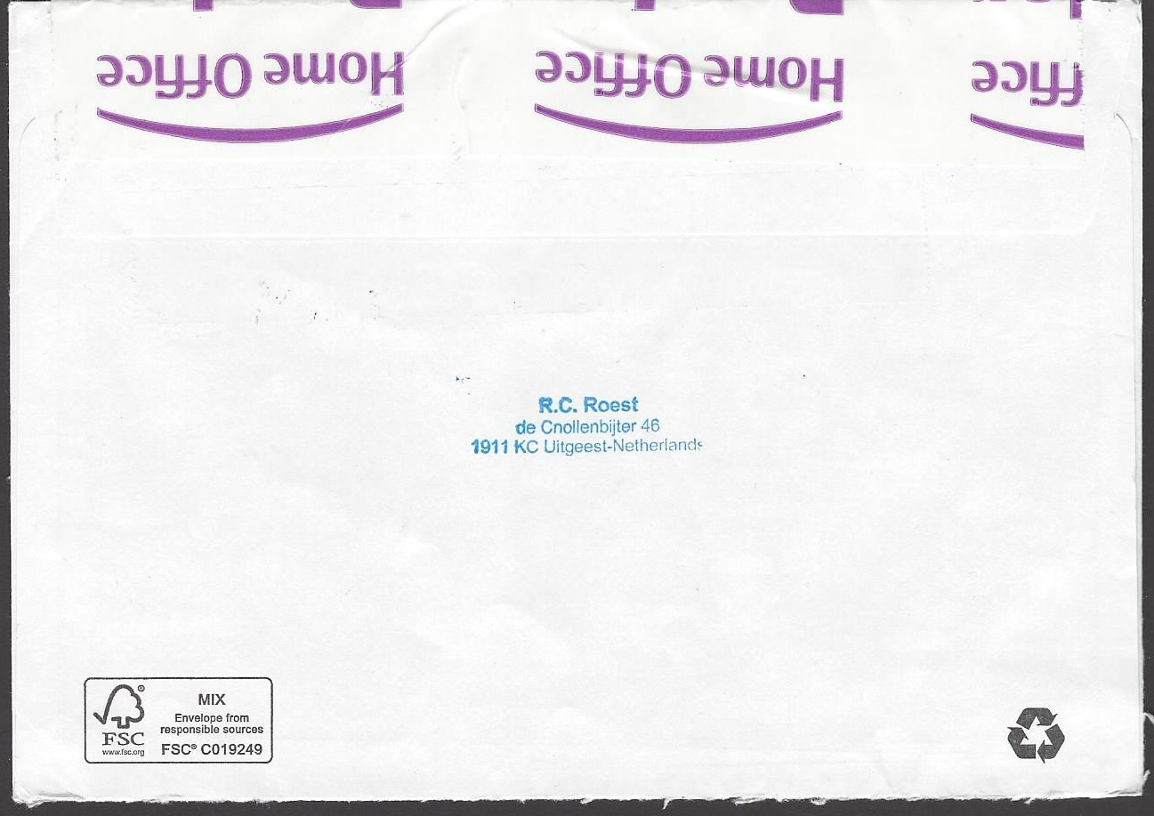

Comments on the newsletter idea and any contributions for future issues are welcome.
Keep well and safe everyone, philately needs you.

