Ipswich Philatelic Society Coronavirus Lockdown Newsletter # 10

I had thought about cheering things up a little by changing the title as lockdown has eased for many of us but, as we still can’t enjoy all our philatelic pursuits like fairs and of course society meetings, I’ll leave it as it is for now however I hope you are all still safe and well and able to enjoy some activities you have missed (like haircuts, shopping and a pint) perhaps I’ll change it next time.

I was amazed that the number of editions has already reached double figures and on a fortnightly issue basis, we’ve been going for about five months. I hope the newsletter is still proving interesting and fulfilling the original idea of keeping society members in touch with both the hobby and, more importantly, each other. To achieve the latter I need members to send in their news about how they are and what they have been doing apart from gardening, decorating and purchasing face masks that just don’t fit.

No news about the restarting of local fairs and like us Sudbury and District Philatelic Society do not envisage opening up again until next year at the earliest. Despite having a smaller membership than our society they consistently achieve better percentage attendances at meetings and hopefully they and similar societies can survive the lockdown. Also I note that CPA at Ely finally succumbed and used internet bidding through Easylive at their auction on 22nd August.

********
I have had no news at all from anyone or about anyone this week and sadly no philatelic contributions either, but the bar has been raised in the ‘what did I do during lockdown in place of stamps’ stakes. After giving birth to two previously unknown poets, Liz Elbourne and Ray Deeks, it appears we have a secret champion ‘whittler’ in our midst in the shape of Ivan Smith who has been busy creating an amazing series of ancient Egyptian figures. Just two of Ivan’s creations, an Egyptian woman grinding corn and an Egyptian god are shown below.
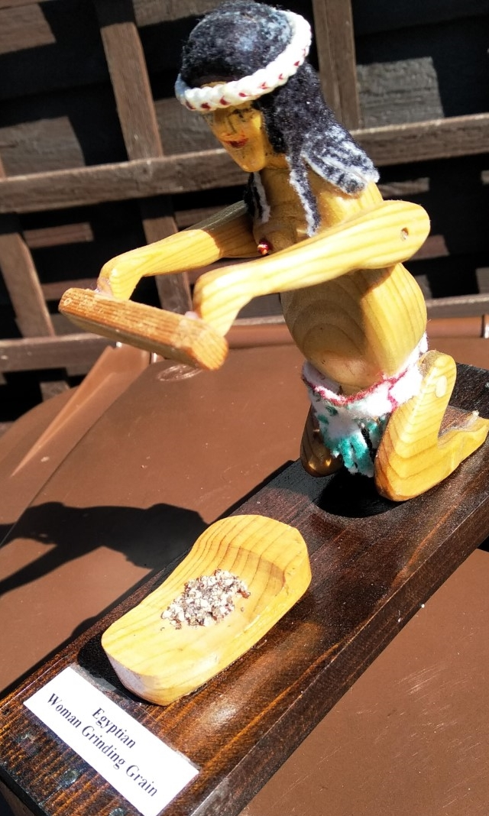
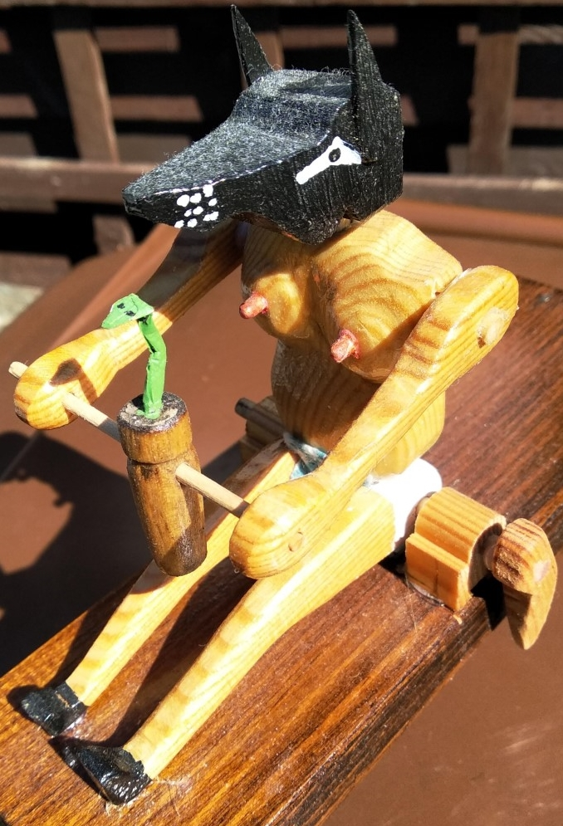

Many thanks for a very different contribution Ivan. (other models including Queen Boudicca are available on request)

********
In the absence of any contributions it has to be two of my items this week. First up the 1921 Netherlands Marine Insurance issue. A touch of absolute genius or a crazy idea?
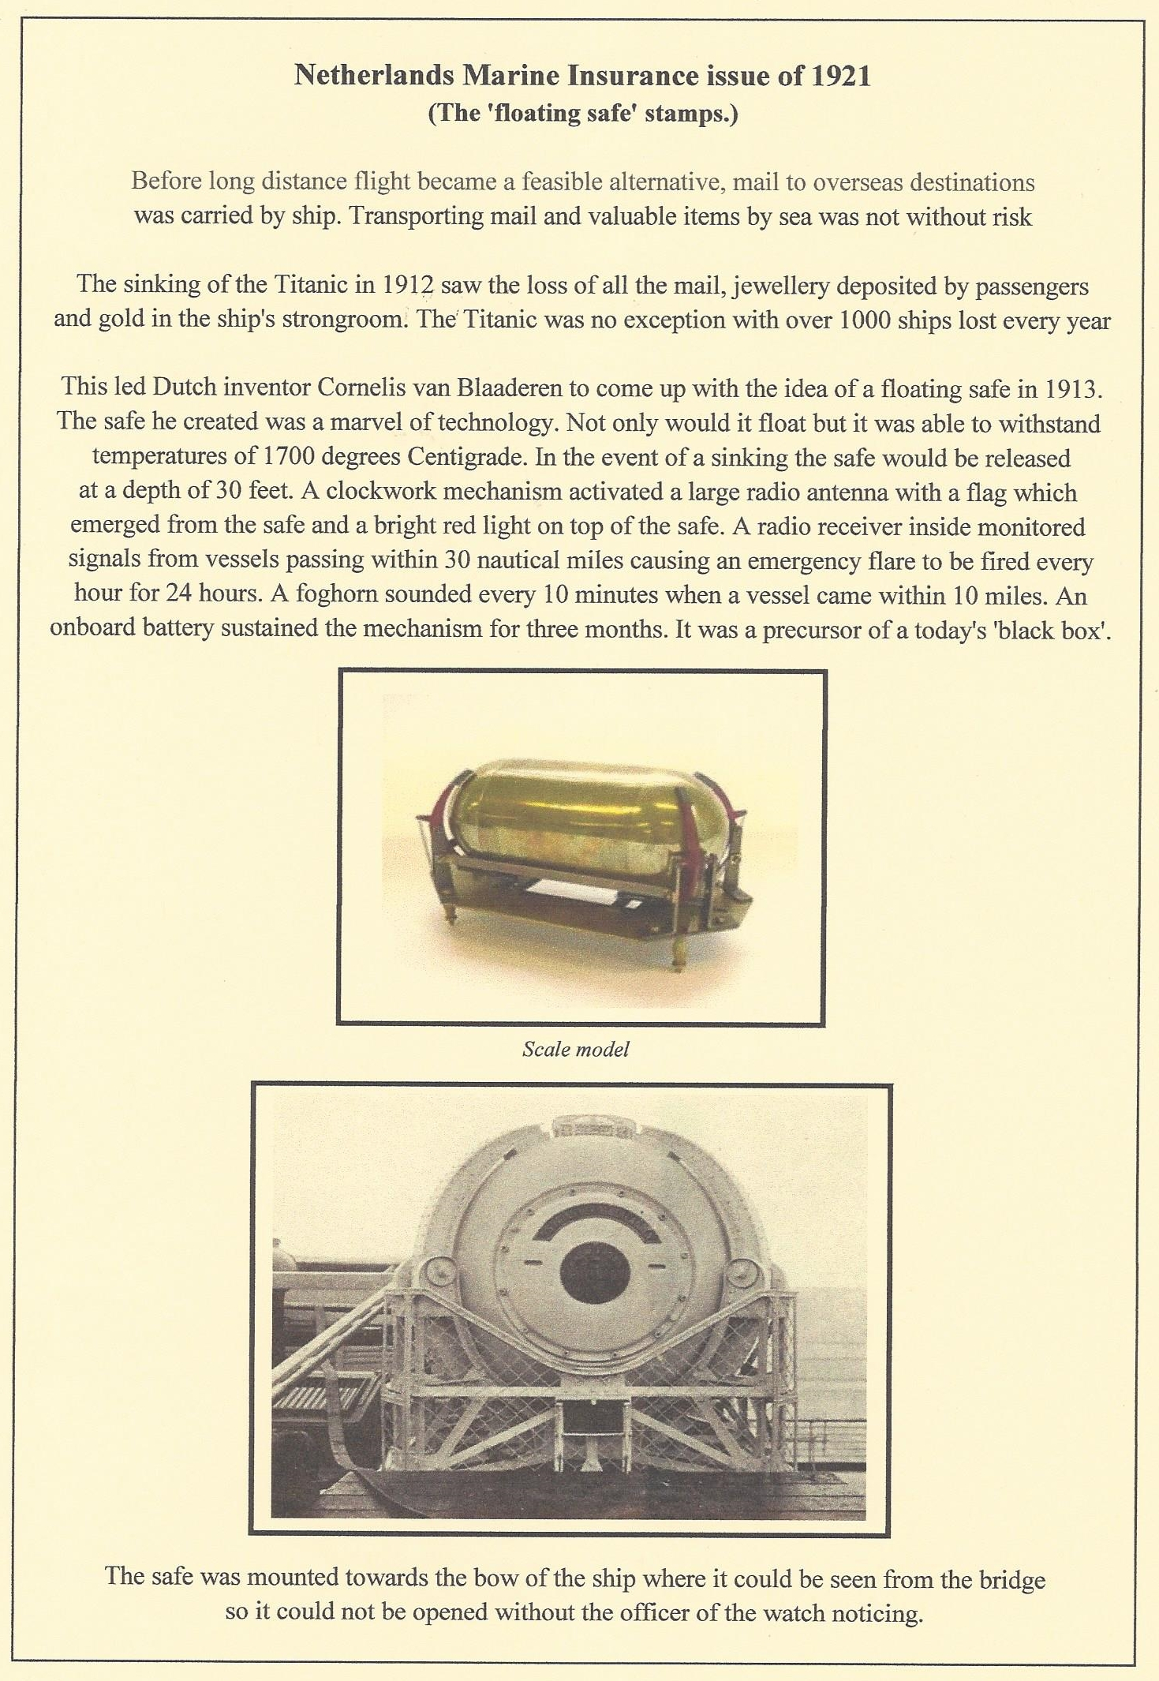

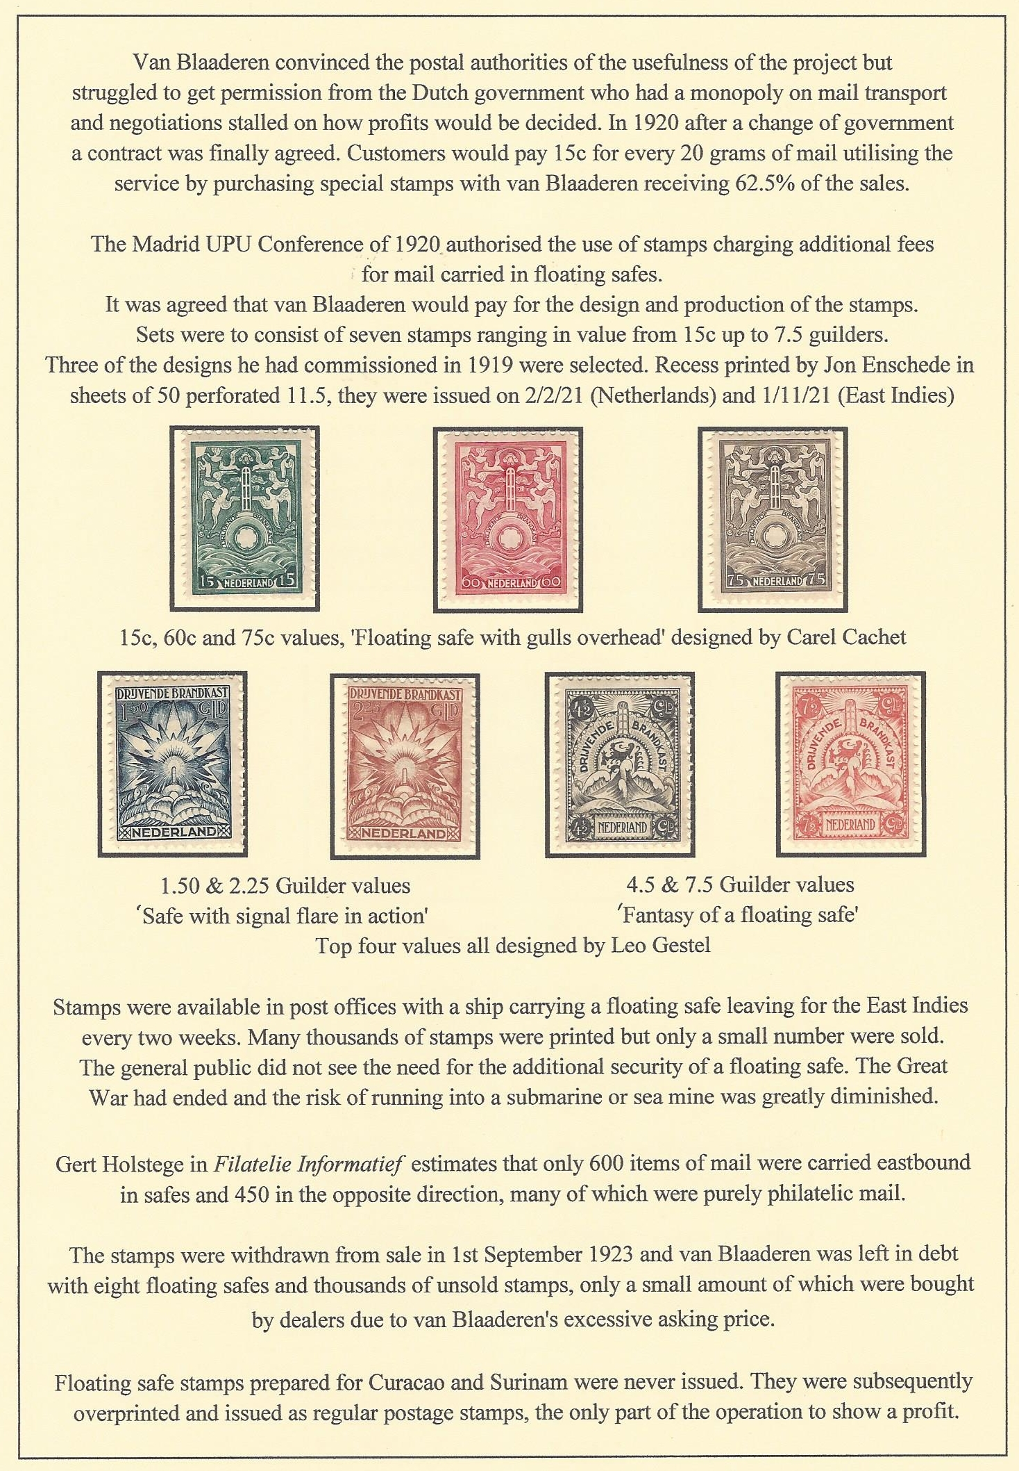

Staying with ships and the sea it’s time we had something of interest for members who are Cinderella collectors and what better than a rare label commemorating the sensational voyage of the infamous Grimsby trawler Girl Pat GY176, for over two months in 1936, the biggest worldwide shipping mystery since the Marie Celeste.
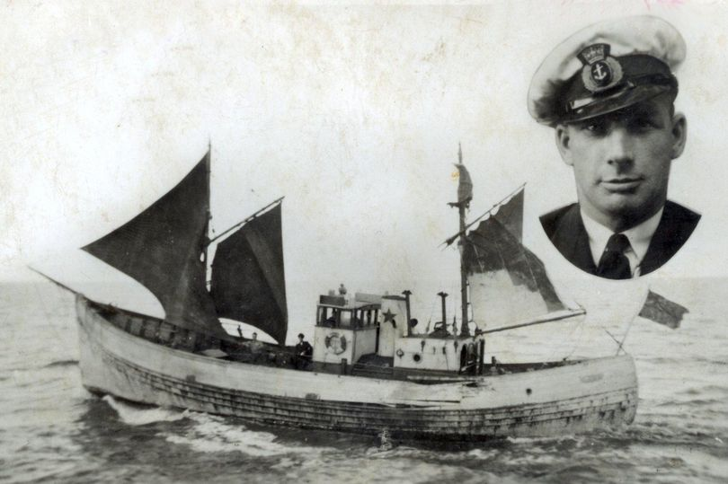
When the Grimsby trawler Girl Pat left her home port on
1st April 1936 an adventure began which, until mid-June,
gripped the imagination of the nation. Skippered by George
‘Dod’ Orsborne, the owners believed she was bound for the
North Sea fishing grounds. Orsborne however had other
plans and, using just a compass and a Woolworth’s school
atlas took his vessel and crew on a ten week voyage ending
6000 nautical miles away in Georgetown British Guiana.

Variously reported as lost with all hands then allegedly sighted in Jersey, Corcubion in Spain, the Savage Islands near Madeira and Dakar in Senegal before the Iles de Salut off British Guiana, the Girl Pat disguised as the ‘Kia-ora’ was eventually arrested after a chase by a police launch and towed into Georgetown.
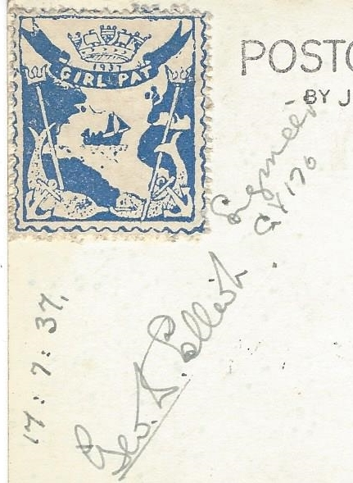
Orsborne and his brother, who was also on board were
arrested whilst the other two crew were released. Both
were returned to UK under the Fugitive Offenders Act
where they were charged with theft of the vessel. Both
went on trial at the Old Bailey. Plans for gun-running
and gold smuggling were inferred in addition to theft
allegations whilst Osborne alleged the owners wanted
him to dispose of the virtually new vessel as part of an
insurance fraud. ‘Dod’ Orsborne and his brother were
sentenced to 18 and 12 months respectively

Years later in his book, Orsborne claimed that he had
been employed on secret work by Naval Intelligence
in connection with the imminent Spanish Civil War.
The Girl Pat meanwhile was sold and between 1937
and the outbreak of WWII she was put on show as a
tourist attraction. Postcards with a label showing the
vessel in mid Atlantic were sold signed by members
of the crew who brought the ship back to the UK, not
sadly by any of those on board during her adventure.
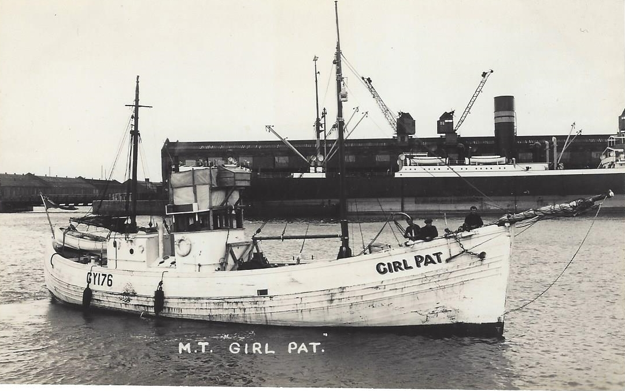
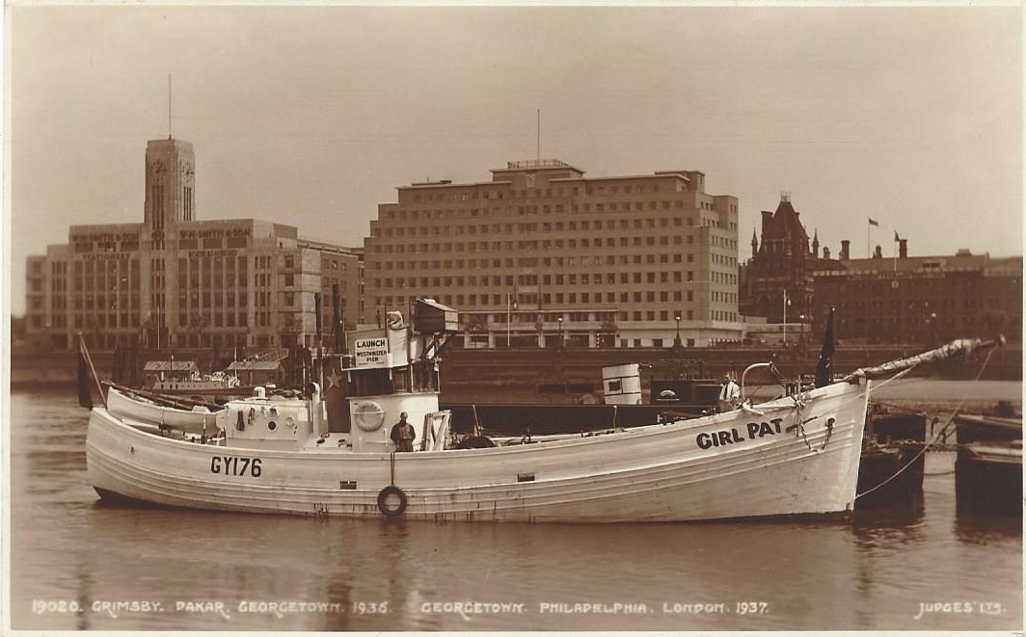

Girl Pat after wartime service in the Royal
Navy was finally sold to the P.L.A and
ended her life on the Thames as wreck-
marking vessel, a less than exciting end
to a great adventure remembered only
through an adhesive label.

That’s all for this edition. To keep things going please send in articles, contributions to ‘my favourite stamp’ or just a note of what you want to see in your newsletter.

