Ipswich Philatelic Society
Coronavirus Lockdown Newsletter #3

First of all many thanks for the feedback about the first two newsletters, it is much appreciated but more importantly, I am pleased it is keeping you all in touch, however remotely, with philately in general and the society in particular. I know I promised to keep it to two pages but I am delighted to say that contributions from members have started to come in so no apologies for the extra pages.

The lockdown, despite some easing and the plans for future relaxation will, I fear, continue to affect us in particular in all aspects of our hobby and we may be amongst the last to get ‘back to normal’. Fairs, auctions and even society meetings when it comes to viewing the displays (and drinking our tea and coffee) do not lend themselves to ‘social distancing’ and you may also, like me, be under lockdown until June 30th anyway. All the more reason then to keep in touch with what fellow society members are doing and what is still happening in the philatelic world.

The ABPS magazine is now only available electronically, with the publication of hard copies currently suspended. The summer edition is on-line now with a plea from the editor for articles for the autumn edition due to the disappearance of society reports.

Auction-wise CPA at Ely has postponed their prestige auction in May but have a postal sale closing at midnight on 31st May. The catalogue and bid forms are on line now at https://www.cpa-ely.co.uk/. Scans of lots are available by email at scans@cpa-ely.co.uk.

Nick Barber at Felixstowe has his next auction on 10th June but it will of course be an on line / postal sale only. The catalogue will be on line at the end of May.

Lockdales catalogue for 17th and 18th June is now on line and viewing is now possible but by appointment only. Interestingly I have just received the latest catalogue from Smits Philately who are offering viewing facilities at their shop in Nieuwegein with hand sanitiser and gloves provided (distancing in the Netherlands is only 1.5 metres).

Bob Harvey is currently checking his flies (don’t laugh, he’s a fisherman hoping to get back to the river bank soon) and he has prepared a number of boxes ready for the exchange packet to start up again when the lockdown rules permit and members feel able and confident to receive and pass the packet once more.

********************

Have you all got your Coronavirus philatelic souvenir yet? No doubt Royal Mail will eventually issue an expensive commemorative set, (never to be seen used on anything other than the FDC) a miniature sheet, prestige booklet and maxi card but, until then, this special cancellation celebrating the 100th birthday of the NHS fundraising hero Captain Thomas Moore is so far the only item out there and I’m not sure if it was in use locally. A much deserved tribute and a wonderful philatelic memory to come out of this difficult time, if you actually want to remember it that is!

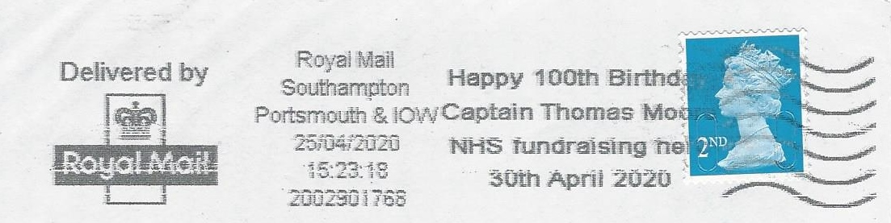

Mark Lendon reports that, having finished all those outdoor jobs, he has finally got around to the ‘sort sometime’ boxes and has turned up a fascinating item relating to Rumanian inflation which is copied with his explanation below. Thank you for your contribution and feedback Mark.

At first glance an ordinary envelope bearing the 8 Lei rate for a registered letter but a little investigation by Mark, copied below, made it far more interesting.

In the late 1990s Romania suffered several rounds of inflation reaching 256% in 1993 and 154% in 1997, before gradually falling to 9% in 2005. On 1st July 2005 the currency was re-valued to be 1/10000 of the previous rate (10000 old lei = 1 new lei)

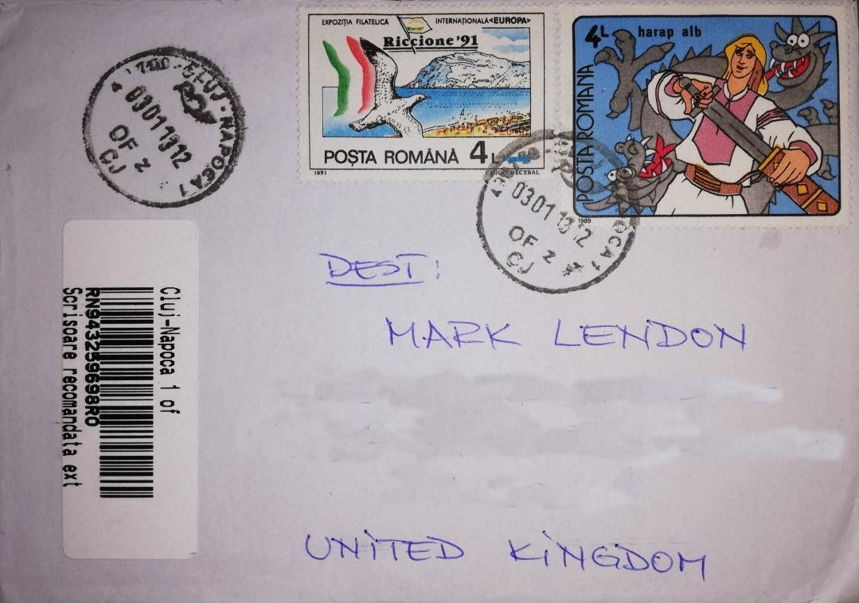

The stamps on this cover are the 4 Lei of 1981 Riccione issue and the 4 Lei of the 1969 Fairy Tales Issue. Both of these stamps are old Lei and so they are in fact worth only 0.0008 Lei, an underpayment of 7.9992 Lei or 99.99% of the postal rate.

As Mark observes, it’s always worth checking even the most innocent looking covers.
(The use of older stamp issues on current mail is interesting. Belgium has still not demonetised the old Belgian franc issues and I received a letter from a Delcampe seller a few months ago bearing, together with modern Euro issues, some 1944 ‘V’ (for Victory) overprints on the definitives re-issued to mark Liberation in 1944!)

*******************

Our President Ken Burr has, as usual, been very busy philatelically as detailed in his excellent contribution which is reproduced below. It includes an item very relevant to today’s infection problems (if only Coronavirus could be so easily disinfected!)

Ken writes: I thought I would begin this article with an example of a disinfected envelope! Items sent by post were frequently subject to disinfection to stop the spread of diseases known to be prevalent in their countries of origin.

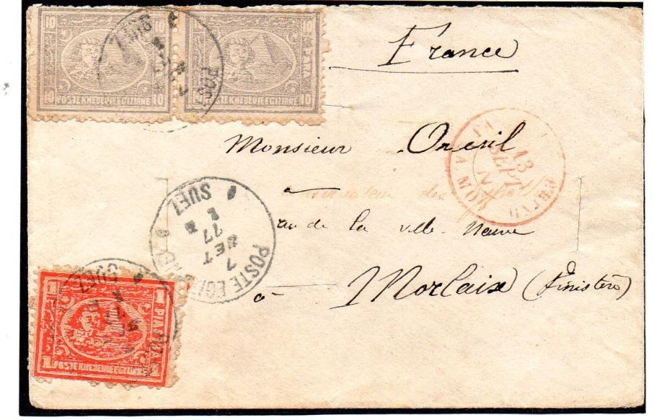

This example was probably brought into Egypt by messenger from a suspect area, possibly Arabia, now Saudi Arabia. It was disinfected at Suez; four slits were made in the envelope in order to ensure the contents were also disinfected. Then the Egyptian stamps were applied; the inner 10 mil stamp partly covers one of the horizontal slits. The letter, addressed to Morlaix France, is a reminder of how society in the past sought to limit the spread of infection.
Just before things shut down for Covid-19 I was working on my entry for a display at the Royal Philatelic Society by members from the east of England. This was to be two frames, 32 sheets, on the port of Valparaiso Chile and its local and international mail. My chosen period included the War of the Pacific between Chile and Peru and Bolivia, when Chile enlarged its territory to the north at the expense of Bolivia. There was also a Royal Navy presence off the coast with official port mail addressed to ships of the Pacific Squadron. Sadly the display was cancelled but we hope it will take place in September when hopefully the Royal will re-open.
The last stamp fair I attended before the lock down was the Bury St Edmunds event at Morton Hall. I always look forward to these fairs and sitting and working through dealers’ stocks. I was on the lookout for Penny Reds printed from Penny Black plates, usually difficult and good French covers from the 1920s to the 1940s. In my experience fair dealers often have the latter items. On this occasion the first GB dealer I asked produced six pretty good Reds printed from Black plates and very fairly priced. These printings are interesting because they sometimes incorporate later repairs and re-entries to the plates. I hope to display some of these items next season when the club has a Penny Black evening which we had to cancel this year. I collect the French covers to illustrate usage of the stamps and I particularly like mixed frankings illustrating the makeup of the relevant postage rate.
My most recent buys were two entires from the 4d Uniform Rate period which ran from 5th December 1839 to 9th January 1840 in Great Britain and Ireland when the 1d Uniform Rate was introduced on January 10th. One was a last day item clearly dated on the 9th January at the double (1 oz) rate of 8d, although the sender has noted ‘under an ounce’ on the face. The second item was mailed before the 5th December but was readdressed and resent on 10th December. I am in the process of sorting out the 2 rates marked on the face to see if they make sense as neither is a 4d Uniform rate. I will be adding both to the Postal Reform section of my GB collection.
Ken closes with the message: ‘Best wishes to everyone during lockdown and use some of that time to work on those stamps you always meant to sort out!’
********************

Another item, hopefully of interest, from my collection. This time it’s a 1935 KLM crash cover. PH-AKM ‘Maraboe’ (Stork), a new DC2 operated by KLM on the East Indies route left Soerabaja on 13th July bound for Schiphol carrying 116 kilos of mail.
The aircraft crashed whilst aborting a takeoff following a refuelling stop in Bushire on 17th July it was totally destroyed by fire and just 25 kilos of mail were recovered. The crew, Messrs Hondong, van Keffikon, Veenendaal and van der Smagt all survived

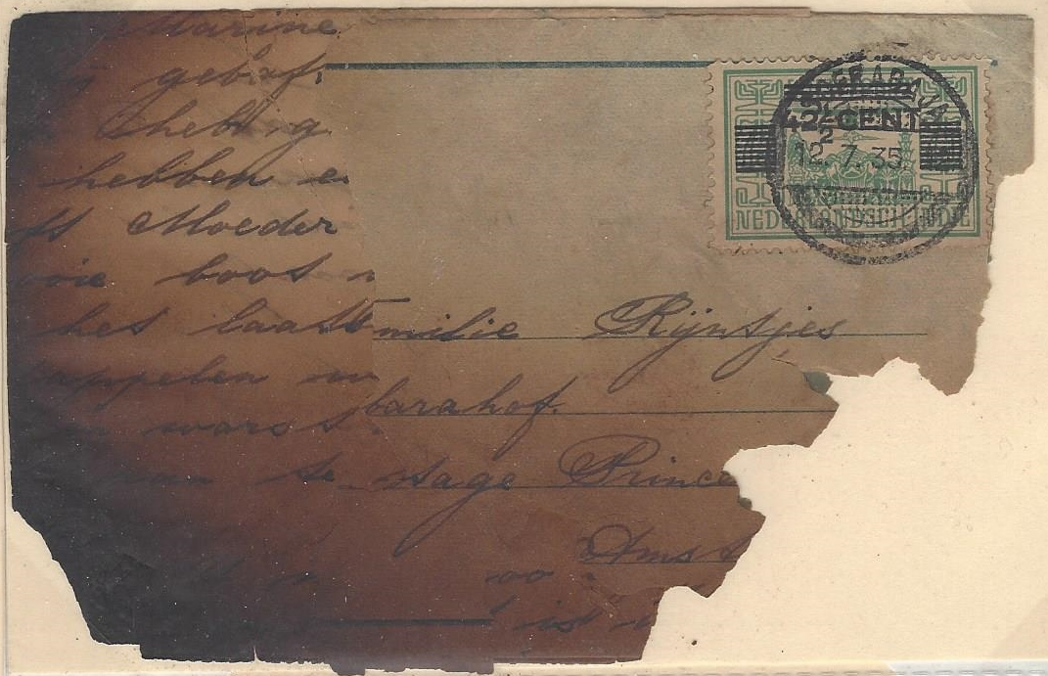
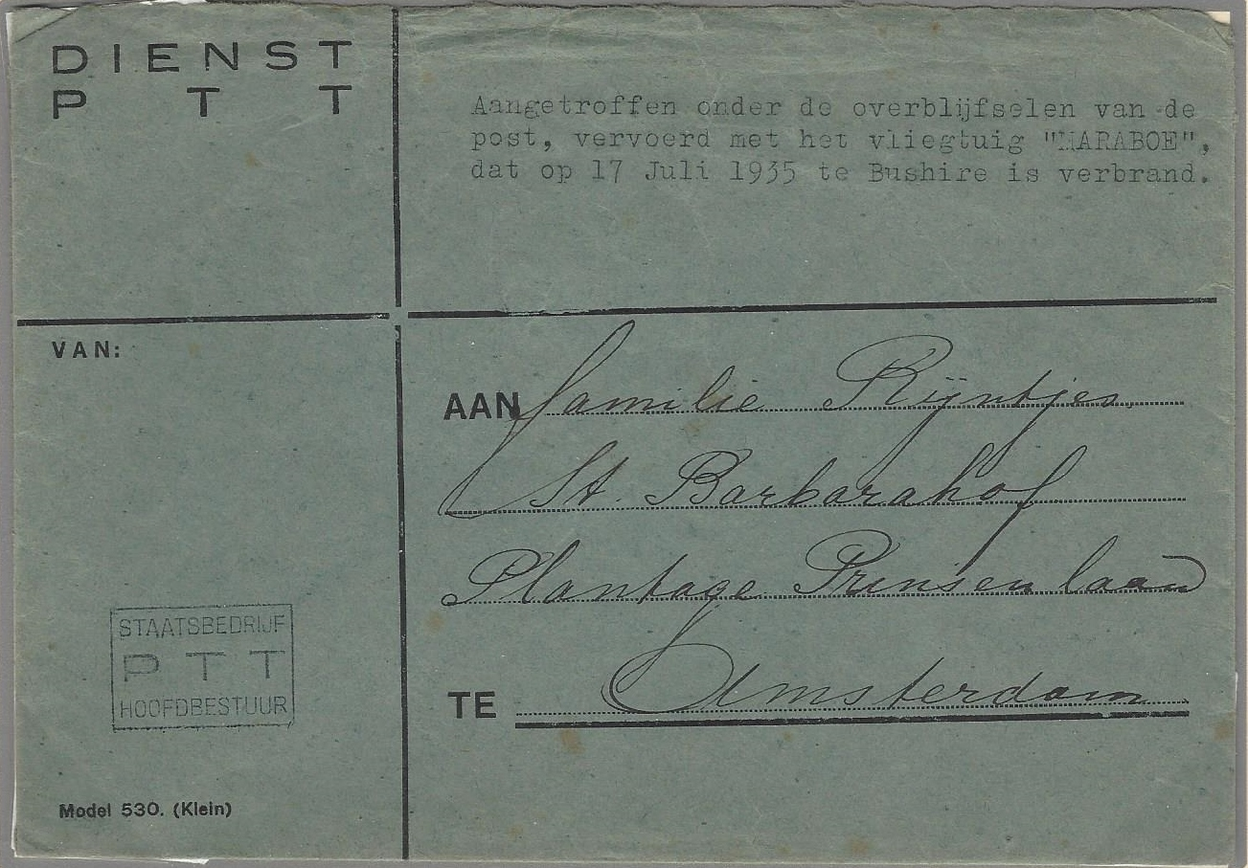

Fire damaged cover and contents recovered from Maraboe crash (L) and Dutch Post Office (PTT) ‘hospital’ envelope (R) used for delivery of the item to the Amsterdam addressee bearing details of its recovery from the crashed aircraft (pictured below).
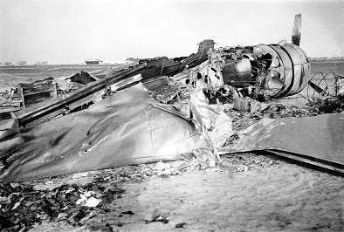

That’s it for newsletter #3. Please keep the feedback, news of what you are up to and suggestions for future issues coming plus details of any items of interest or articles for inclusion in future editions.

With that in mind how about a section simply entitled ‘my favourite stamp’? Just send me an email (rogerswindells@gmail.com) naming your favourite stamp and why. Don’t worry if you can’t scan it or attach a copy of it to your email, I’ll find one (unless of course it’s your favourite because there are only three copies known!)

We are in for a treat next time with a poem from a member written with both philately and forces service in mind. Keep safe everyone, don’t forget philately needs you!

