Ipswich Philatelic Society Coronavirus Lockdown Newsletter #5

Despite the easing of lockdown most of us are still in a philatelically-free, if still not actually stamp-free, zone. No news on societies being able to hold meetings or dealers arranging fairs yet but as Bob Harvey told us last time hopefully the exchange packet is not far from resumption. If you haven’t already done so can you all please let Bob know your thoughts on receiving and delivering boxes again.
********
More nice feedback has been received about the newsletter, for which much thanks together with an interesting contribution from Liz Elbourne. Liz and Ron are safe and well in their village community gardening (aren’t we all) and sorting stamps, Ron is tangling with stuff he didn’t even know he had and Liz is rearranging her extensive food and drink thematic collection into countries.

The lack of news and advertisers has seen the Ipswich Star publishing more and more items under the title ‘Days Gone By’ with many photographs credited to ex-Star photographer and society member Ivan Smith. Nice to see your handiwork Ivan and I hope you get paid royalties!
********
Some more Society news as our programme secretary Andy Soutar reports as follows:

‘Hello fellow Ipswich PS members. By now our philatelic season should have ended and I would have mostly completed the programme for next season 2020-21.
Sadly the Coronavirus and subsequent lockdown prematurely shortened our 2019-20 season in March, in all we lost five meetings, and at this time we are not sure when the society will be able to have any sort of meetings again. Cedarwood School might have reopened but they possibly would not be keen for people to be using the school in the evenings.

Because of this I have not continued to make plans for next seasons meetings, but I had already booked three speakers to visit and give displays (which may or may not happen.) One of these was Terry Harrison who was to have visited on the first evening we lost. Hopefully a new date of May 2021 could be safe for him to display St. Vincent for us and the four other ‘lost’ evenings can be moved into the new season at short notice. The other two meetings, Hungarian inflation and the Penny Black evening can easily be fitted in again as these were both 'in house' events.

When the virus is under control and/or there is a vaccine and the government give the go ahead for meetings like ours to take place again I will produce a new programme, hopefully for a full season, or whatever the regulations and the school allow.
Stephen Teuma had the annual auction list all ready to go when our season ended prematurely so holding that is a priority. We also lost the AGM and as I’m sure the society rules don’t have this eventuality covered, sorting it will lead to some head scratching no doubt. Keep well and stay safe.’

********
Excellent news just in about the Association of Essex Philatelic Societies Spring Rally competition. Although the entries could not be displayed due to the enforced cancellation of the Rayleigh Fair, they were still judged with outstanding results with
Ipswich PS virtually sweeping the board with six trophies as follows:-
Ipswich Philatelic Society retained the Stokes Cup and we are just one good result in the autumn away from the overall Presidents Trophy.

Steve Teuma won the Traditional (Stamps and Postal Stationery) Trophy for his entry ‘George V penny reds and first commemoratives’.

Andy Soutar won the Postal History Trophy, the George Pearson Award (‘best all foreign material entry’) and the Classic Trophy (entries consisting of all pre-1901 material) for his entry ‘French Postal History to 1900’.

Andy’s trophies (if he ever actually receives them due to the lockdown) are being delivered by HGV!

Finally I was judged the winner of the Aerophilatelic Trophy for ‘The KLM 1928 Experimental Mail Flights’
********
On now to this week’s first contribution and my thanks to life member Liz Elbourne. It’s been submitted by Liz under the ‘my favourite’ idea but it’s an interesting military and thematic postal history card, rather than a stamp, with a later story attached.

In 2014 Liz bought a postcard from the British Postmark Society. It caught her attention as it is about a food product, (her thematic topic) has postal history interest and tapped into the national mood of remembering the start of the Great War.

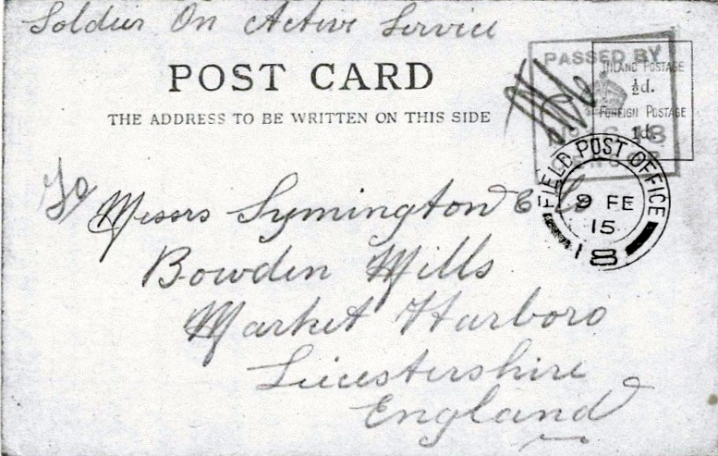

Written in pencil and addressed to Messrs Symington & Co, Bowden Mills, Market Harboro, Leicestershire, the card which is postmarked ‘Field Post Office 18’ is dated ‘9 Fe 15’. Bearing a red censor mark, the sender has written ‘Soldier on active service at the top of the address side of the card.

The message is a request to Symingtons for samples of their soup powders which the writer(s) had enjoyed in the trenches, courtesy of a fellow soldier’s generosity, finding the product ‘appetising and of delicious flavours’ and highly recommending it.

The senders identify themselves as 8690 Pte H Thundercliffe and 3145 Pte G West both of ‘A Company, 2nd Sherwood Foresters, 14th Infantry Brigade, 6th Division British Ex(peditionary) Forces’.
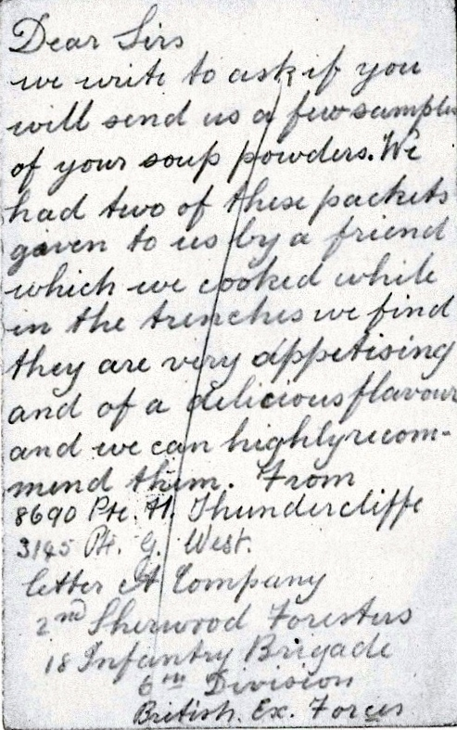

Liz’s homework established Symingtons are still in existence, now outside Leeds, and she sent them a copy of the card. The CEO expressed interest and said the copy would be displayed in Head Office Reception. He also asked Liz for first refusal should she ever sell the item. Generously Liz donated the card and received an invitation to visit the company together with a ‘goody box’ containing a wide range of their products.

Liz and Ron later took up the invitation and they enjoyed VIP treatment, hospitality and a grand tour of the company’s factories around Leeds. The original card was seen framed and hanging in pride of place in the Head Office foyer.

Sadly Private George West was killed on 4th October 1917 aged 26 whilst his pal Pte. Thundercliffe appears to have survived the war.

Liz closes, ‘This postcard, purchased to pursue a philatelic interest in the theme of food and also in postal history, has given me a lot of pleasure and plenty to think about. That is why it is my favourite.’

********
Liz’s military card leads me neatly on to a notification from Steve Teuma that the British Forces Postal History Society has anticipated the importance of keeping all philatelists involved in the hobby during lockdown. To that end are making their summer journal available free of charge at http://www.forcespostalhistorysociety.org.uk.
Even if you’re not into military postal history it’s a great read packed with diverse and absolutely fascinating material.
********
Next we have an article contributed by multi-trophy winner Andy Soutar looking at the inception, development and use of postage dues with particular reference to their use in Grenada, one of Andy’s collecting areas. Many thanks Andy.

Postage due – and a question
Ever since the introduction of the pre-payment of postage there has been a need to identify items which have been underpaid. This mail could be returned to the sender or the missing postage could be collected from the addressee.

Later the amount due was written on the item of mail along with a ‘T’ indicating tax. France was the first to issue special ‘postage due’ imperforate stamps in 1859. Not all countries used postage due stamps, in Germany the outstanding amount due (1½ times the deficiency) was added boldly in crayon along with a ‘Porto’ (postage) handstamp.
The first Great Britain postage dues stamps were issued in 1914, and continued in use up to 2000 when a flat rate was charged that included a handling fee. At first postage due stamps were not made available to the public in unused condition so early issues can be expensive but Post Offices soon realised there was money to be made from collectors so this policy changed.

The first British Empire country to issue postage due stamps was Trinidad in 1885, the design, in black, was a simple one with a large numeral indicating value. Grenada followed in 1892 with a very similar design.
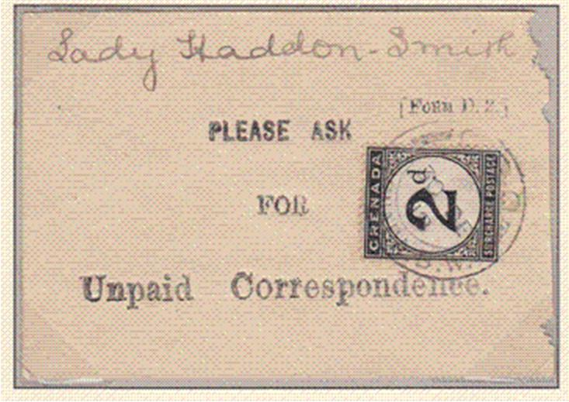

The item illustrated is from Grenada. Dated 1919 the 2d postage due stamp is attached to a small piece of paper marked ‘Form D2’. Was this delivered to the addressee to advise that a letter awaited collection at the GPO and that a payment was required or was the ‘Form D2’ kept at the GPO and the stamp cancelled when the 2d tax had been paid? The form has ‘Lady Haddon-Smith’ in manuscript, she was the wife of the Governor of the Windward Islands, clearly no favours were given!

********
Well that’s all for this issue. Please keep the feedback and any suggestions coming to let me know you are finding the newsletter interesting and consider sending articles for inclusion.(please copy any items as jpeg) My email is rogerswindells@gmail.com.

Also please don’t forget the ‘my favourite stamp and why’ section, I need as many contributions from members as possible to make it interesting. In the meantime stay safe and well and get on with those stamps and covers you’d totally forgotten about.

