Ipswich Philatelic Society Coronavirus Lockdown Newsletter #6

By the time you read this the shops and the pub will be open again (but I’m still not going anywhere!) and the social distancing requirements will have been reduced but it still doesn’t help very much with stamp fairs and most importantly society meetings.
I had a call from Colchester PS this week to let me know their annual fair at Stanway in October has sadly been cancelled. As far as our society is concerned I know the committee are working hard in an attempt to devise a safe way, within any remaining restrictions and acceptable to the school, that we might start our new season or even hold our own fair.
Bob has almost finalised his plans for the safe resumption of the exchange packet. It may entail changes to the way the boxes are passed and to the paperwork but he will be contacting everyone individually by email or letter with the fine details. He has the boxes all ready to go as soon as enough members indicate they are ready for it to resume so when you have seen and read Bob’s ideas on how it will work please let him know as soon as possible if you wish to be included.

*********
An item in the East Anglian Daily Times on Saturday 13th of June rang all sorts of bells. One of a series of regular articles by the Ipswich Society it featured well known Ipswich slavery abolitionist Richard Dykes Alexander banker of St Matthews Street whose wife Ann was the sender of the outstanding cover in the article contributed by Francis Dunn in newsletter #4. A photograph of Alexander’s house in St Matthews Street showed that it once housed a camera obscura in a large dome on the corner.

********
Steve Teuma has sent another superb contribution this time inspired by his lockdown project of organising and writing up his early Suffolk postal history collection. He has kindly copied three interesting items for us with full details and reference numbers of the various marks taken from the Willcocks & Jay's (W&J) County Catalogue. (Interestingly Steve’s research shows that two of the items ‘don’t quite fit the book’!)
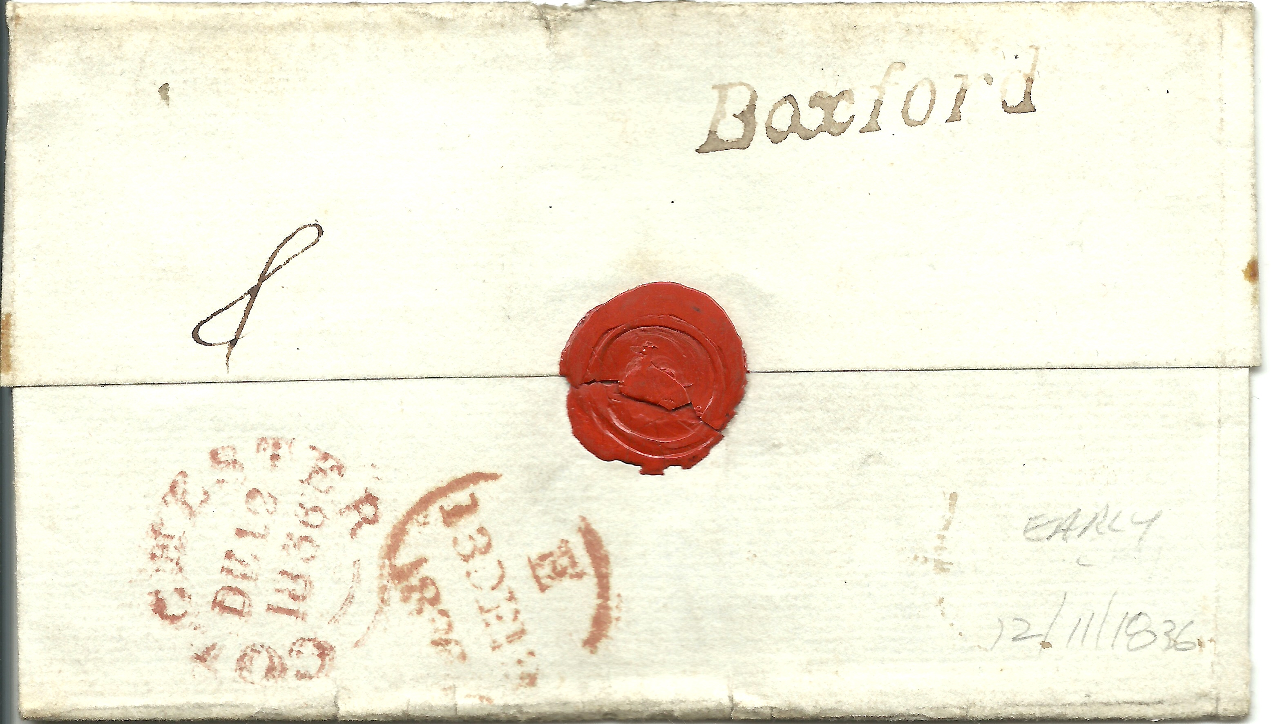

Boxford mark (SK75) in use 1836-1840. This item was sent via Colchester to London in 1836 (the first year of use). Bears a Colchester CDS for Dec 12 1836.
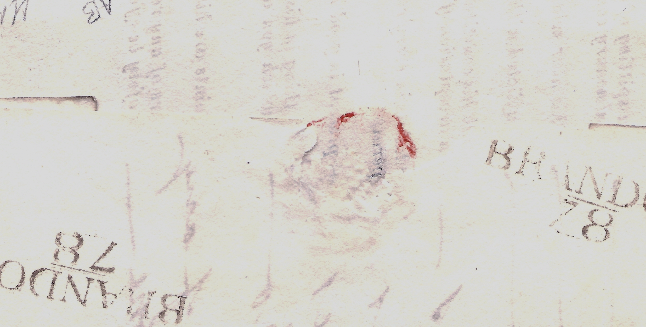

An insurance health questionnaire sent back to Norwich Union at Norwich. On reverse are two BRANDON/78 mileage marks. Unfortunately the sheet is undated and the marks do not measure the same as those listed in W&J. Only one BRANDON/78 (SK48) is shown as in use between 1808-1824, measuring 36x11 mm. The mark on this item measures 36 x 12mm. Not a lot of difference but other markings in W&J have measurements that differ in millimetres and are thus different markings. SK46 and 47 are prime examples, both are BRANDON/79, but measuring 34x11mm and 35x12mm respectively,
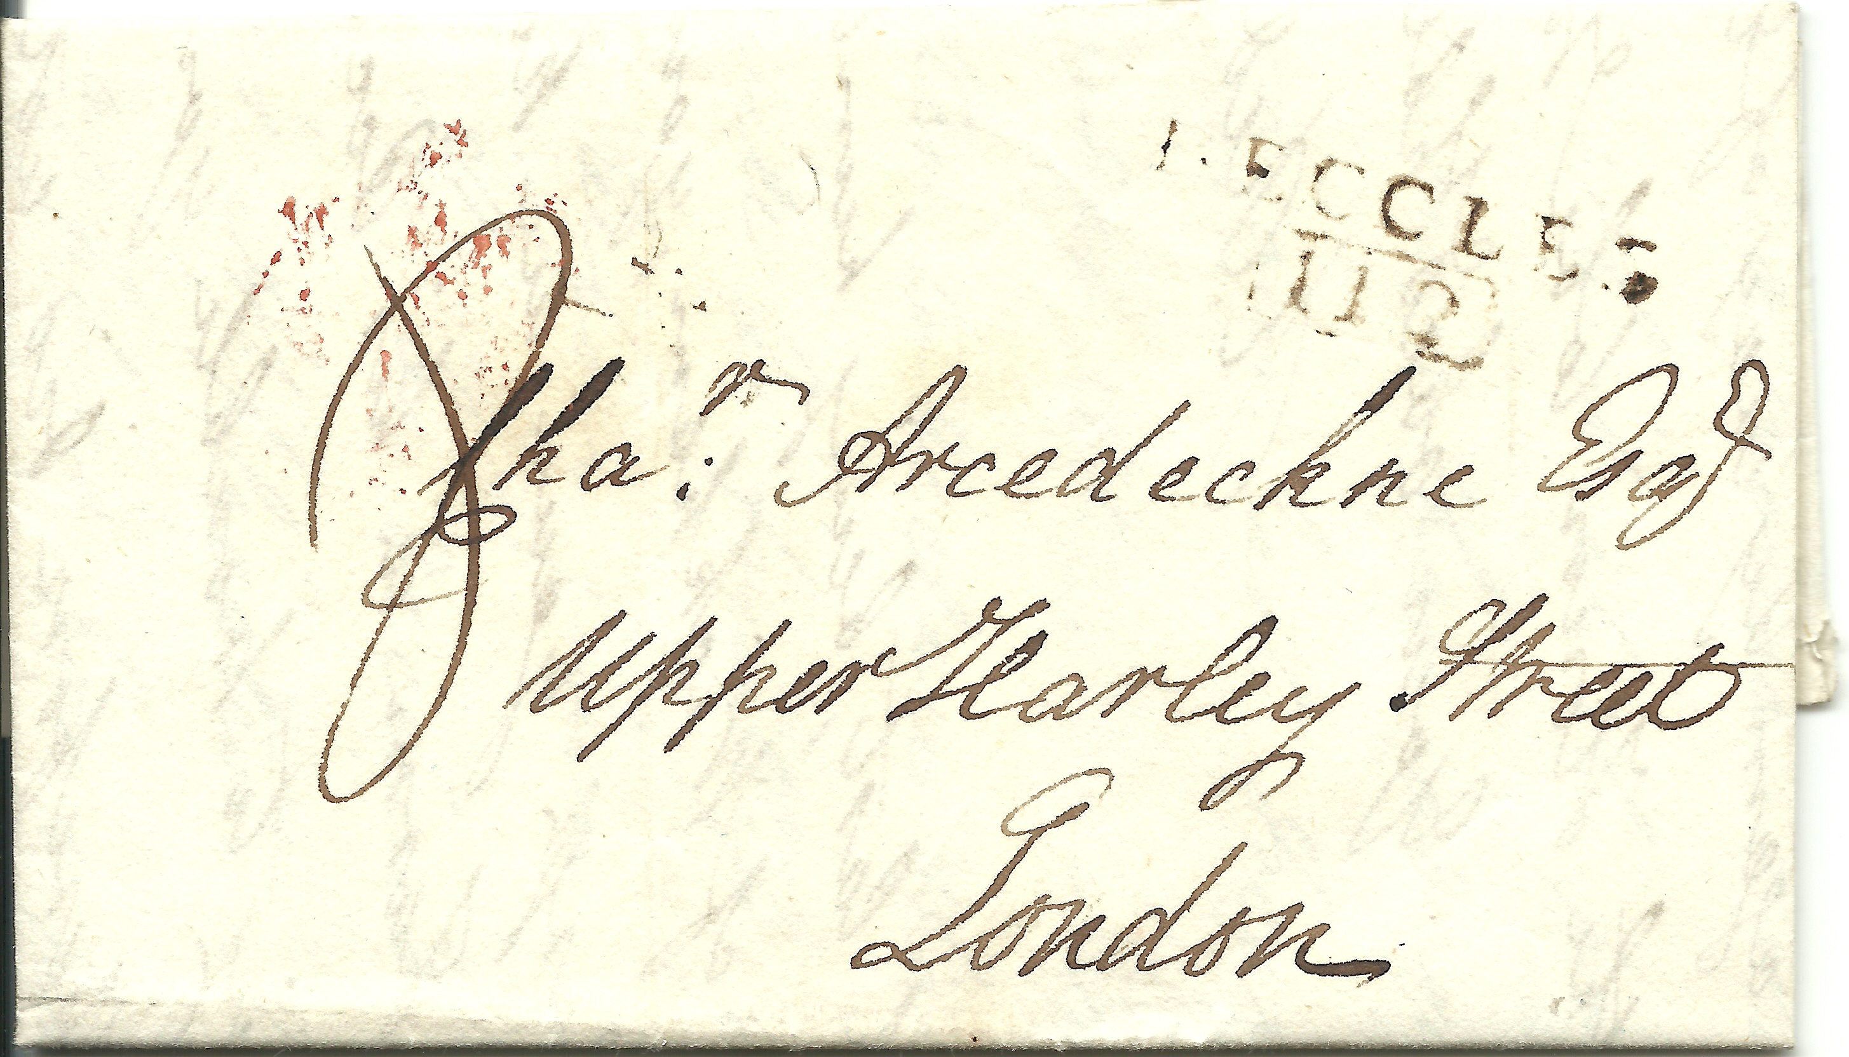

BECCLES/112 boxed mileage mark (SK18) which was in use 1822-1827. Sent to Chaloner Arcedeckne (pronounced Archdeacon) at Harley Street. However, this letter is dated 1807, well before the date in the W& J Catalogue.

********
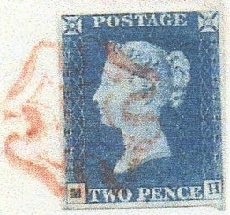
My thanks to Francis Dunn for making the first contribution to the
‘My favourite stamp and why’ section which he explains as follows:

‘The 1840 2d blue, along with the 1d black is my favourite design.
As many members know I do not collect stamps as such but this
issue appeals as a simple, yet effective stamp design even allowing
for the complex engine-turned security background.
Since blue is my favourite colour the 2d value has to be my No.1’.
Ray Deeks’ poem in newsletter #4, clearly inspired Liz Elbourne who has written what she insists is a ‘ditty’, rather than a poem, about our society meetings.
Wednesday Evenings
We meet on Wednesday evenings, some young but mostly old. We hear from expert speakers and stamps are bought and sold.
Some collect thematics, castles, birds or fruits. Some look at postal history, and study rates and routes.
We look at heads of Kings and Queens and other famous names. We view the items mounted and displayed on wooden frames.
We look at very early stamps, penny reds and twopenny blues. At overprints and forgeries, censor marks and postage dues.
And when the meeting’s over, and the stamps are put away. We wish each other “goodnight” ‘til we meet another day.
My thanks to Liz for an absolutely charming and highly relevant little ‘ditty’ which Ed Hitchings has asked permission to use in his newsletter for Sudbury Society under the title ‘Tuesday evenings’, with a nice credit to Liz of course.

********
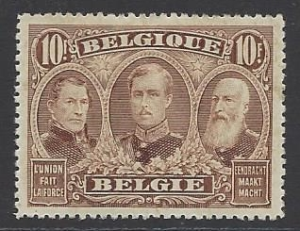
In the absence of any other contributions to the ‘My
favourite stamp and why’ section (and to keep Francis
Dunn company) I’m afraid it has to be my choice. I had
great difficulty making my mind up but in the end the
superb Belgian 10F value depicting the three Kings of
the Belgians printed during the Great War, initially in
London and later in Haarlem, from plates prepared by
Waterlow, wins the day for its beautifully engraved
images of Leopolds I & II and Albert I.

********
Please keep your contributions and feedback coming in, anything and everything is welcome (it doesn’t have to be poetry) I need articles, your favourite stamp, a cover, a story or, more importantly perhaps, just your news about how you are, what you have been up and any news about fellow members. Plus of course any philatelic moans and groans. A short email to rogerswindells@gmail.com will keep your newsletter going.

Finally my thanks, in advance, to Colin Whitmore for a great article detailing how one man’s love affair with the new issues of GB (and other countries) came to an end thanks to Royal Mail (and to a lesser extent Stanley Gibbons) due to the sheer number of new issues, their cost and the difficulty in obtaining certain ones coupled with Gibbons’ inability to produce album page supplements promptly. Colin voices what I have heard from many collectors of GB new issues in recent years, it’s a good read and rather than split it over two issues it will appear in full in newsletter #7.

