Ipswich Philatelic Society Coronavirus Lockdown Newsletter #8

Welcome to Newsletter #8 and my thanks to those who gave positive feedback on, and contributed to, the last two issues. I hope everyone is still safe and well and getting something out of the newsletter in the absence of meetings and fairs.

Members news-wise I have been in touch with Pearl and Selwyn Cooper who are well and still locked down, Ron Ambrose is busy bidding for stamps on line and will by now have managed a pint. Fred Smith at Felixstowe watches the increasing numbers apparently desperate to visit the seaside from the safety of his balcony whilst Ivan Smith was at home ‘whittling’ and looking forward to a visit from Robert Mason.

By the time you read this, members who are on the Exchange Packet circuit will have already received the message by email about the possible restart and the proposed new arrangements This is just a reminder, please don’t forget you must let Tony Blumfield know if you want to opt in as new circulation lists will have to be prepared.
********
I understand one of the regular Marks Tey dealers is giving up fairs to concentrate on Ebay as he’s been doing so well and it’s easier to sit at home than hump crates of albums in and out of village halls. I wonder though if his increased on-line sales are attributable to the lockdown and disappearance of fairs. Will Ebay take a down turn when fairs restart in favour of that ‘face-to-face meeting others feeling’ enjoyed by so many? For his sake I hope not, but if people are worried about going out to fairs and have got used to on-line purchases so that Ebay impacts even more, then I fear for us dyed-in-the-wool fair dealers. We shall see but it’s a bold move by him.
There may actually be some movement on the Marks Tey fair, although personally I think it might be too soon and too risky (after 14 weeks of ‘shielding’ I don’t intend to take any chances now!) Anyway, I had call last week about the possible resumption in September, apparently the village hall committee may be prepared to allow the fair to restart, presumably if they like the arrangements the organiser has in mind re distancing etc. I‘m not convinced it will work, even before the lockdown the fair was inundated with hordes of people arriving and wanting entry before the dealers were set up and well before opening time. After seven months (Feb to Sept) of no fairs I can’t imagine a) what it might be like (providing everyone isn’t at home on Ebay) and b) how just one chair and one customer for every 6ft of table can possibly work or be adhered to never mind the crowded aisles. Colchester PS have already postponed their fair in October and I fear our own will soon follow so I’m not minded to start in September. Watch this space for updates.

Alliance Auctions of Dunmow are hoping to go public again in August (hall owners permitting). Lockdales arrangements however remain unchanged at the moment, their next stamp and postcard auction is July 31st.

********
Three contributions this time to the ‘my favourite stamp and why’ section. Well, four actually, as Steve Teuma can’t make his mind up between two, a problem which might account for the lack of contributions generally. (Don’t worry if you have more than one favourite and can’t decide between them, just send me details of both)
First up is Brian Thompson who nominates the George VI penny blue as his favourite. He describes it as a wonderful simple design and adds that it was the first stamp he collected as a seven year old. (I often wonder, having seen the first very simple designs that were issued, what the other stamps of Edward VIII would have been like had he not abdicated)
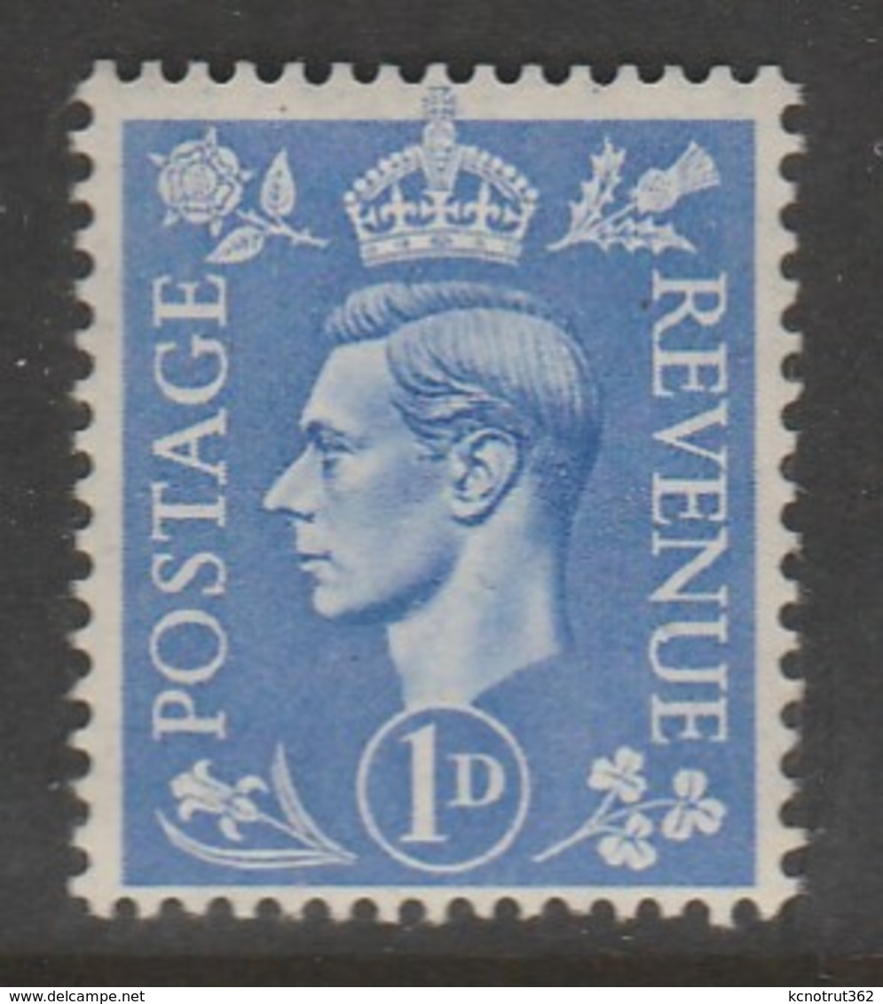

Brian also adds to the two recent items about Richard Dykes the Ipswich abolitionist. He writes, ’The note in the last newsletter about Richard Dykes Alexander reminded me of another prominent abolitionist, Thomas Clarkson, who is buried in Playford Churchyard. I attended Henry Thornton Grammar School in London (Thornton was also an abolitionist) and the four school houses were named after abolitionists; Clarkson, Wilberforce, Macaulay and Stephen. I was in Clarkson House. Clarkson died in Ipswich on 26th September 1846’. My thanks to Brian for these contributions.
********
Next my thanks also to Steve Teuma who explains his choices as follows, ’With regard to 'My Favourite Stamp' I attach two of mine, one GB and one from my Malta collection (my paternal heritage).
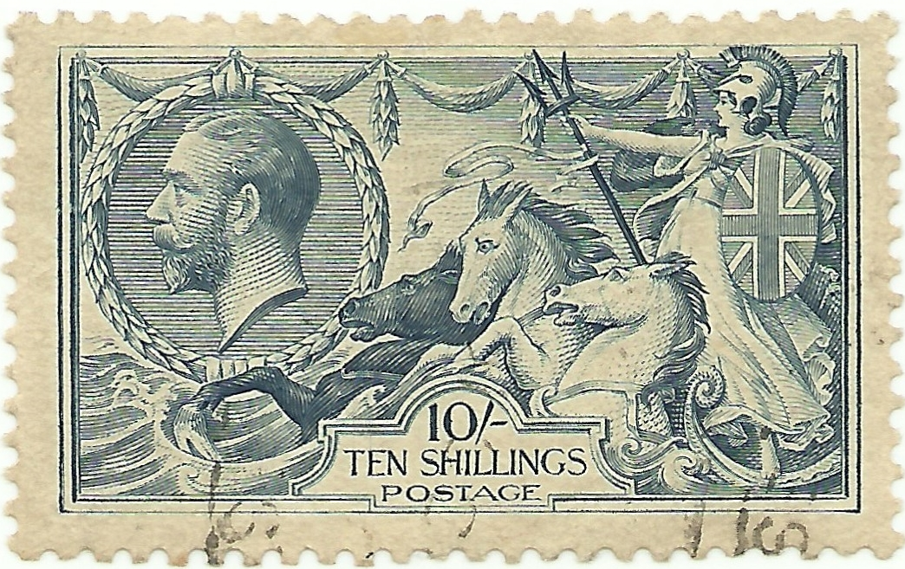
The GB stamp has to be the famous Seahorse issue of George V. Its intricacy and superb engraving has to be the favourite of a lot of people, and I am no exception. Designed by Bertram Mackennel and engraved by J.A.C Harrison for issue from 1913 through to 1934 in various values by several printers.

My favourite stamp from Malta is the 10/- ‘Shipwreck of St Paul’. As those who collect Commonwealth stamps will know, stamps were issued over a number of years utilising several different printers and watermarks. This particular design was issued four times, firstly in 1899 with Crown CA watermark as a 'Postage' only stamp.
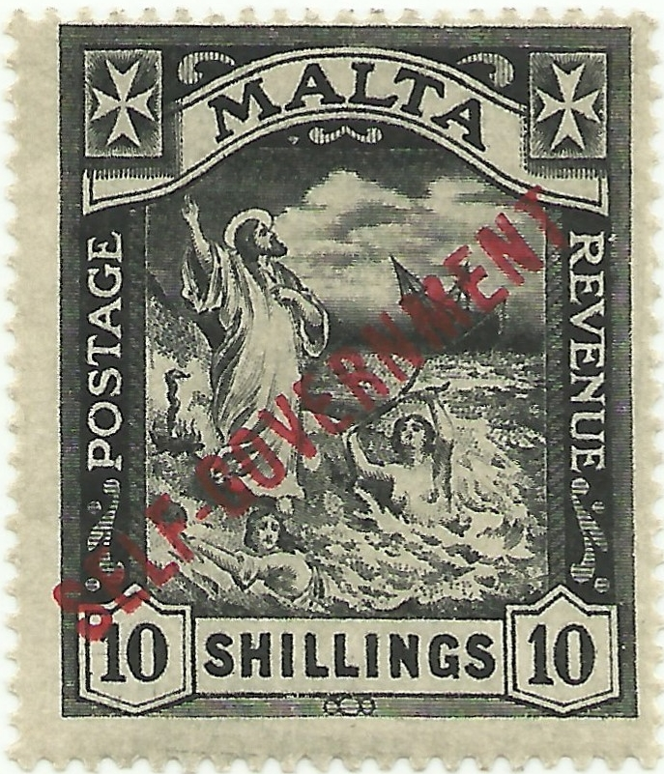
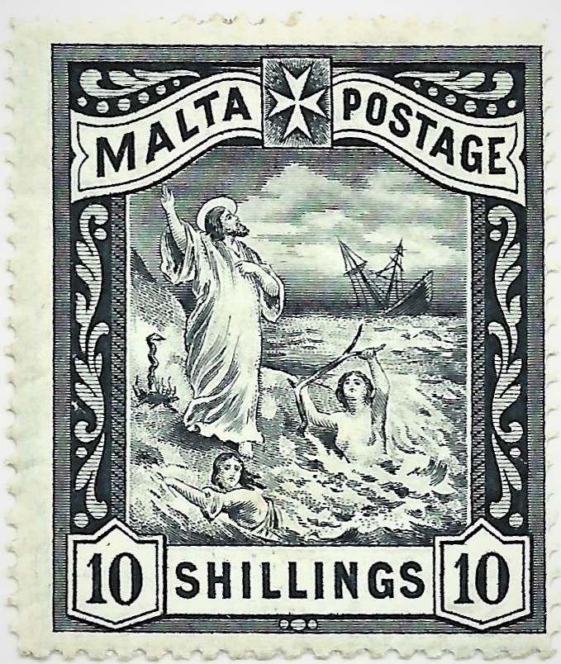

In 1919 the design was changed slightly to include the words ‘Postage and Revenue’ as well as the addition of a Maltese Cross in the top corners on Multiple Crown CA paper. This later design was then re-issued on Multiple Script CA paper in 1922 and again, also in 1922, overprinted 'SELF-GOVERNMENT'. Values vary, depending on the issue, from £100 to £4500.’
********
Last up this time in the ‘my favourite stamp and why’ section is Andy Soutar with a ‘my favourite stamp (which I haven’t got) and why’ contribution, Andy explains:-
‘British forces asserted British rule of the Falkland Islands in 1833 In 1933 a set of twelve stamps was printed by Bradbury Wilkinson to celebrate the ‘Centenary of British Administration’. All the stamps have a simple frame in colour with a vignette in black and 1833-1933 in the design. I particularly like the £1 stamp showing the portrait of KG5 at a slight angle. All the designs are lovely, I have them up to the 6d value, the rest being well out of reach!’
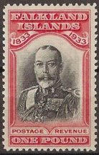
I totally agree with Andy’s choice in fact I think it is probably the most magnificent British Empire stamp ever. Thanks for suggesting it Andy.
********
Finally another superb article from our very own hyperinflation expert Andy Soutar.
From 1916 postage rates in Germany had been steadily increasing two fold or more. The treaty of Versailles in 1919 had imposed reparations of 132 billion gold marks on Germany to pay for war damage caused which fuelled a further increase in inflation. By August 1923 inflation was to accelerate to hyperinflation.

On 24th August the cost of posting an inland letter, up to 20 grams, went up from 1,000 marks up to 20,000 marks, a 20 fold increase with other postal rates also increasing inline. It would not be practical for the public to affix 20 times more stamps on mail as at that time the highest value definitive stamp was the large numeral 5,000 mark stamp which would soon be used up.

Emergency provisional stamps were urgently needed, three now obsolete stamp values 12, 25 & 200 marks were taken and surcharged ‘20 Tausend’ (inland letter / registration rate) and a 30pf stamp was also surcharged ‘8 Tausend’ (local letter / inland postcard rate). They were surcharged by the Reichsdruckerei, the state printing works in Berlin and issued on 24th August, the first day of the rate increase (the 20,000 on 12 marks was issued a day later).

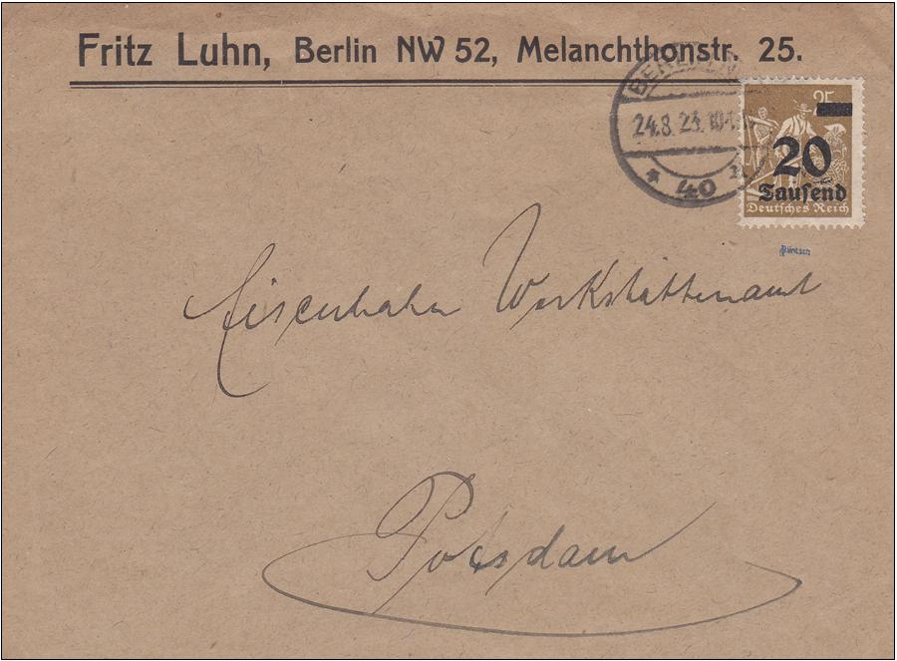
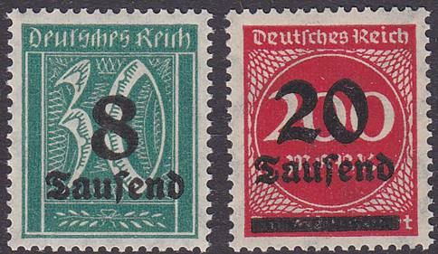

8 & 20 Tausend mark surcharges
issued on 24th August 1923.

(Right) First day use of 20 tausend
mark surcharged rate on 24th August
1923 Berlin to Potsdam

Using up obsolete sheets of low value stamps for large value surcharges was open to forgery. The solution was to take the original printing plates and reprint the stamps in different colours to the originals before surcharging them with the higher values.
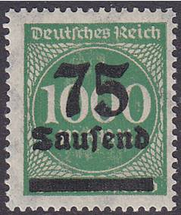

On the 1st September rates increased again, the inland letter rate rose to
75,000 marks so the small numeral 400 mark (brown) and 1,000 mark
(grey) stamps were reprinted yellow-green and surcharged ‘75 Tausend’.
More stamps were surcharged up to 2,000,000 marks in Berlin until
October 1923 to keep inline with ever increasing postal rates.

75 Tausend mark surcharge on 1,000 mark yellow-green reprint 1st September 1923.

From the 9th October new stamps in a ‘Rosette’ design were gradually issued in values from 500,000 marks up to 50,000,000,000 marks (the highest German face value stamp), many would soon be of no value and were themselves surcharged.

As the Reichsdruckerei was so busy printing and surcharging stamps and banknotes, eleven regional directorates of post around Germany took on stamp surcharging duties, to supply their local areas. These surcharges were different to those surcharged in Berlin and such was the urgency for them, that stamps in the original colours were once again used. Stamps printed at these sites can be identified by the type of surcharge plate used, especially along the top margin of the sheets of 100 stamps.

The German currency was revalued on 1st December 1923 and six new ‘renten-pfennige’ stamps were issued. The old inflation stamps could be exchanged for the new stamps or could be used up to the end of December 1923. Covers with a mix of both types of stamps are very desirable.

********
In addition to the points raised in his article in newsletter #7 about collecting modern issues, Colin Whitmore also makes a valid observation about modern used Canadian material as follows: ‘Whilst we are talking about Canadian stamps, had you noticed the lack of used Canadian stamps on the market? This is probably down to a Canadian Government directive that all correspondence envelopes in offices must be shredded in their entirety, stamps and all. So the main source of Canadian kiloware, commercial ‘office mail’ is no longer’. Does anyone share this view about ‘their’ countries? It certainly appears to be the case with Belgium where modern kiloware with a good mixture of stamps is hard to find. I doubt it’s destroyed unlike Canada. Could it be that commercial ‘office mail’ simply doesn’t use adhesives any more (and it’s not just GB suffering the awful white printed sticky label plague)
********
That’s it for this issue, I hope there’s something in it for everyone. Please keep your feedback, contributions (especially for the ‘my favourite stamp and why’ section) and suggestions about what you’d like in future newsletters coming in to my email rogerswindells@gmail.com. We have two excellent items from Keith Spurling lined up for next time and a strange item I’ve just received from Belgium.

