Ipswich Philatelic Society Coronavirus Lockdown Newsletter #9

By the time you read this you will already be aware that Bob Harvey passed away on August 3rd after a short illness. Bob had been the mainstay of the society for some time occupying the two vital roles of treasurer and exchange packet secretary as well as organising the fairs and being involved in virtually every other every event and activity of the society. I am sure that all members will be greatly saddened by this devastating news and all our thoughts are with Bob’s wife Eileen and their family at this time.
********
Whilst there will be no meetings until at least the New Year, the exchange packet has been restarted but you are still requested to notify Tony Blumfield should you not wish to receive it at present to avoid members making unnecessary delivery journeys.

********
I have also received some sad news from Bury St Edmunds Philatelic Society. Rod Finn, stalwart of Bury Society who held every position on their committee over the years, passed away in June. He had been in poor health for some time but had continued to play a large part in the running of the society and will perhaps be best known to many of our members for organising the annual stamp fair at Moreton Hall including the 2020 fair, held in February, which was probably the last fair in East Anglia to go ahead before lockdown. Our condolences go to his wife Christine and their family.
********
Courtesy of Keith Spurling, (who hasn’t given up on GB new issues yet) we have an interesting item under the heading perhaps of ‘The Event that Never Was’. I refer of course to London 2020 which fell victim to Covid19 and will now be London 2022. Philatelic items were already in production and Keith has offered one for our interest here for those who may not be aware of them. Much as I object to the endless ’any excuse’ issue of limited / prestige items, I think the booklet below is particularly nice.
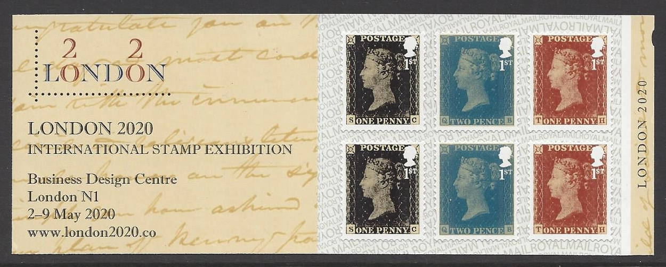

London 2020 first class booklet of six based on penny black, red and twopenny blue
Incidentally how will they redesign the logo as 2022 I wonder. London 2020 cleverly utilised the two letter ‘o’s in London as the zeros in 2020 (or vice versa).Will they not bother reprinting the philatelic items, somehow I doubt that don’t you? (Does anyone out there want to buy any London 2020 lapel badges by the way?)
********
Thinking about it, ‘The Event that Never Was’ would make an interesting thematic collection or display. I haven’t actually seen any, but knowing just how many Olympics stamps for example (not to mention other major events) are commemorated well in advance by virtually every country in the world from Russia to the tiniest atoll in the Pacific, then issues for the postponed 2020 event in Japan must be in their second or maybe even third series for some countries by now. Perhaps any modern Japan collectors can let us know if the Olympic Games were heavily anticipated in advance philatelically. I’ve seen a Belgian issue and I’m sure they are not alone.
********
Some of you may remember my note a couple of newsletters ago about Belgium still not having demonetised the old Belgian franc. I mentioned receiving a mixed franking
letter with old pre-Euro stamps and modern issues. Today’s cover which contained stamps from a fellow Delcampe stamp dealer in Belgium surely beats them all.

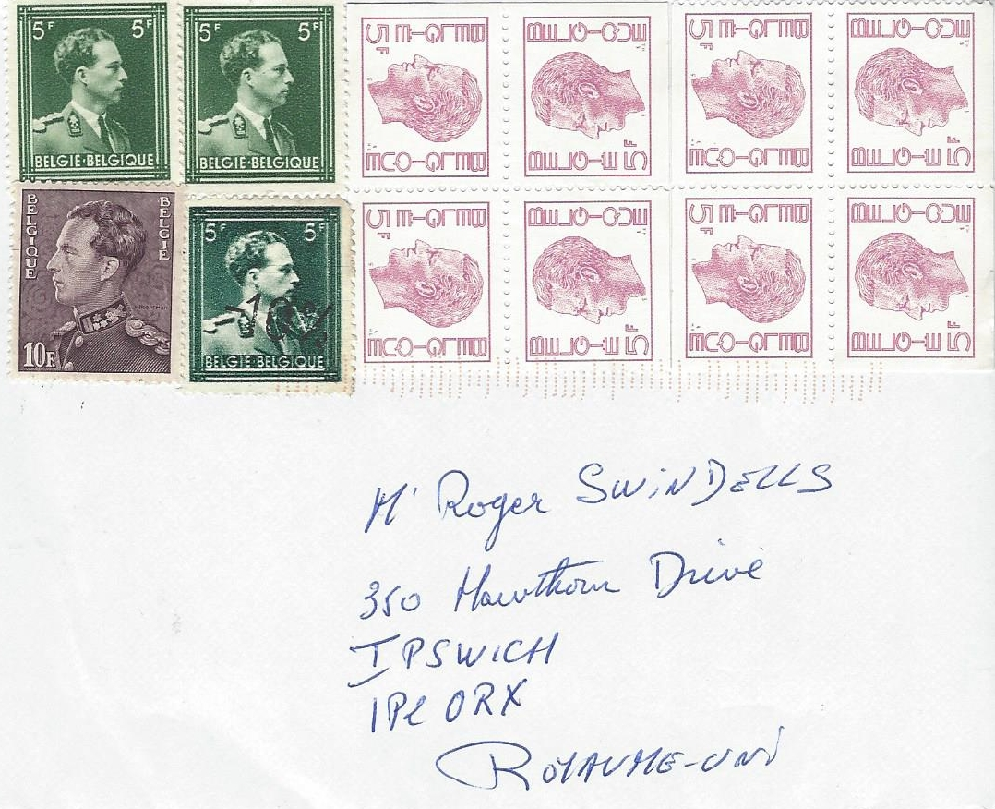

Envelope received July 2020 ex Belgium bearing Belgian franc definitives as follows: 1943 Leopold III 5fr x2, 1951 Leopold III 10fr, 1943 Leopold III 5fr overprinted -10% (revaluation) in June 1946 and 2 x1973 Baudouin 20fr (5x4) booklet panes
Little wonder then why, how ever much mail I receive from Belgian dealers, I just can’t seem to get any modern fine used. (Perhaps I’m just jealous as I am sitting on a huge stock of mint GB pre-decimalisation issues that I can’t use on my mail to them!)
********
Incidentally on the auction front I noted a large number of mixed lots and boxes in the last Lockdales auction and in Barber’s auction on 5th August. Clearly some folk are taking the opportunity to sell their bulk lots, rather than using the time to sort them out, presumably hoping for an increased demand for bulk lots during lockdown.
Also while I’m on the subject what are the thoughts of those who would normally attend and bid in person? Have you adapted to bidding on-line (with the additional payment that involves) or have you been leaving bids ‘on the book’? I ask because I am a great believer in attending in person whenever possible, to see who I’m up against and to put in that extra (often badly judged) bid at the last moment. I’ve never been lucky with leaving bids in advance anyway and internet bidding leaves me cold.
Don’t complain, even Queen Victoria wears a mask!

I suggested a few weeks ago, when we featured the special cancel for (now Sir) Tom Moore, that Corona virus might one day become a new thematic subject and what other items, even commemoratives, we might expect eventually from Royal Mail.

Well, two of the world’s most prolific stamp (I use the word loosely) issuing nations have not let us down. Sierra Leone and Togo have issued miniature sheets entitled ‘The Penny Black against Covid 19’ each consisting of six stamps featuring images of the Penny Black with Queen Victoria sporting a colourful selection of face masks.
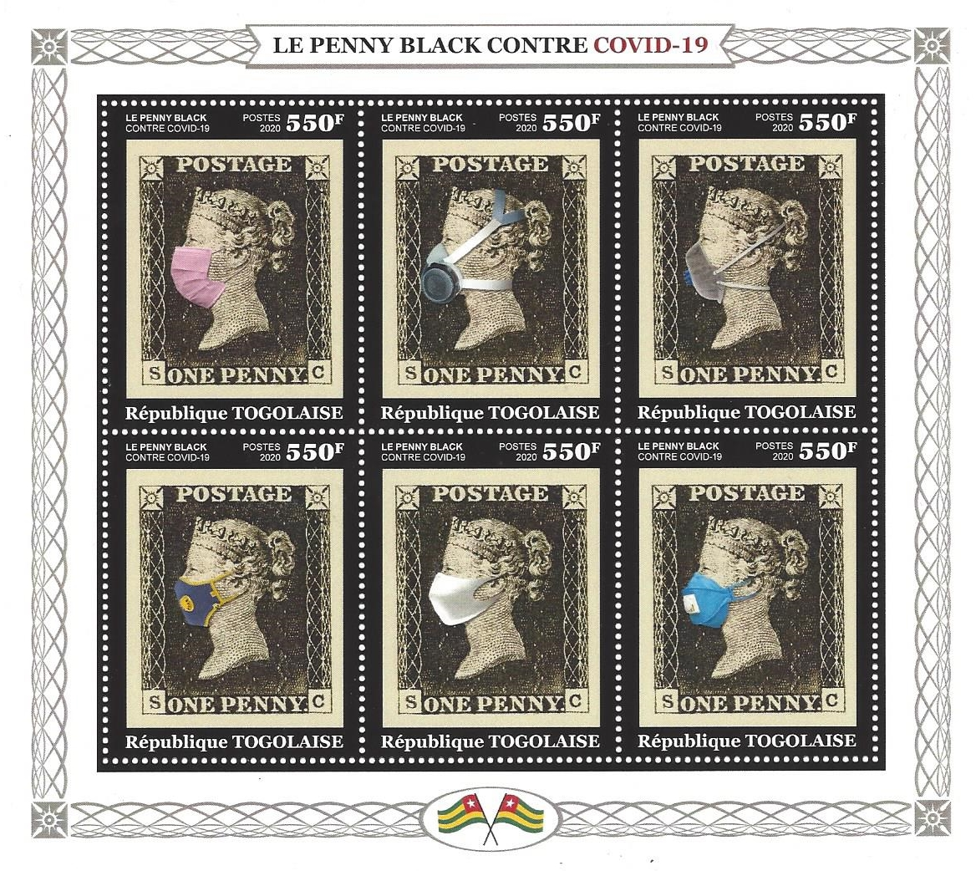
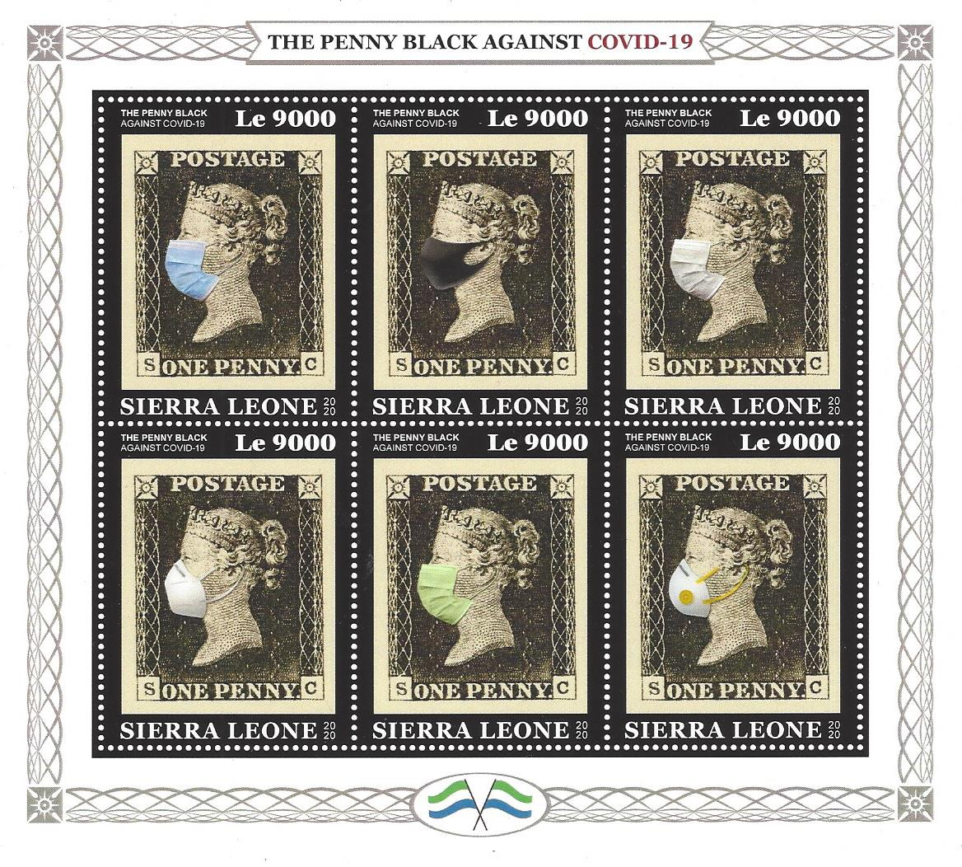

‘We are not amused’ springs to mind but as well as swelling the coffers of the issuing countries (surely these stamps will never see genuine postal use) perhaps we should give them the benefit of the doubt and accept that they are also promoting the use of masks. So, if Queen Victoria can wear one, then when you go to the shops so can you!

My thanks to Keith Spurling for the two African philatelic gems reproduced above.

********
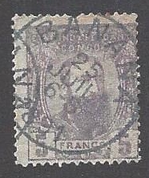
A pleasing number of contributions to the ‘my favourite stamp and why’
section this time. Firstly two stamps selected by Ray Deeks for the their
cancellations, both of which will have Liz Elbourne’s mouth watering
due to their perfect connection to her ‘food and drink’ thematic interest.

First up is a 5F King Leopold II definitive for the Independent State of
the (Belgian) Congo beautifully cancelled ‘Banana’ on 25th July 1891
(and yes, it is the good one, SG12, the 5f violet).

Ray’s second selection is a King Albert I 50c definitive cancelled on 27th
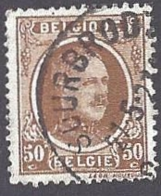
May 1927 in the Ardennes village of Sourbrodt (translates as sourbread)
purchased from the first exchange packet box post lockdown for a mere 5p.

Ray, no doubt still dizzy from his tangle with the early Belgian numeral
cancels, observes that his main interest these days is in good post marks
with, as he calls it, ‘an added plus’. These two stamps certainly have that.

Our next contributor is Ivan ‘The Whittler’ Smith (more of that next
time). Ivan has chosen the camel mounted desert postman design as
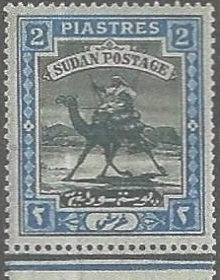
his favourite. Like many of us he has happy memories of taking his
pocket money down to the shops to choose from one of the many
hundreds of packets of totally worthless, but nevertheless fascinating
stamps, from countries around the world not even mentioned by the
geography master. Ivan shares some wonderful memories of his
early collecting days and how things used to be as follows:-
‘It all started when I was a small boy, a pupil of the old St. Matthews School in Ipswich, during the start of the WWII. All the pupils collected stamps which we swapped during the lunch break (we were not welded to mobile phones in those days).
Our sources of supply were two shops in Ipswich. One was Woottons hairdressers which also sold stamps and fireworks, located next to the old picture house (known as the Flea Pit) where Boots is today, and Woolworths. Each had a large display counter and for sixpence you could get a packet of 20 assorted stamps or a pack of two higher value stamps. I was advised by my father to go for the higher values which I did and this is how I first got my favourite stamp which was the Sudan camel riding postman’.

********
Finally in the ‘my favourite stamp and why’ section a contribution from Chris Roe
who puts forward the outstanding George VI high value key
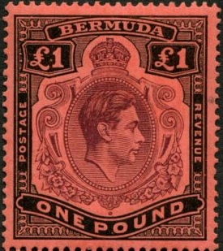
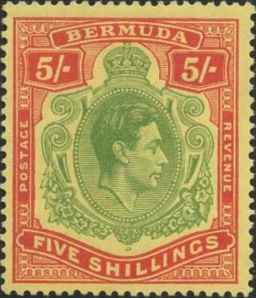
plates issue of Bermuda. This superb design began in the reign
of Edward VII and ran through both George V and George VI.
Chris writes:
‘My favourites are the 5/- green, red and yellow and the £1
violet, black and scarlet. There are a number of values and
shades in this issue and a page of eight different examples
is my favourite item in my whole stamp collection’.

An excellent choice Chris and thank you for your input.
(good luck with those shades – you’ll need it!)
********

Just room for an item which arrived today in the form of a special cancel in memory of World Cup 1966 hero, the late Jack Charlton who passed away a couple of weeks ago. I don’t know how widespread its usage is going to be but any football or general sports thematic collector is welcome to it if you don’t find one on your own mail.
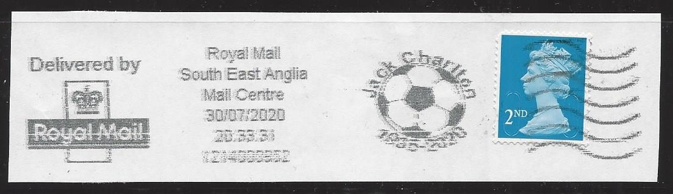

That’s all for this issue. Many thanks to Keith and those who have contributed to the ‘my favourite stamp’ section. Please keep items coming in, there are still at least 70 of you who still haven’t told your fellow members what you collect and what you like best. It’s your newsletter, I just put it together using your contributions. If enough people find it interesting I am happy to carry on until we all meet again, just let me know at rogerswindells@gmail.com. Stay safe and well everybody.

