Ipswich Philatelic Society Newsletter #12

In the absence of any news from or about members and no major updates on fairs or auctions (except to say Marks Tey fair will not recommence before January 2021 at the earliest) it’s on to the first item in this week’s busy edition, an excellent postal history article about wartime mail from Ken Burr. My thanks for a fascinating article.
The impact of war on postal services
Most collectors of stamps and postal history will encounter items relating to war or civil disturbance. This includes stamps with special overprints for expeditionary forces or occupation, letters marked returned or delayed because of enemy action and military mail produced by forces engaged in warfare or occupation of captured territory. There are also the letters from people forced to seek or use novel ways to circumvent war time restrictions. I have chosen four items of postal history to introduce the subject and to illustrate the impact of war and occupation.
The first of these relates to occupation and annexation of territory. Switzerland was overrun by France in 1798 and incorporated into the French administrative and postal system. The wrapper illustrated below bears a French style ’99 GENEVE’ and bears a cachet of origin of the Prefecture of the Department of Leman in which Geneva was located.
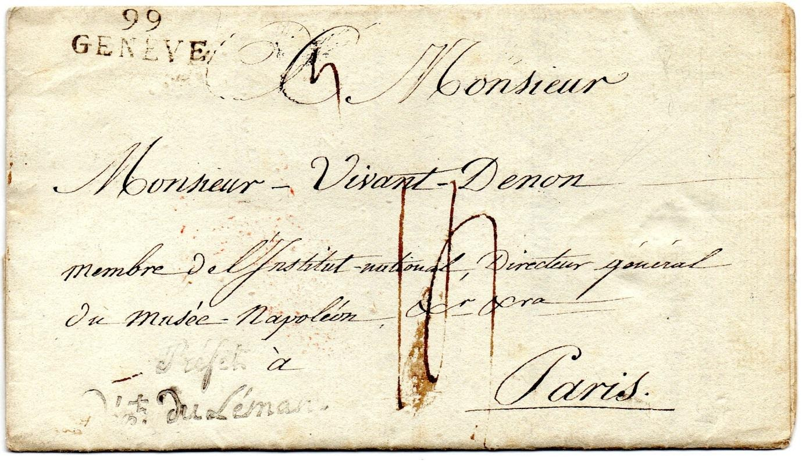
It is dated internally ‘6 Messidor year 12 of the French Republic’, equating to Monday 25th June 1804 and rated at 14 decimes on the face. It is addressed to Monsieur Vivant Denon, Member of the National Institute and Director General of the Musee Napoleon, the Louvre. The Louvre was renamed in honour of Napoleon in 1803. Dominique Vivant Denon was one of the leading scholars of his day, accompanied Napoleon on his invasion of Egypt and wrote ‘Journey in Lower and Upper Egypt’ on his return. As well as the Louvre he had general oversight of all French museums until 1814.Denon’s link to war goes beyond the Egyptian campaign because he looted the churches and palaces of Italy, Germany and the Netherlands of works of art on behalf of Napoleon. The looted works from occupied territories were added to the Louvre’s collections, although many were repatriated under the terms of the 1815 Treaty of Paris. Given Denon’s role it is likely that this letter from the Prefecture of Leman related to works of art or antiquities. Annoyingly the text of the letter following the formal address has been torn out so we cannot know for certain, but the heading does refer to the department of coins and medals.
The second example is a Field Post Correspondence Card written during the Franco-Prussian War of 1870-71 and dated 15 November 1870 from Sedan.
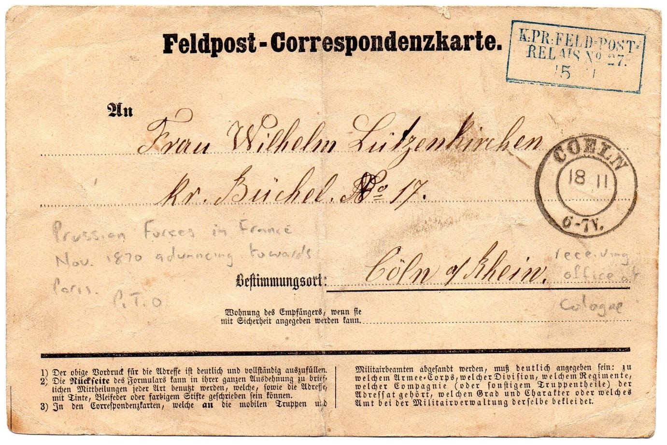
The battle of Sedan, fought 1 to 2 September 1870, resulted in the capture of the French Emperor, Napoleon III, the fall of the Second French Empire and victory for Prussia and its allies. Napoleon III abdicated but the French government in Paris proclaimed a Government of National Defence on 4 September. Paris was then besieged by the Germans from 19 September.
The card is from a Wilhelm Lutzenkirchen to his wife Lenor in Cologne, franked with a blue framed ‘KPr Feldpost Relais No 27’ and date stamped with the receiver COELN 18.11. (Cologne).The card is an early example of a pre-printed mail form specially created for military communication, in this case with loved ones. By providing this service modern states were not only enhancing morale in their armed forces but also exercising control over the correspondence of ordinary servicemen. This was to lead to the development of full scale censorship of letters of service personnel in the world wars of the next century.
The third item follows on from the second, because with Paris surrounded by the Germans, its citizens, unable to send letters by road and rail, decided to use ‘Ballons Monte’, manned balloons.
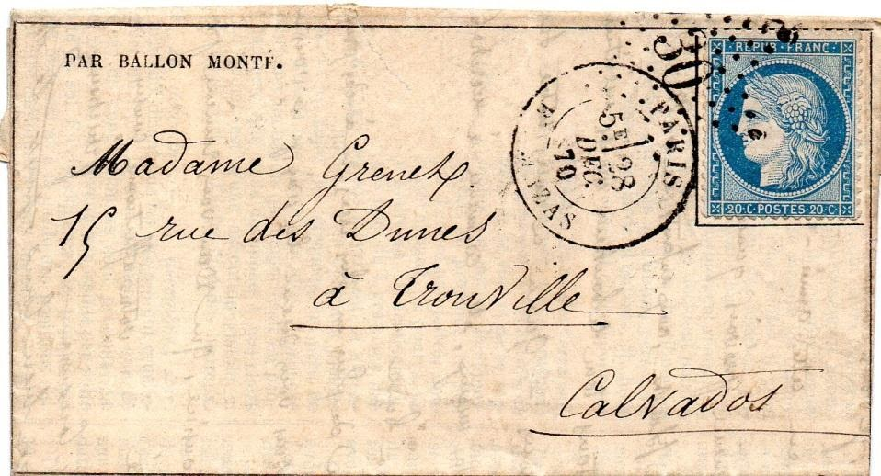
The balloons were prepared and filled with coal gas in the huge Paris railway stations, the only buildings high and spacious enough to accommodate such large objects. They were hand made and stitched by competent needleworkers.67 balloons were released during the siege, 55 of which were authorised to carry mail. The balloons were intended to land beyond the German occupied areas around Paris and the letters were then put into the normal French mail system. This example addressed to Trouville, Calvados, was sent via the balloon ‘Bayard’ and consists of the printed Lettre-Journal De Paris No 20 and a letter written on the blank part of the journal sheet. This is from one ‘Elodie’ to her cousin. The Journal describes the military situation and proposals by the Germans for exchange of prisoners. The mailing date on the Paris CDS is 28 December 1870 and the incomplete Trouville receiver on the reverse appears to show 30 or 31December for the arrival date. Most of the balloons delivered mail successfully, although one was blown as far as Norway and another had the bad luck to land in Munich! The use of balloons in this way is a good example of human ingenuity in overcoming an obstacle caused by war.
My final example on the same theme dates from World War II where disruption of mail services was widespread. Citizens of countries who were at war with each other, or under military occupation often needed to communicate with friends and relatives. One way was to communicate via a neutral country. The cover featured here was sent from Italy to the UK via an undercover address in Lisbon in neutral Portugal administered by Thomas Cook & Sons. It was franked by the sender with a 1.25 Lira deep blue Italian stamp and addressed to PO Box 506, Lisbon.
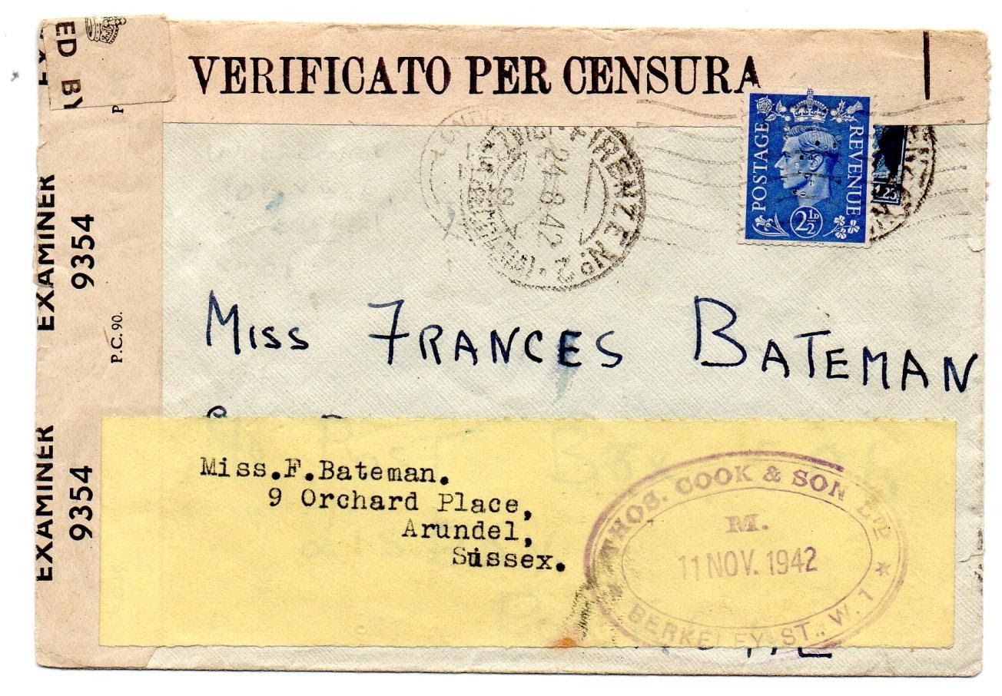
The Italian CDS of Firenze (Florence) is dated 24 August 1942; additionally the cover has been passed by the Italian censor. Thomas Cook added the yellow address label with the UK address of the intended recipient and the 2½d GB perfined (TCS) light ultramarine. This was cancelled on arrival in London 11 November 1942 prior to transmission to Arundel, Sussex. The letter was also opened and taped by the UK examiner 9354. Earlier in the war the service was used by German and other Axis country citizens to communicate with relatives and friends in Canada via the then neutral United States.
This is a vast and diverse subject and in this article I have briefly introduced a few of its aspects. In the next article I will be discussing and illustrating wartime censorship within the UK and stamps of Great Britain overprinted for use in some of the territories occupied by British forces.
********
Now we come to two very welcome contributions in the ‘my favourite stamp’ section, and the story of one of Europe’s rarest stamps.
Firstly two items from the Elbourne household where Ron, put in the shade by Liz in their own ‘contributions competition’, tells us about his favourite stamp which recalls memories of his childhood, education and the country of his birth. Ron writes:
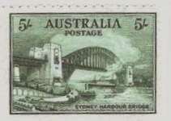
‘I thought I had better make a contribution to our magazine
as so far Liz seems to have hogged all the limelight from
the Elbourne household.
The picture on this stamp is of Sydney Harbour Bridge, and
is one of a set of three with the same image celebrating
the opening of the bridge in 1932. The bridge joins the
Central business area of Sydney with the northern suburbs.
Why is it my favourite stamp? It is a beautiful thing to look
at and was one of the many stamps left to me by my father
who bought them at face value from his local Post Office in the New South Wales country town of Leeton where I was born. The stamp is one year older than me!
It is a lovely reminder to me of Sydney, where I once lived, went to school, studied at University and started work.’

Liz meanwhile responds as follows:
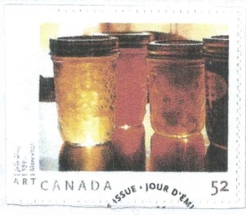

‘Issued in 2007 to celebrate the work of Canadian photographer Mary
Pratt the stamp shows jars of jam so that they positively glow with
colour and fruit. The design is elegantly simple with no need for
embellishment or words. Summed up in the words of the photographer
‘My role seems to have been to make people see things they have never
noticed before to help them find the simple beauty of things around
them.’ Next time you use a jar of jam, hold it up to the light and you
will see what this stamp is all about.’
********

August 1920 and a philatelic rarity is born.
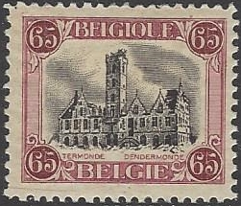
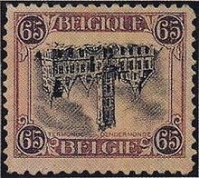

Just room to celebrate the centenary of the issue of
Belgium’s version of the ‘inverted Jenny’. Recess
printed by Enschede in Haarlem, the 65c stamp
depicting the town hall in Dendermonde, was for the
express letter rate. Two sheets of 25 from the first
run were printed with the black centre inverted.
One full sheet was retrieved together with seven
copies from the second sheet. Of the eighteen stamps sold fifteen are known mint and two used. In the second printing two sheets of 50 had the centre inverted but both were retrieved before going on sale. It is Belgium’s rarest and most highly catalogued stamp. Gibbons has it at £130,000 and the official Belgian catalogue at 125,000 Euros
The example at the left above is from my collection, the one on the right sadly isn’t.

********
That’s all for #12. My thanks as usual to those who contributed. Please keep items coming in. If you can’t contribute personally just tell me, rogerswindells@gmail.com what you would like to see in the newsletter and I’ll try my best to include something.

