Ipswich Philatelic Society Newsletter #14

Well sadly it looks like the second wave of this awful virus is upon us and, in addition to the threat to health and possible further enforced restrictions, it means philatelic society meetings are unlikely to start in January as planned. Hopefully the exchange packet and postal/ internet auctions will continue allowing us to carry on with our hobby (those who didn’t get everything up to date first time around have no excuse now.)

I have some news of member’s activities. Mike Smith has been on a nice trip with Janet to Portsmouth, Ray and Sheila Deeks have spent a few days in Norfolk, Francis Dunn is well and doing a little gardening while I am trying to get on with a second book (without doing the necessary research in the Netherlands.) My stock is sitting here, with many new acquisitions unsorted and unpriced as I can’t get up any enthusiasm with no sign of any of ‘my’ fairs resuming and frankly I am thinking about giving up dealing. It is rumoured that the Sunday fair at Braintree has restarted. I don’t know dates I’m afraid or how many dealers are involved as it is not an event I ever attended but I am surprised and I wonder how safe social distancing is being achieved and whether it will survive any ‘second wave’ restrictions yet to be announced.

Fame at last, we made the ABPS magazine! The Autumn issue of the ABPS magazine, normally available in hard copy via the society, is now on line at https://www.abps.org.uk/magazines and under the ‘Societies News’ section the editor has been kind enough to print the item which appeared in our very first newsletter, the ‘opened by Border Force’ letter. The magazine, which also lists our clean sweep in the Stokes Cup under the AEPS section, is probably the most interesting issue I have ever seen (and not just because we are in it) as it contains a large number of small articles and reports with something of interest to everyone following a plea for contributions from the editor (I’m not the only one) which is why I sent our bit in. I won’t reproduce any of the items here but please read it on line yourselves, it contains a wide variety of very interesting stuff.

********
On to this week’s first item, another one of mine I’m afraid, but hopefully interesting nevertheless. I recall a speaker showing items relating to the anniversary of the Penny Black who pointed out that, due to WWII, stamp issues and celebrations marking the anniversary were less numerous than might have been expected. It’s a philatelic item produced by the Rotterdam Philatelic Society which, still unaffected by the war, was clearly determined to commemorate the centenary. The card, celebrating the postage stamp as ‘een eeuw oud’ (‘a century old’) bears a reproduction of the Penny Black and a special philatelic cancel from the Rotterdam Society dated 6th May caught my eye as Germany attacked the Netherlands just four days later. After days of fierce fighting, Rotterdam was carpet bombed totally destroying 75% of the old city forcing the Dutch to surrender on 14th May. It’s a lovely souvenir item but one wonders when and where in the devastated city, and under German occupation, the members of the Rotterdam Philatelic Society met again.
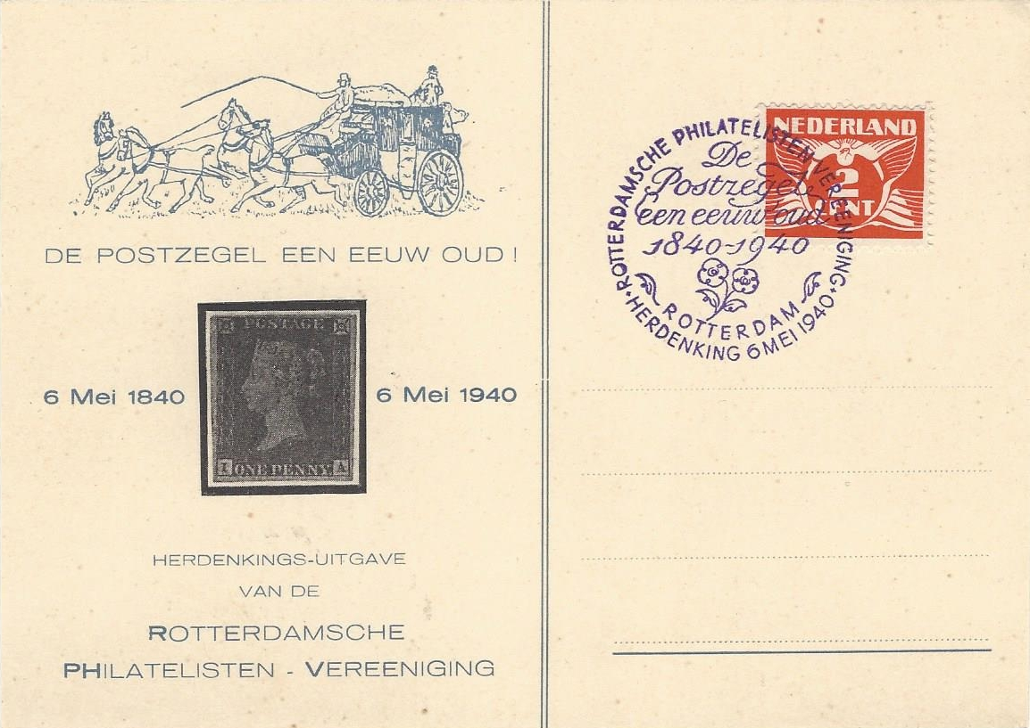

In the ‘One Hundred Years Ago this Month’ section this week it’s the centenary of the
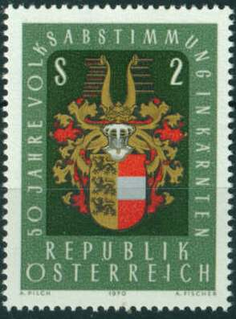
Carinthian plebiscite held on 10 October 1920 in the area predominantly settled by
Carinthian Slovenes. It determined the final southern border between the Republic
of Austria and the newly formed Kingdom of Serbs, Croats and Slovenes (Yugoslavia)
after World War I. 22,025 votes (59.1% of the total cast) were in favour of adhesion
to Austria and 15,279 (40.9%) in favour of annexation by the Kingdom of the Serbs,
Croats and Slovenes. Austria commemorated the 50th anniversary of the plebiscite in
1970 with a 2 Schilling stamp depicting the Arms of Carinthia.

********
Next I am delighted to include a ‘guest item’ from distinguished philatelist and siege of Mafeking expert John Ineson, long serving president of the Sudbury and District Philatelic Society. Included in a message he sent to Ed Hitchings about the Whitfield King item in the Sudbury newsletter (and he mentioned our newsletter too) was the following article, one of his regular contributions to the Scout and Guide Stamp Club publication under the heading ‘John’s Jottings’, which he has kindly allowed me to use. John writes :
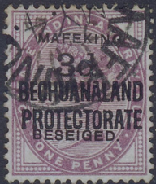
‘I have recently been asked to give my thoughts about a Mafeking (S.G.12)
overprinted stamp by the editor of the GB Overprints Society. For many
years I was asked to give opinions on some overprinted Mafeking stamps by
the British Philatelic Association (B.P.A.) Expert Committee, and this was
before stamps could be enlarged on a computer allowing flaws or fakes to
be seen much easier. Sometimes it used to take up to 30 minutes to look at
the cancel and overprint, with much measuring and comparing with genuine
items in my own collection. On looking at the stamp shown, I spent some time
looking at the overprint and cancel and soon noticed that this stamp had a fake
cancel of “MY 4” postmark as this was larger than the genuine. Also the
‘Mafeking’ and ‘Besieged’ overprints were not aligned correctly. It was not
until I had virtually finished looking at the stamp, that I noticed that the word ‘Besieged’ was not spelled correctly. As we learnt at school it was always “I before E except after C” (although there are exceptions such as weird, heir, seize etc,). I have never seen this ‘Beseiged’ fake before, but maybe you have.’

********
Commonplace these days and issued in vast quantities using any flimsy excuse and often as an expensive add-on to a commemorative set, miniature sheets, (normally mint as they are rarely postally used) are familiar to us all irrespective of which country or countries we collect but when and where did it all start?
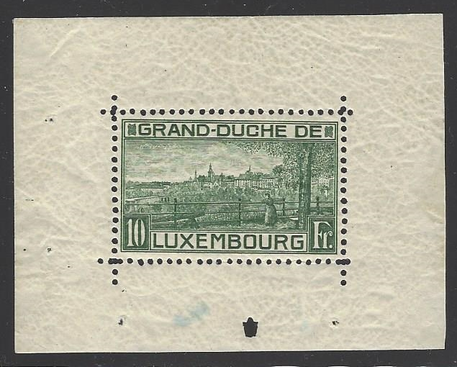

The honour (or should it be the blame) for being the first goes to Luxembourg on 3rd January 1923. The sheet commemorated the birth of Princess Elisabeth on 22nd December 1922 to Grand Duchess Charlotte and Prince Felix of Bourbon-Parma. Consisting of a single stamp with a value of 10F depicting a view of
Luxembourg city, designed and engraved by Henri Cheffer, it was recess printed in Haarlem by J. Enschede.

Next it’s thanks once again to regular contributor Andy Soutar for another excellent article this time about an under-rated and often ignored aspect of philately, postal stationery. Hope it gives some of you ideas.

Collect Postal Stationery
Want to add another aspect to your collection? This is worth a look. Just about every country around the world either has or currently does issue postal stationery (PS). This can be postcards, envelopes, letter-cards, aerogrammes, registered envelopes etc, They all have an imprinted stamp that will pay a postage rate for inland or foreign mail. As countries joined the UPU in the 19th century there was a requirement to issue certain PS items, often postcards. Some of these postcards were issued in very small numbers and can be hard to find but others are more affordable. A development from the standard postcard was the lettercard, the message is written and then sealed inside by moistening three gummed edges, thus making the message more secure from the eyes of postal staff and even nosey family members!
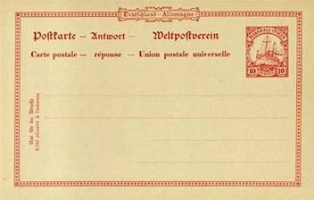

1879 75c French lettercard, the first issued
lettercard for use on the Paris pneumatic post
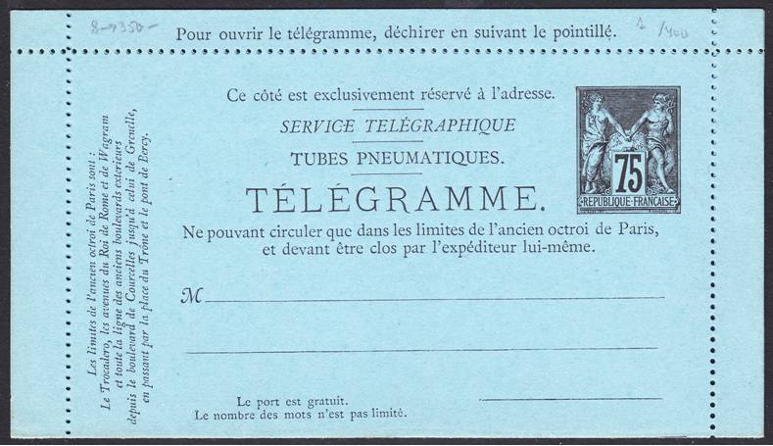

10pf postcard from the
German Marshall Islands

PS can be treated just like collecting stamps - used or unused, the imprinted stamp can be the same design as standard postage stamps but some designs can be different. Many older printed albums have spaces for PS ‘cut-outs’ when the imprinted stamp has been clipped from a PS item, this is not a practice promoted these days, it’s best to leave PS items intact! In GB it was permitted to paste an unused PS ‘cut-out’ onto another postal item to pay a postage rate or for use as part of a make up rate, these can be collected from the QV, KEVII & KGV periods.

Also, just like postage stamps, PS was often overprinted and/or surcharged to keep up with postage rate increases, changes of currency, changes in a countries name, in occupied areas, for use by armed forces and for many other reasons. PS can also form a specialised collection, in Austria, France and Germany bespoke PS was issued to only be used in pneumatic mail systems, mail was placed in small canisters so PS was ideal for this purpose however is was not always permitted to enclose anything inside as this could make the item over the allowed weight, postage due could then be charged. Registered mail also uses PS, special stout envelopes were produced usually with an embossed stamp on the envelope front or flap, sometimes the postage rate was included or regular postage stamps were added, especially if the item was heavy. GB has issued much PS over the years, this is often not expensive and a very interesting and colourful collection can quickly be formed. In the Stanley Gibbons Monthly magazine there is often an article written by Peter van Gelder who is a Postal Stationery expert, it is well worth looking out his article for an interesting and informative read. So go for it and start a postal stationery collection.

Finally Andy treats us to an item of postal humour, courtesy of George Woolnough the original owner, in the form of a press cutting marking the 4d 2nd class letter rate of September 1968. Described as a guide to help GPO employees to delay 4d items, (and deliver 2nd class parcels badly) ex-postal workers amongst our members may not appreciate it but perhaps they can tell us if there was a dislike of the two rates or, more likely was this simply a political cartoon criticising the inception of a perceived ‘second rate’ service?
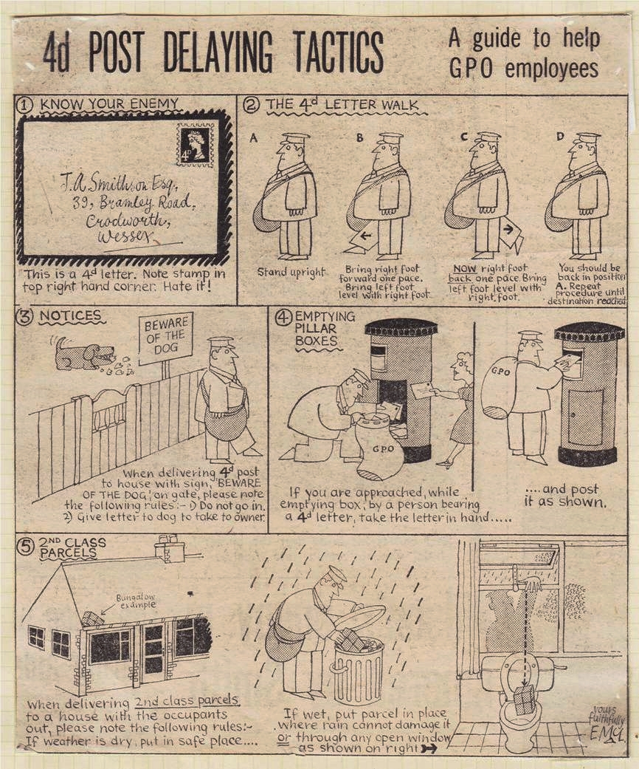

That’s all for this edition. Once again I would ask you all to make a contribution to the newsletter. It doesn’t have to be a long article, in fact the shorter space fillers are actually better as it means there is more variety and more chance there will be something of interest to more readers. There are still 70 members who haven’t contributed or are still to reveal their favourite stamp. Just telephone me or email the details, if you can’t copy the stamp don’t worry, just tell me what it is and I’m sure I’ll find an image of it somewhere.

If we are to struggle through new restrictions, at whatever level, I think it’s important that we keep in touch with each other and our hobby, it was after all the reason the newsletter began. So come on, let me know you are alright and what you are up to (if you can’t email ring me on 01473 680090) I need news of you all !
Stay safe and well, remember you have to leave the pub by 10pm and no carousing drunkenly around town in a bigger group than six people!

