Ipswich Philatelic Society Newsletter #19
New Year 2021 Edition

First of all a happy and prosperous New Year to you all, hopefully a better one than 2020 and maybe with the prospect, at some time, of us all getting together at a society meeting once again (note to Janet and June, get the kettle on and get baking) However with at least three months of winter and almost certainly with some sort of restrictions still ahead, it’s time once again, now that last mince pie has been consumed and that distant cousin has finally sobered up and gone home, to turn our thoughts to philately.

With that in mind and in the continued absence of fairs and meetings, plus the effect on public auctions, it’s the right time to mention what has been (and will still be for many) the only source of material, the Society’s Exchange Packet. In particular I would like to pass on my thanks to the whole team of volunteers who work hard to keep the packet running smoothly and to all the vendors who contribute their unwanted items for sale
********
The first contribution this week is from ‘Mark Poste’. I particularly like it as it’s an interesting study of a lesser known service (to me anyway) and a little collected area of philately, plus it’s good for the newsletter, and hopefully interesting for everyone, to see articles on less mainstream subjects. So my thanks to ‘Mark Poste’ and perhaps he can display this material for us at a society meeting in the future. (Sign him up Andy!)

NACHNAHME (CASH ON DELIVERY) SYSTEM
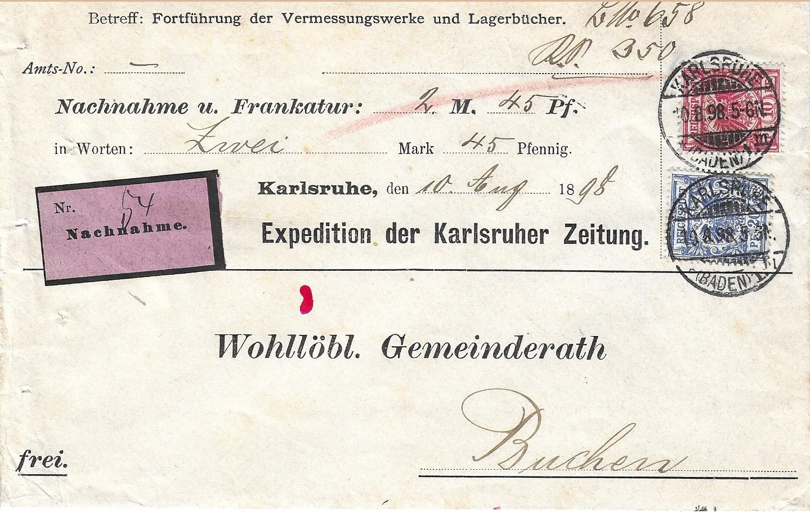

Early Nachnahme 10.08.98. Karlsruher to Buchen for 2mk 45 pf with red crayon underscored.

This is an abbreviated look into a service first introduced in 1848 and revamped for the German Empire by the Reichpost on 7 September 1878. The service employed either pre-printed ’Nachnahme’ postal stationery cards or postal stationery cards with ‘Nachnahme’ stickers.

- COD was limited to a sum of 150 marks per item
- Additional fees could exceed this limit
- Words and numbers for marks but numbers for pfennigs and parcels to use parcel card as well.
- Certificate for consignee of costs including registered or express mail.
- COD amount to be returned to place of posting within 7 days to release the item.
- COD transmitted to sender by postal order without deductions and noted on a slip for the recipient.
- Postage and fees were payable.

Use of this service when crossing borders such as Germany to Switzerland involved currency changes as did states like Wurttemburg and Bavaria with different fee scales. This was a reliable service particularly up to and during the inflation period as it secured payment. The early stickers in pink/lilac were replaced by the
triangular orange ones which had black profiles or were pre-printed. (The service, reformed after the war, and still in use in West Germany in 1980, is a totally different philatelic collecting area.)

Changes to the service
Storage of items for seven days was introduced and fees simplified with a flat rate fee of 10 pf regardless of the amount of COD payment requested, plus postage. Bavaria however retained its rising scale of fees until 1920 when it joined the Reich Postal Territory.

The Post Office would transfer the amount collected to the sender by money order and from 1909 would make this transfer directly to the sender’s postal cheque account (Postcheckonto) by using a payment card (Zahlkarte). In both cases a fee was deducted. (Does this feel familiar to today’s `on line` banking/living?)

The bottom left area was used by the postman to record notes such as ‘not found at home or ‘period of credit extended’ (to the maximum of seven days and the requested date) or perhaps ‘payment refused / not honoured’. For small fees or irregular amounts `rounding up’ was allowed. Postage rates for COD postcards could be sent at the lowest printed matter rate from 1 July 1906.

(Examples of more ‘Nachnahme’ cards follow; I hope I have interpreted Mark’s descriptions correctly!)
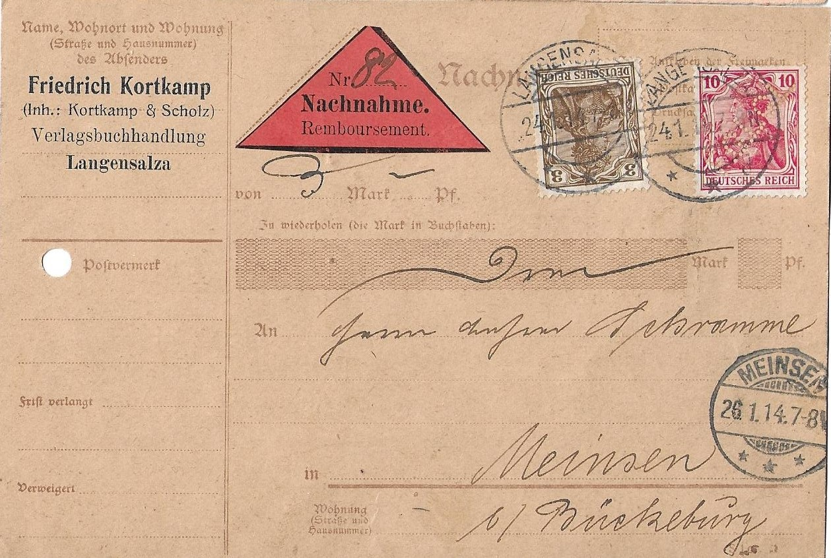

1914 Nachname card with 10 pf perfin and reversed 3 pf Germania
post marked 24,1.14 Lagensalza. The registered triangle 82 has
`Remboursement` which is usually needed for currency differences
is for 3 marks only. Acceptance at Meinsen is shown below 26.1.14
The back displays a full advert for the 3 m cost.

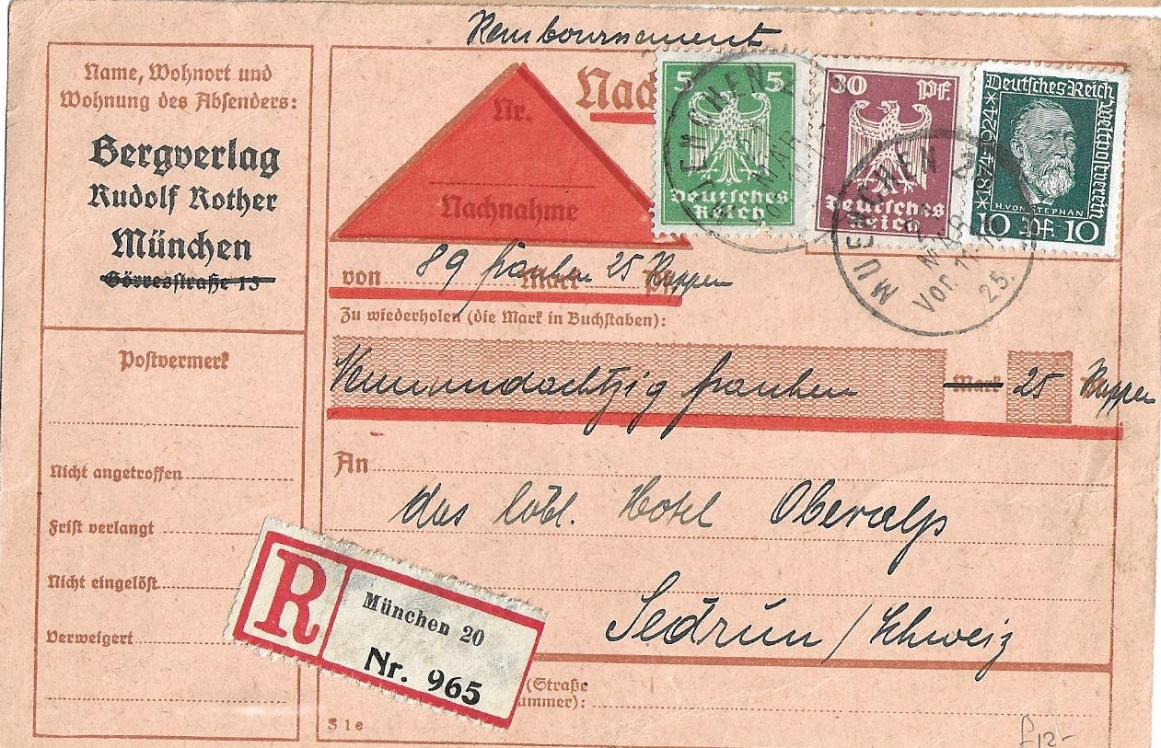

Registered Munich Nachname card endorsed `Remboursement at
the top as it is addressed to Switzerland and the currency is Swiss.
Postage of 45 Pf cancelled with Munchen 21 Mar 25 was for
payment of subscription arrears for the Deutache Alpenseitung.
Acceptance at Sedrun Switzerland 23.111.25 is on the back.
Numerous calculations in pencil and ink to justify the charges.
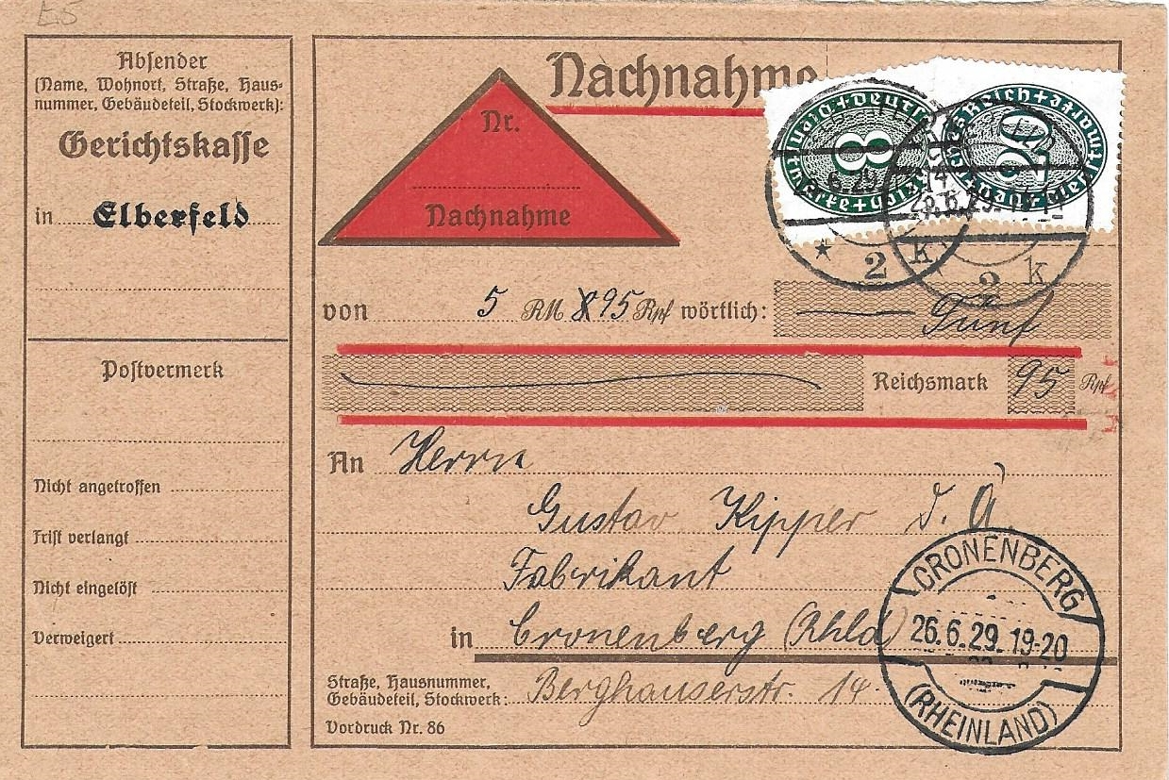

26.6.29 Nachname card for 5 Rm 95 Rpf sent from Elberfeld to Cronenberg (Rheinland) which has a fine cancelled receipt. The
back, which is pre-printed, has been filled in with details of the
charges dated 17 Juni 1929 and signed as it appears to be a debt
approved by a court of law.

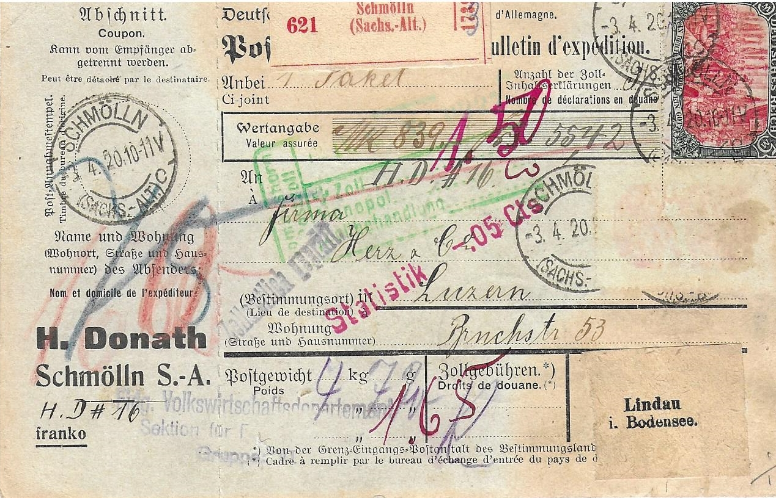

This parcel card seems to have everything including a missing
stamp. Schmolln to Lucerne (Luzen) with small label bottom right
showing the route Lindau in Bodensee. Swiss customs inspected
in green with 1.50 in red ink. The ‘volkswirt’ in violet is an
`economic` charge in red ink of 1.65, and a ‘Statistik’ charge in
red for -.05 cts. Two crayon marks in blue and red on the left and
a label in red 621 Schmolln (Sachs,-Alt) 1739 endorsed 3 at top.

Thanks to ‘Mark Poste’ for this insight into a fascinating and unusual corner of the German postal system.

Another outstanding contribution next from Francis Dunn in the form of a Transatlantic cover from 1853.
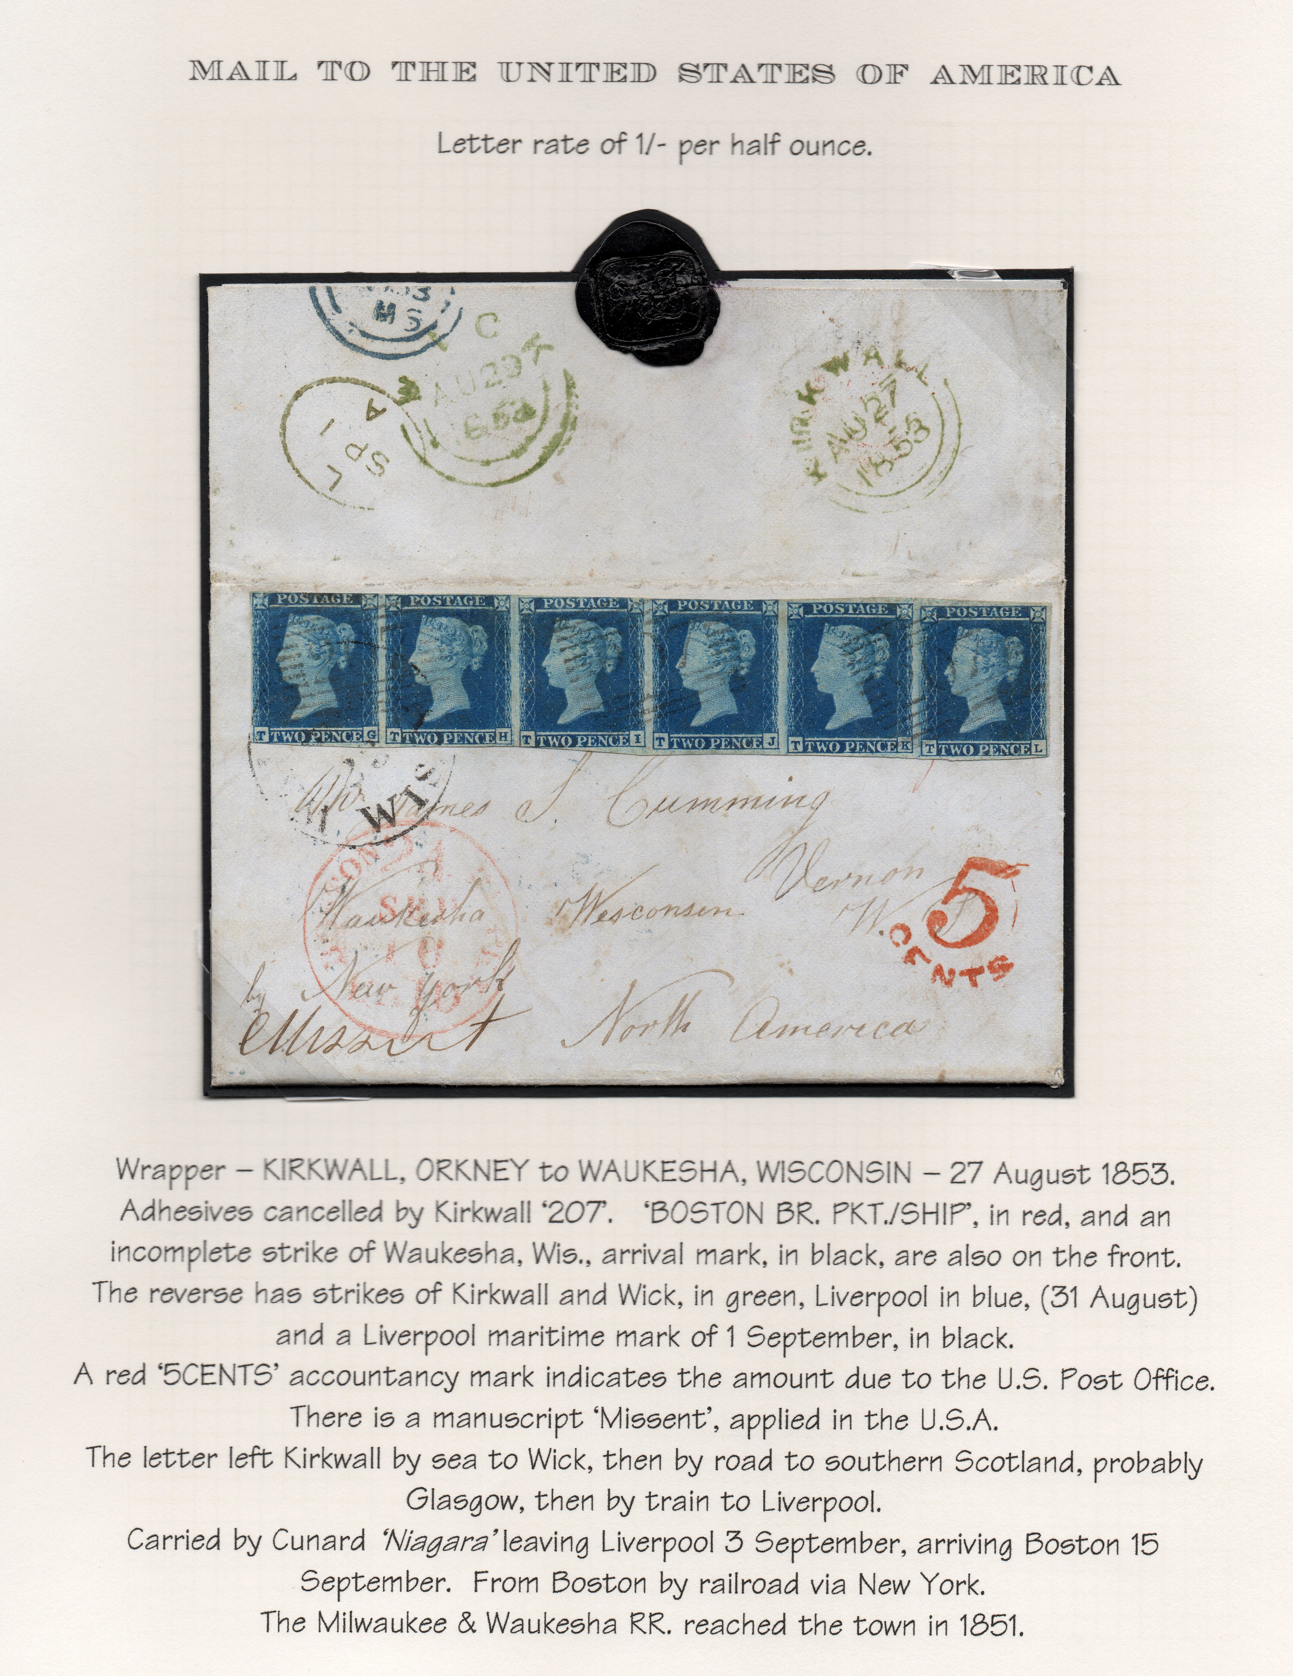

Francis provides us with some additional information:
‘Cover sent to the American Mid-West in 1853. Posted at Kirkwall in the Orkney Islands 27th August 1853, arriving Waukesha, Wisconsin 23rd September. The strip of six 1841 type 2d. adhesives is cancelled by Kirkwall '207' handstamps. Carried by Cunard steamship 'Niagara' arriving Boston on 3rd September. By this time (1853) railroads existed from Boston, via New York and Milwaukee all the way to Waukesha.’

‘Note the manuscript ‘missent’ at bottom left. It appears a sorting office mistakenly sent the cover to Waukesha when careful examination shows it was addressed to Vernon, Waukesha County, Wisconsin. It should also be noted that payment of the 1/- rate was made by the use of six 2d. adhesives. A 1/- embossed adhesive was introduced in 1847 (remaining current until 1856) however distribution was strictly limited, supplies being available only at five London offices, Dublin, Edinburgh and just 109 provincial offices.’

No contributions were received for the ‘my favourite stamp’ section this week and finding something for the ‘One Hundred Years Ago this Month’ section has proved difficult, firstly due to the rarity of commemorative issues generally in January 1921 and the apparent lack of major historical events worldwide in January of that year which could have been commemorated 50 years later in 1971. (What obscure centenaries might be remembered (in order to sell stamps) with issues in 2021 remains to be seen.) I have therefore delved into my Luxembourg collection again finding something that fits, virtually exactly, date-wise.

A major event occurred in Luxembourg on 5th January 1921 with the birth to Grand Duchess Charlotte of a son Crown Prince Jean, later to become Grand Duke in 1964. The birth of Jean came at the end of what had been a seven year period of major upheaval in the Grand Duchy.

Occupied by Germany in the Great War in 1914 and liberated, due to the withdrawal of the occupiers, just five days before the armistice on November 11th 1918, Luxembourg was politically in turmoil. Grand Duchess Marie Adelaide, viewed as having collaborated (when in fact she merely co-operated in order to ensure her people were not ill-treated by the occupiers) was forced to abdicate on 15th January 1919, after a referendum, in favour of Charlotte, after a reign of just seven years.
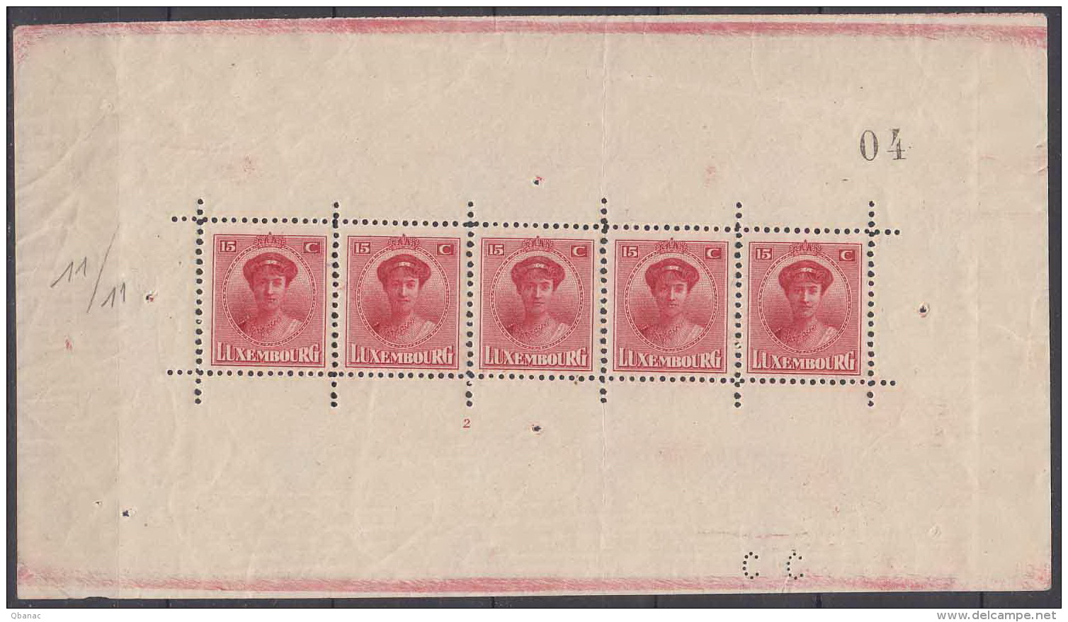

Jean’s birth was marked with the issue, on 6th of January 1921, of a 15c definitive in deep carmine depicting his mother Grand Duchess Charlotte. Designed and engraved by H. Cheffer and recess printed, the first printing was issued in sheets of five perforated 11 and later in sheets of 25 with compound perforations (and again in September 1921 in sheets of 100 perforated 11.5)
********
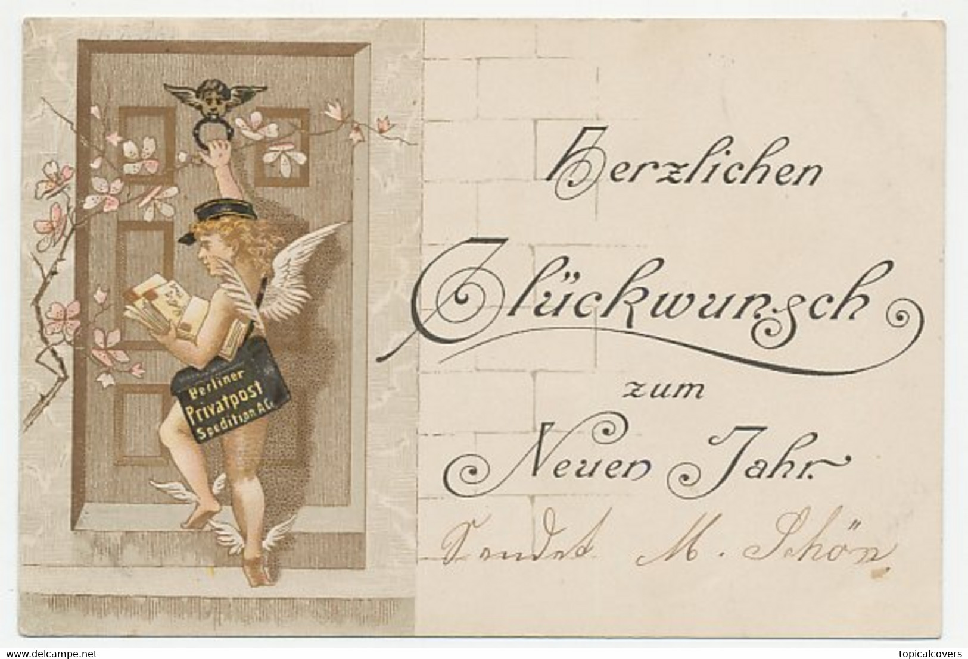
Finally, to wish everyone a Happy New Year, the
reverse of a privately printed Berlin 5pf local postal
stationery New Year Greetings card from 1896
depicting a very angelic postwoman totally unlike
the fella who delivers to me!.

It looks like stamp club meetings might still, despite
the magic vaccine, be some way off so, with your
agreement I’ll carry on with the newsletter until then
Please let me have your contributions and let me
know what you would like to see in it plus, most
importantly, how you all are and what you are doing.

