Ipswich Philatelic Society Newsletter #21

Quite where we will be Covid lockdown-wise by the time you all read this I don’t know, but many of you should have had the jab(s) in your arm by now and might therefore be venturing out into the world again. I just hope people will continue to wear masks and maintain social distancing, I was concerned the relaxation in August would lead many to act as if it was all over, and I fear the arrival of the vaccine may do the same.

Don’t forget its Lockdales stamp auction on 3rd February, It’s a much reduced catalogue with on line, telephone or postal bids only of course and unfortunately no viewing (although photocopies can be supplied)

Anyway, enough of the doom and gloom of Covid, (until we get to this week’s Thematic Corner) I hope everyone is safe and well. Please let me have news of what you’ve all been doing, it’s supposed to be a newsletter to keep members in touch not just simply sharing philatelic articles so I need to hear from you.

********
We start off this edition with another excellent article from our programme secretary Andy Soutar lifting the lid on those tiny little blue German stamps that you first saw many years ago as a young inexperienced collector but had absolutely no idea what they were for. My thanks as usual Andy for a superb contribution.

TAX STAMPS - NOTOPFER/2 BERLIN/ STEUERMARKE - 1948 to 1956

At the end of World War II Germany was divided into four zones of influence and control, the American, British, French and Soviet Zones and the city of Berlin was split into four similarly designated sectors.

The ‘Reichmark’ had been the currency used in Germany since the end of 1923 but it was debased with the printing of more banknotes by the Soviets. On the 18th June 1948 the Allies announced that a new currency the ‘Deutsche Mark’ would be introduced on the 21st June 1948. The Soviets refused its use in Berlin and responded by cutting all land links to and from West Berlin unless the new currency was withdrawn.

The Berlin Airlift 26th June 1948 to 30th September 1949
The Western Allies organised an ‘Air Bridge’ in order to keep West Berlin supplied, 200,000 sorties were flown with 3,475 tons of supplies daily. The Soviets lifted the blockade on 12th May 1949 but the supply flights continued in case the Soviets resumed the blockade.

The obligatory tax
As a way of paying for the massive cost of the airlift, the German Parliament passed a law placing an obligatory tax of 2pf on various types of mail. Special 2pf blue stamps were prepared inscribed ‘NOTOPHER/2 BERLIN/STEUERMARKE’ (Emergency Victims/2 Berlin/Tax Stamp)

This was a flat rate obligatory tax and was added in addition the postage rate. The stamps were first issued on 1st December 1948 and were sold by post offices to be applied to German inland mail. Used only for tax on mail and initially only in the American and British Zones, the tax did not apply to mail to or from Berlin, to the Soviet Zone or on foreign mail. The 2pf tax was later applied, at various times, on mail in Baden, Rhineland-Pfalz and Wurttemberg which were in the French Zone.

When added to postage the 2pf represented a tax of 10% on the inland letter rate of 20pf and 50% on the 4pf printed matter rate, but it was later removed from the latter. Payment of the tax was gradually relaxed on certain types of mail and the 2pf tax could also be paid as part of a single franking.
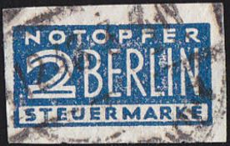
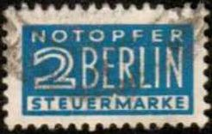

The stamps
The stamps were printed in sheets of 200 in numerous shades of blue, with the first issue being imperforate.
Two types of printing processes were employed incorporating four design types, three watermark papers and no less than sixteen official perforations and imperforate varieties. Stamps exist perforated between 9 & 10 by local postmasters, privately rouletted and imperforate on one, two and three sides.
The obligatory 2pf tax finished at the end of March 1956 having raised many millions of Deutschemarks.
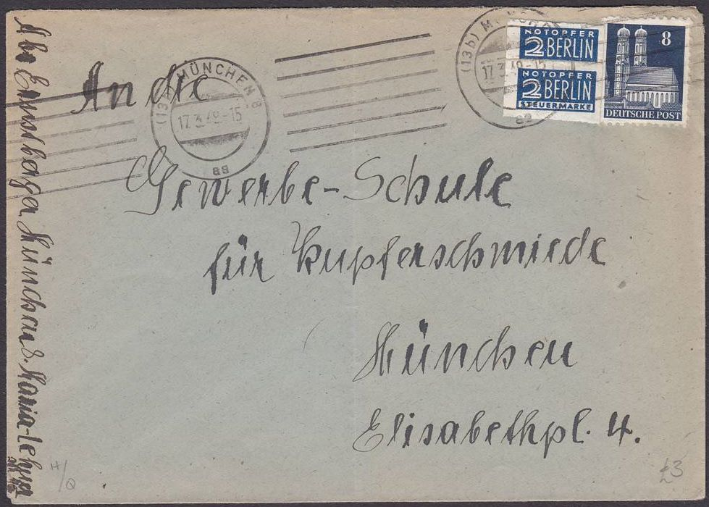
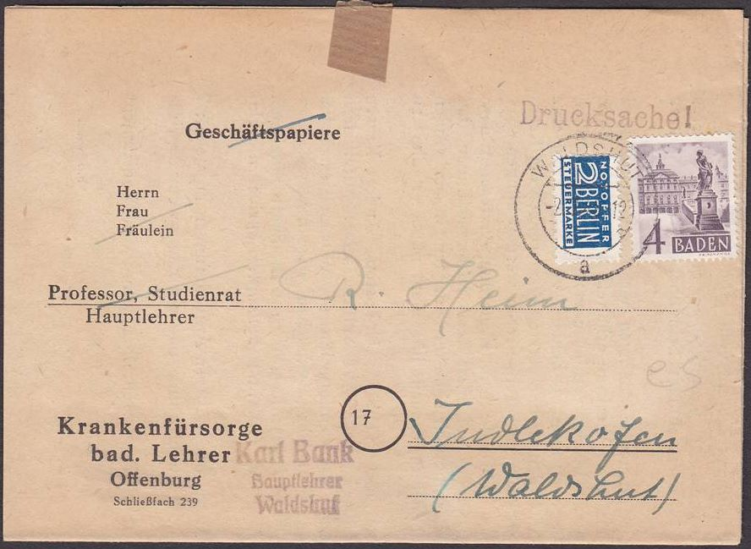

Above left:- 17th March 1949 - A local letter within Munich @10pf rate, bearing 1x 8pf and 2 x 2pf imperforate tax stamps (it was not allowed to pay part of the postage using a 2pf tax stamp!)
Above right:- 2nd July 1949 - Printed matter posted in Baden, @4pf rate, early use of a tax stamp on mail from the French Zone (2nd day of use)
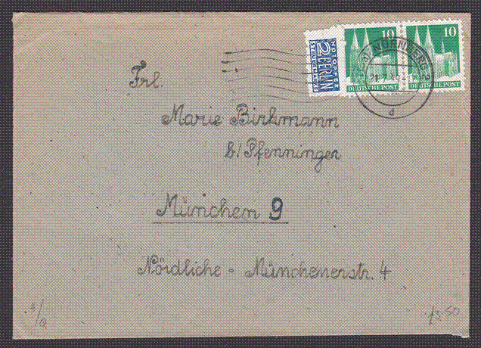
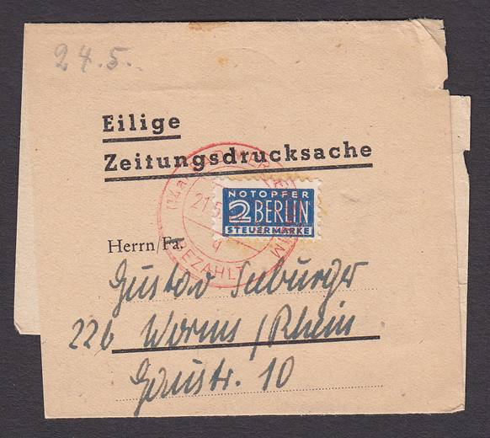

Above:- 21st July 1949, inland letter posted
at Nürnberg, @20pf rate, 2pf tax stamp with
a locally produced perforation of 8 -9.
Right: - 21st May 1949, newspaper wrapper
posted from Bad Mergentheim, postage fee
paid in cash as indicated by the red 'Bezahlt'
(paid) handstamp over a 2pf tax stamp.
********
Next we have a ‘mystery’ item, or rather a mystery cancellation, sent in by Tony Blumfield with a request for help from members. It’s a superb ‘Ipswich Sorting Tender’ strike dated 16th
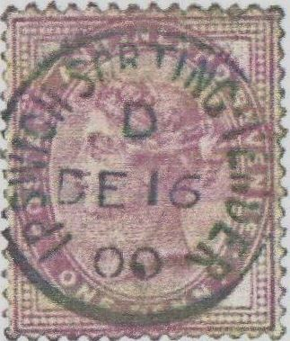
December 1900 on a one penny lilac but Tony’s research has hit the buffers
(see what I did there?) His source shows the East Anglian TPO began in 1929
as a result of a major reorganisation following a period when TPOs, District
Sorting Carriages, Railway Post Offices and Bag Tenders proliferated throughout
the Eastern Region. Connected loosely with this service and also established in the
1929 scheme was the Norwich – London TPO. Can anyone help Tony please?

Chris Bullard has sent an article under the ‘my favourite stamp and why’ heading nominating the superb £1 PUC of 1929. An excellent choice and I am just amazed it has not been nominated before. Chris writes :-

‘Hi there to all society members and wishing you and your families a belated Happy New Year and good health after such a crazy 2020. I hope you find my article interesting and enjoyable to read.

After collecting GB stamps for several years I find the earlier stamps much more pleasing to the eye and attractive due to the effort and detail in their design. Modern stamps seem to be more technical and lack vision and creativity which is a shame when celebrating different anniversaries and events. Digital design I feel lacks the artistic flair needed to please the stamp collector and enhance the album.

I often look at my albums and notice the earlier part of the collection is far superior to the modern. Maybe because I have always enjoyed the traditional elegant designs and the love of art perhaps I expect a ‘Michelangelo touch of class’ every time. I also miss the various plate numbers and watermarks that made these stamps more interesting and made searching for possible varieties more exciting.

With that in mind I would like to share with you my favourite GB stamp, the beautiful 1929 PUC £1.
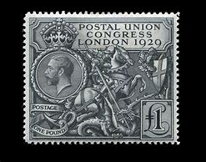
The stamp has the lot, style, elegance, class and very British.
Expensive at the time, equivalent to £65-00 in today’s money
but worth every penny. Its sheer size stands out, tall and bold
proudly stating the strength and power of the British Empire.

It was only the second British commemorative stamp to be
issued after the British Empire Exhibition design of 1924-25

The ‘Instructions to Artists’ for the submission of designs
stipulated ‘it is desirable that any design for the £1 stamp
should be either of national significance or symbolic of the
assembly which it is intended to commemorate’.

Every four years the Postal Union Congress (PUC) used to meet to discuss the issues involved in sending stamps across international borders. The 1929 meeting was held in London and to commemorate the event the Post Office produced a set of five stamps in all.
The £1 stamp was designed by Harold Nelson and features the head of King George V and an image of St George and the dragon which had originally been drawn as an essay for the 1924 British Empire Exhibition stamps. A committee was formed to solicit designs and the chosen design from the 16 submitted was approved by Queen Mary as the King was ill with septicaemia.
Recess printed by Bradbury,Wilkinson & Co, the contract was given to them on condition that the stamp would be engraved by J.A.C.Harrison. He had to be given special permission to do the work as he was under contract to Waterlow & Sons at the time. Original trials were made in numerous colours, black was chosen as it was felt it would sharpen the contrast and accentuate the darker parts of the engraving.
The stamp was given a unique design of GVR Royal Cypher watermark and was issued in sheets of 20 (4 horizontally x 5 vertically) A total of 61,000 were printed together with four, small format, low values printed by Waterlow making up the 1929 Postal Union Congress set, criticised at the time because of the high face value stamp.
As the other stamps in the set were low values, it has been speculated that the value of the large stamp may have been set at £1 to produce a more impressive souvenir for the visiting postal delegates to the Congress. Alternatively, others have simply seen it as a cynical attempt to extract as much money as possible from stamp collectors (Editors note: a trait currently successfully employed with modern GB issues!).

Stanley Phillips commented in Gibbons Stamp Monthly that the stamp was "Britain’s disgrace". He also said that"...the policy of issuing a set consisting of four low value stamps and then a one pound denomination is absolutely indefensible’’.
Not only was it much bigger than the other stamps, but the £1 value had a very elaborate design showing St George attacking a dragon. It seems odd that such violent imagery was used to promote a conference on international co-operation. However this was because the image, although not adopted, had originally been designed for the British Empire Exhibition stamps of 1924, and the image of St. George (the symbol of Britain) slaying evil forces is therefore perhaps less surprising. The designs which were finally chosen for the stamps of 1924-25 British Empire Exhibition certainly displayed the same perfection and style.
Its very interesting how we all started collecting stamps, whether it was a parent, grandfather, best friend or brother /sister .The result remains the same, something grabbed our attention and led us to this interesting and fascinating hobby.’
My thanks to Chris for a splendid in depth article on a wonderful stamp and for your kind remarks about the newsletter.
********
Now for an interesting first contribution from Ron Ambrose.
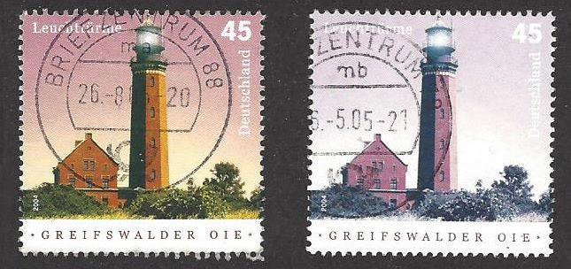
Ron, who specialises in Germany has turned up an interesting
variety, error or is it just faded in some way? It’s a F/U copy
of SG 3279, hugely different in every colour (at right) to the
normal stamp (at left). It’s clearly not a ‘missing colour’ error
or the use of a ‘wrong’ colour as every single area from sky to
lighthouse, to foreground is all different to the normal stamp.
That said if it has been affected by exposure to sunlight I
would have expected the colours to be simply faded or less
intense rather than every colour appearing so different (the brown and green in particular) Ideas please?

********
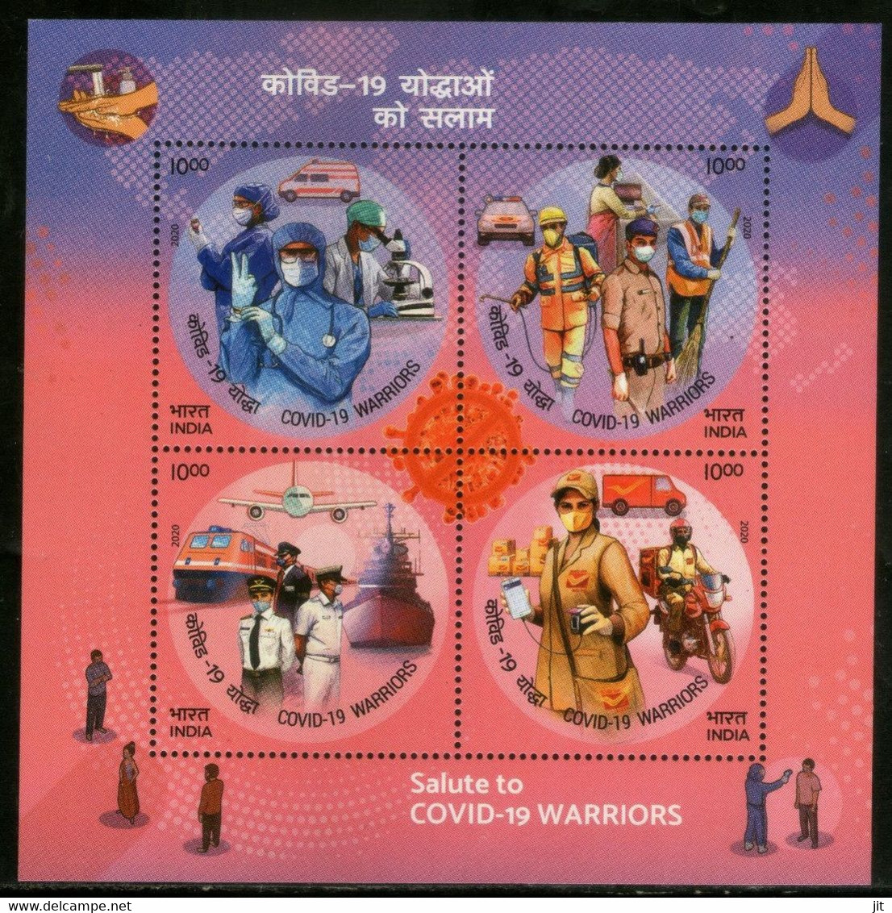

Finally this week a quick dive into ‘Covid thematic corner’ with an
attractive miniature sheet from India, sadly one of the world’s worst
affected nations. The sheet entitled ‘Covid warriors’ pays tribute to
all those involved in the fight against the virus from the health and
emergency services to transport and the postal service. It’s a nicely
executed sheet to add to that ever growing collection of Coronavirus
thematic items.

I think it’s probably time we left Covid behind (at least as far as the
‘thematic corner’ is concerned anyway) so next time we’ll do that
‘beer and birds’ topic I mentioned but I would still like to hear the
suggestions of some of our thematic collector members.

********
As it looks like the newsletter may well have to go on for some time yet please let me have your thoughts about the content. Is the balance right? Too much postal history or too little, too many stamps or too few, I want to hear what you would like to see featured and I will try to oblige unless of course, as it’s your speciality, you might like to write something. There are some great articles lined up for future editions from Francis Dunn, Colin Whitmore, Ray Deeks, Steve Teuma and Andy Soutar, plus my some of my rubbish if necessary, but I need contributions from all members, a little titbit such as ‘my favourite stamp’, (that’s an easy one surely), ‘thematic corner’ or perhaps details of any non-philatelic things you’ve been getting up to.

