Ipswich Philatelic Society Newsletter #22

Some very sad news to start this week’s edition. As most of you will know by now Fred Smith passed away at home in Felixstowe on 27th January after a long illness. Fred was a stalwart of our society having served for many years on the committee, latterly as treasurer. He was primarily a keen Swiss collector amassing a large amount of fine material which he showed at various societies.
Fred worked for some time in Australia on a project connected to his UK employment for Anglian Water and travelled worldwide with his wife Cynthia. After Cynthia’s death he moved from the family home to a new apartment overlooking the sea at Felixstowe enjoying lengthy bracing walks along the seafront while his health allowed, his stamp and record collections and travelling.
Prior to his illness he travelled extensively to Thailand, Turkey (as part of his interest in the Gallipoli campaign), South Africa (to Boer and Zulu wars sites), Namibia, the Greek Islands and Italy.
A member of both Leiston and District and Sudbury and District philatelic societies Fred was renowned at Sudbury, in addition to his displays on ‘members evening’, for the prompt payment of his subscriptions, brought about no doubt by his time spent chasing late payers whilst treasurer at Ipswich! He was a good friend to many and will be greatly missed. Our condolences go out to his daughters Debbie and Carolyn and his son Tim.

Sadly I also have to report the deaths of Ipswich member Brian Chambers and long time classic GB dealer Ray Watts who was well known for many years to all who frequented fairs.

********
Did anyone buy anything in Lockdale’s auction? I hear, thanks to the winter and the latest lockdown no doubt, that prices were high. A lot of Victorian covers estimated at £50-60 fetched £3000! I sometimes wonder if auctioneers and sellers estimates are total guesswork. As you may know I have decided to hang up my tweezers (on a dealing as opposed to collecting level) and all my stock will be going into auction but I’m going to wait until the Covid restrictions are relaxed enough to allow it to be properly viewed.

As it stands I have done nothing to prepare my stock for auction despite having had months of lockdown in which to get on with it, nor have I even finished mounting up all the material destined for my Benelux collections which leads nicely into a detailed article from a determined Colin Whitmore who, unlike me has clearly made good use of his time.
********
Album Contents by Colin Whitmore

I expect a lot of you like me, started your collections way back in your childhood and I remember going to a second-hand / antique shop in south London on a Saturday morning to spend my 1/- pocket money on a few stamps. The owner had a couple of stock books with what, to me then, were treasures and I remember the thrill at buying a penny red for a few coppers. One time I even secured an ivory head variety, what a scoop!

Anyway, over the years the collection grew and the interest became more specialised. In the flats where I lived one of the neighbours was a member of the British Philatelic Society or some such and I got a lot of help and guidance from him.

Other things in life tended to put stamps on the back burner, like girls, pubs, you know the sort of things, and the biggest one was having to work for a living, so the collection was dormant for long periods at a time.
Once I was married and settled down with most of the jobs done on the house etc. my mind turned once again to the collection and I eventually sought out and joined the I.P.S. having moved up to Ipswich.

By this time the collection had grown to some twenty plus albums – it’s a lot more now – and when I wanted to check whether I wanted something or not, or indeed put something in the collection, it is a case of remembering which album I need to check in. For instance Great Britain is held in 8 volumes, you can make

a guess but it is frequently wrong. I have often thought that what I need to do is make a list of exactly what each album contains, but I have never had the time to do it, there is always something requiring my attention. Until now when along came Covid! I’ve done all the jobs I can think of so no excuse any longer.

Question was, how to set about this. Do I write it out as a list or use the computer? The latter is preferable. You can save it, alter it as required, print and read it (unlike my writing). Do I use a database? No, just Word and Tab across for the columns. Do I just list year to year? Add SG numbers? Add page numbers? Add notes as applicable?

I made a start based on the above starting with Great Britain:

GB Vol 1 1940 to 1970
pp 1 – 121 SG 1 – 840
A1 – 4 Reg. G7 – 14, IoM 1 – 7, NI 1 – 11, S 1 – 13, W 1 -12
B1 – 6 Dues D1 – 76
(Most of it is self explanatory, ‘pp’ being page numbers of general issues, ‘Reg’ being Regional issues and ‘Dues’ of course Postage Dues.)

Fairly pleased with the outcome I progressed with the rest of Great Britain and the collection but I soon realised that things were to become a little more complicated when I tackled the British stamp issues used at overseas post offices such as Kuwait, Bahrain etc. as a lot more information was required:
GB Overprints abroad Arrowfile Binder Blue (Window Bookcase)
1948 – 1960 Bahrain SG 51 – 116 Cat pp 82
1888 – 1927 Bechuanaland SG 9 – 98 82
1885 – 1914 Levant, Turkish Currency SG 1 – 40 115Paras,Piastres
1905 – 1920 “ British “ SG L1 – 17, Z176 – 187 115
1920 – 1921 British PO’s in Constantinople SG Z186 – 201, SG 41 – 50 116 Piastres
1916 British Field Office in Salonica SG 51 – 58 (Levant) 117
1942 Middle East Forces SGM 1 – 21, SGMD1 – 5 117 M.E.F.

First of all, my collection is housed in one main bookcase with an overflow in a second bookcase (sited on the window wall of my den), so the location is inserted. I have also yet to find title labels that will stick to the Arrowfile binders, so they go by colours. There is more information about the country. I have inserted the catalogue page number for reference and on the extreme right are ‘clues’ to typical overprints. The box above only shows part of the GB used abroad as an example.

I had thought that the listing would take up an A5 page and just be handy on the bookcase, how wrong can you be! I am now nearly at the bottom of the 5th A4 page with about a quarter of the collection yet to catalogue! Just a thought, I could print off sections of the list as applicable to each country so I have one small sheet for the albums of a country as well as the ‘Master List’.

Recently I had a couple of IPS boxes to check through and as I had done a trial print of my “Album Contents List” I used this when putting my purchases, 149 items, away in my collection. It certainly was much quicker than before! Actually it has not taken as long to do as I thought it would. I would think I have spent about six, two hour sessions inputting the information from the albums and then going back over with the catalogue to input any additional information, taking it country by country. It has been quite enjoyable refreshing my memory looking through the collection and learning some new facts from the catalogue.

********
My thanks to Colin for an excellent article and, for the computer literate, some great ideas on how to lay hands on the right album quickly, I’m sure he has put many of us to shame. My only effort to reorganise my collection was confined to moving Belgian railways and dues into a new binder and my only effort to label my albums was a failure as all the labels dropped off!

On next to a great response following Tony Blumfield’s request for information about his Ipswich TPO cancellation in the last issue. I am delighted to print both answers I have received as it demonstrates just what I was hoping the newsletter would achieve, contact between members, assistance with questions and
general sharing of detailed knowledge, my thanks to Francis Dunn and Steve Teuma for their fantastic contributions, Tony will I am sure be delighted..

Francis writes, ‘Research carried out by Mrs Gladys Driver (later Mrs Wilton) who was a well known postal historian specialising in postal history and was a prominent member of our Society tells me that mail coach
contracts (London-Ipswich) expired in1846 and arrangements were made for the railway to take over.
Guards were appointed and in 1847 a contractor was also appointed for a Royal Mail Cart to take a guard and mailbags from the post office to Ipswich Station which was at that time, prior to the building of the tunnel, off Wherstead Road. The Ipswich Sunday Sorting Tender started in 1849.
In 1858 the Ipswich District Sorting Carriage was established. This enabled mail sorting for various areas on certain of the London bound 'Up Night Mail' trains. Unfortunately economics forced the withdrawal of these Sorting Carriages in 1869.
In late 1868 the Ipswich Sorting Tender began as a ‘Night Mail’, the ‘Day Mail’ being introduced later.

Steve neatly adds further information on more recent changes to the service, ’With regard to Tony's query about the TPO marking, I'm afraid he has it slightly wrong. The East Anglia TPO was totally different from the Ipswich TPO that he has, prior to 1929.
The East Anglia TPO actually started in 1869 as a sorting tender between Norwich and Ely and was indeed reorganised in 1929 as Tony stated. However, the Ipswich TPO is totally different and started as a sorting tender in 1872 between Ipswich and London, after various amalgamations.
The cancel on Tony’s QV penny lilac was sent to Ipswich in Nov 1876. The code letter 'D' at top was to indicate ‘Day Up’ or ‘Down’ along with code 'C'. Codes 'A' and 'B' indicating ‘Night Up’ and ‘Down’.
The information has been gathered from the book - The History of the Travelling Post Offices of Great Britain by H S Wilson published by the Railway Philatelic Group in 1975. The book has a lot of information on both the Ipswich TPO and East Anglia TPO which eventually merged (but too much to write here)’

********
Time now to show some stamps and covers starting with a contribution from Mike Hole about the UPU 75th Anniversary on 10th October 1949 with a first day cover bearing a block of the low values sent to Ireland.
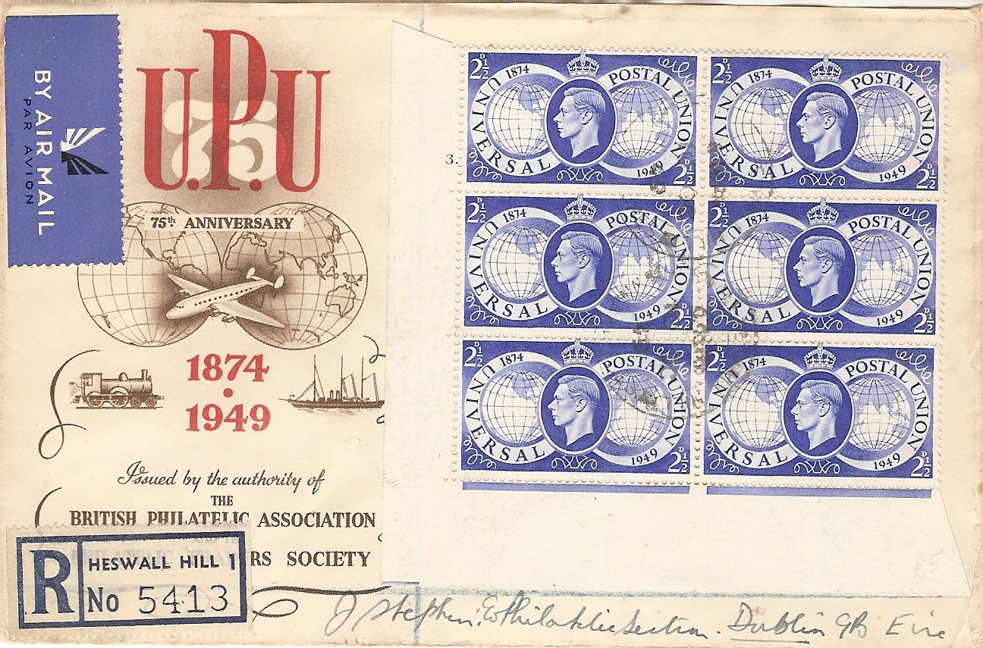

The first international postal congress was convened in Berne, Switzerland on 15 September 1874 (although a conference in Paris had been attended by the world's major postal administrations in May 1863). On 9th October 1874 Britain and 21 other nations signed a convention, effective from 1st July the following year, which embodied the agreements reached on the ‘reciprocal exchange and unimpeded transit of letter posts
and the uniformity of tariff levels’. To maintain this co-operation the congress instituted the ‘Union Generale des Postes’; at the following congress, held in Paris in 1878, the name was changed to ‘Union Postale Universelle’ or UPU (Universal Postal Union).

Next is an incorrect double US postage charge on an interesting cover from Francis Dunn. Francis writes:

‘A transatlantic cover sent from Edinburgh in 1843. At Boston a postal clerk applied a charge for inland mail to New York at double the correct rate. The stamps are four margin except for the right hand end, bottom half. It is always difficult to find four margins all round on long strips (six stamps in this case)’
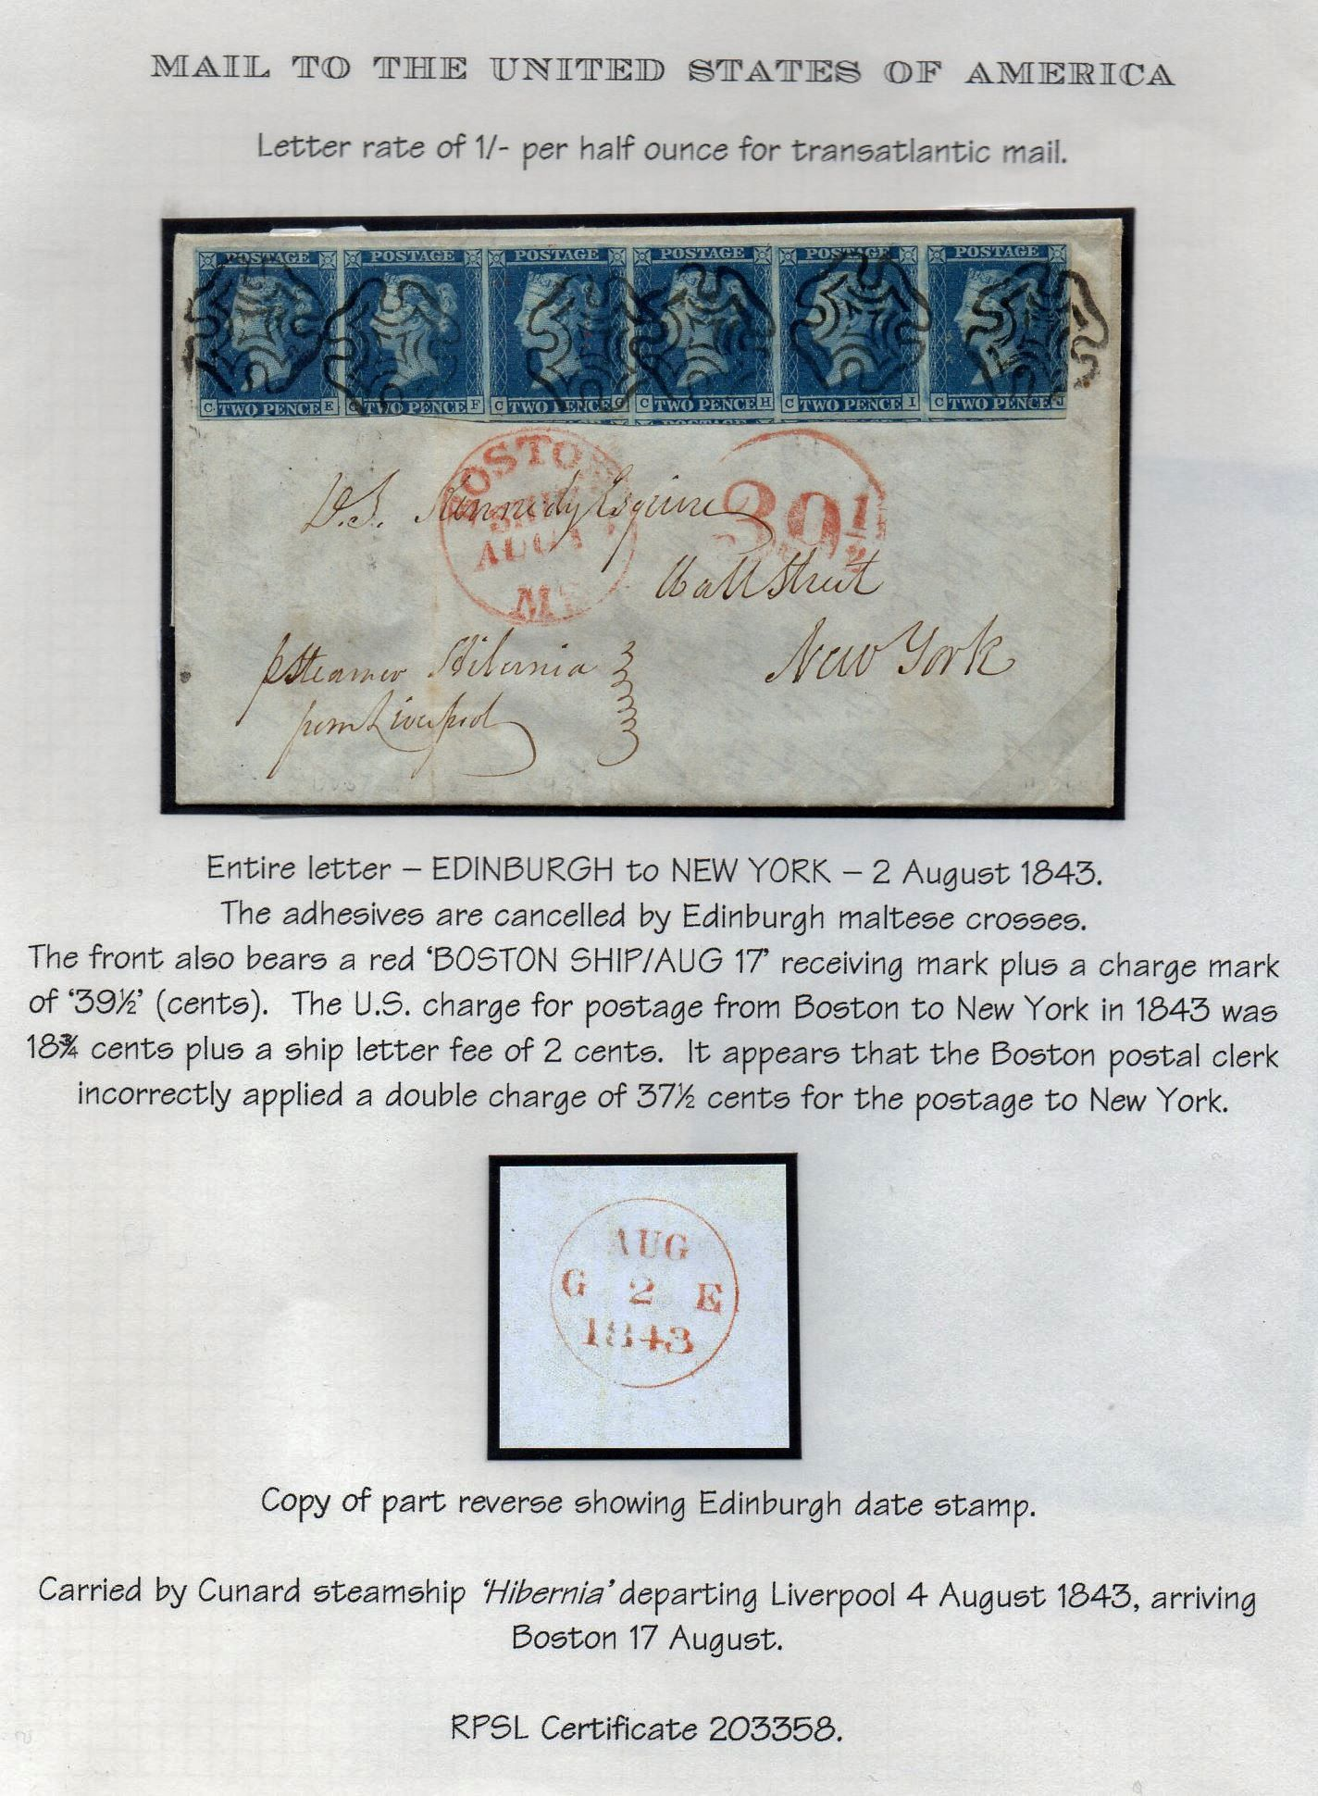

My thanks to Francis (who apologies unnecessarily for a manuscript amendment I doubt many of you will even notice) for another lovely item.
********
That’s all for another issue, please keep reading and contributing. There are some excellent articles to come next time but I am always in need of short items on thematics or ‘my favourite stamp’ to fill those frustrating gaps which seem to occur at the foot of every page! A two or three liner will do and I’ll find the image (hopefully) Get your vaccinations done (it’s very cold walking from the car park to the vaccination building at Trinity Park by the way!) and please keep well everyone.

