Ipswich Philatelic Society Newsletter #24

I know it is now over two weeks since the Prime Minister announced his ‘road map’ out of Covid lockdown but I had just finished Newsletter #23 when he let us in on it and I wasn’t disposed to try to fit it in belatedly. Just a thought, but why is it a ‘road map’? Less than 15% of people actually use road maps these days (50% of the population probably don’t know how to anyway) so why couldn’t it just be a good old fashioned ‘plan’?
On then to how it might affect us. In the midst of all the stages of the ‘road map’ and the ’tests’ each step must pass I know when I might get a haircut but I am still in the dark about where we stand on meetings of societies and clubs like ours and on stamp fairs. I was concerned that ‘social distancing’ was not pushed more prominently amidst the promises about pubs, clubs and holidays but whenever we and fair organisers can open again must surely hinge on both that and whether the owners of the venues like Marks Tey hall, and in our case, the school, are prepared to host events and meetings again. Also of course, what level of attendance might we and other much smaller societies expect? Numbers might actually fall to levels where some venues are too large post Covid.
Whatever happens please be assured that the committee are making plans and discussing any changes that will enable us to meet again as soon as it is both possible and safe to do so, in September perhaps? In the meantime the packet and this simple communication must suffice to keep us in touch with our hobby, however in order to continue with a healthy packet more books are urgently needed. A few books from each packet member will make all the difference. Please try to contribute to keep the packet going strong.

********
No news from any members this week so on to the articles starting with a little ‘poser’ sent in by Ray Deeks.
Basic Better Best
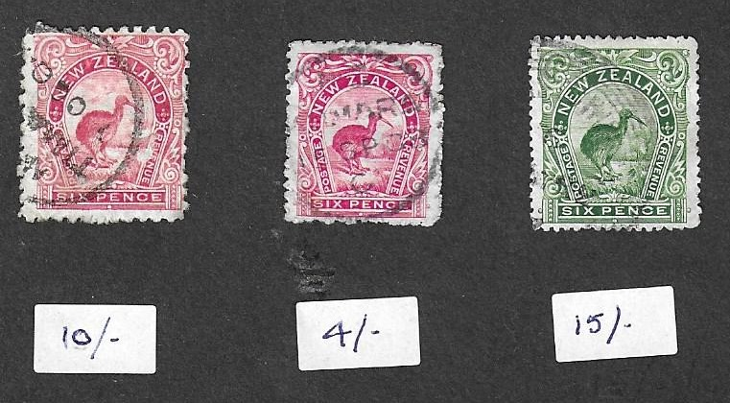

Like many of us, Ray, whilst perusing one of his many collections (and probably an area of that collection he rarely visits) wondered how catalogue values might have changed since he originally collected the stamps compared to, if not today, than certainly in a far more recent catalogue.
One stamp in particular and its subsequent re-issues captured his interest and he poses a question about their values for members to consider. No cheating allowed, (you will be cheating no one but yourselves) and if you do look it up and your ‘more up to date catalogue’ happens to be more recent than Ray’s (which isn’t really that recent) then the answer might even have changed again anyway, so here we go.
Ray has chosen the New Zealand Kiwi pictorial issues of 1898 in pink (left), 1899 reduced red (centre) and the small version of 1907/8 in green (right) which are pictured above. Shown below each stamp is the SG catalogue value from 1970 but which, by 2014 (Ray’s latest catalogue), is the basic, the better and the best value-wise? Also for the more knowledgeable among you, what (without looking), were the values in 2014?

My thanks to Ray for our first quiz question which hopefully may lead others to send in their ‘posers’ too.

Colin Whitmore emailed about an item in Stamp Magazine which stated: ‘Security printer De La Rue could soon be producing a new type of stamp. It has been in discussion with governments over plans to introduce ‘Covid-19 passports’, or certificates of immunity.’ Which governments are not specified and whether the ‘stamps’ will be a once and for all adhesive in a ‘passport’ or one applied at regular intervals to a card after say a test or booster jab is not clear.

I can however think of one person, Edward Hitchings Esq., long time chairman at Sudbury, who will be rubbing his hands together at the thought of adding Covid passport stamps to his collection of Vehicle Excise Licences, Duty free tobacco stamps for pensioners, and Argentinian prostitutes three monthly ‘clear of disease’ stamps (yes really!)
********

Colin also writes a piece which he has called ‘May the ‘Force’ leave you alone’. (The article might also be entitled ‘Another example of Government bureaucracy has turned up’)

Some of you will know one of my interests on the thematic side is motorcycles on stamps. I have chosen those last three words deliberately as I am not interested if there is a small ‘smudge’ in the corner of a design deemed to be a motorcycle. The motorcycle must be the main theme of the stamp design for it to be included in my collection. Some time back I made contact with and joined Motor Filatelisten Nederland (Motorcycle Philatelists Netherlands). The benefits are that we pool information about finds, new issues etc. There are opportunities to buy and sell stamps, and there is a quarterly Newsletter. The downside is that the newsletter is in Dutch, but as they say ‘a picture speaks a thousand words’ and all new issues are pictured. If an article looks interesting I scan it and use Google Translate to find out what it is about. In any case, about a month later I get an English translation via e-mail.

All the aforementioned information is really background to the main reason for my writing this article and that is to bring to your attention a worrying aspect of International Post probably due to BREXIT! I mentioned above that as a member of MFN I receive regular Newsletters and recently one dropped on my doormat, but one with a difference.

In addition to the usual Dutch MFN stamps (and a cheery Christmas greeting in Dutch) there was sticky plastic tape inscribed with ‘Force’ in purple along the top, and the tape had been stuck over the top of the stamps. Further investigation showed that the A5 plain white envelope weighing only 58gm had been opened and resealed with this tape fully inscribed, back and front, ‘Home Office Border Force’. The stamps were 1.5cm down from the top edge of the envelope and a little bit of care when fixing the tape could have avoided them. The tape will not peel off the stamps!
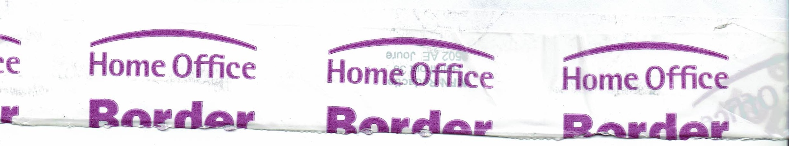

What was the need to open this innocuous envelope?
They have never been opened before. The point is that
a lot of genuine used stamps are going to be ruined if
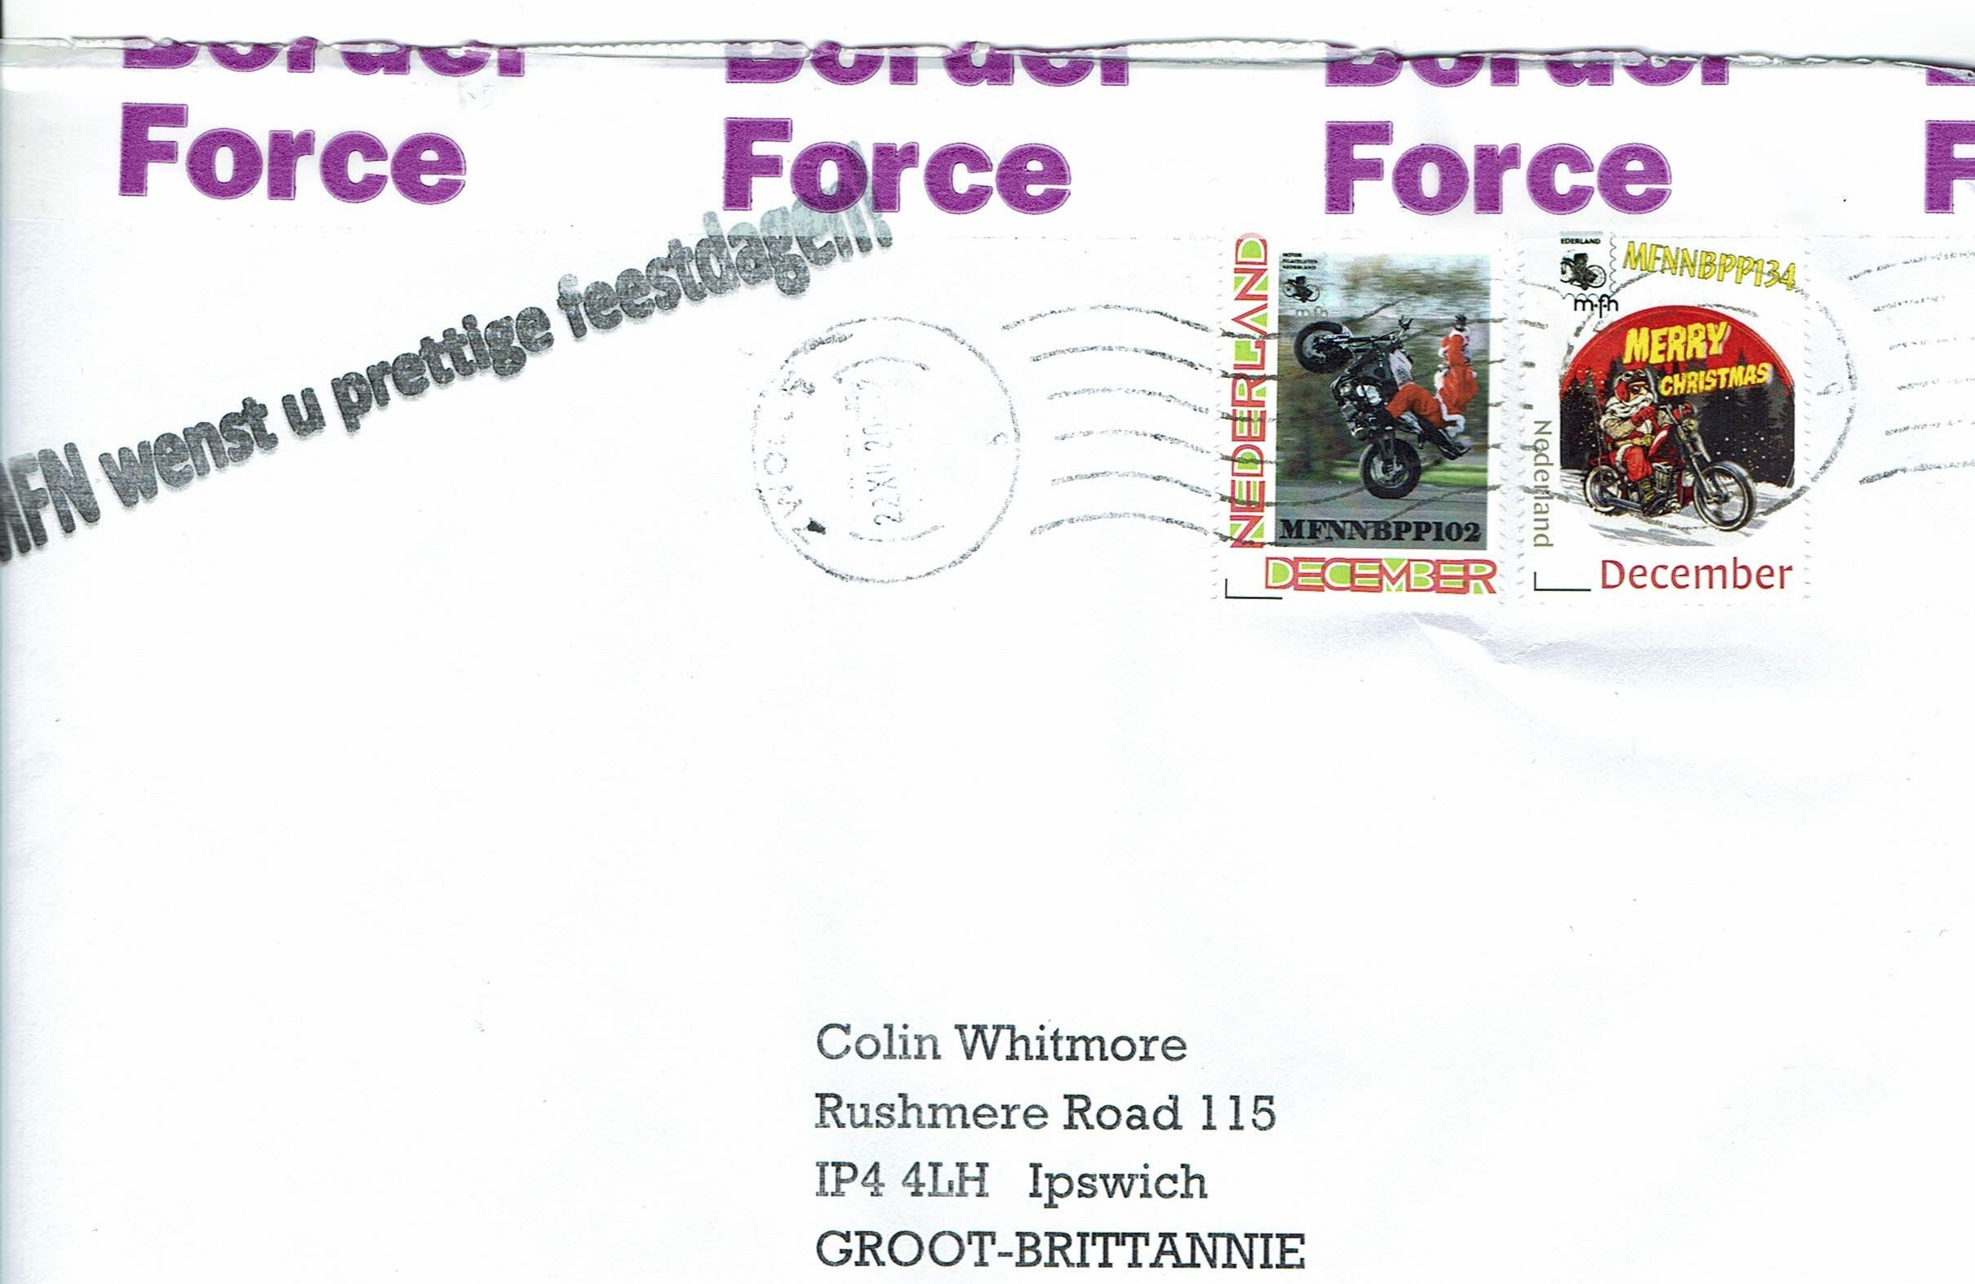
the Border Force carries on like this to any degree. I sent
an e-mail enquiring as to why my mail was opened
and had an auto reply saying I would get a response
within four days. Two weeks later I had another e-mail
from the Home Office saying I would get a reply in
twenty days. I shall not hold my breath!

********
My thanks to Colin for this article and for re-assuring me
that I am not alone as regular readers will recall an item
of mine, similarly opened for examination, formed the
main article in Newsletter #1. Colin did get a his reply
stating, as I expected, that it was opened in order to check for prohibited or restricted items (in an envelope?)

Next my thanks to Andy Soutar for another superb contribution, is there no end to what this man collects?

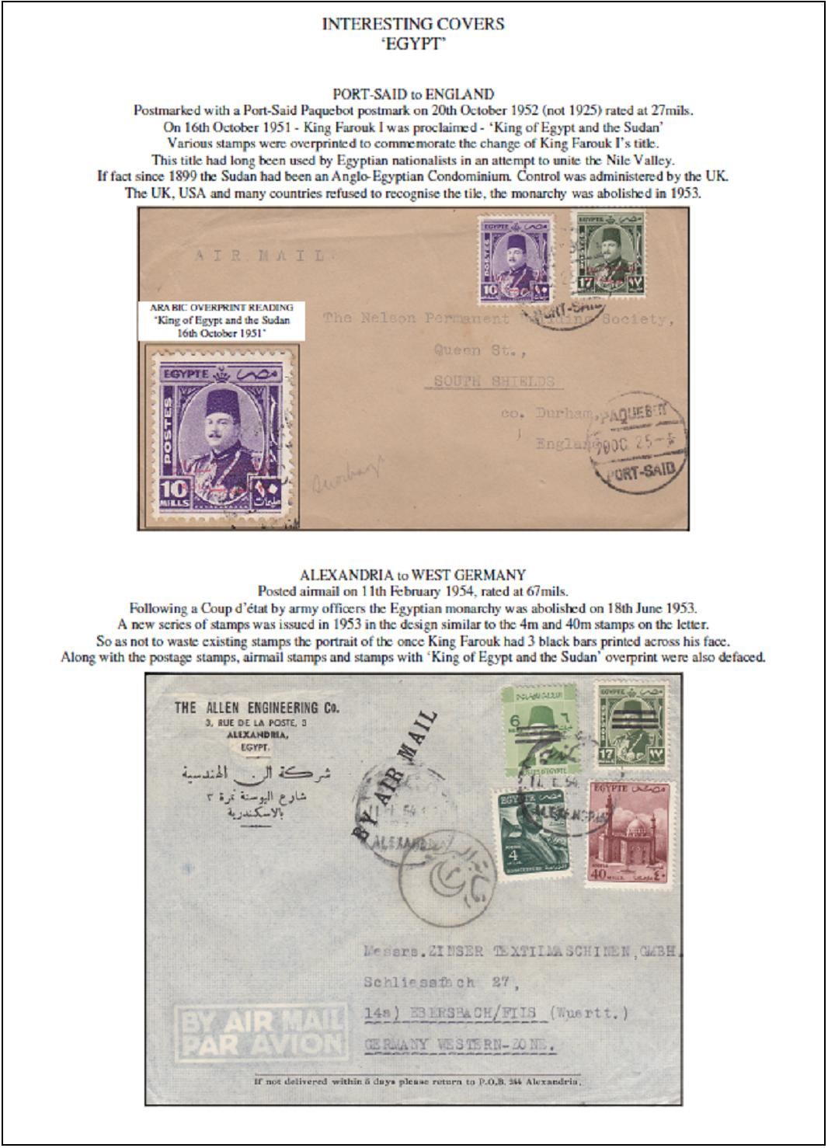

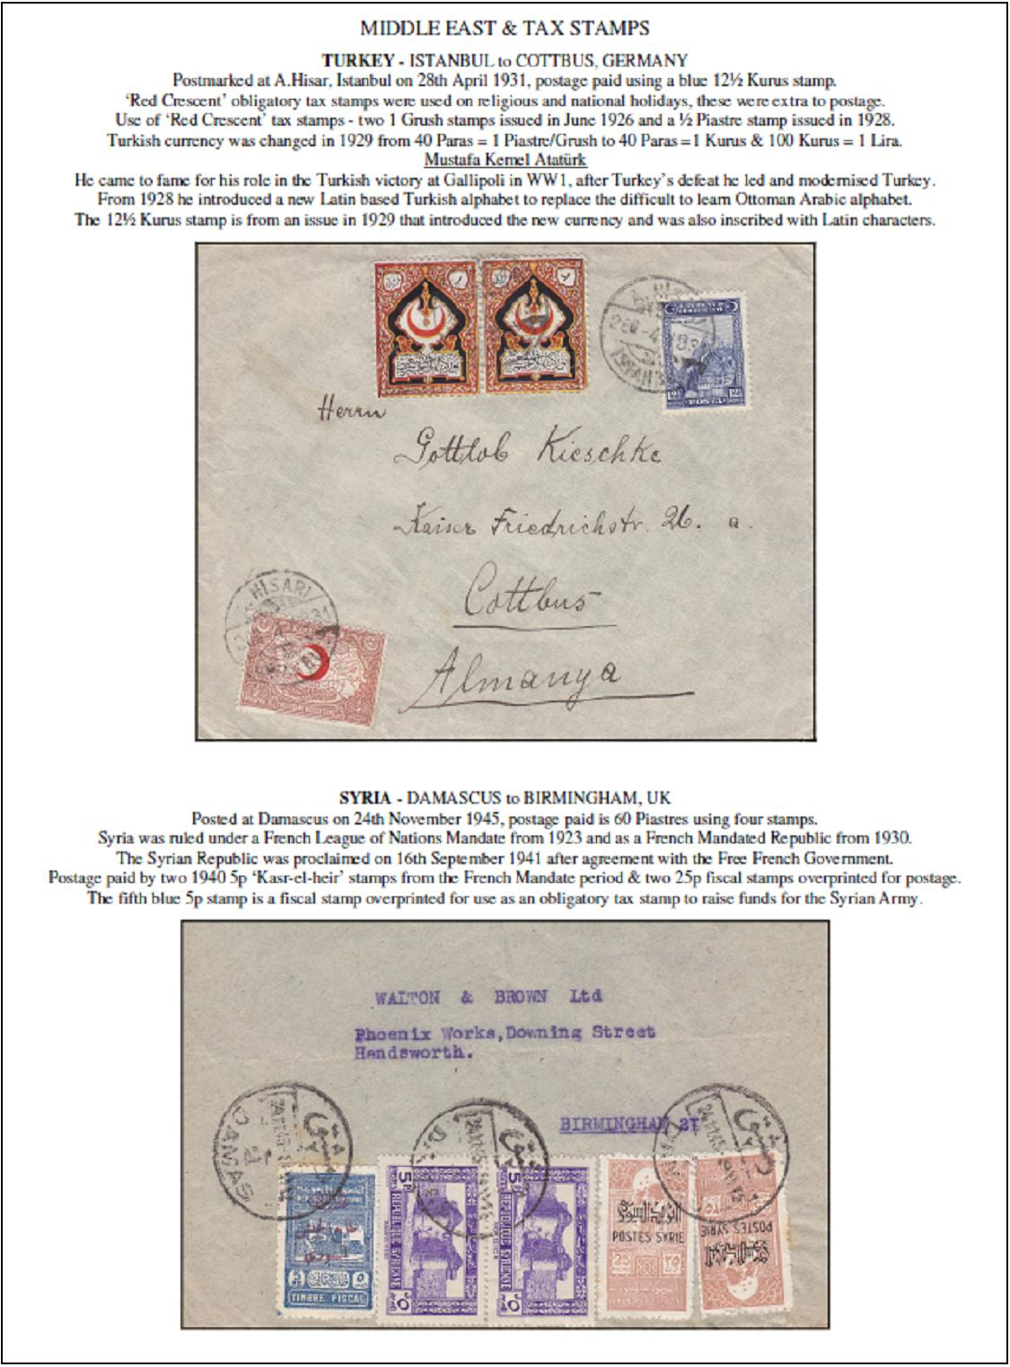

Please keep your contributions coming in, the next edition marks the newsletter’s first anniversary!

