Ipswich Philatelic Society Newsletter #26

First of all our belated best wishes and congratulations (in addition to those they received from H.M. The Queen) to Pearl and Selwyn Cooper who celebrated their Diamond Wedding anniversary in late March. Sadly due to lockdown rules they were unable to celebrate with their family in person (or hit a nightclub) but thanks to the miracles of modern electronic science hopefully they were all able to speak to each other.

Things are slowly returning to normal on the auction front with Lockdales now able to offer viewing once again, albeit ‘by appointment only’ in time for their 21st April stamp sale, the catalogue for which is on line now. I am still ploughing through my stock ready for auction but it’s taking forever as I hadn’t realised just how much I have accumulated over the years. That might however be a good thing as unrestricted viewing will probably be allowed again by the time I am ready. CPA at Ely have a postal / online auction on 1st May
Nick Barber has lots going on in Felixstowe at the moment. He ran a ‘timed’ sale between 17th and 24th March. Did anyone leave a bid and was anyone successful I wonder? Please let me know. He is opening a new, larger, shop at 152 Hamilton Road, hopefully before his next auction which is planned for April 21st. Dependent on the next step in the lockdown easing plan, viewing for that auction, although probably still by appointment, should be available at the new shop from April 12th. A new website is also planned.

Incidentally I had toyed with the idea of making this Volume 2 Number 1 but hopefully it won’t be another year before we meet again and the newsletter will be defunct so it’s just plain old number 26. On now to this week’s articles starting with another excellent contribution from Ray Deeks (what doesn’t this man collect?)

********
‘Around the world in under two weeks’ by Ray Deeks
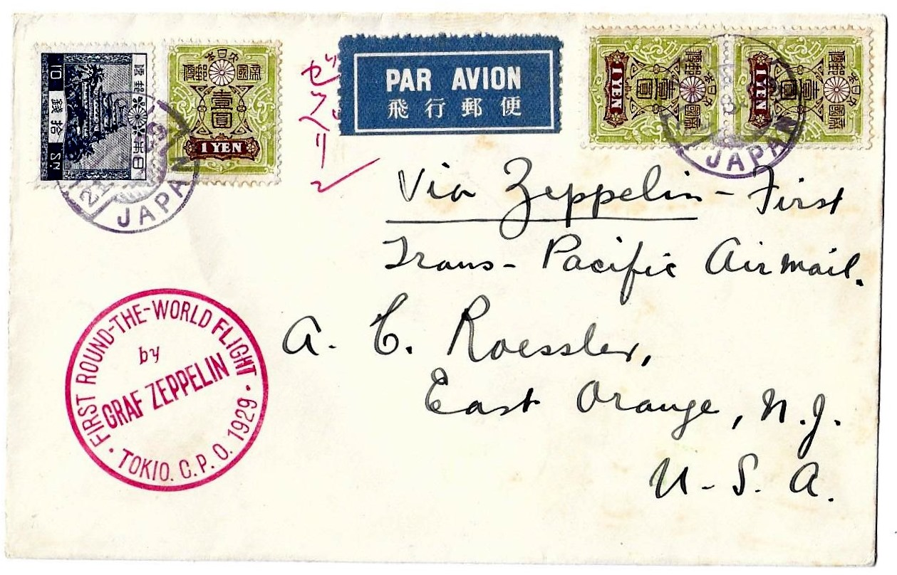

Cover from Japan – U.S.A. leg of the Graf Zeppelin 1929 Round the World Flight

Hugo Eckener, manager of the Luftschiffbau Zeppelin company and commander of the Graf Zeppelin, dreamed of a flight around the world in under two weeks but in order to finance the attempt money had to raised. William Rudolph Hearst the U.S. newspaper magnate pledged $100,000 for the English language rights to the story but, as German newspapers could only afford $12,500, Eckener had only half the amount he needed. However stamp collectors, who love mail carried by air to distant countries, were prepared to pay a premium for flown covers thus making up the shortfall.
The first element of the ‘American Dream’ was to be a flight from Lakehurst U.S.A. to the home base at Friedrichshafen prior to a 7000 mile leg over Russia, Siberia then south to Tokyo avoiding high mountains but risking extreme weather. The cover illustrates the Pacific crossing from Japan to San Francisco, Los Angeles and back to Lakehurst. Charles Rosendahl, who was the captain of the airship Los Angeles, built in Germany then handed to the U.S.A. as Great War reparations, was on board representing the US Navy and was the sender of this cover. Although the flight received much publicity it took 23 days rather than just 14.

Now we come to another fascinating guest item from John Ineson President of Sudbury and District Philatelic Society. Members may recall a previous article from John in Newsletter #14. He has once again kindly allowed me to use one of his ‘jottings’. This time it’s a piece he has put together for the Anglo-Boer War Philatelic Society looking at ‘impossible’ dates on Mafeking cancellations. Many thanks John.
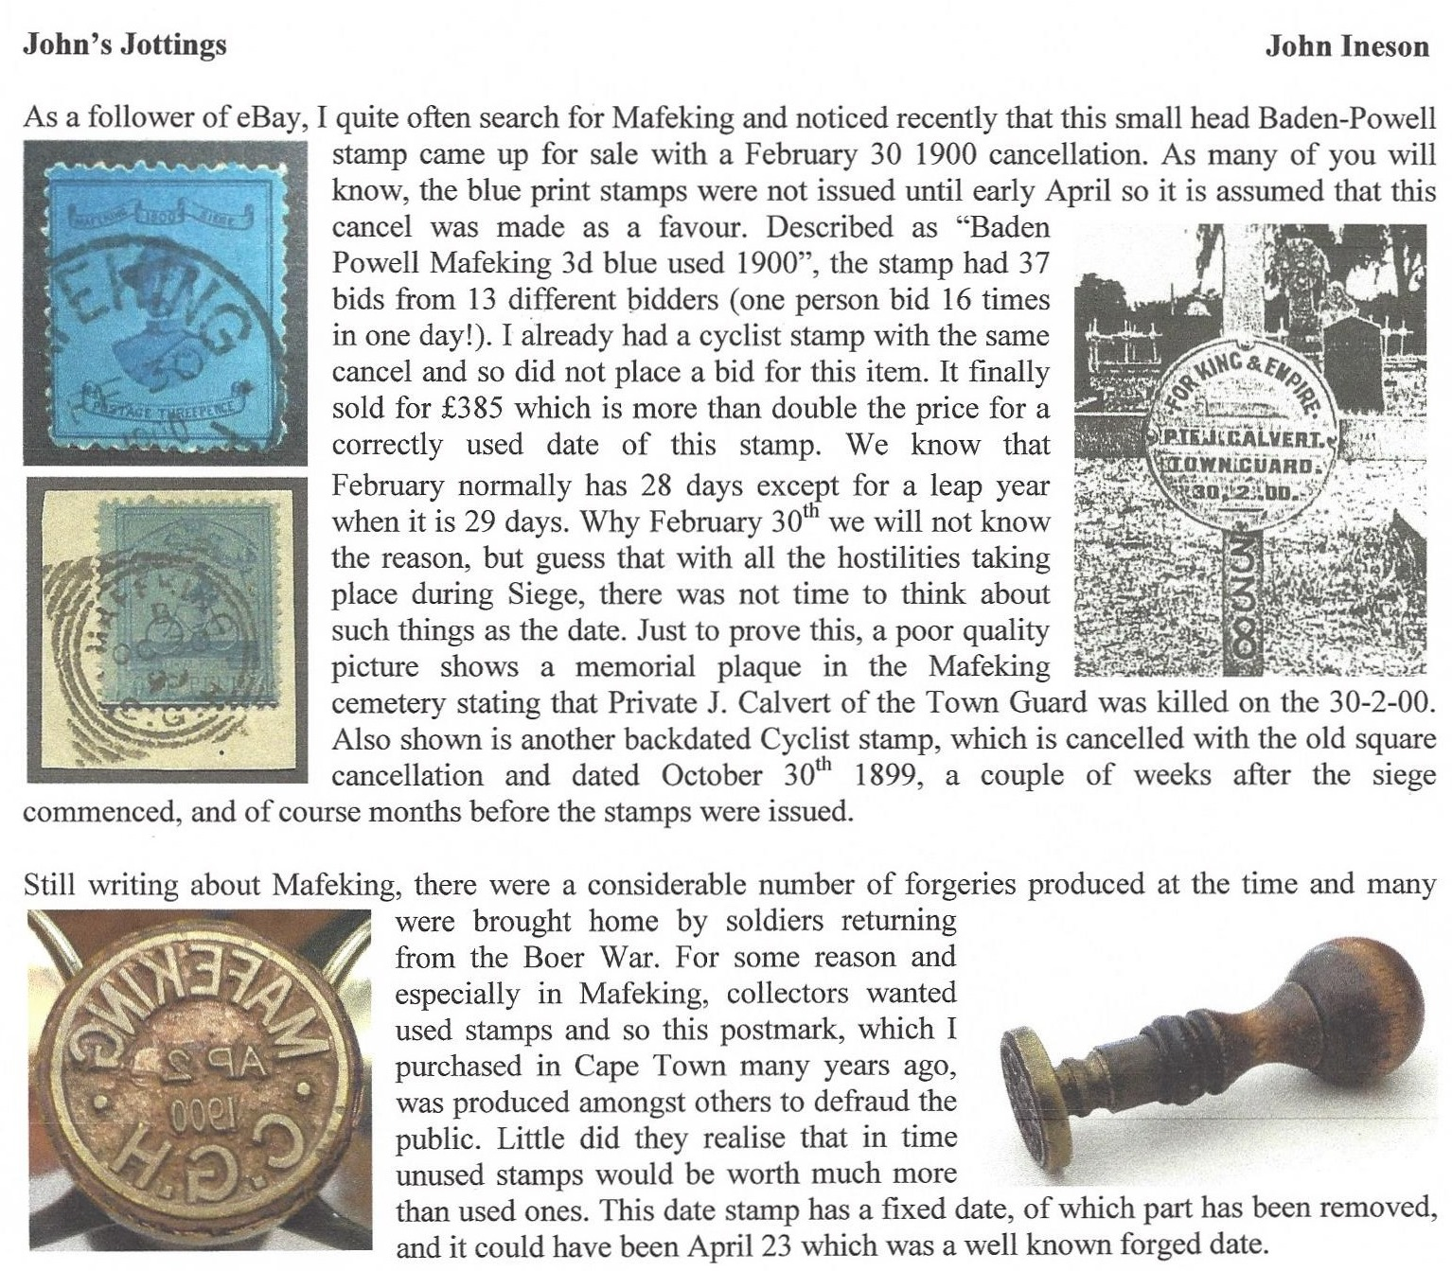

********
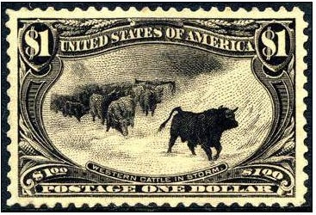
Peter Walkey has sent in his nomination in the ‘My Favourite Stamp’
section choosing the magnificent £1 PUC of Great Britain but great
minds obviously think alike as it was nominated by Chris Bullard and
has already appeared in Newsletter #23. Fortunately Pete also sent in
an alternative in the shape of the stamp nominated by stamp clubs in
the U.S. as ‘the most beautiful stamp ever issued’ namely the $1 of the
1898 Trans –Mississippi Exposition issue depicting ‘Western Cattle
in a Storm’. (Taken from a 1878 painting called ‘The Vanguard’ by
Scottish artist John A. MacWhirter, it actually features a group of
cattle in a snowstorm in the Scottish Highlands). My thanks Peter for two admirable choices!

Next it’s another outstanding item of early Transatlantic mail from Francis Dunn who writes :

‘A rare transatlantic cover from the Maltese cross period at the one ounce rate of 2/- franked by 12 x 1841 type 2d. blues. More often than not senders paid postage in cash for the higher rates. Postal clerks then applied appropriate manuscript marks to indicate payment. In 1847 the first 1/- stamp was introduced so providing an easier alternative although distribution was limited to relatively few post offices.’
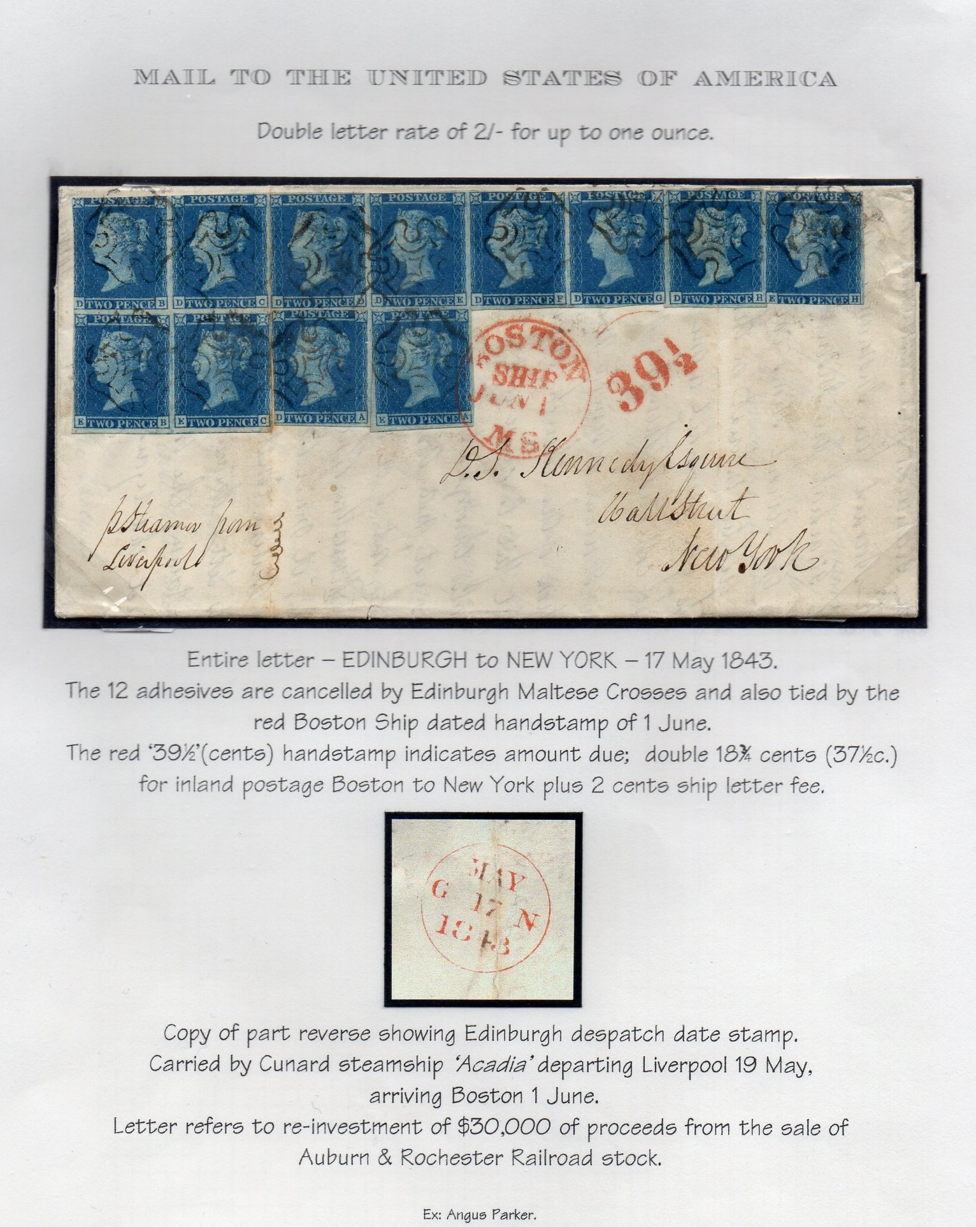

Finally this week it’s thanks once again to Andy Soutar for a fascinating item featuring yet another area of his collecting interests with material I had never even seen before and which I had absolutely no idea about.
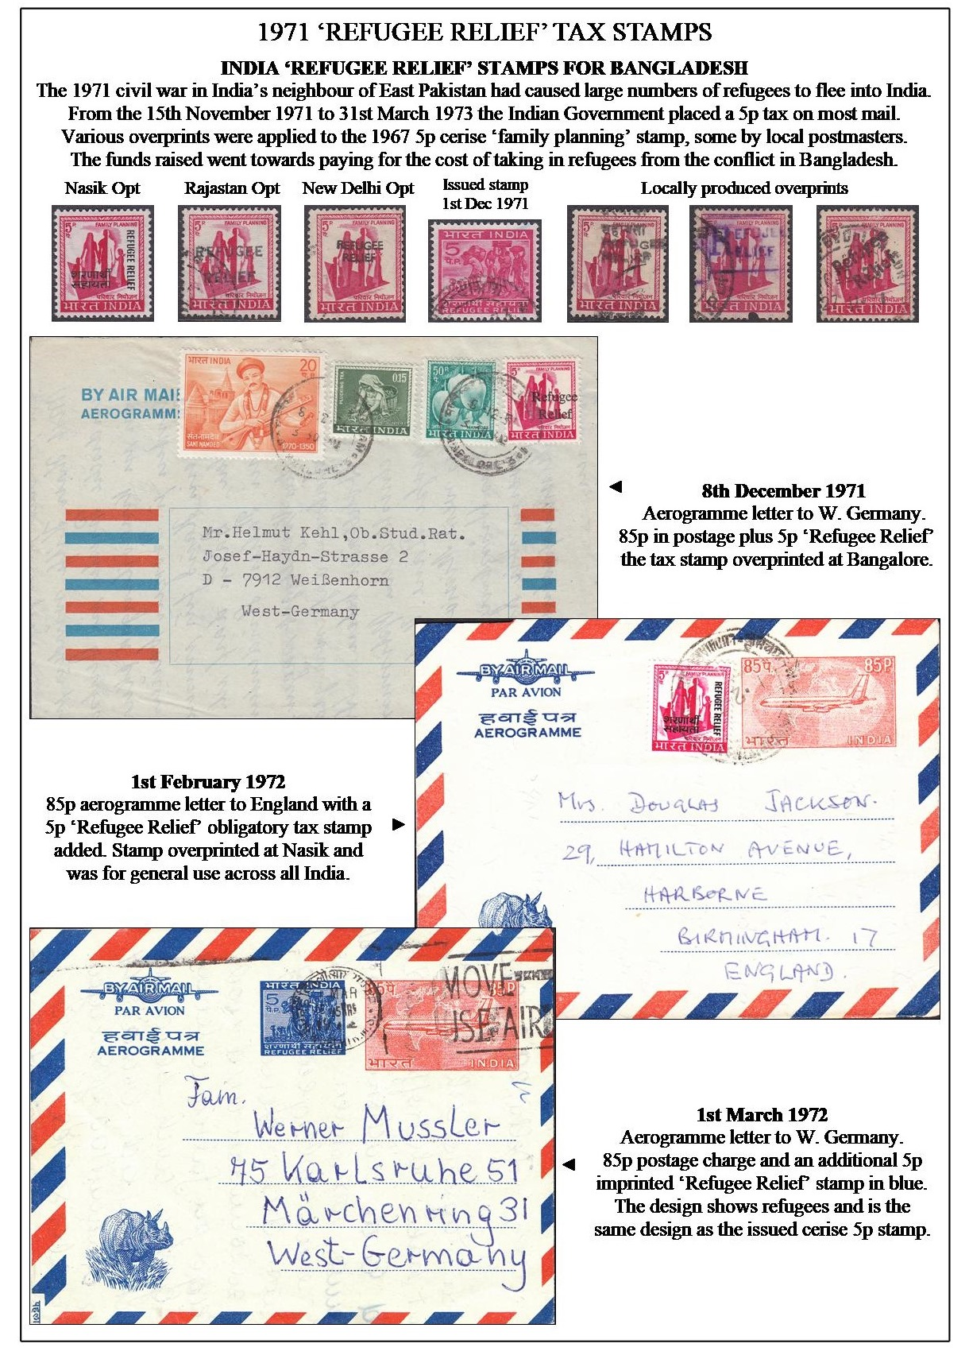

That’s all for another issue. Keep well, get that second jab and please let me have comments and articles.

