Ipswich Philatelic Society Newsletter #27

Some positive news about stamp fairs this week. Marks Tey will restart on Saturday 17th July and will be held on the third Saturday of September and November before going monthly in 2022. Braintree will start again on June 27th but will not run in 2022 while Sue Pope hopes to start Lavenham again later in the year.

Did anyone manage to view the lots at Lockdales between 12th, when viewing by appointment started, and the auction itself on 21st and did anyone actually manage to buy anything? I’m told prices are still high due to the demand lockdown has caused. I’m just hoping they stay that way until I get all my stock ready to sell!

By popular demand (well one member suggested it – thank you Francis the cheque is in the post) this issue features lots of bits and pieces of junk from my Benelux collections, KLM airmail covers, thematics and, for Cinderella collectors and aviation historians, some rare publicity labels from early French aviation ‘fêtes’.

********
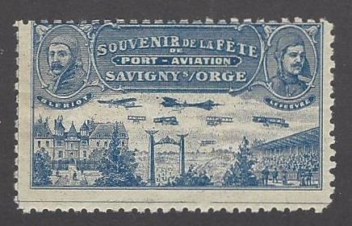
First we fly to France in 1909 and 1910. The French were probably the
first to have organised aviation meetings attended by thousands intent
on witnessing early aircraft and their brave pilots competing for huge
cash prizes for both racing and endurance. The Port-Aviation airfield at
Savigny-sur-Orge hosted a number of events in the Summer of 1909 at
which Louis Bleriot practised for his famous channel flight in July and
the world’s first ‘stunt’ pilot, Eugene Lefebvre, demonstrated his skills.

Reims hosted an international meeting, the Grande Semaine d’Aviation in
August with prizes of Fr 200,000 on offer. Bleriot and Lefebvre were in
the French team which contested The Gordon Bennett Trophy race on the 22 22nd finishing second and fourth respectively. Lefebvre treated the crowds
to a display of stunt flying described by the New York Times as ‘driving at
the crowded tribunes, turning in the nick of time, sailing off and swooping
down again until he made the flags on the pillars and the plumes on the hats
of the ladies flutter and so played at will for our applause’. He was fined $4
by the judges for displaying ‘excessive recklessness and daring’!

Only nine days after the Reims event Lefebvre was killed in a crash at the Port-Aviation field at Juvisy when
the plane he was testing dropped to the ground from twenty feet. In doing so he became the first person to die whilst actually piloting a powered airplane and just the second person to be killed in an airplane crash.

Caen hosted a week long event at the end of July 1910 immediately followed by a three day show at Troyes.
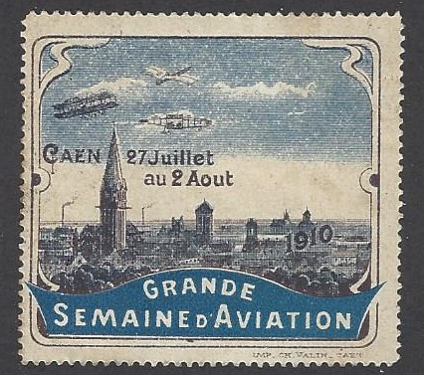
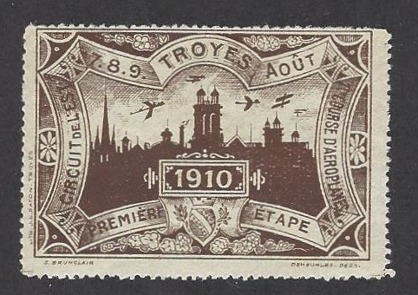

A mere four years later skills honed in the early displays and races in the skies over France turned to mortal combat in those same skies in the Great War. Also I wonder what the excited public of 1909 and 1910 would make of it if they were to find themselves at Duxford or watching the Red Arrows a 100 years later.

After satisfying the Cinderella collectors it’s time for something for the thematic fans and as promised a number of newsletters ago it’s the overdue ‘Thematic Corner’ item on beer and birds. Firstly I have chosen a new Belgian issue on maxi-card, the Cuckoo by Andre Buzin, in my opinion the world’s greatest bird artist.
From the Hawfinch and Blue Tit in 1985 to the Cuckoo

in 2021 Buzin has produced over 120 stamps featuring
birds for the Belgian Postal Service together with many
other issues depicting animals and flowers. Birds are
undoubtedly one of the most common themes found on
stamps worldwide but Buzin’s designs are surely at the top top of the tree (see what I did there?) and could easily
form a thematic collection on their own if split into the
different types of bird. All European birds of prey and
owls have featured as well as water and garden birds.
Buzin’s designs are surely a must for bird collectors.

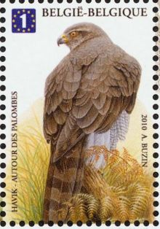
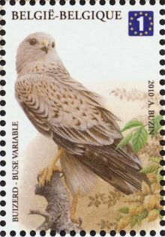
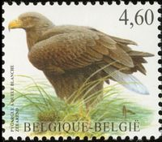


On now to the subject of beer, my particular thematic interest as most will know. I include it here to show some of the many different items depicting the topic which can be incorporated into a thematic collection.

Meter marks are still extensively used in the EU especially in the beer trade. There 1000s to choose from and a collection of beer meter marks alone would fill many albums. Shown here are meter marks from two
towns advertising their local brew. Also beer themed are mini-sheets, cancellations, maxi-cards and postal
stationery including a rare postal stationery card advertising beer and tobacco withdrawn shortly after issue
following public complaints. Beer themed items are endless!
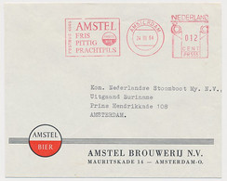
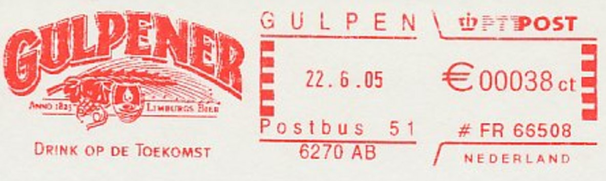

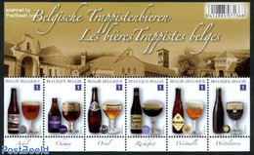

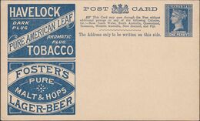

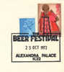
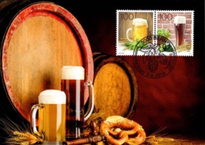

On now to an interesting aspect of Belgian philately, the ‘Dominical’ or ‘do not deliver on a Sunday’ label.
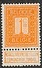
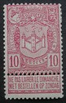
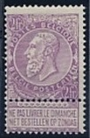
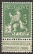
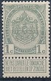
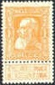
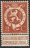

All the issues from the definitives of 1893 (SG 78-92) through to the Albert I definitives of 1912-14 (SG 133-150) carried a detachable label or bandalette at the bottom of the stamp instructing in both French (’Ne pas livrer le Dimanche’) and Flemish (‘Niet bestellen op Zondag’) that the item was not to be delivered on a Sunday. These bandalettes were known as ‘dominical’ labels implying their association with the Lord’s Day.
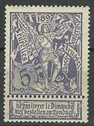
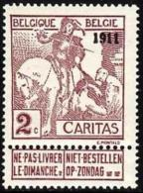
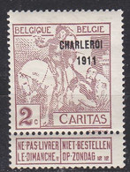
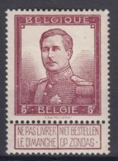
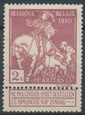

Belgium, which became independent in 1830, was traditionally an area with strong Catholic links as opposed to the Netherlands which was primarily Protestant. When the Belgian Post Office was established letters were delivered seven days a week. In 1884 the Belgian Catholic Party was elected and the new Catholic Postmaster decided that people should be allowed to choose whether they got post on Sundays. Thereafter stamps carried the labels which had to be removed if a Sunday delivery was required. Similar wording appeared on postal stationery and letter cards where the sender had to cross out the wording on the label to consent to a Sunday delivery.

In practice very few people would have detached the label. Belgium was a small country with good transport links. Letters posted on Sundays, Mondays, Tuesdays, Wednesdays and Thursdays were unlikely to have been delivered on a Sunday anyway. Labels were generally only removed by the irreligious or in cases where delivery was so urgent that any day would suffice. The stamps with labels were issued until 1914. During the Great War almost all of Belgium was under German control so the Post Office virtually ceased to function. After the war, largely due to the increased power of the unions, Sunday deliveries were abolished.

The two registered covers below show the different views of the sender and / or the recipient. The one on the left from Mons to Brussels indicates Sunday delivery is an option (label removed) whilst the cover to France on the right, to a titled lady in a chateau, should not be delivered on a Sunday (labels left intact)
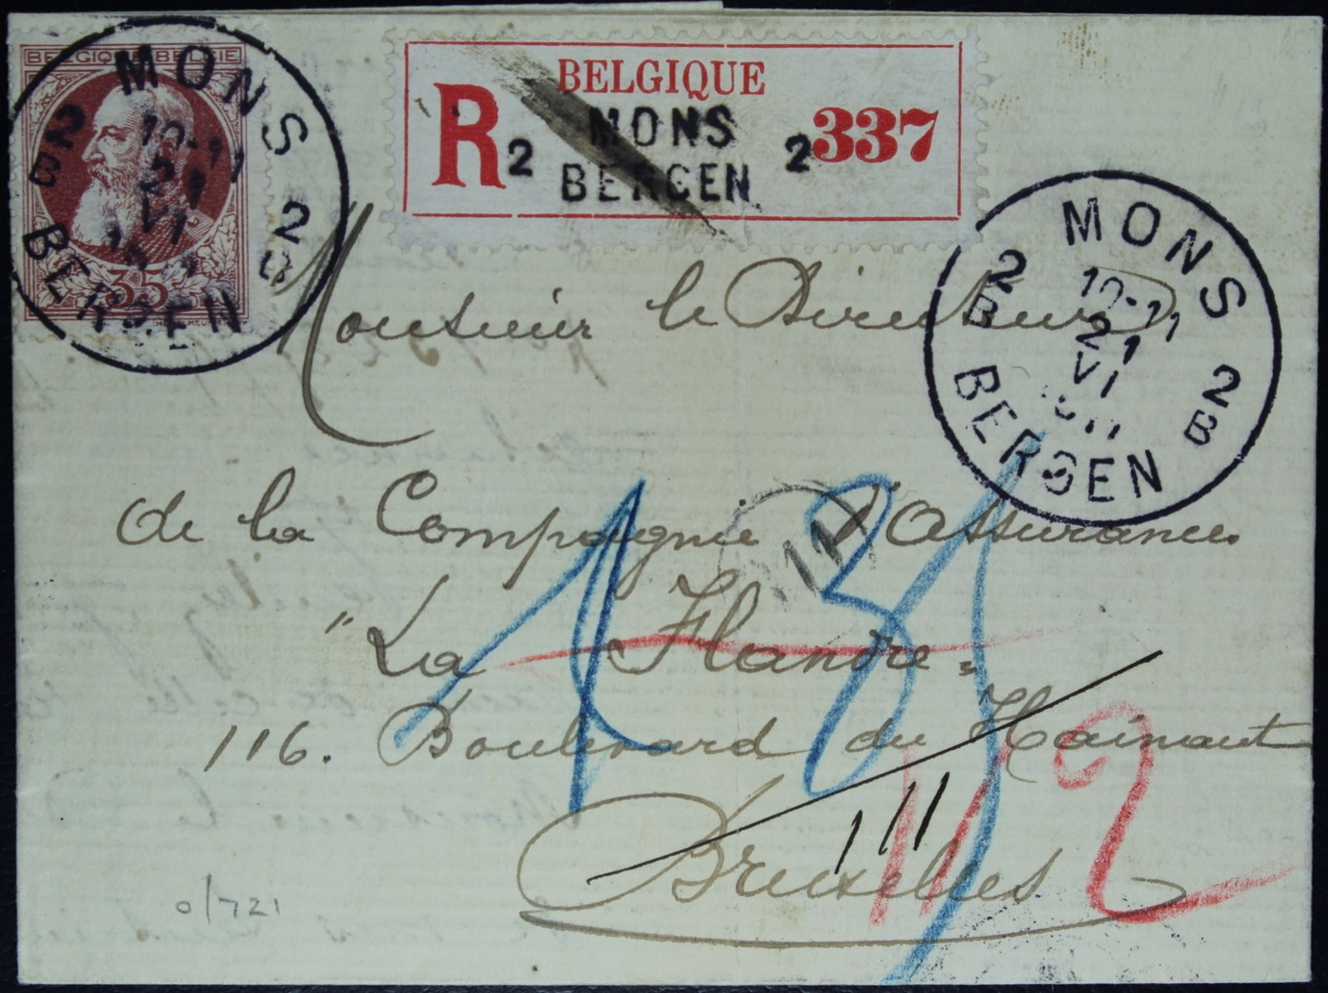
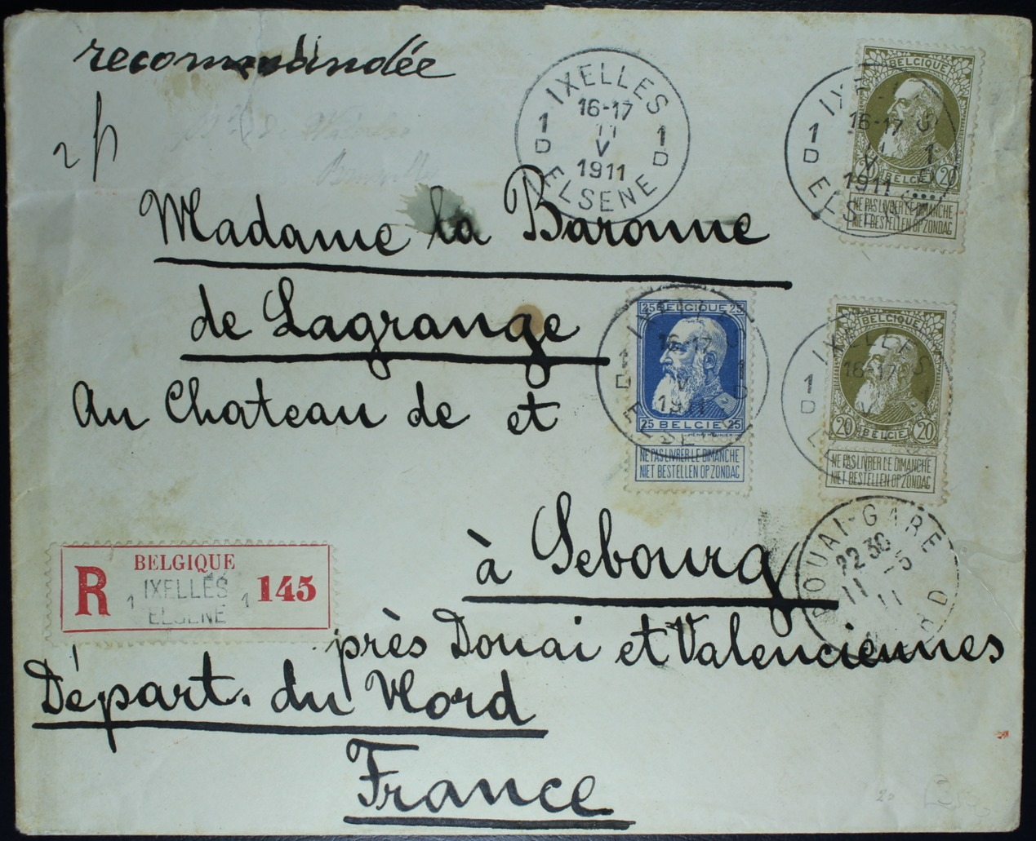

Finally it’s KLM (again). I struggled to decide what to show this time. I’ve shown a crash cover before but that still left over 400 covers, many mundane, some interesting, to pick from. Eventually I have chosen a registered commercial cover posted at Lampegan, a small railway halt, which originated from a tea company based at a remote hill station which was then flown from Batavia to Schiphol by KLM aircraft ‘Ijsvogel’ for collection at a post office in den Haag where an arrival mark dated ten months later was wrongly (?) applied
