Ipswich Philatelic Society Newsletter #28

I don’t know if we have any Swiss collectors amongst our members but for anyone interested Fred Smith’s outstanding lifetime collection (together no doubt with some other bits and pieces) will be going on sale at Lockdales, probably in their June auction. Fred’s wish was that all proceeds from the sale be donated to St Elizabeth’s Hospice. It should make good money and hopefully Lockdales will ensure that it is split into a number of smaller lots so there will be something for everyone. If you are interested please bid generously.
********
On then to the philatelic bit and this week we have some excellent member’s articles (so no need for any more of my rubbish). First up are two contributions from Keith Spurling. I particularly like the first one as it shows how a simple Victorian cover can, with research, give an insight into what life was like in the 1870s.
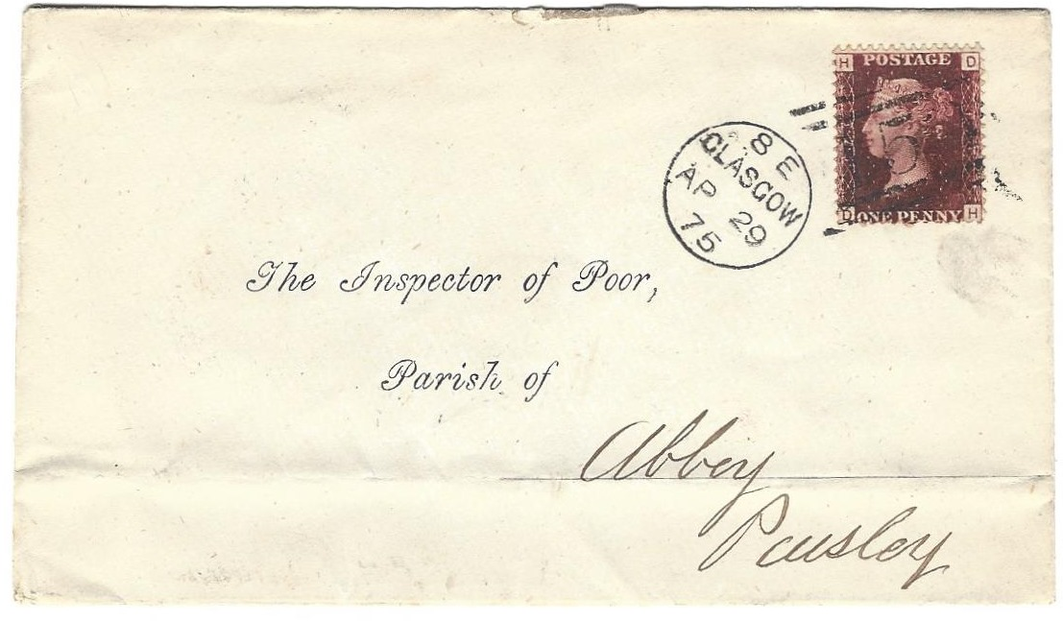

Cover bearing 1d lake red plate 71 posted in S.E Glasgow 29/4/75 to ‘The Inspector of Poor, Parish of Abbey, Paisley’. Paisley receiving mark 29/4/75 on reverse.

The cover, destined for the inspector at the workhouse in the Abbey parish of Paisley was, judging from the pre-printed portion of the address, sent from those responsible centrally for workhouses in the county. In Victorian times Abbey parish sported two ‘poorhouses’, Craw Road built in 1849 which replaced the one at Sneddon dating from 1752. By the 1870s the ‘Inspector of Poor’ in Abbey was responsible only for the Craw Road premises to which an asylum wing and hospital had been added. The inspector clearly had a horrible job. Following an inspection in 1874, just a year before this cover was sent, it was recommended that ‘chamber pots be used to replace the present wooden utensils and that the eggs of vermin were found in considerable numbers in the heads of girl inmates’. I hope the addressee of the cover was well paid for his most unpleasant employment but sadly I doubt it. On now to Keith’s other, more light hearted, contribution.
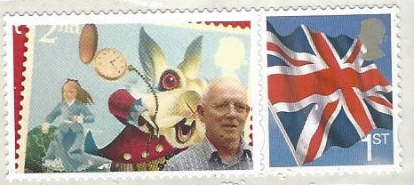
Keith’s other item is one in the ‘my favourite stamp’
section and what a choice it is! Very often we have
heard from visiting speakers that an item they are
showing is ‘one of two (or three) known’. Well I am
amazed to say that Keith Spurling is the owner of, and
this newsletter is proud to show, an item which is the
only one known (who said ‘thank goodness’?). Just a
single item, mercifully not a full ‘Smiler’ sheet, it was
produced at Stampex and depicts Keith looking rather
apprehensive as he poses for the camera, possibly due to the crazy watch-wielding white rabbit behind him!

Now we come to another excellent contribution from Liz Elbourne. Inspired by the Covid vaccination programme Liz has looked at the work of Edward Jenner under the title ‘If you don’t like needles look away now’ demonstrating ‘Scientists’ as another collectable theme plus the additional information and enjoyment research can bring to a thematic collection. Many thanks Liz and I was pleased to hear you and Ron are well.
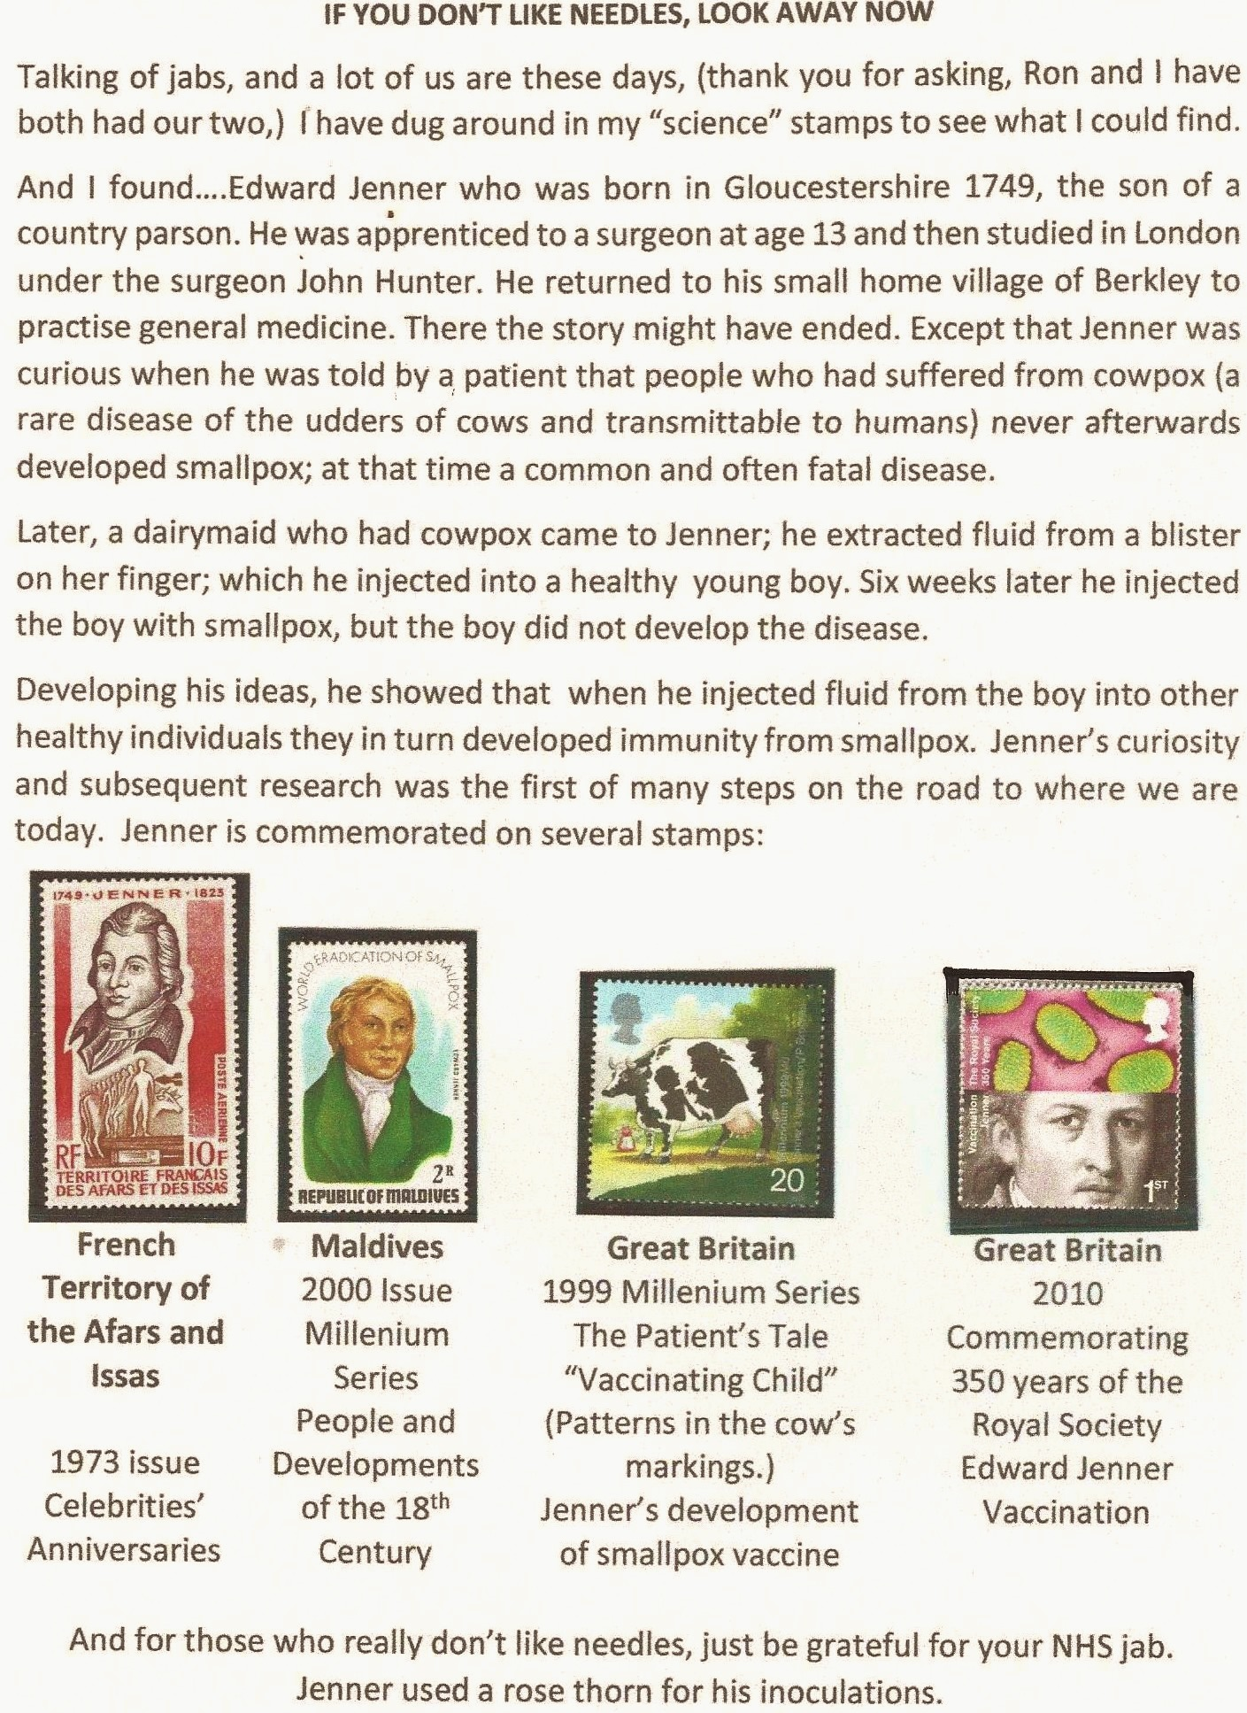

Next, as we haven’t had one for a while, it’s time for another ‘100 years ago’ item. This time it’s Rumania, which celebrated the 50th anniversary of the founding of the Rumanian Communist Party in May 1921 with a stamp issue on 8th May 1971.‘The Secret Printing Press’, ‘Emblem and Red Flags’ and ‘The Builders’, were designed by a man with surely the longest name of any stamp designer, Aida Tasgian-Constantinescu.
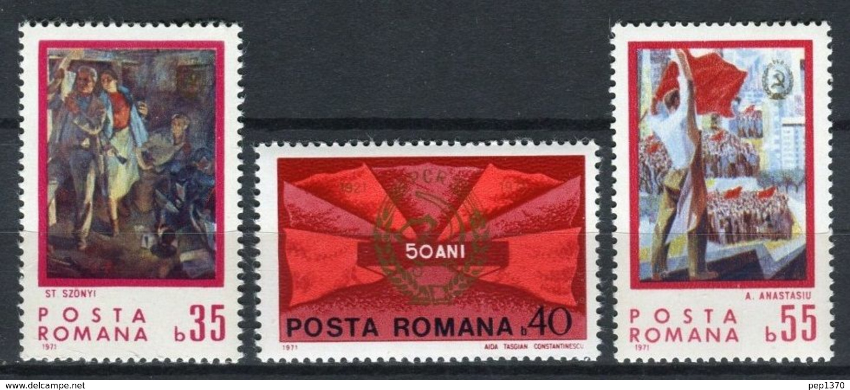

The first congress was held in Bucharest in 1921 when Gheorghe Cristescu was elected as General Secretary which post he held until 1924 when the party was outlawed, existing thereafter only on the fringe of Rumanian politics through various front organisations until just after WWII when, with Russian support, it forced the abdication of King Michael I, establishing undisguised Communist rule in 1948.

********
Finally another excellent contribution from our prolific Aldeburgh correspondent Ray Deeks. Staying with his Zeppelin topic Ray introduces us to Italy’s interest in airships with a piece about a 1928 Italian led airship expedition over the ice cap which ended in a crash and the death of the world’s best known explorer.
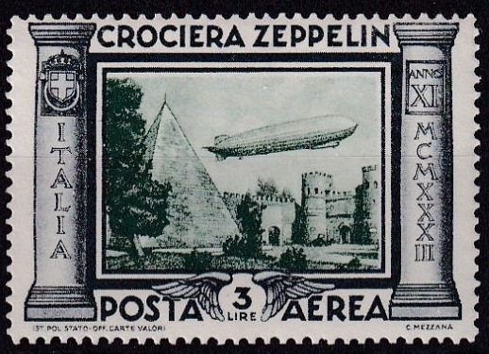
The North Pole Attraction
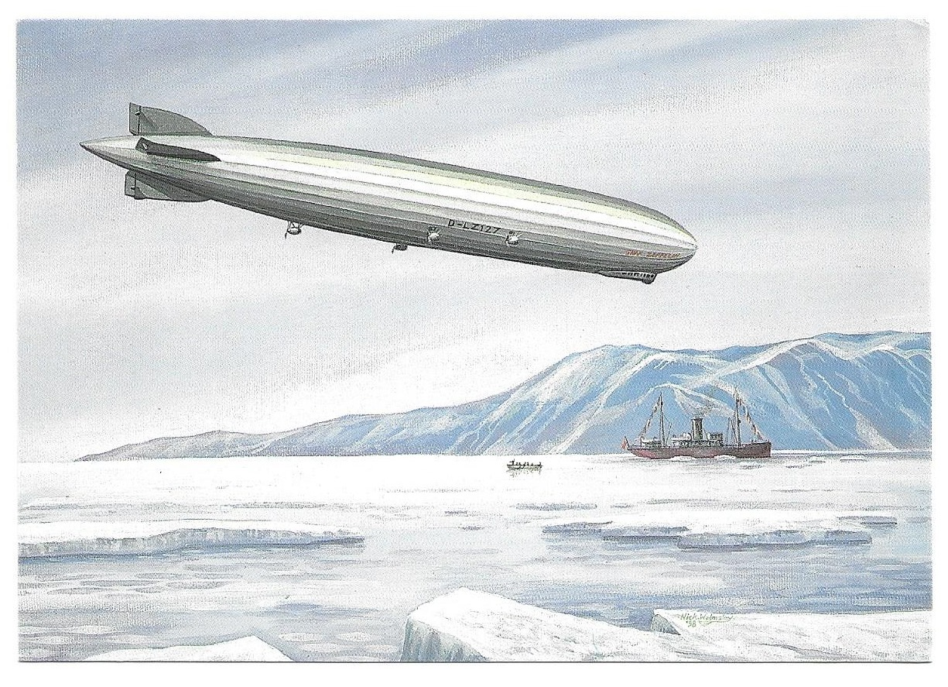
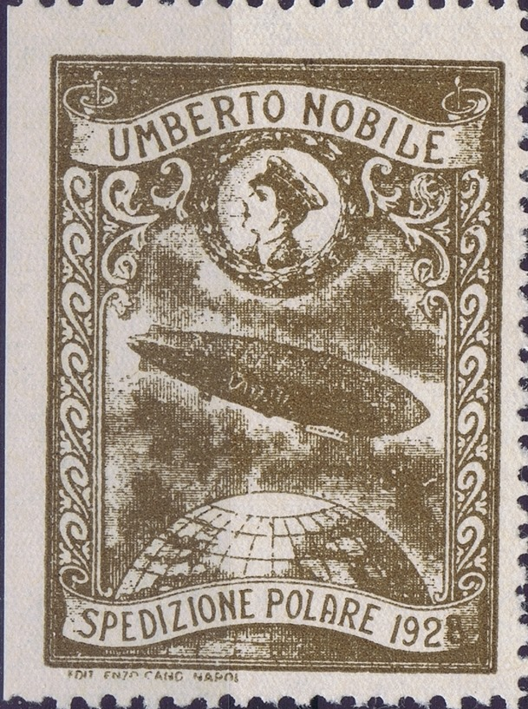



Italy built several semi-rigid airships and in 1928 a team led by General Umberto Nobile set out for Norway and the North Pole in the airship Italia, crashing on the ice cap and setting in motion a badly coordinated rescue plan involving two whaling ships and three flying boats. Roald Amundsen hero of the South Pole expedition and a North Pole airship flight in 1926 became involved and set out in another aircraft a French Latham 47 flying boat but disappeared on the 18th June over the Barents Sea failing to reach the North Pole or the crashed airship. Nobile and the crew of Italia were eventually found and rescued after 45 days.

Nobile’s ill-fated expedition featured on a series of Cinderella labels while Italy’s love affair with the airship led to the issue of six values commemorating the Graf Zeppelin flight of 1933. Russia commemorated Amundsen with a stamp depicting his successful 1926 polar flight in the airship ‘Norge’. (see images above)

Ray’s piece ends with two covers from more successful Polar flights carried out by Graf Zeppelin in 1931.
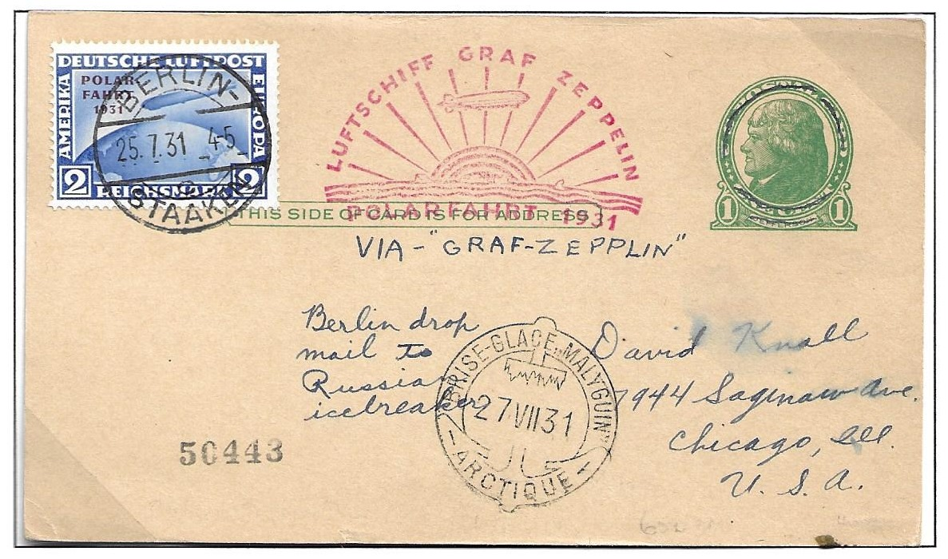

USA 1c postal stationery card uprated with 2M German Zeppelin issue with ‘Polar Flight 1931’ overprint. Posted Berlin Staaken (in the borough of Spandau) on 25th July 1951. The item, which bears the ‘Graf Zeppelin Polar Flight’ cachet was dropped to the icebreaker Malyuin at the North Pole on 27th July 1931
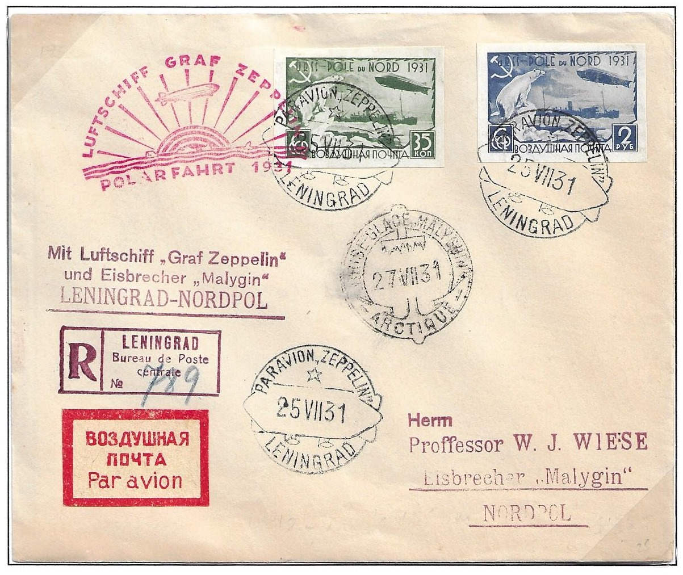

Registered cover to Prof. W J Wiese on board the Malyuin. Posted Leningrad 25th July bearing Russian ‘Pole du Nord’ adhesives with Zeppelin cancellations, two different Graf Zeppelin cachets and Malyuin receipt cancellation.

My thanks as usual to all contributors and please keep your articles, news and suggestions coming.

