Ipswich Philatelic Society Coronavirus Lockdown Newsletter #2

You probably won’t get this second newsletter for another couple of weeks but I thought I’d better get on with it or, knowing me, it might have turned into a one issue wonder, so I’m actually writing this on May 1st. By the time you read this many of you should have been sorting out and mounting all the purchases you would have made on the society visit to the sadly cancelled London 2020.

I wonder how many of you are already up to date on your stamps and how many of you still haven’t opened that album or box which you always meant to get on with. Sadly it appears we are going to have plenty of time in lockdown so no excuses. One of our members, Ray Deeks, has I know finally bitten the bullet after many years and is currently tackling his long held accumulation of the barred numeral cancels on the ‘Epaulettes’ and ‘Medallion’ issues of Belgium. Good luck with that Ray!

I have no other news of members at the moment and no feedback as yet on the first newsletter but I have had an email updating me about Lockdales auctions. As you will no doubt know by now their auctions will only be by postal, internet or, for those spending big money, telephone, bidding for the immediate future. They are also moving away from the expensive, glossy, hard copy catalogues but the catalogue will of course be on line on their own site and on the ‘Saleroom’ and ‘Easylive’ internet bidding sites.

Their next stamp and postcard auction will be a midweek sale on Wednesday 17th and Thursday 18th of June, sadly viewing will not be possible. Lots will all be small with no bulk or ‘glory boxes. Coins, medals and militaria will be in a separate sale at the end of May.

Alliance at Great Dunmow are still running their monthly auctions but of course it is now a postal/internet sale only. They are however still offering large bulk lots (which they will collect from vendors) so in the unlikely event that you are up to date and want enough material to keep going through lockdown, get bidding!

On to a couple of philatelic items which may be of interest. Firstly an ‘if only’ block.
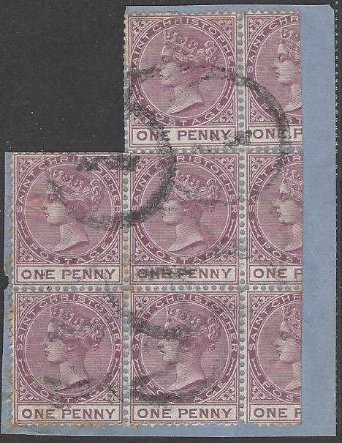

It’s an ‘if only’ because if it were genuine (and I don’t suppose for a minute that it is) it would be a wonderful block of SG 6 x5 and SG 6a x3 of St Christopher on piece with a catalogue value of over £7500. Sadly it’s almost certainly a ‘creation’ (rather than a forgery as the stamps themselves are genuine) where the three stamps on the right have been apparently peeled back from the piece in order to cut and create vertical bisects which if correct would catalogue at £2500 each.

The ‘bisects’ are of course not tied to the piece (in fact none of the stamps are tied) which rather gives it away and the cancellations on the rest of the block look suspicious to me anyway. Bisecting was authorised for use between March and June 1882 to make up the 2.5d letter rate. What value stamp was in the gap at the top left corner we’ll never know and what would have required an 8d rate or possibly more (assuming the three on the right were at one time complete 1d stamps) I don’t know, a parcel perhaps? In fact I wonder whether the block ever genuinely postally used at all
An interesting item never the less.

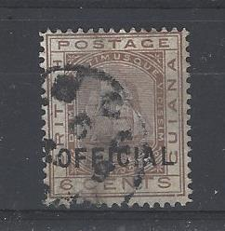

On to another, hopefully, interesting item, again an early one but this time almost certainly a forged ‘official’ overprint (I think) raising the catalogue value from a mere £13 to a heady £600.

It purports to be a used copy of SG O9 of British Guiana but Gibbons notes that ‘official’ overprints have been extensively forged. It’s the old problem is it a genuine used O9 or is it SG 129 cancelled before a false ‘official overprint was added? I don’t know about you but I am useless at deciphering which came first the overprint or the cancel despite the strongest glass and lamp so it’s on its way for an opinion from Larry Lewendon at Norwich PS the forgeries king. A ‘real thing’ verdict would be nice!

Well that’s it for Newsletter No2. It’s already grown to two sheets from the first one. I don’t intend it to turn into anything too lengthy but I would of course welcome any contributions about interesting items, news of members or simply what you are doing during the lockdown plus of course I would like feedback about whether you even like the idea of keeping in touch this way (it could be a long time yet before we all get together again)

Keep safe, philately needs you!

